PROJECT 6
Aggressive Scan Analysis
Category: Network Security & Recon | Difficulty: Intermediate
Target: Metasploitable 2 (192.168.80.133) | Status: Completed

Objective
To run Nmap's aggressive scan mode against the target, combining OS detection, version detection, default script scanning (NSE), and traceroute in a single scan, and identify any new findings beyond the individual scans done in Projects 3 to 5.

Tools Used
- Kali Linux — attacker/scanning machine
- Nmap 7.99 — aggressive scan (-A)

What -A Includes
- -O OS detection (already seen in Project 5)
- -sV Service version detection (already seen in Project 4)
- -sC Runs Nmap's default safe scripts against each open port — new for this project
- --traceroute Maps the network path to the target — new for this project

Step-by-Step Process
Command: nmap -A -p- 192.168.80.133
All 65,535 ports were scanned again (as in Project 3) since earlier projects showed that important services can sit outside the default port list. The scan took about 2.5 minutes to complete.
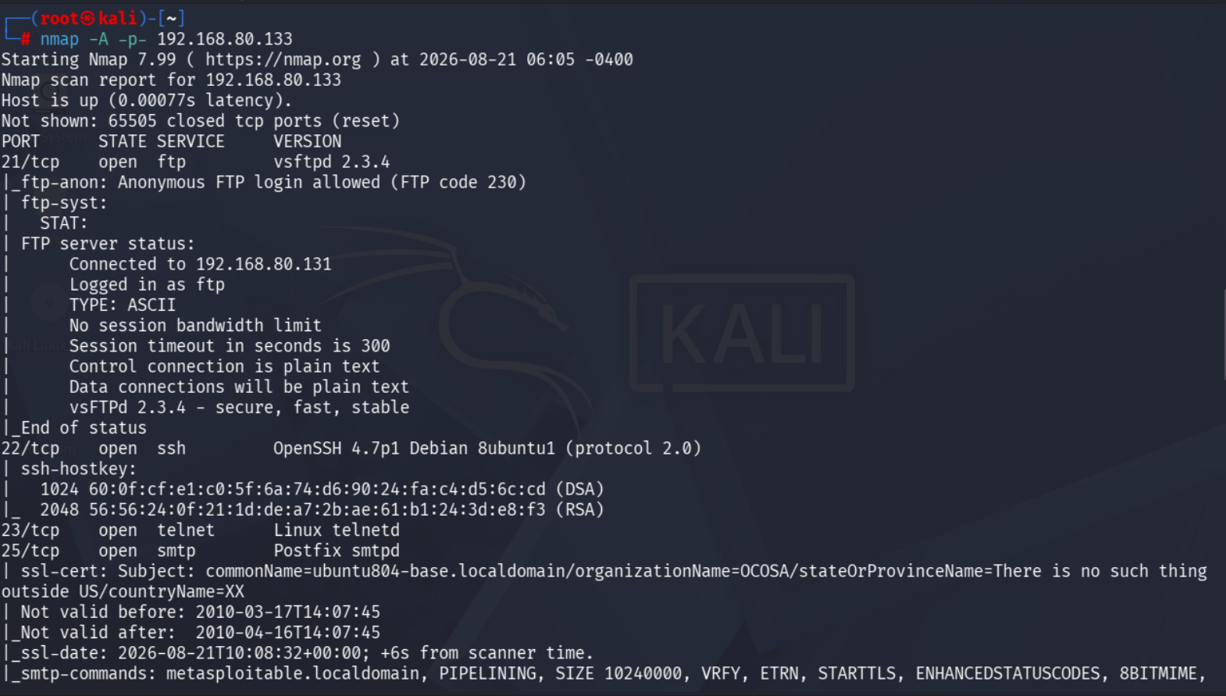
Figure 1 — FTP script results: anonymous login confirmed
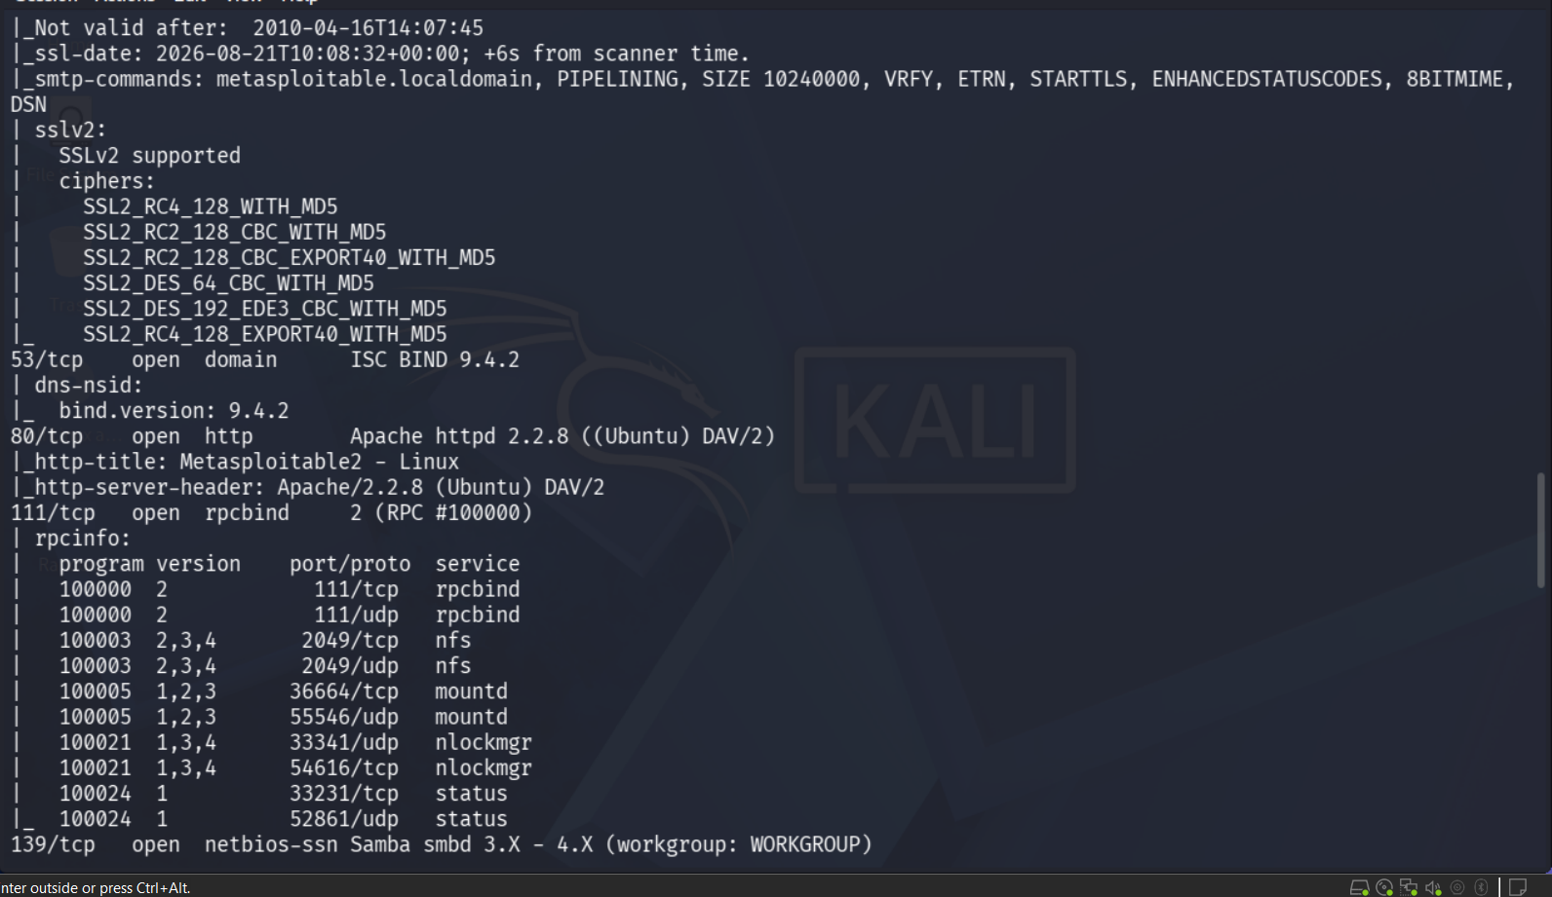
Figure 2 — SMTP SSL certificate and RPC service listing
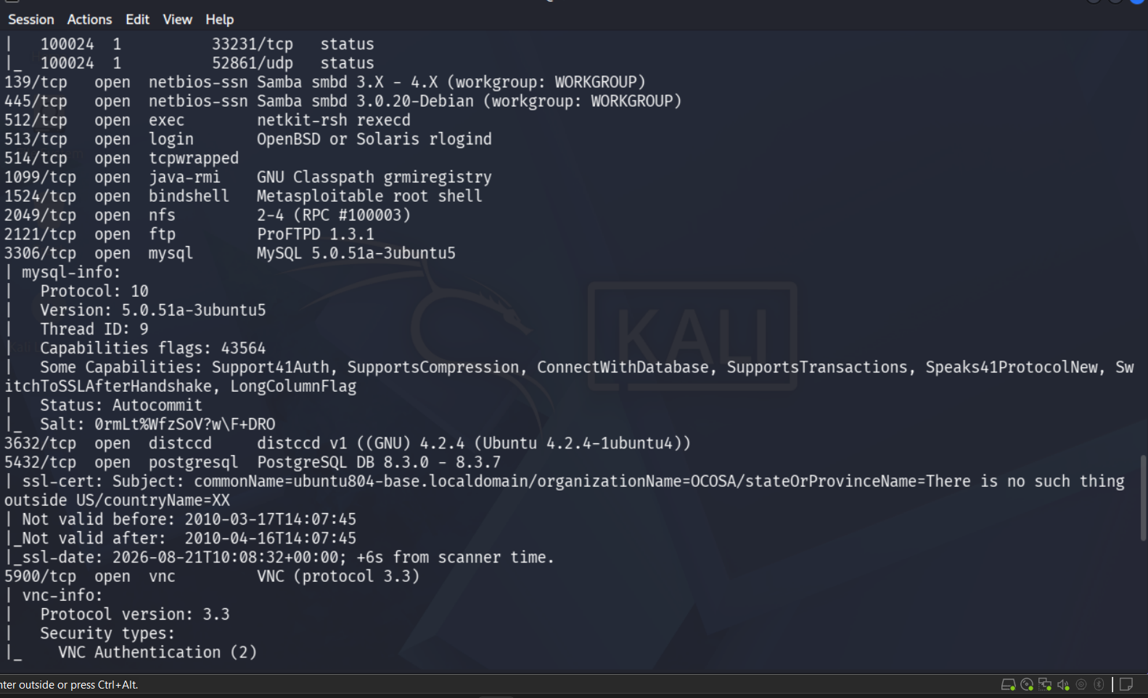
Figure 3 — MySQL and VNC script results
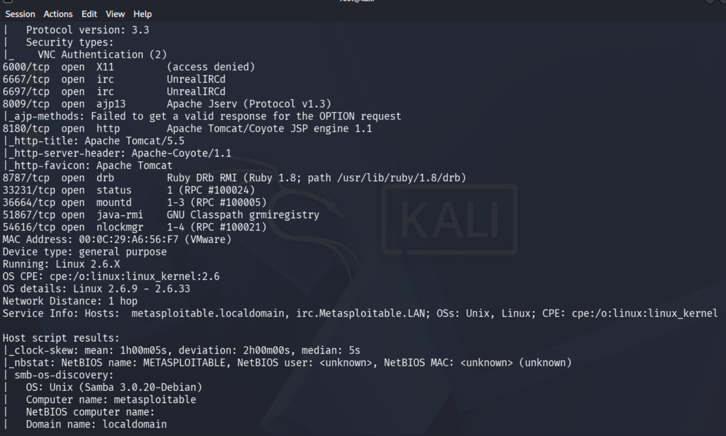
Figure 4 — IRC, Tomcat, and Ruby DRb results
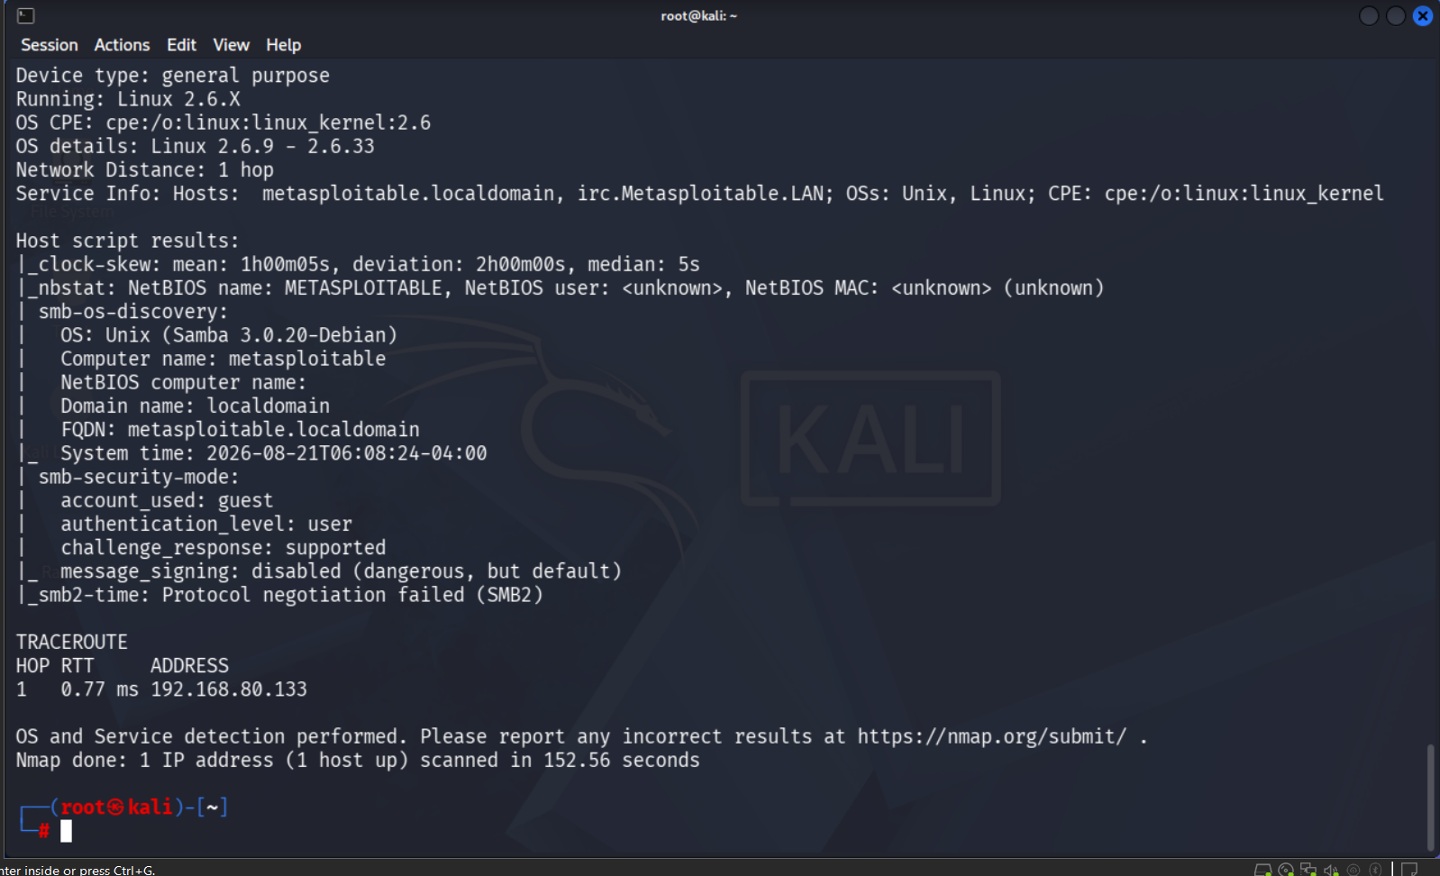
Figure 5 — SMB security mode and traceroute

Findings
New information found by the default NSE scripts, beyond what earlier projects already showed:
Area | New information from NSE scripts
FTP (21) | Anonymous login actively tested and confirmed working (code 230)
SMTP (25) | SSL certificate expired since 2010; SSLv2 with MD5 ciphers still supported
HTTP (80) | Page title confirms “Metasploitable2 - Linux”
RPC (111) | Full list of every RPC program, version, and port via rpcinfo
MySQL (3306) | Protocol/version details and password salt exposed
VNC (5900) | Authentication type confirmed as the older, weaker VNC Authentication (2)
Tomcat (8180) | Identified as Apache Tomcat/5.5 specifically
SMB (139/445) | Message signing disabled — flagged “dangerous, but default” by Nmap itself
SMB (139/445) | Computer name, domain, and OS build exposed via smb-os-discovery
Traceroute | 1 hop to target, confirming same local network (matches Project 2 and 5)

Risk Analysis
- FTP anonymous login — actively confirmed — The script directly logged in as “anonymous” and succeeded (FTP code 230). This moves the risk from “possible” (Project 1) to “confirmed working right now.” Anyone can access the FTP server with no credentials.
- SMB message signing disabled — Nmap's own script labels this “dangerous, but default.” Without signing, SMB traffic can be intercepted and modified in transit, enabling relay attacks between the target and other machines.
- Very old, broken SSL supported (SMTP) — The mail server still accepts SSLv2 with MD5-based ciphers. Both SSLv2 and MD5 are considered cryptographically broken and should not be usable on any service.
- Weak VNC authentication — VNC protocol 3.3 uses an old, weak authentication scheme with known bypass methods, in addition to the port already being exposed.
- Full RPC service map exposed — rpcinfo returned an exact list of every RPC program, version, and port. This removes any guesswork for an attacker targeting RPC-based services like NFS.

Conclusion & Recommendation
The aggressive scan's default scripts turned several earlier assumptions into confirmed findings, most notably working anonymous FTP access and disabled SMB signing. Combined with the backdoors found in Project 4 and the outdated kernel from Project 5, this host has multiple independent, low-effort paths to compromise. Recommendation: disable anonymous FTP, enforce SMB signing, and remove support for SSLv2 and MD5-based ciphers on all services.

