PROJECT 15
Mapping Active Services in a Network
Category: Network Security & Recon | Difficulty: Intermediate
Target: 192.168.80.133, .254, .131 | Status: Completed

Objective
To build a combined map of every active service running across multiple hosts on the network at once, rather than scanning one target in isolation.

Tools Used
- Kali Linux — attacker/scanning machine
- Nmap 7.99 — service version detection across multiple hosts

Step-by-Step Process
Command: nmap -sV 192.168.80.133 192.168.80.254 192.168.80.131
Ran version detection against three hosts at once — the target, the newly-found .254 device, and Kali itself — to see what services each one exposes.
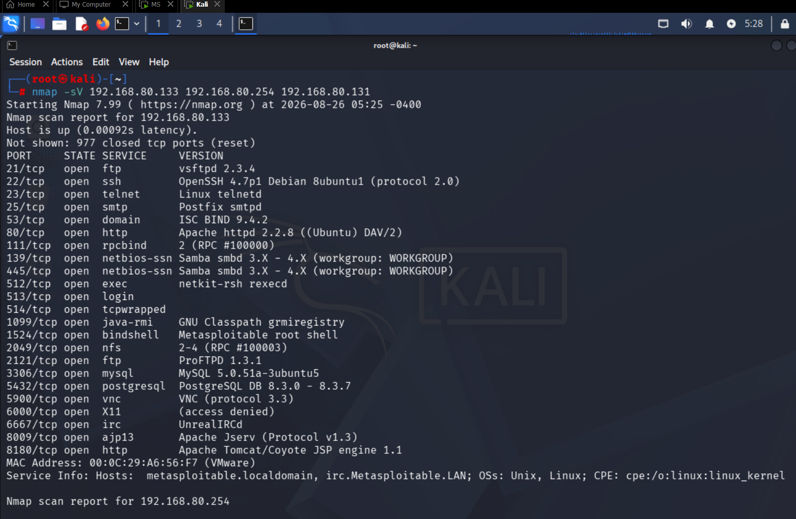
Figure 1 — Service map results for 192.168.80.133

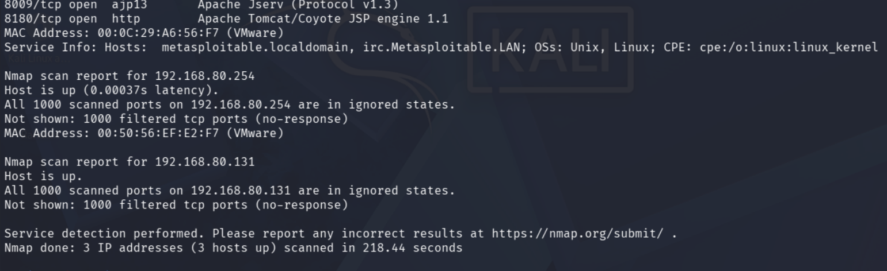
Figure 2 — Results for 192.168.80.254 and 192.168.80.131

Findings
192.168.80.133 (Metasploitable 2) returned its full, familiar 23-service list, including the critical bindshell on port 1524 and UnrealIRCd on 6667. 192.168.80.254 showed no open TCP ports in its default 1000-port range — all ports filtered/closed. 192.168.80.131 (Kali itself) also returned no open ports, consistent with a hardened attacker workstation not running exposed services.

Risk Analysis
- A multi-host service map shows relative exposure at a glance — 192.168.80.133 stands out immediately as the only host running numerous exposed, high-risk services.
- Hosts with no open services are not necessarily uninteresting — a device like .254 that responds to ARP but shows nothing open may still be worth deeper investigation with a full port range scan.

Conclusion & Recommendation
Combining service detection across multiple hosts in one scan makes it easy to see which machines carry the most risk. Metasploitable 2 remains by far the most exposed host on the network.
Recommendation: prioritize remediation on 192.168.80.133 first, and run a full port-range scan against 192.168.80.254 to rule out non-default services.

