PROJECT 11
Network Topology Mapping of Lab Network
Category: Network Security & Recon | Difficulty: Intermediate
Target: Subnet 192.168.80.0/24 | Status: Completed

Objective
To map out the devices present on the lab network by identifying every live host on the subnet, along with their IP and MAC addresses, to build a picture of the lab's network structure.

Tools Used
- Kali Linux — attacker/scanning machine
- Nmap 7.99 — subnet-wide ping sweep

Step-by-Step Process
Command: nmap -v -sn 192.168.80.1/24
Ran a ping sweep (-sn) across the entire /24 subnet instead of a single target, to discover every live device on the lab network at once. This checks all 255 possible addresses and reports which ones respond, along with their MAC address where available.
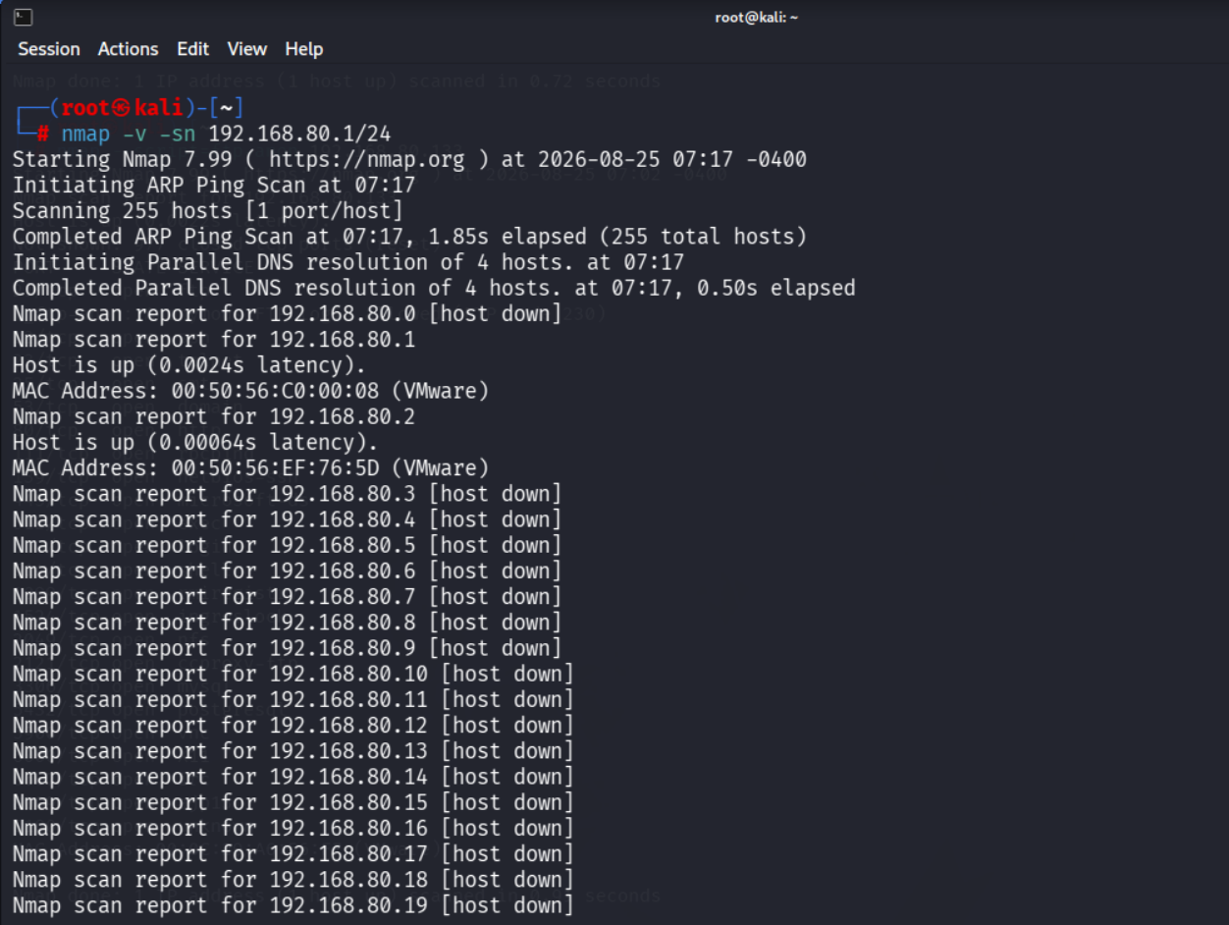
Figure 1 — Subnet-wide ping sweep starting, gateway and NAT device discovered
The scan continued through the full address range, and the target machine was confirmed live further down the results:
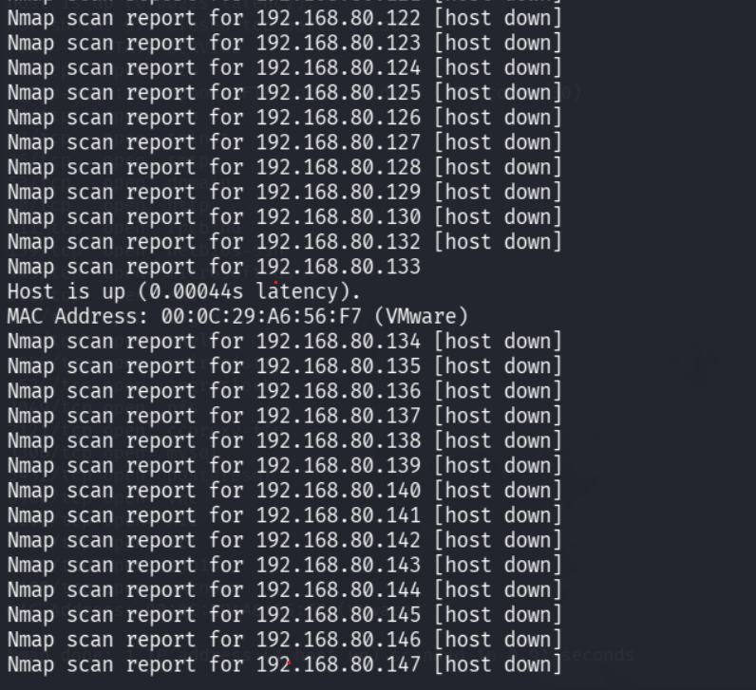
Figure 2 — Metasploitable 2 (192.168.80.133) confirmed up during the sweep

Findings
Out of the full 255-address range, only a small number of hosts responded as live:
IP Address | MAC Address | Role
192.168.80.1 | 00:50:56:C0:00:08 (VMware) | Gateway / router
192.168.80.2 | 00:50:56:EF:76:5D (VMware) | VMware NAT device
192.168.80.131 | — (local host) | Kali Linux (attacker machine — running the scan)
192.168.80.133 | 00:0C:29:A6:56:F7 (VMware) | Metasploitable 2 (target machine)

Kali itself (192.168.80.131) does not appear in its own scan output, since a host does not need to ping itself to know it's active — it is included here as the machine performing the scan. No additional lab devices (such as the Windows Server 2019 VM) were live at the time of this scan. All responding hosts carry VMware MAC address prefixes, confirming this is an entirely virtualized lab environment on a single flat subnet, with no routing hops between devices.

Risk Analysis
- A flat network with no segmentation — means that if one machine on this subnet is compromised, an attacker has direct, unobstructed access to every other machine on it — there is no internal firewall or VLAN boundary to slow them down.
- Mapping the topology is often an attacker's first move after gaining any foothold — knowing exactly what else is reachable on the network lets them plan further movement quickly.

Conclusion & Recommendation
The subnet-wide ping sweep confirmed a small, flat lab network consisting of the gateway, a NAT device, the Kali attacker machine, and the Metasploitable 2 target — all on the same unsegmented subnet.
Recommendation: in a real environment, critical systems should be separated onto different network segments (VLANs) so that a single compromised host cannot directly reach every other machine on the network. This baseline host list is also useful going forward as a reference point for spotting any unauthorized new devices that appear on the subnet later.

