PROJECT 17
IP Range Discovery in Unknown Network
Category: Network Security & Recon | Difficulty: Intermediate
Target: Subnet 192.168.80.0/24 | Status: Completed

Objective
To discover which IP addresses are actually in use across the full subnet range, as if approaching the network without prior knowledge of what's connected.

Tools Used
- Kali Linux — attacker/scanning machine
- Nmap 7.99 — full-range ping sweep

Step-by-Step Process
Command: nmap -sn 192.168.80.0/24
Swept the entire 256-address range to identify every IP currently responding, without assuming any prior knowledge of the network layout.
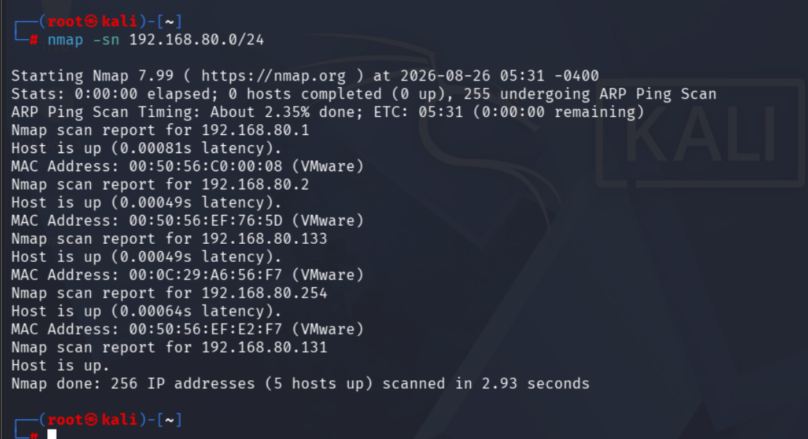
Figure 1 — Full subnet sweep results, 5 hosts found

Findings
5 hosts responded out of the full 256-address range: 192.168.80.1, .2, .131, .133, and .254 — matching the combined results of Projects 11 and 13, confirming a consistent, complete picture of the active IP range.

Risk Analysis
- A wide, mostly-empty IP range is normal in a lab/NAT setup — but in a real network, a large unused range can hide unauthorized devices if not periodically re-swept.

Conclusion & Recommendation
The active IP range for this lab subnet was confirmed as a small, consistent set of 5 hosts out of 256 possible addresses.
Recommendation: periodically re-run full-range discovery scans on production networks to catch any newly connected, unauthorized devices.

