PROJECT 9
Banner Grabbing from Open Services
Category: Network Security & Recon | Difficulty: Intermediate
Target: Metasploitable 2 (192.168.80.133) | Status: Completed

Objective
To connect to open services on the target and capture their banners — the text a service sends when a connection is made — in order to identify exact software names and versions that a basic port scan alone does not confirm.

Tools Used
- Kali Linux — attacker/scanning machine
- Netcat — manual banner grabbing
- Nmap 7.99 — automated banner grabbing via the banner NSE script

Step-by-Step Process
Manual banners were grabbed first for a few key services, then Nmap's banner script was run to automatically capture banners across every open port at once.
Command: nc -nv 192.168.80.133 21
Connected directly to FTP (21), SSH (22), and SMTP (25) one at a time. Each service replied immediately with its own banner line, confirming the exact software running.
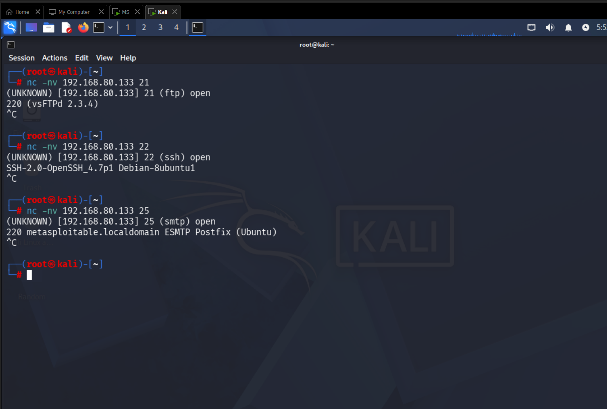
Figure 1 — Manual Netcat banner grabs: FTP, SSH, and SMTP
Command: nmap -v -sV --script=banner 192.168.80.133
The banner NSE script automates the same process across all open ports in a single scan, combined with version detection (-sV) for extra confirmation.
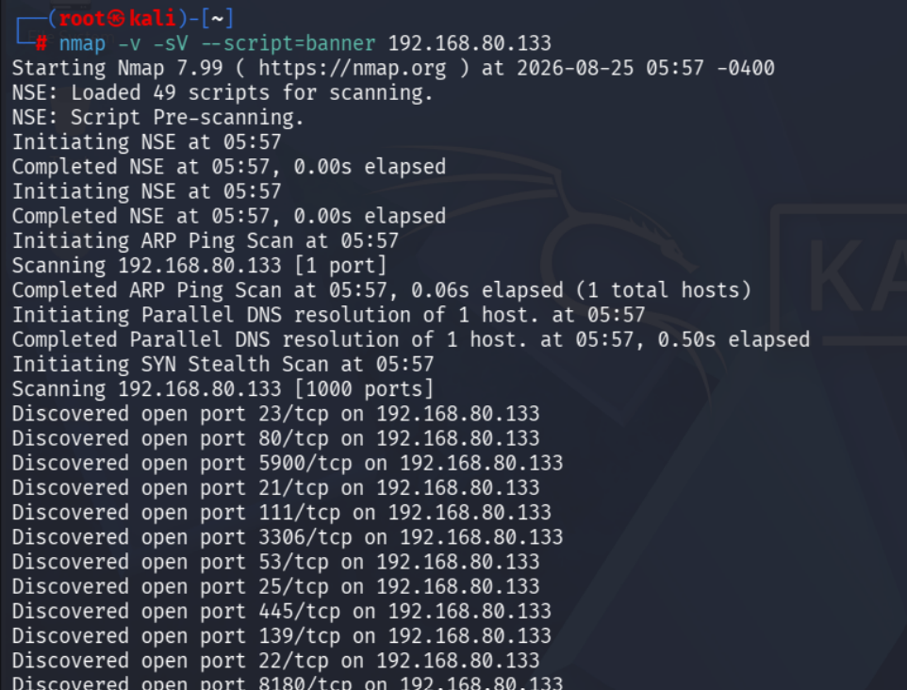
Figure 2 — Nmap banner script scan starting, discovering open ports

The completed scan returned a banner for nearly every open service:
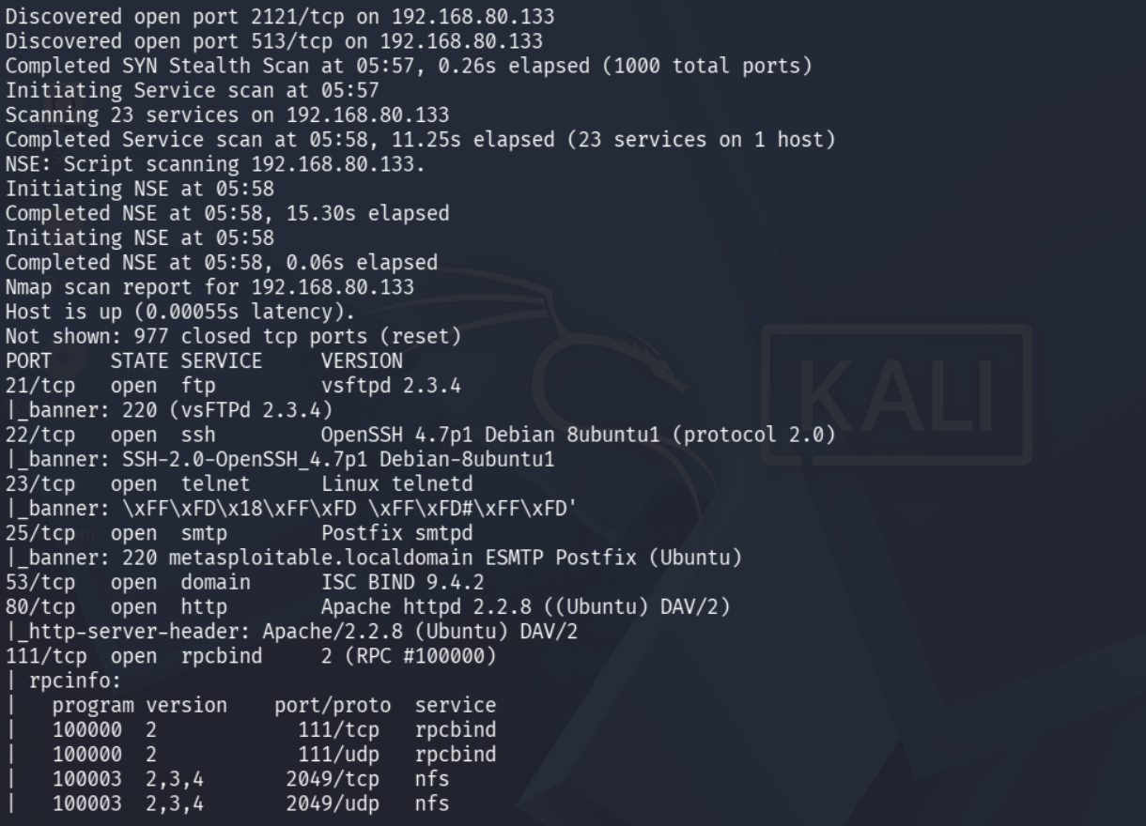
Figure 3 — Nmap banner script results, part 1
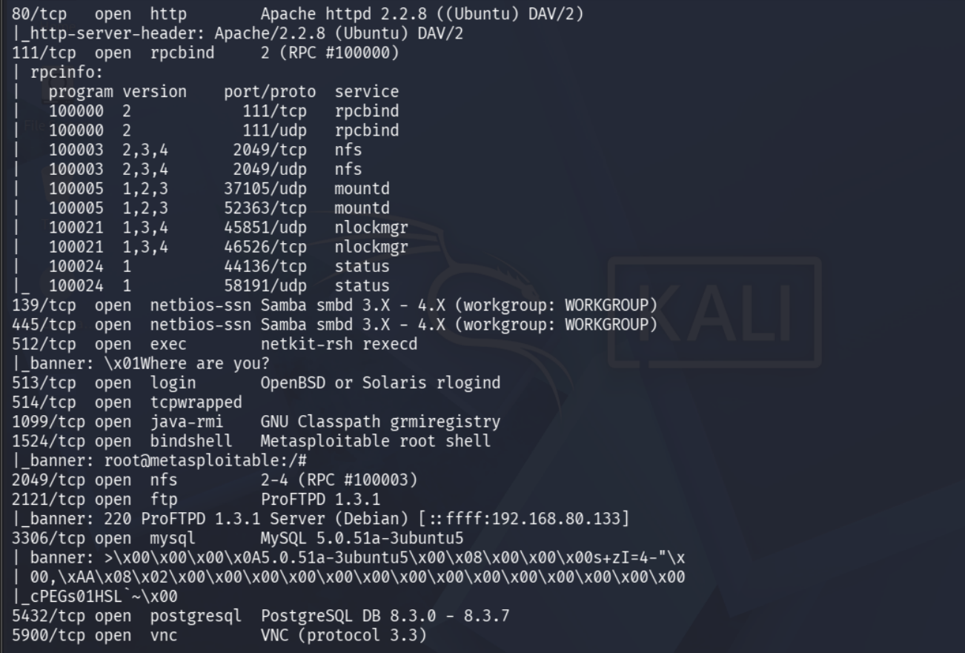
Figure 4 — Nmap banner script results, part 2

Findings
Banners were successfully captured for nearly all open ports, several of which reveal outdated or high-risk software versions:
Port | Service | Banner / Version | Note
21/tcp | FTP | vsftpd 2.3.4 | Known backdoored version (CVE-2011-2523)
22/tcp | SSH | OpenSSH 4.7p1 Debian 8ubuntu1 | Outdated — multiple known CVEs
23/tcp | Telnet | Linux telnetd | Unencrypted login — credentials sent in plaintext
25/tcp | SMTP | Postfix smtpd (Ubuntu) | Standard mail banner, version not overly revealing
80/tcp | HTTP | Apache httpd 2.2.8 (Ubuntu) DAV/2 | Outdated Apache with WebDAV module enabled
512/tcp | exec | netkit-rsh rexecd | Legacy remote exec service — no encryption
1524/tcp | bindshell | Metasploitable root shell | Direct unauthenticated root shell — critical
2121/tcp | FTP | ProFTPD 1.3.1 | Second FTP service, older version
3306/tcp | MySQL | MySQL 5.0.51a-3ubuntu5 | Outdated database version

The most critical finding is port 1524, which identifies itself directly as “Metasploitable root shell” — an open, unauthenticated root-level shell reachable over the network.

Risk Analysis
- Banners hand attackers a shortcut — instead of guessing what software is running, an attacker gets the exact name and version, making it trivial to look up known public exploits for that specific release.
- vsFTPd 2.3.4 is a textbook example — this exact version has a well-documented public backdoor (CVE-2011-2523) that grants a remote shell with no credentials needed.
- Port 1524 is the single biggest risk on this host — a service that announces itself as a root shell requires no exploitation at all — anyone who reaches it on the network already has full control.
- Best practice is to suppress or alter banners — in a real environment, revealing exact software versions to any anonymous connection makes reconnaissance trivial for an attacker.

Conclusion & Recommendation
Both manual and automated banner grabbing confirmed exact software versions for nearly every open service on the target, several of which are outdated or directly exploitable — most notably the vsFTPd 2.3.4 backdoor and the exposed root shell on port 1524.
Recommendation: service banners should be disabled or customized in production environments so they do not reveal exact version numbers. All outdated services identified here — FTP, SSH, Apache, and MySQL — should be patched or upgraded, and the port 1524 root shell should be treated as an immediate critical finding requiring the service to be removed entirely.

