PROJECT 3
Port Scanning of a Target Network
Category: Network Security & Recon | Difficulty: Intermediate
Target: Metasploitable 2 (192.168.80.133) | Status: Completed

Objective
To perform a full port scan across all 65,535 TCP ports on the target host, and compare it against a default scan to identify any services that a standard scan would have missed.

Tools Used
- Kali Linux — attacker/scanning machine
- Nmap 7.99 — port and service scanning

Step-by-Step Process
Step 1 — Default Scan (Top 1000 Ports)
Command: nmap 192.168.80.133
By default, Nmap only checks the 1,000 most commonly used ports rather than all 65,535. This scan (from Project 1) found 23 open ports.
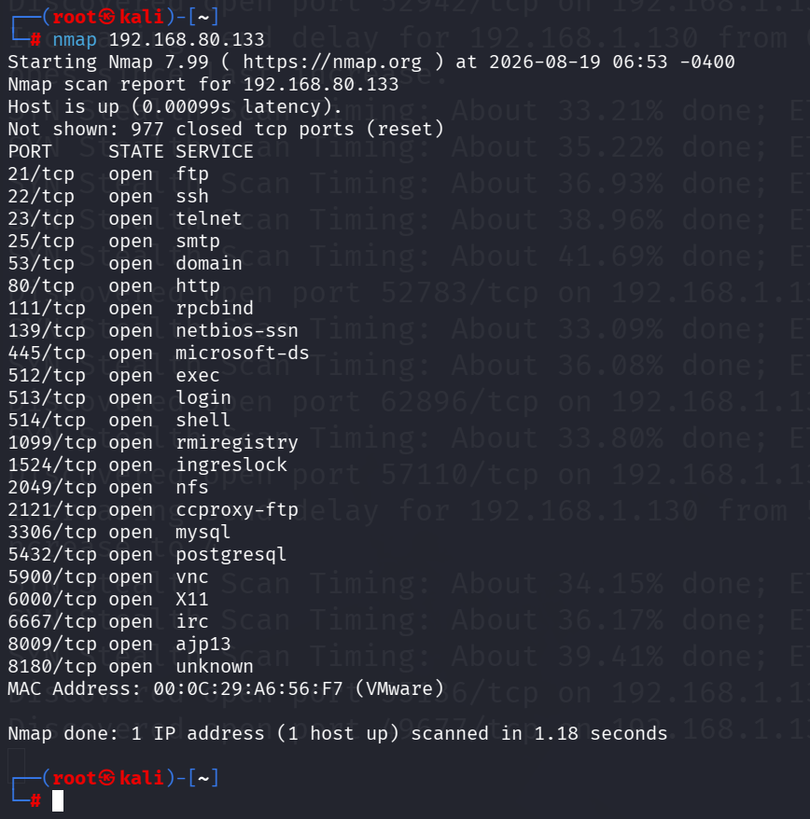
Figure 1 — Default scan (top 1000 ports) — 23 open ports
Step 2 — Full Port Scan (All 65,535 Ports)
Command: nmap -v -Pn -p- 192.168.80.133
- -v Verbose — prints each discovered port live as it is found, instead of only at the end.
- -Pn Skips the host-alive check and scans directly. Prevents Nmap from wrongly skipping a host that is up but not replying to ping (e.g. behind a firewall).
- -p- Scans all 65,535 TCP ports instead of just the default top 1000.
This scan found 30 open ports — 7 more than the default scan.
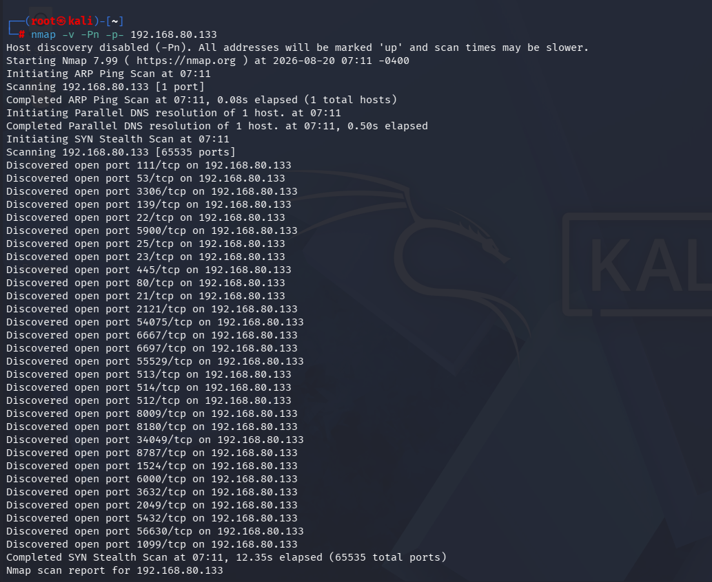
Figure 2 — Full scan running, ports discovered live
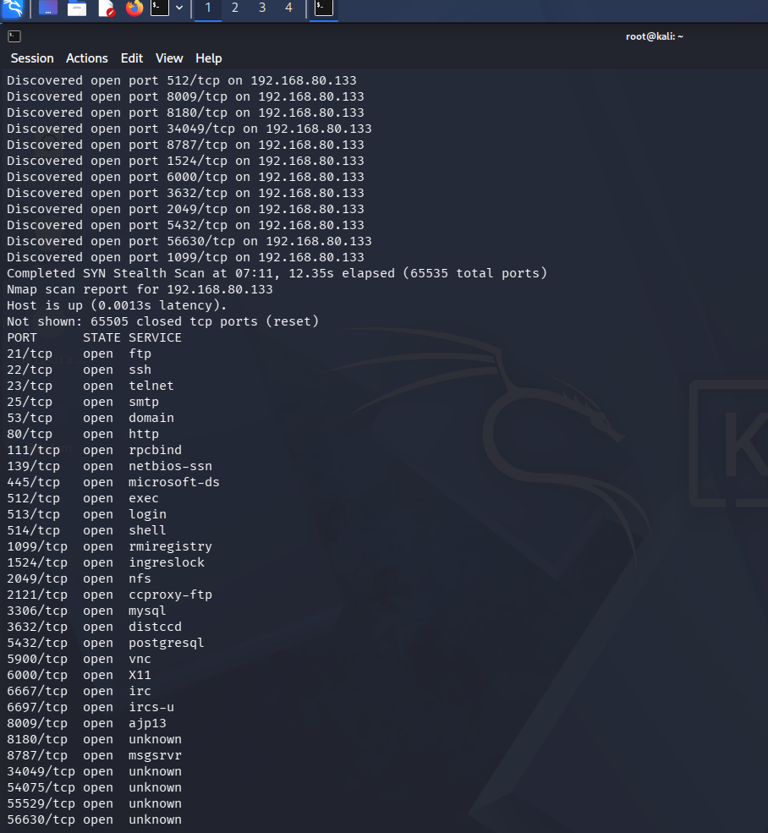
Figure 3 — Full scan final results — 30 open ports

Findings
The full scan found 7 open ports that the default scan completely missed:
Port | Service | Note
3632 | distccd | Critical — unauthenticated remote command execution
6697 | ircs-u | IRC over SSL — extra chat service, unnecessary attack surface
8787 | msgsrvr | Unidentified messaging service — needs confirmation
34049 / 54075 / 55529 / 56630 | unknown | Ephemeral (randomly assigned) ports
The four unlabelled high-numbered ports (34049, 54075, 55529, 56630) are ephemeral ports — some services (such as rmiregistry on port 1099) pick a random high port each time they start, instead of using a fixed one. These numbers would likely differ on a re-scan, and are not a separate issue on their own.

Risk Analysis
- Missed by default scan — port 3632 (distccd) — This is the single most important finding of this project. distccd on this version is a known, critical vulnerability: it lets an attacker run commands on the machine remotely with no login or password at all. A default scan alone would have completely missed this.
- Relying on a default scan alone — A default scan only checks the 1,000 most common ports. Any service intentionally or accidentally run on a non-standard port — like distccd here — will not be detected. A full scan should always be run at least once per assessment.
- IRC-over-SSL (6697) and additional web-adjacent service (8787) — Extra unmonitored services increase the number of ways in. Each one needs to be individually confirmed as necessary, or removed.

Conclusion & Recommendation
A full port scan uncovered 7 services hidden from the default scan, including a critical unauthenticated remote-command vulnerability on port 3632. Relying on default Nmap settings alone is not sufficient for a real assessment. Recommendation: always run a full-range scan (-p-) as a baseline, and disable or firewall distccd and any other non-essential service found outside the standard port range.

