PROJECT 1
Basic Network Reconnaissance using Nmap
Category: Network Security & Recon | Difficulty: Intermediate
Target: Metasploitable 2 (192.168.80.133) | Status: Completed

Objective
To identify live hosts on the target subnet and gather basic information about the services running on the discovered target, as the first step in a network security assessment.

Tools Used
- Kali Linux — attacker/scanning machine
- Nmap 7.99 — network discovery and port scanning
- Target: Metasploitable 2 (192.168.80.133) — intentionally vulnerable practice VM

Step-by-Step Process
Step 1 — Host Discovery (Ping Sweep)
Command: nmap -sn 192.168.80.0/24
The subnet was swept to find which hosts were active before targeting any single machine. 5 live hosts were discovered, including the target at 192.168.80.133.
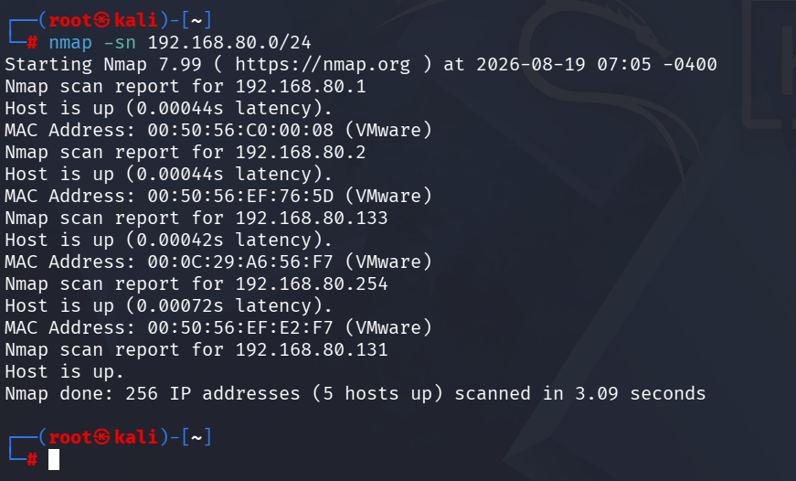
Figure 1 — Host discovery via ping sweep

Step 2 — Connectivity Check
Command: ping 192.168.80.133
The discovered target was pinged to confirm it was reliably reachable before running a full scan. 10/10 packets were received with 0% packet loss.
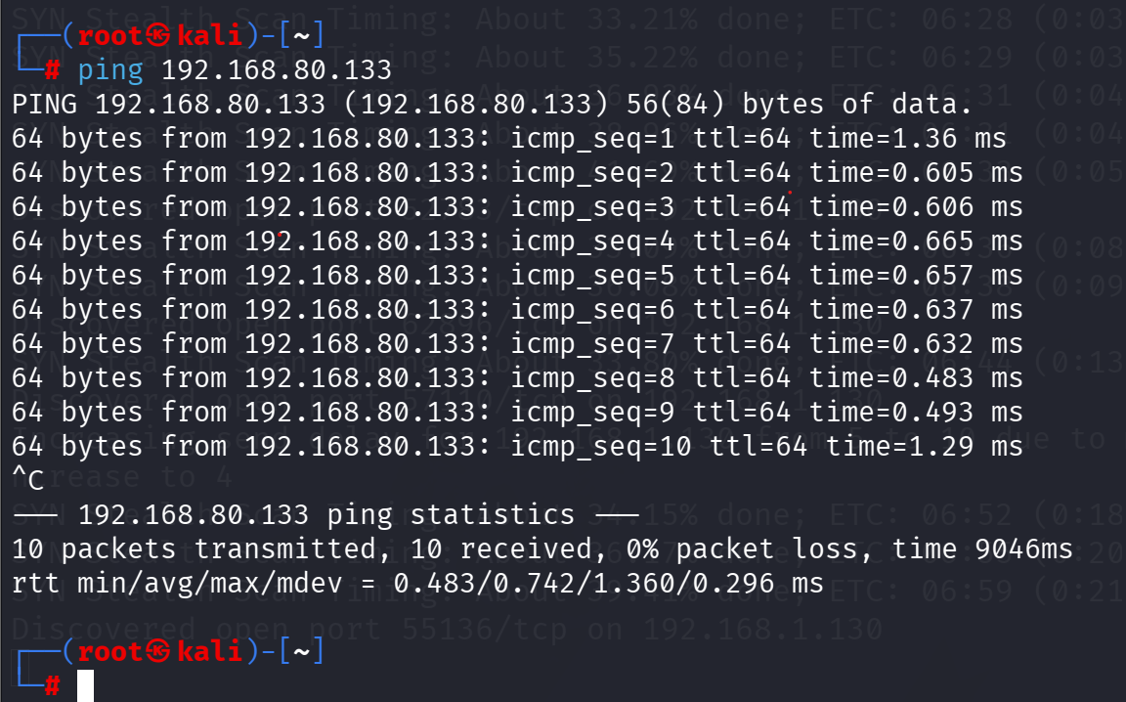
Figure 2 — Connectivity confirmed to target host
Step 3 — Port and Service Scan
Command: nmap 192.168.80.133
A standard scan was run against the target to identify open ports and the services running behind them. 25 open ports were found.
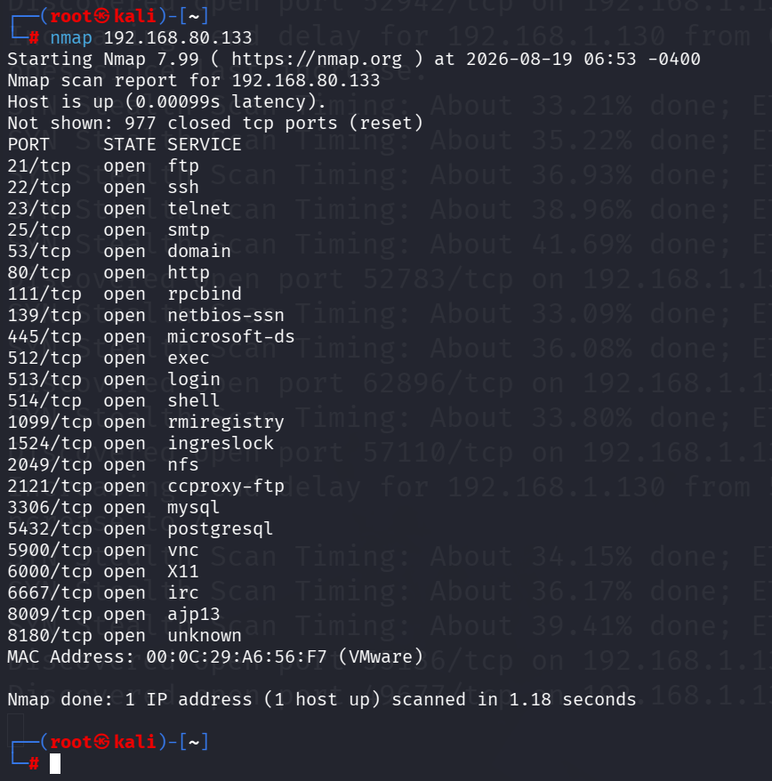
Figure 3 — Open ports and services on target host

Findings
23 open ports were identified on the target. Key services of note:
Port | Service | Note
21 | ftp | Often allows anonymous login
22 | ssh | Standard remote login
23 | telnet | Unencrypted remote login — high risk
25 | smtp | Mail service
80 | http | Web server
111 | rpcbind | Frequently exploitable
139 / 445 | netbios-ssn / microsoft-ds | Windows file sharing (SMB)
512 / 513 / 514 | exec / login / shell | Legacy r-services — unencrypted, insecure
3306 | mysql | Database exposed directly to network
5432 | postgresql | Database exposed directly to network
5900 | vnc | Remote desktop access
6667 | irc | Chat service, sometimes used as a backdoor channel

Risk Analysis
- Telnet (23) and r-services — exec/login/shell (512–514) — Send data, including credentials, in plain text. Considered obsolete and should not exist on any network.
- FTP (21) — Commonly allows anonymous login, risking exposure of files stored on the server.
- Database ports exposed — MySQL (3306), PostgreSQL (5432) — Databases should only be reachable through the application layer, not directly from the network. An open database port lets anyone who can reach the IP connect straight to the database, bypassing the application's login checks and input validation entirely — allowing direct password attacks or data extraction.
- Large number of open services (25 on one host) — Every open port is a potential entry point. A high count increases the attack surface significantly.
- 1524 – ingreslock---This one's important. In Metasploitable2, this port is a known backdoor. If it's open, it usually means a root shell is sitting there waiting, no exploit needed, just connect and you're in as root. Worth calling out specifically in your report as the most critical finding.

Conclusion & Recommendation
The target host exposes a large number of legacy and insecure services. Telnet and r-services should be replaced with SSH, unused services should be disabled, and database ports should be firewalled from direct external access so that all access goes through the application layer.

