PROJECT 8
Firewall Detection Using Scan Results
Category: Network Security & Recon | Difficulty: Intermediate
Target: Metasploitable 2 (192.168.80.133) | Status: Completed

Objective
To determine whether the target host is protected by a firewall or packet filtering, by analyzing patterns across earlier scan results (Projects 3, 6, and 7) and confirming with a dedicated ACK scan and UDP scan.

Tools Used
- Kali Linux — attacker/scanning machine
- Nmap 7.99 — ACK scan and UDP scan
- Prior results from Project 3 (full port scan), Project 6 (aggressive scan), and Project 7 (stealth vs. connect scan)

Step-by-Step Process
Reviewed the Project 3, 6, and 7 results for any port reported as “filtered.” Every port across all three reports came back as either open or closed (“reset” in the stealth scan, “conn-refused” in the connect scan) — never filtered. Two follow-up scans were then run to confirm this directly.
Command: nmap -v -sU 192.168.80.133
-sU scans UDP ports specifically. This checks whether any UDP-based filtering was present that the earlier TCP-only scans would have missed.
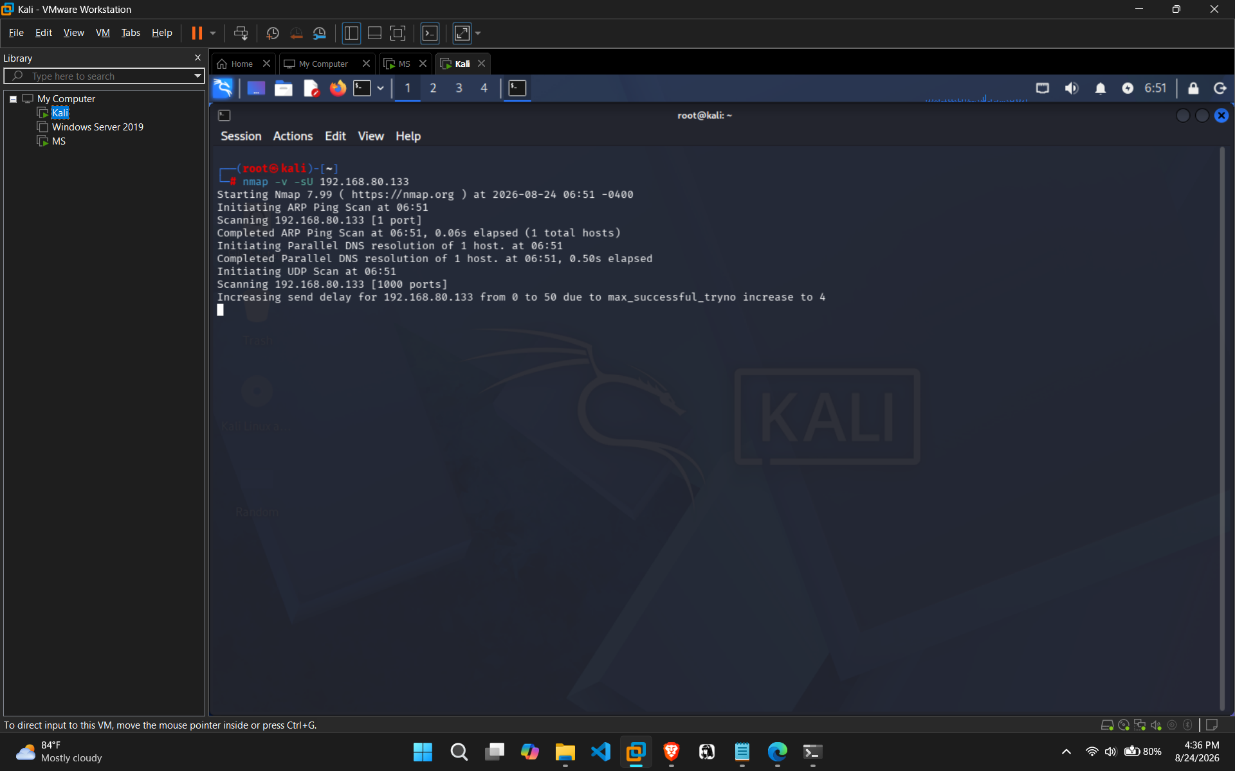
Figure 1 — UDP scan in progress against 192.168.80.133
Command: nmap -v -sA 192.168.80.133
-sA is built specifically to detect firewalls. It does not report open/closed ports — only whether packets are being filtered (blocked) or not.
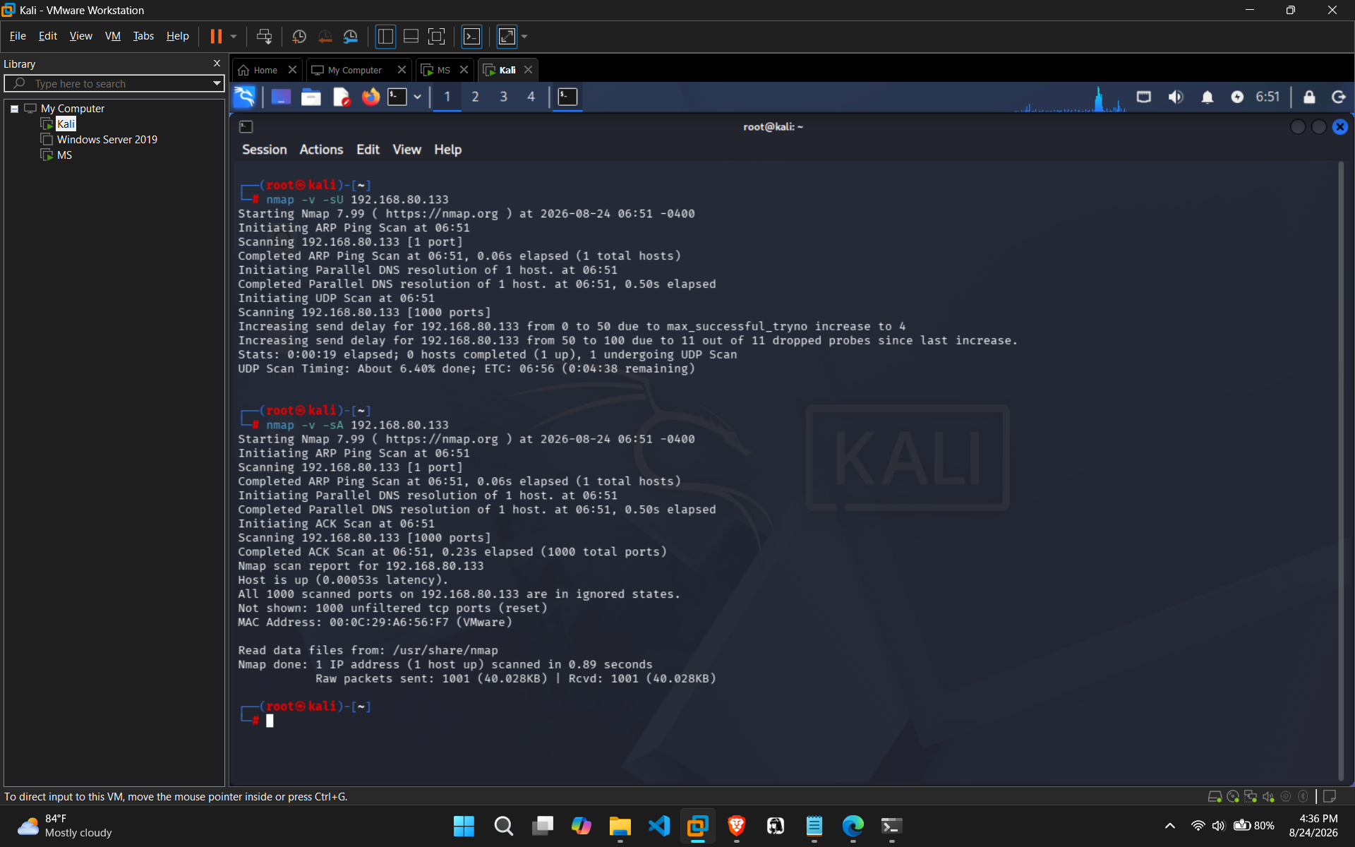
Figure 2 — ACK scan results: all 1000 ports “unfiltered”

Findings
The ACK scan result confirms what the earlier projects already suggested — Nmap reported: “All 1000 scanned ports on 192.168.80.133 are in ignored states. Not shown: 1000 unfiltered tcp ports (reset).”
Check | Result
Project 3 — Full port scan (65,535 ports) | No ports reported as "filtered" — all open or closed
Project 6 — Aggressive scan (-A, all ports) | No ports reported as "filtered" — consistent with Project 3
Project 7 — Stealth (-sS) vs Connect (-sT) | Identical results between both methods — no filtering discrepancy
Project 8 — ACK scan (-sA), top 1000 ports | All 1000 ports returned "unfiltered" (reset) — confirms no firewall

Every check across four separate projects agrees: there is no firewall or packet-filtering device sitting in front of the target.

Risk Analysis
- No firewall means zero extra barrier — every open port found in Project 3 (including the critical distccd backdoor on port 3632) is directly reachable with nothing to slow down or obscure an attacker's reconnaissance.
- Combined with existing weaknesses — anonymous FTP access, disabled SMB signing, and outdated SSL (found in Project 6) mean these services are fully exposed to anyone who can reach the host, with no filtering in the way.
- An “unfiltered” result is useful recon for an attacker too — it tells them there is no firewall to plan around, making the target an easier, more predictable one to attack.

Conclusion & Recommendation
Across four independent checks — the full port scan, the aggressive scan, the stealth/connect comparison, and a dedicated ACK scan — no evidence of firewall or packet filtering was found on the target. This is consistent with Metasploitable 2's design as an intentionally unprotected practice target.
Recommendation: in a real environment, this host should sit behind a properly configured firewall (e.g., iptables/ufw) that restricts access to only the ports genuinely required, rather than exposing every running service directly to the network. Firewalling should be treated as a priority alongside patching the individual vulnerable services already identified.

