PROJECT 12
Device Identification in LAN
Category: Network Security & Recon | Difficulty: Intermediate
Target: 192.168.80.1, .2, .133 | Status: Completed

Objective
To identify what type of device and operating system each live host found in Project 11 is actually running, using Nmap's OS detection against the gateway, NAT device, and target machine.

Tools Used
- Kali Linux — attacker/scanning machine
- Nmap 7.99 — OS detection (-O) against all three known hosts

Step-by-Step Process
Command: nmap -v -O 192.168.80.1 192.168.80.2 192.168.80.133
Ran OS detection against all three hosts identified in Project 11 in a single scan. Nmap sends a series of probes to each host and compares the responses against its OS fingerprint database to guess the device type and operating system.
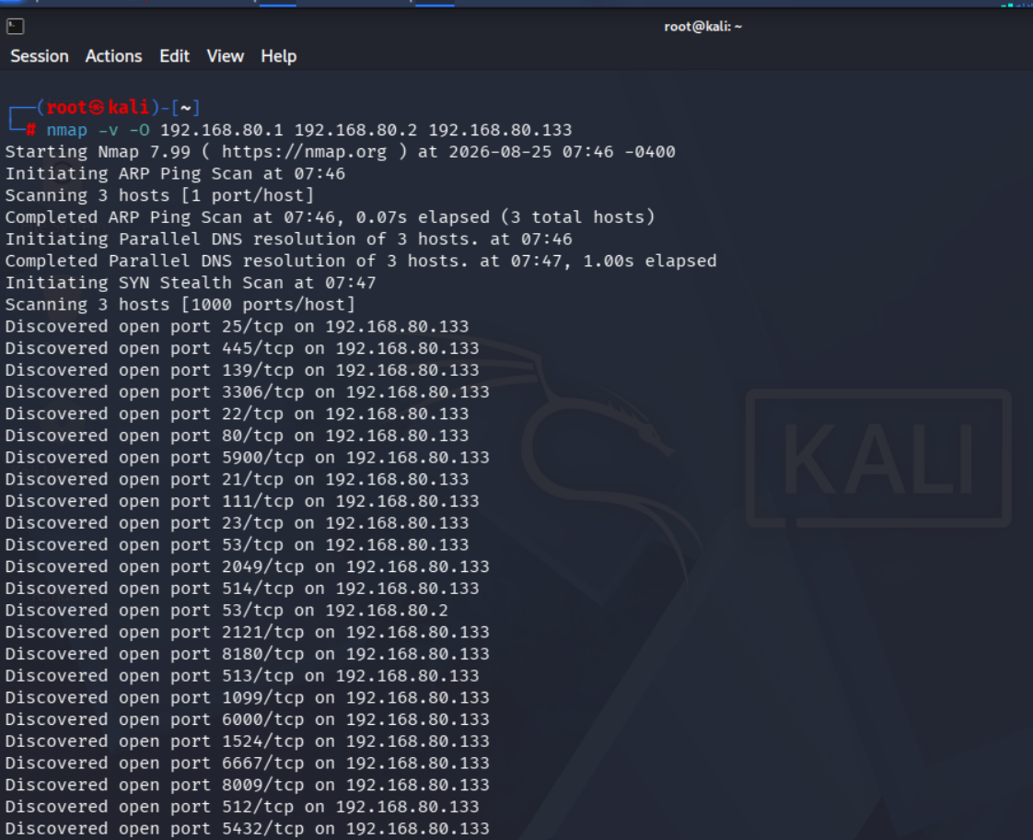
Figure 1 — OS detection scan starting against all three hosts

The completed results gave a clear picture for the gateway and NAT device, and confirmed the target's open ports again:
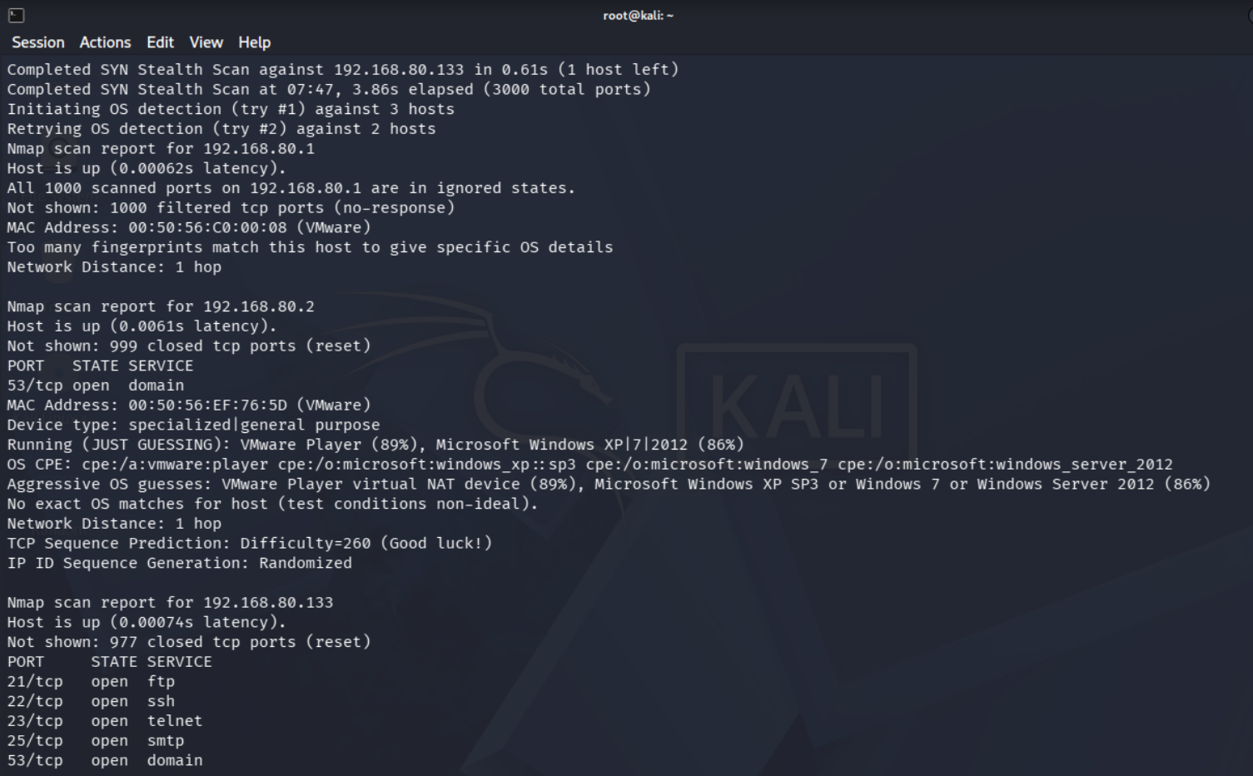
Figure 2 — OS detection results for 192.168.80.1, .2, and .133

Findings
OS detection produced a confident guess for one host and an inconclusive one for another, which is itself a normal and expected result in a virtual lab:
IP | Role | OS / Device Guess | Hops
192.168.80.1 | Gateway / router | Too many fingerprint matches — no specific OS confirmed | 1 hop
192.168.80.2 | VMware NAT device | Best guess: VMware Player virtual NAT device (89%); Windows XP/7/2012 also matched (86%) but unconfirmed | 1 hop
192.168.80.133 | Metasploitable 2 (target) | Linux (confirmed in earlier projects via service banners); 23 open ports found here again | 1 hop

Nmap could not confidently fingerprint the gateway (192.168.80.1), reporting too many equally-likely matches. For 192.168.80.2, VMware's own virtual NAT device was the top guess, alongside several Windows guesses Nmap itself flagged as low-confidence. Both results are typical of virtual network adapters, which do not always respond like a real physical OS.

Risk Analysis
- OS fingerprinting helps an attacker choose the right exploits — knowing a target is Linux vs. Windows immediately narrows down which vulnerabilities and payloads are relevant, saving significant reconnaissance time.
- Inconclusive OS guesses on the gateway/NAT device are not a weakness here — since these are lab infrastructure, not the actual assessment target — but in a real network, an unidentifiable device would warrant closer manual investigation.
- Combined with the banner and service data from earlier projects — the target machine's OS and exact service versions are now fully confirmed, giving a complete picture for planning further testing.

Conclusion & Recommendation
OS detection was run successfully against all three known hosts on the lab subnet. The gateway returned no confident match, the NAT device was best identified as a VMware virtual adapter, and the target machine's Linux-based identity (already established through service banners in earlier projects) was reconfirmed alongside its full list of 23 open ports.
Recommendation: device identification should be run as a standard early step in any assessment, since it directly informs which vulnerabilities and exploits are worth investigating next. Devices that return inconclusive OS results in a real environment should be flagged for manual follow-up rather than left unidentified.

