PROJECT 18
MAC Address Identification & Vendor Lookup
Category: Network Security & Recon | Difficulty: Intermediate
Target: Subnet 192.168.80.0/24 | Status: Completed

Objective
To identify the hardware vendor behind each device on the network using its MAC address, reusing data already collected from the ARP scan.

Tools Used
- Kali Linux — attacker/scanning machine
- arp-scan — automatically resolves vendor from MAC OUI

Step-by-Step Process
Reused the ARP scan from Project 13, which already resolves the vendor name for each MAC address automatically from its OUI (Organizationally Unique Identifier) prefix.
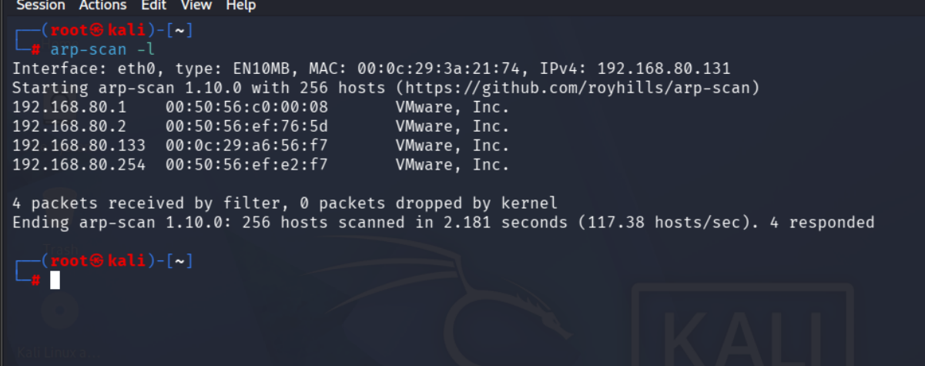
Figure 1 — ARP scan showing MAC address and resolved vendor for each host

Findings
IP Address | MAC Prefix (OUI) | Vendor
192.168.80.1 | 00:50:56 | VMware, Inc.
192.168.80.2 | 00:50:56 | VMware, Inc.
192.168.80.133 | 00:0c:29 | VMware, Inc.
192.168.80.254 | 00:50:56 | VMware, Inc.

Every device on this subnet resolves to VMware, Inc., confirming the entire lab environment is fully virtualized with no physical hardware present on this network segment.

Risk Analysis
- MAC vendor lookup is a fast way to spot unexpected devices — on a real network, seeing a vendor other than the organization's standard hardware supplier is an immediate red flag for rogue devices.

Conclusion & Recommendation
All devices identified on this subnet trace back to VMware, confirming a fully virtualized lab with no unexpected hardware vendors present.
Recommendation: maintain a baseline list of approved vendor OUIs for production networks and alert on any MAC address resolving outside that list.

