PROJECT 13
Network Mapping Using ARP Scan
Category: Network Security & Recon | Difficulty: Intermediate
Target: Subnet 192.168.80.0/24 | Status: Completed

Objective
To map live devices on the lab subnet using ARP requests instead of ICMP ping, which works reliably even against hosts that block ping.

Tools Used
- Kali Linux — attacker/scanning machine
- arp-scan — Layer 2 ARP-based host discovery

Step-by-Step Process
Command: arp-scan -l
Scanned the local subnet using ARP requests. Unlike a ping sweep, ARP scanning works at Layer 2 and cannot be blocked by host-based firewalls, making it a more reliable discovery method on a local network.
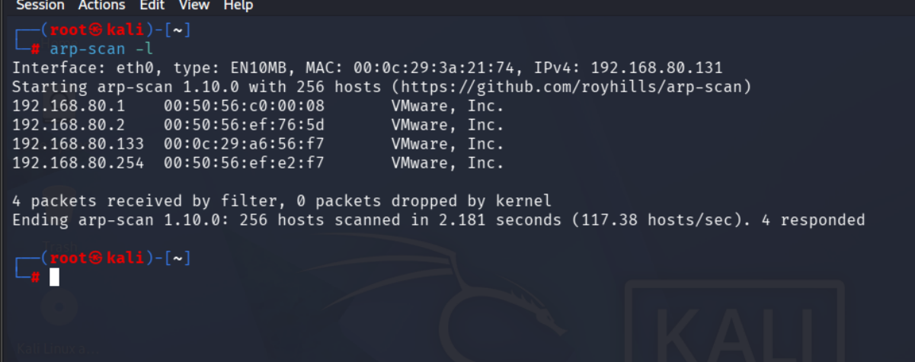
Figure 1 — ARP scan results across the local subnet

Findings
The ARP scan found 4 responding hosts, each with vendor info resolved directly from the MAC address:
IP Address | MAC Address | Vendor
192.168.80.1 | 00:50:56:c0:00:08 | VMware, Inc.
192.168.80.2 | 00:50:56:ef:76:5d | VMware, Inc.
192.168.80.133 | 00:0c:29:a6:56:f7 | VMware, Inc.
192.168.80.254 | 00:50:56:ef:e2:f7 | VMware, Inc. (newly discovered)

Note: 192.168.80.254 was not seen in the Project 11 ping sweep, but responded here — a good example of why ARP-based discovery can be more thorough than ICMP-based discovery on a local subnet.

Risk Analysis
- ARP scanning cannot be blocked by IP-layer firewall rules — since it operates below IP, at Layer 2 — a host that ignores ping can still be discovered this way.
- Vendor lookup from MAC addresses aids reconnaissance — immediately telling an attacker what kind of hardware/hypervisor they are dealing with.

Conclusion & Recommendation
ARP scanning discovered all previously known hosts plus one additional device (192.168.80.254) not seen in the earlier ping sweep, confirming it as a more thorough local discovery method.
Recommendation: use ARP-based discovery alongside ICMP sweeps for a complete host inventory on any local subnet.

