PROJECT 20
Identify Unused IP Addresses in Subnet
Category: Network Security & Recon | Difficulty: Intermediate
Target: Subnet 192.168.80.0/24 | Status: Completed

Objective
To identify which IP addresses in the subnet are currently unused, based on the full-range sweep already performed.

Tools Used
- Reused results from Project 17 (nmap -sn 192.168.80.0/24) — no new scan required

Step-by-Step Process
Reviewed the full-range ping sweep results and separated the responding hosts from the addresses that reported [host down].
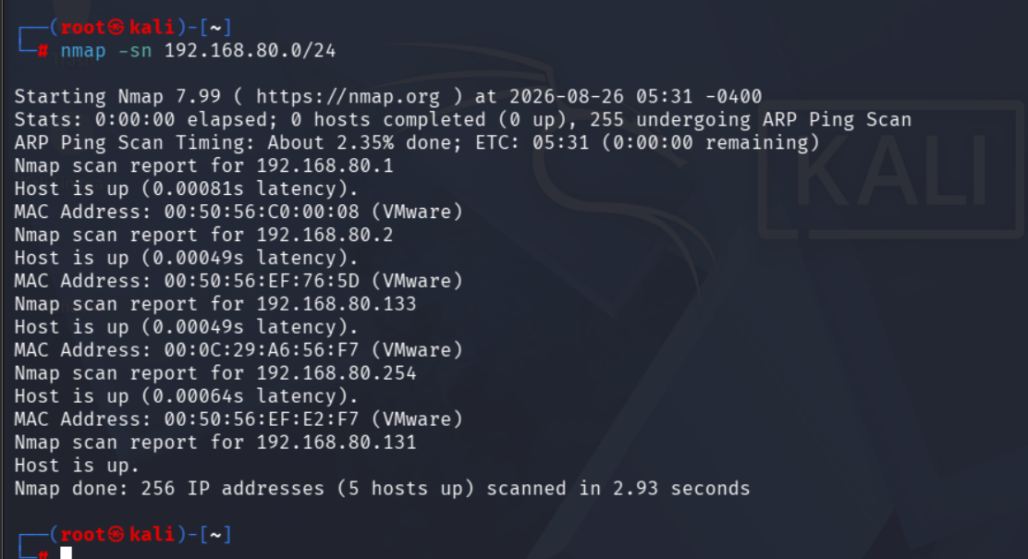
Figure 1 — Full subnet sweep, most addresses reporting [host down]

Findings
Out of 256 possible addresses in the /24 range, only 5 are currently in use (192.168.80.1, .2, .131, .133, .254). The remaining 251 addresses are unused and available, reported as [host down] throughout the sweep.

Risk Analysis
- A large pool of unused addresses is expected in a small lab/NAT subnet — but on a production network, an unusually large unused range can make it easier for a rogue device to blend in undetected if monitoring isn't in place.

Conclusion & Recommendation
251 out of 256 addresses in this subnet are currently unused, leaving substantial address space available.
Recommendation: use DHCP logging or periodic sweeps in production environments to track which addresses are actually in use over time, making it easier to spot anomalies.

