PROJECT 10
Nmap NSE Script Scanning Basics
Category: Network Security & Recon | Difficulty: Intermediate
Target: Metasploitable 2 (192.168.80.133) | Status: Completed

Objective
To get familiar with Nmap's Scripting Engine (NSE) — a system of built-in scripts that go beyond basic port scanning to gather extra service information and check for known vulnerabilities.

Tools Used
- Kali Linux — attacker/scanning machine
- Nmap 7.99 — default scripts (-sC) and a targeted script (ftp-anon)

Step-by-Step Process
Command: nmap -sC 192.168.80.133
Ran Nmap's default set of safe NSE scripts against the target. This goes beyond a plain port scan — for every open port, it also gathers extra details like FTP server status, SSH host keys, SSL certificate info, and SMB configuration.
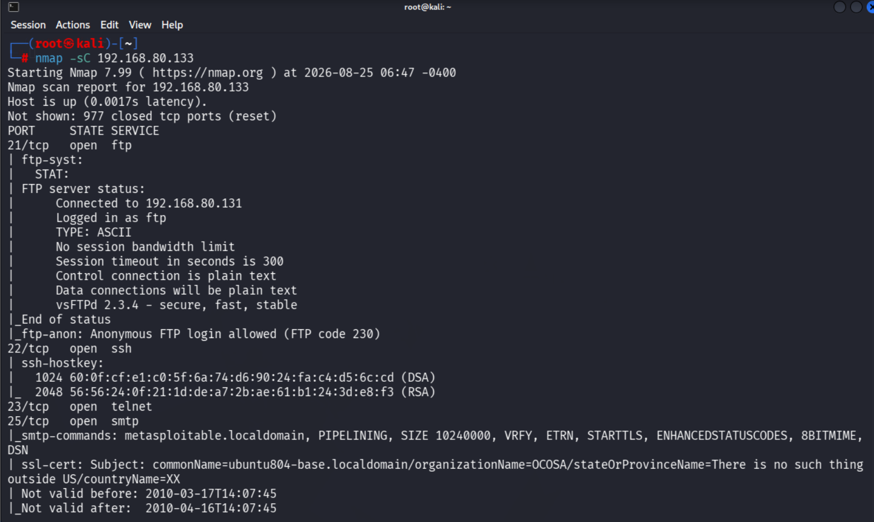
Figure 1 — Default script scan (-sC): FTP status and anonymous login flagged
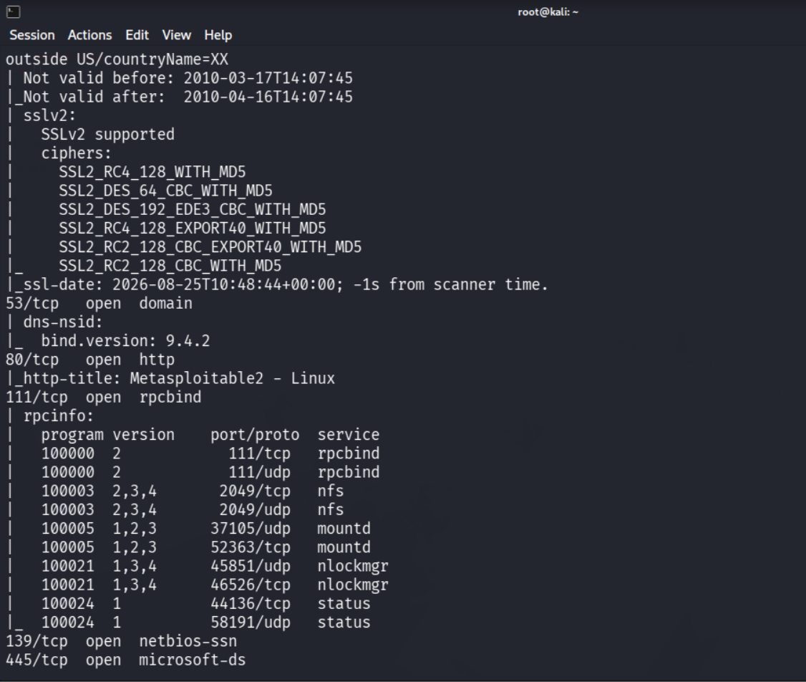
Figure 2 — Default script scan continued: SSL cipher details and RPC/SMB service info

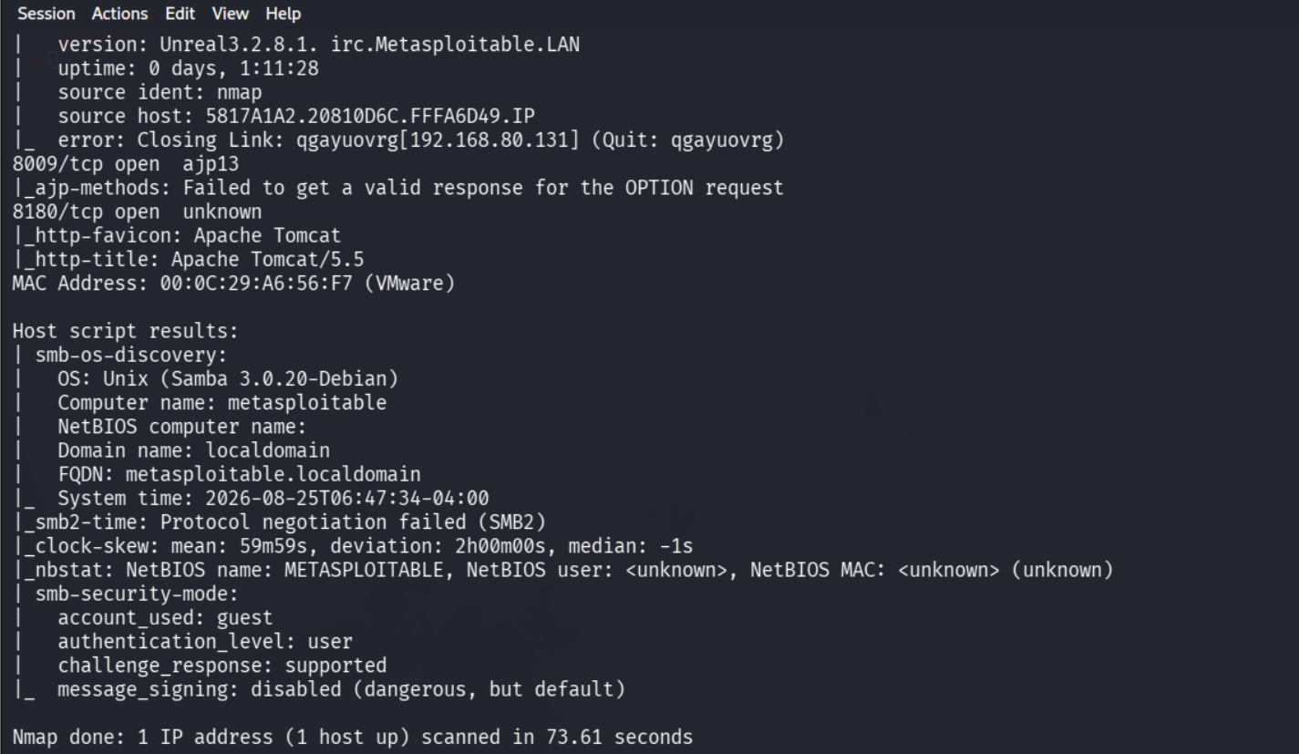
Figure 3 — Default script scan finishing: IRC service version, and host-level SMB security details
Command: nmap --script=ftp-anon 192.168.80.133
Ran a single targeted script against the FTP port to confirm the anonymous-login finding on its own, separate from the full default scan.
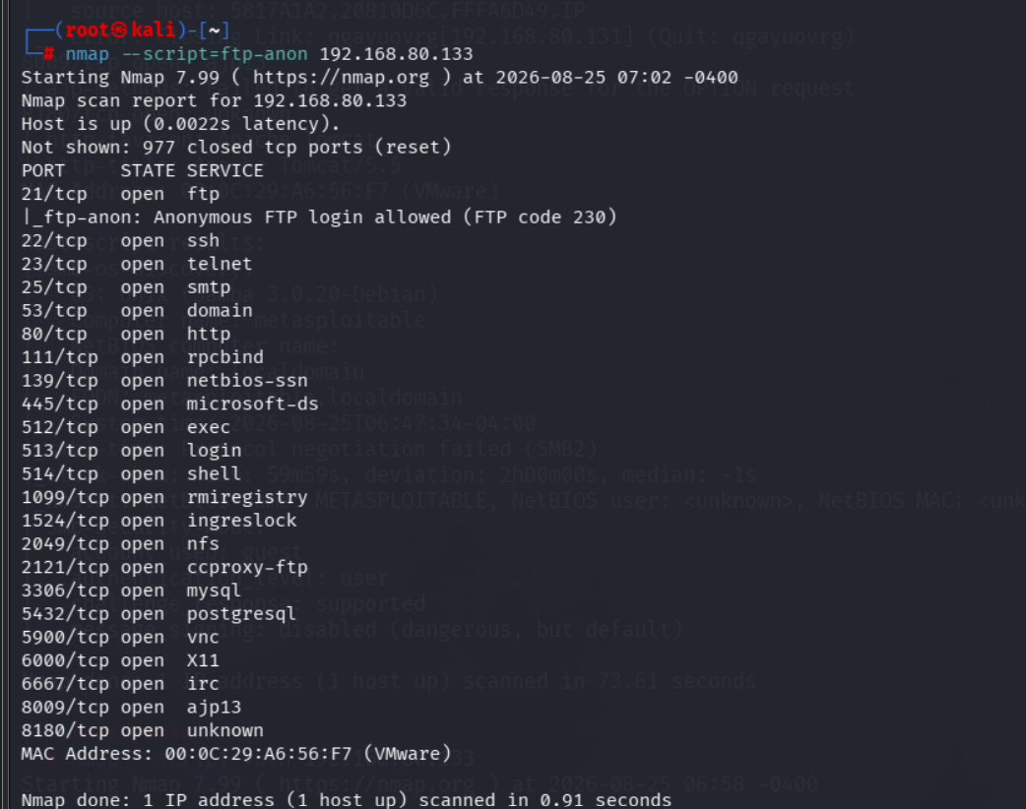
Figure 4 — Targeted ftp-anon script confirming anonymous FTP access

Findings
The default script scan surfaced several issues automatically, without needing separate manual checks:
Script / Port | Result | Severity
ftp-anon (port 21) | Anonymous FTP login allowed (FTP code 230) | High — no credentials needed
ssl-cert (port 25) | Expired cert (valid 2010 only), weak org fields | Medium — no real trust anchor
sslv2 (port 25) | SSLv2 supported with RC4/DES/MD5 ciphers | High — SSLv2 and these ciphers are broken
smb-security-mode (445) | message_signing: disabled (dangerous, but default) | High — allows SMB relay attacks
Port 6667 (irc) | Unreal3.2.8.1 — a known backdoored IRC daemon version | Critical — public remote exploit exists
http-title (port 80) | Reveals "Metasploitable2 - Linux" | Low — info disclosure only

Risk Analysis
- NSE turns a simple scanner into a lightweight vulnerability assessment tool — the default script set alone found anonymous FTP access, a broken SSL configuration, and dangerous SMB settings — all without running a single manual command.
- The Unreal IRC daemon (port 6667) is the most serious finding here — this specific version has a well-known public backdoor that allows remote command execution with no authentication.
- SMB signing being disabled enables relay attacks — an attacker on the same network can potentially intercept and relay SMB authentication to gain unauthorized access.
- Anonymous FTP and an expired, weak SSL cert are lower-effort wins for an attacker — but combined with everything else found across this internship so far, they add up to a very exposed host.

Conclusion & Recommendation
Nmap's default NSE scripts (-sC) proved far more useful than a plain port scan, surfacing multiple real issues automatically — most notably a backdoored IRC service, anonymous FTP access, and insecure SMB signing settings. A targeted script (ftp-anon) was also used to confirm one finding in isolation, showing how individual scripts can be run on demand.
Recommendation: disable or remove the Unreal IRC service entirely, disable anonymous FTP access, enable SMB signing, and replace the expired SSL certificate with a valid one. NSE default and vulnerability scripts should become a standard first step in future assessments, since they consistently surface real, exploitable issues quickly.

