PROJECT 4
Service Version Detection on Open Ports
Category: Network Security & Recon | Difficulty: Intermediate
Target: Metasploitable 2 (192.168.80.133) | Status: Completed

Objective
To identify the exact software name and version running behind every open port on the target, since specific versions often have known, documented vulnerabilities.

Tools Used
- Kali Linux — attacker/scanning machine
- Nmap 7.99 — service version detection

Step-by-Step Process
Running the Scan
Command: nmap -v -sV -Pn -p- 192.168.80.133
- -sV Version detection — probes each open port to identify the exact software and version running behind it, instead of just reporting the port as open.
- -p- Scans all 65,535 ports, since Project 3 showed important services (distccd) live outside the default range.
- -Pn / -v Same as Project 3 — skip the alive-check, show results live.
Version detection takes longer than a normal scan, since Nmap has to actually communicate with each service rather than just check if the port responds. The scan took about 2 minutes for all 30 open ports.

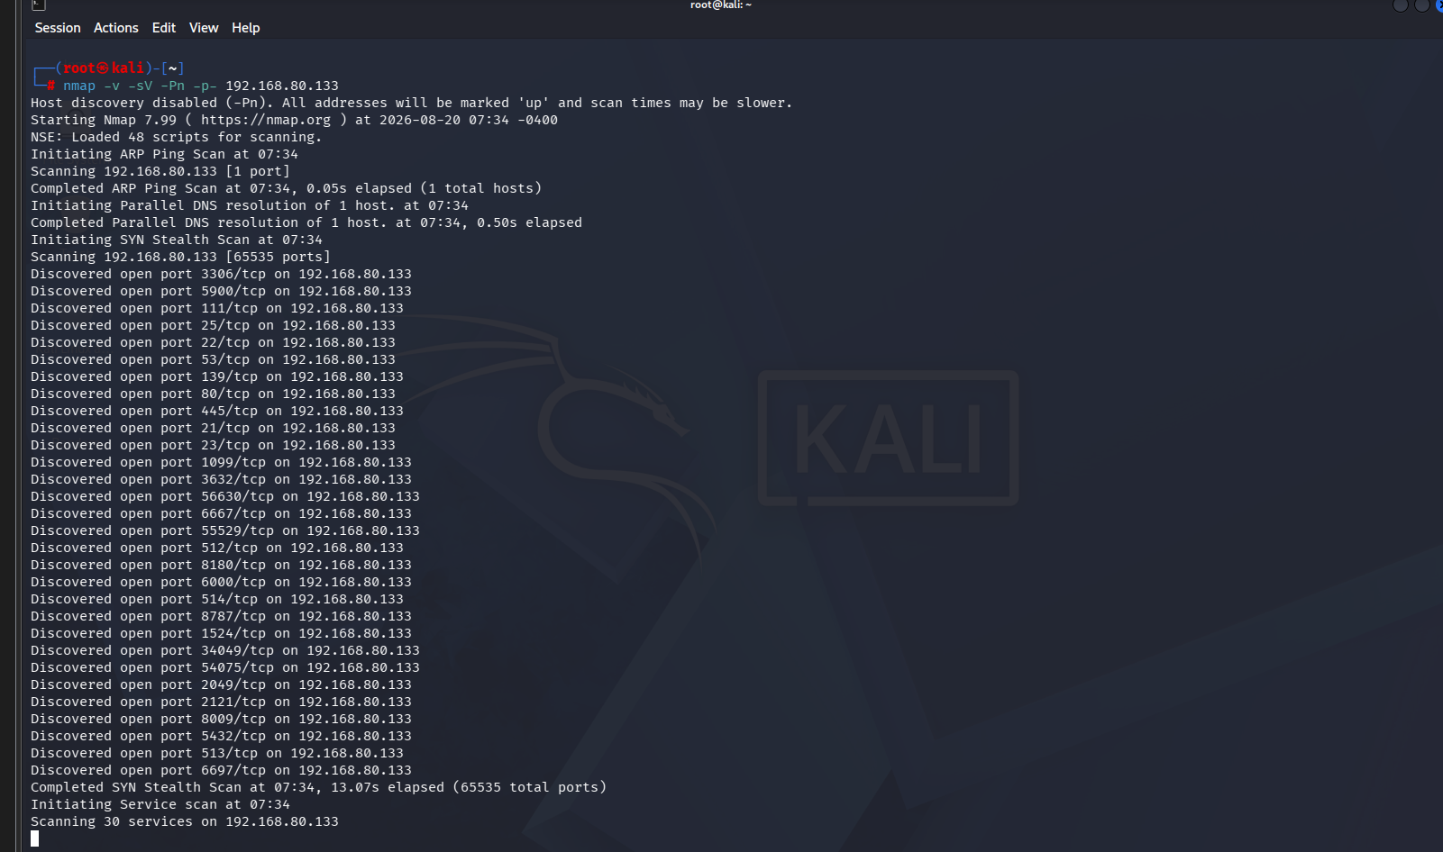
Figure 1 — Version detection scan in progress
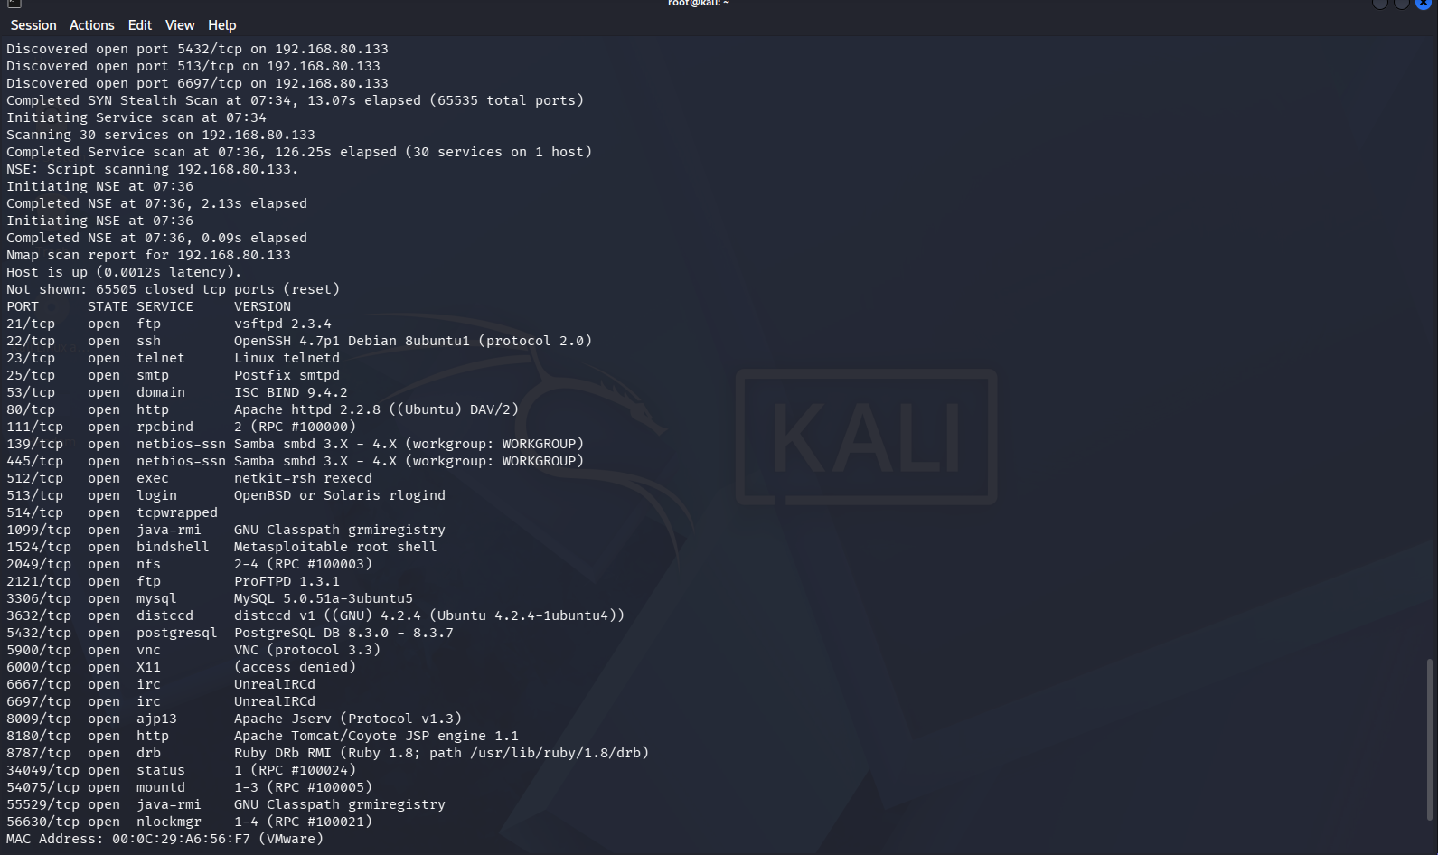
Figure 2 — Full results: service and version per open port

Findings
Exact software and version identified for all 30 open ports:
Port | Service | Version
21 | ftp | vsftpd 2.3.4 — known backdoored version
22 | ssh | OpenSSH 4.7p1 Debian 8ubuntu1
23 | telnet | Linux telnetd
25 | smtp | Postfix smtpd
53 | domain | ISC BIND 9.4.2
80 | http | Apache httpd 2.2.8 (Ubuntu) DAV/2
111 | rpcbind | RPC #100000
139 / 445 | netbios-ssn | Samba smbd 3.X – 4.X
512 | exec | netkit-rsh rexecd
513 | login | OpenBSD or Solaris rlogind
514 | tcpwrapped | —
1099 | java-rmi | GNU Classpath grmiregistry
1524 | bindshell | Metasploitable root shell — confirmed backdoor
2049 | nfs | RPC #100003
2121 | ftp | ProFTPD 1.3.1
3306 | mysql | MySQL 5.0.51a-3ubuntu5
3632 | distccd | distccd v1 (Ubuntu 4.2.4-1ubuntu4) — RCE, from Project 3
5432 | postgresql | PostgreSQL DB 8.3.0 – 8.3.7
5900 | vnc | VNC (protocol 3.3)
6000 | X11 | access denied
6667 / 6697 | irc | UnrealIRCd — known backdoored version
8009 | ajp13 | Apache Jserv (Protocol v1.3)
8180 | http | Apache Tomcat/Coyote JSP engine 1.1
8787 | drb | Ruby DRb RMI (Ruby 1.8) — no built-in auth
34049 | status | RPC #100024
54075 | mountd | RPC #100005
55529 | java-rmi | GNU Classpath grmiregistry
56630 | nlockmgr | RPC #100021

Risk Analysis
- vsftpd 2.3.4 (port 21) — This exact version is publicly known to contain a backdoor planted in the source code — connecting with a specific crafted username opens a remote root shell with no password. One of the most critical findings on this host.
- Port 1524 — Nmap identifies it directly as “Metasploitable root shell” — This confirms the port found in Project 1 (ingreslock) is an active backdoor giving instant root access, no authentication needed.
- UnrealIRCd (ports 6667, 6697) — This IRC server version has a publicly known backdoor that lets an attacker execute commands remotely, similar in impact to the vsftpd issue.
- Ruby DRb service (port 8787) — Ruby DRb has no built-in authentication by default. If reachable, it can allow an attacker to run arbitrary code on the host.
- Outdated software across the board — OpenSSH 4.7p1, Apache 2.2.8, Samba 3.X, MySQL 5.0.51a, and PostgreSQL 8.3 are all years out of date. Older versions accumulate publicly known vulnerabilities over time, making version detection like this the fastest way to find likely weak points.

Conclusion & Recommendation
Version detection revealed multiple services with publicly known backdoors (vsftpd 2.3.4, UnrealIRCd, port 1524) in addition to the earlier distccd finding, meaning this host can be fully compromised through several independent paths. All flagged services should be patched, updated, or removed, and no service should be exposed to the network without a clear business need.

