PROJECT 5
OS Detection using Nmap Fingerprinting
Category: Network Security & Recon | Difficulty: Intermediate
Target: Metasploitable 2 (192.168.80.133) | Status: Completed

Objective
To identify the target's operating system and kernel version without logging in, using Nmap's OS fingerprinting, since the OS in use determines which exploits could actually work against the host.

Tools Used
- Kali Linux — attacker/scanning machine
- Nmap 7.99 — OS fingerprinting

Step-by-Step Process
Running the Scan
Command: nmap -v -Pn -O 192.168.80.133
- -O OS detection — sends a set of unusual, edge-case packets and compares how the target responds against a database of known operating system fingerprints.
- -Pn Used here since the target is already confirmed alive from earlier projects — skips the alive-check and scans directly.
- -v Shows results live instead of only at the end.
Nmap does not know the machine is “Metasploitable” — that is just a VM nickname, not something visible over the network. What it identifies is the real underlying OS and kernel range.
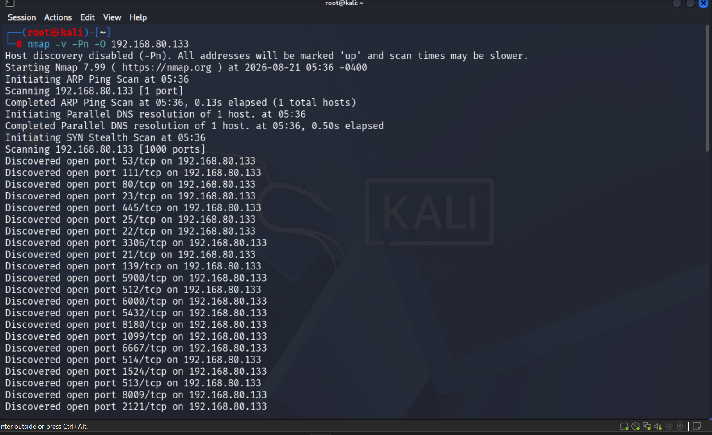
Figure 1 — OS detection scan running
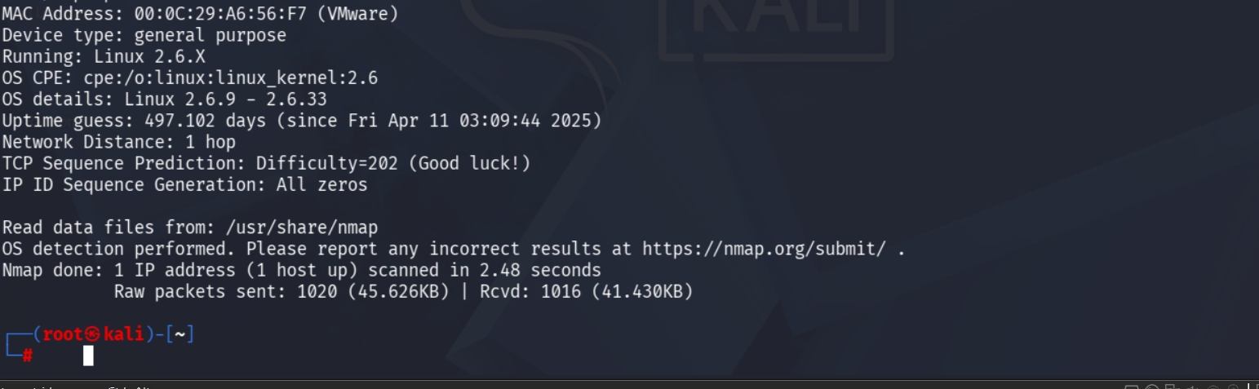
Figure 2 — OS fingerprint results

Findings
Attribute | Result
Device type | General purpose
Running | Linux 2.6.X
OS details | Linux kernel 2.6.9 – 2.6.33
Network distance | 1 hop (same local network)
TCP sequence prediction | Difficulty = 202 — flagged “Good luck!” by Nmap (low/guessable)
IP ID sequence generation | All zeros — static, does not randomize

Risk Analysis
- Very outdated Linux kernel (2.6.9 – 2.6.33) — This kernel range is well over a decade old and unsupported. Matches the known Ubuntu 8.04 base of Metasploitable2 — consistent with every outdated service found in Project 4.
- Exact OS narrows down attacker effort — Once the OS family and kernel range are known, an attacker skips irrelevant exploits (e.g. Windows-specific ones) and searches only for Linux kernel exploits in this exact range — making an attack much faster to plan.
- Predictable TCP sequence numbers (Difficulty = 202) — Nmap's own “Good luck!” comment flags this as a low, guessable difficulty score. On a well-secured modern system this value is far higher (effectively random). Low randomness here could allow an attacker to inject or spoof packets into a TCP connection without needing to observe the real traffic first.
- IP ID Sequence Generation: All zeros — The host does not vary its IP ID field at all. This simplistic behavior could let an attacker use this machine as a hidden relay (an “idle scan” zombie) to anonymously scan other hosts on the network without those scans being traced back to the attacker.

Conclusion & Recommendation
OS fingerprinting confirmed an old, unsupported Linux kernel, matching the outdated services identified in earlier projects. It also revealed weaknesses in the underlying network stack itself (predictable TCP sequence numbers, static IP ID) — meaning the risk here goes beyond individual vulnerable services. Recommendation: a full OS and kernel upgrade is needed, since patching individual services alone would not fix these lower-level network stack weaknesses.

