COMP8851 — Model Improvement Report
Sai Manoj Polina — LSTM Improvement Group: MDS-IoT-Yu2 | Supervisor: Dr Yu Zhang

Before vs After Comparison MAE and RMSE

Metric | Original LSTM | Improved LSTM
Window Size | 200 | 400
Dropout | 0.3 | 0.5
MAE (°) | 67.05 | 69.22
RMSE (°) | 83.61 | 86.08
Training Time (minutes) | 345.76 | 620.36
Training Time (hours) | 5.8 | 10.34
Early Stopping | Epoch 14 | Epoch 20

Report scenario breakdown for both versions.

Scenario | Original MAE | Improved MAE | Difference
Straight Walking | 59.96 | 61.00 | +1.04
Sharp Turns | 86.07 | 84.44 | -1.63
Short Trajectories | 69.03 | 73.43 | +4.40
Long Trajectories | 65.08 | 65.01 | -0.07

loss curves for both versions side by side.
Before:
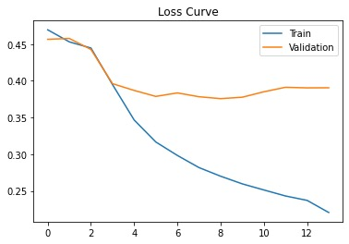

After:
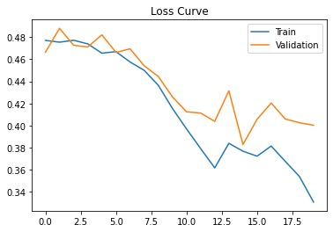

Reflection Part 1
- Did overfitting reduce based on the loss curve? What specific change caused this and why does that change address the overfitting mechanism?
Yes, overfitting was reduced in the improved model. In the original LSTM, the training loss continued decreasing while the validation loss plateaued around epoch 5 and remained relatively unchanged until early stopping at epoch 14. This created a noticeable gap between the training and validation loss curves, indicating that the model was memorising training patterns rather than learning features that generalised well to unseen data.
In the improved model, the validation loss continued decreasing for a longer period and reached its lowest value around epoch 15. Although a gap still existed between training and validation loss, it was smaller and the validation loss remained more stable throughout training. The primary reason for this improvement was increasing the dropout rate from 0.3 to 0.5. Higher dropout randomly disables more neurons during training, forcing the network to learn more robust representations rather than relying on specific neurons. This reduces co-adaptation between neurons and improves generalisation performance. Therefore, the loss curves suggest that the stronger dropout regularisation successfully reduced overfitting.

- Did overall MAE improve or worsen after the changes? What architectural or training reason do you think explains this outcome?

The overall MAE worsened after the modifications. The original model achieved an MAE of 67.05°, whereas the improved model achieved an MAE of 69.22°. Similarly, RMSE increased from 83.61° to 86.08°.
This outcome suggests that while regularisation reduced overfitting, it may also have reduced the model's ability to learn complex motion patterns. Increasing dropout to 0.5 removes a large proportion of network activations during training, which can limit the effective learning capacity of the model. Additionally, increasing the input window from 200 to 400 timesteps substantially increased sequence length and training complexity. The LSTM must now learn dependencies over a much longer sequence, which may have made optimisation more difficult. As a result, the model generalised slightly better but achieved lower predictive accuracy on the test set.

- Did sharp turn MAE improve with wider windows? Why would a wider window help or not help with sharp turns specifically. Think about what extra context 400 timesteps provides compared to 200.
Yes, sharp turn performance improved slightly. The sharp turn MAE decreased from 86.07° to 84.44°, representing a modest improvement of approximately 1.63°.
A wider input window provides the model with additional temporal context before and after a directional change. The original model only observed 200 timesteps (1 second of data), whereas the improved model observed 400 timesteps (2 seconds of data). This additional context allows the LSTM to capture motion patterns leading into and following a turn, which can help the model better understand changes in heading direction.
However, the improvement was relatively small because LSTM architectures still struggle with rapid transitions and long-range dependencies. While the wider window provided more information, the network may not have been able to fully utilise this extra context due to the inherent limitations of recurrent architectures.

- Overall do you think the LSTM limitations come from the architecture itself or from the training setup? Justify your reasoning with reference to your results.

Based on the results, the primary limitation appears to come from the LSTM architecture rather than the training setup. The improvement experiments directly addressed two major training-related issues: overfitting and limited temporal context. Increasing dropout reduced overfitting, while increasing the input window doubled the amount of temporal information available to the model. Despite these changes, overall MAE and RMSE became slightly worse.
If the training setup had been the main limitation, a substantial improvement in overall performance would have been expected after addressing these issues. Instead, only a small improvement was observed in sharp-turn scenarios, while overall accuracy declined. This suggests that the architecture itself is struggling to model the complex motion dynamics present in the heading estimation task.
LSTM networks process information sequentially and lack mechanisms such as self-attention that allow models to focus on the most important parts of a sequence. This makes them less effective at handling long-range dependencies, noisy sensor data, and rapid directional changes. Therefore, the results indicate that the architecture is the dominant bottleneck affecting performance.

Conclusion
The improvement experiment successfully reduced overfitting and slightly improved sharp-turn performance. However, these benefits did not translate into better overall accuracy. The improved model produced a higher MAE (69.22°) and RMSE (86.08°) while requiring significantly longer training time (10.34 hours). These findings suggest that the primary limitation lies in the LSTM architecture itself rather than the training configuration, and future work should explore attention-based or hybrid architectures for improved heading estimation

Reflection Part 2 — Cross-Model (Fill In After Everyone Submits Improved Result

