System is starting executing the Scenario: "Create an initial Quote for Home Building And Content Insurance Product"

---------------------------------------

Logged in to site with the following user id cAdhikari

New Home Buildings and Contents Insurance type quote creation process initiated

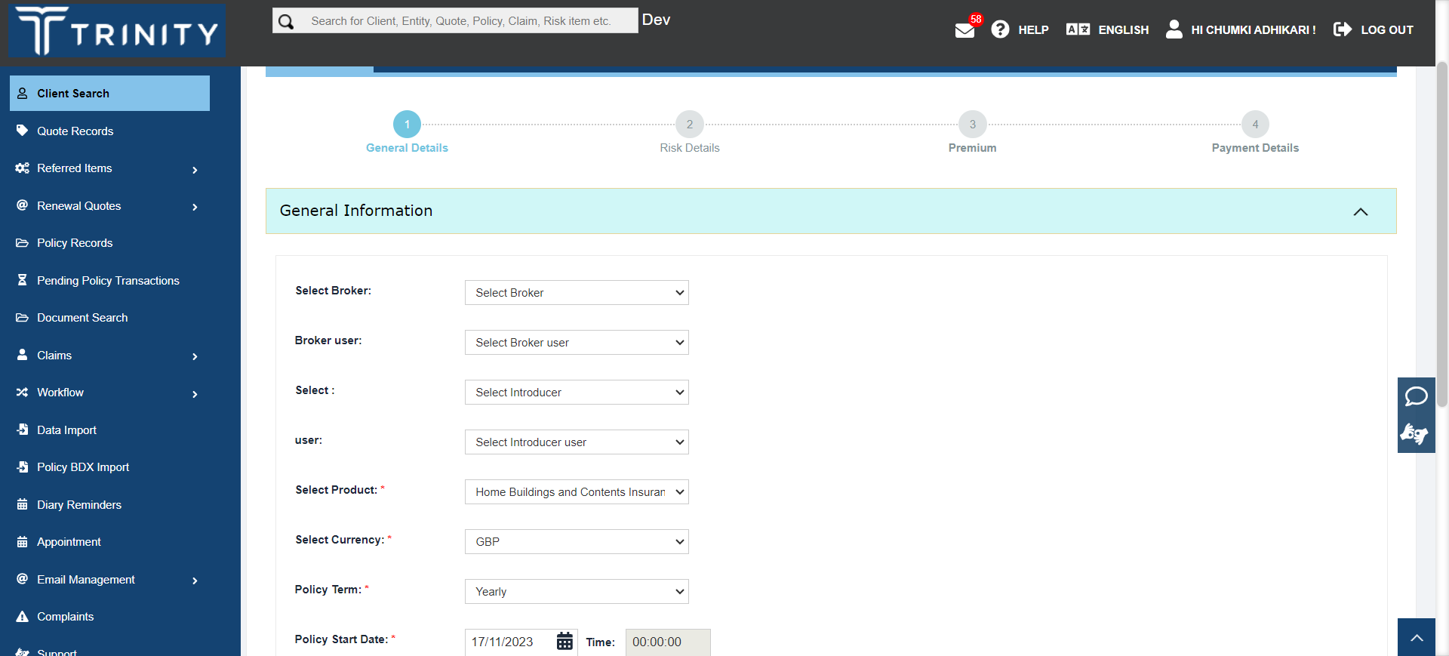

Scenario: "Create an initial Quote for Home Building And Content Insurance Product" got "FAILED", Screenshot for the failed scenario displayed below

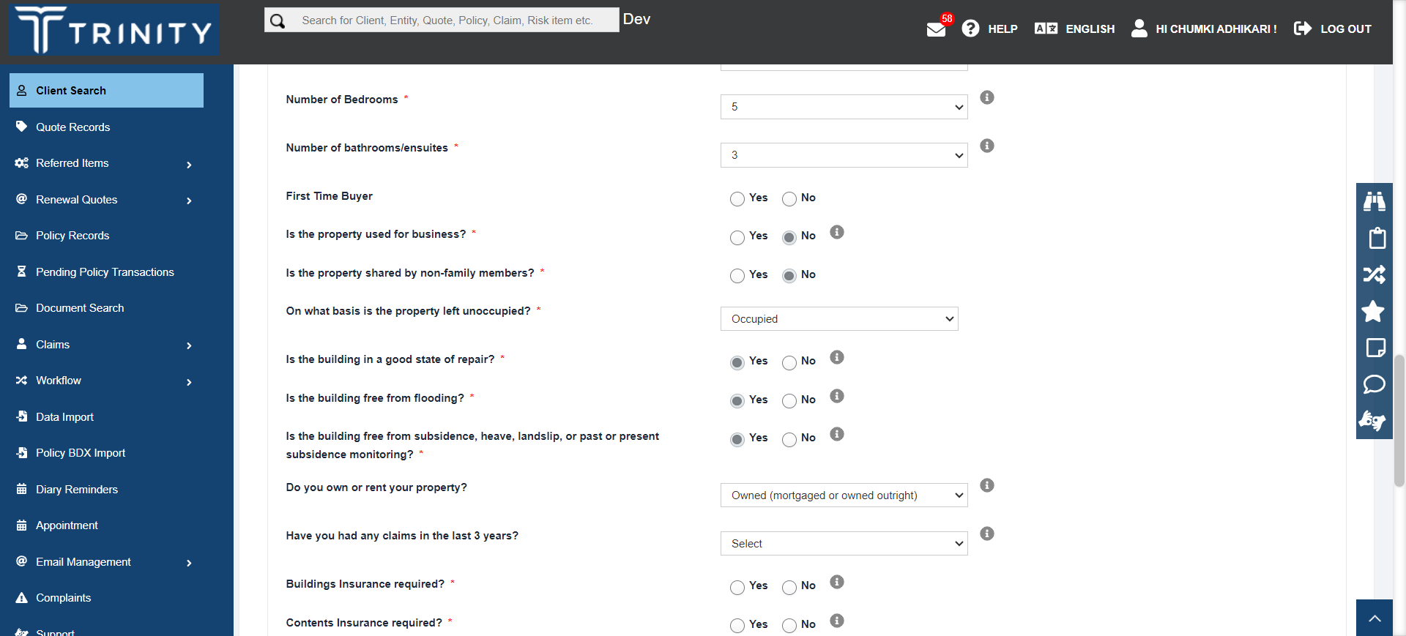

Test Status for the Scenario: "Create an initial Quote for Home Building And Content Insurance Product" is: "FAILED"

---------------------------------------