Sprint Review and Retrospective
This deliverable looks back at pilot process of the SNHU Travel project, under scrum framework of agile methodology. This document explains the how the team approached scrum agile framework approach facilitated the development efforts, and some of the lessons learned.
Roles in a Scrum Team
My team consisted of a scrum master, a product owner, some developers, and testers. Everyone had their own tasks and responsibility in the project. I was able to experience all the roles, and understand each roles responsibilities, and each roles rely on the other roles to contribute to the project.
Scrum Master
Scrum Master (SM) is the facilitator of a scrum team. SM is responsible to facilitate various scrum events such as planning, refinement, reviews and most importantly the sprint retro. SM makes sure the team adheres to scrum principles, coaches the team on agile principles to help the team improve continuously, and monitors the teams progress and provides feedback to improve.
Product Owner
Product Owner (PO) is responsible in maximizing the value of the product, and work of the team. PO manages the stakeholders expectations and communicate product vision to the development team as well as to the stakeholders. He creates detailed and concise user stories by engaging with the stake holders and the end users. Other responsibilities of the PO includes organizing and prioritizing the backlog items that the product team will be working on during the sprint, and adjusting the backlog items based on the feedback received from the stakeholders and the end users. During the course of the development, there were some changes in requirement from the stake holder where they wanted to focus on detox travel packages. The PO was prompt to create user stories accordingly, and assign it to developer which promotes communication, and transparency.
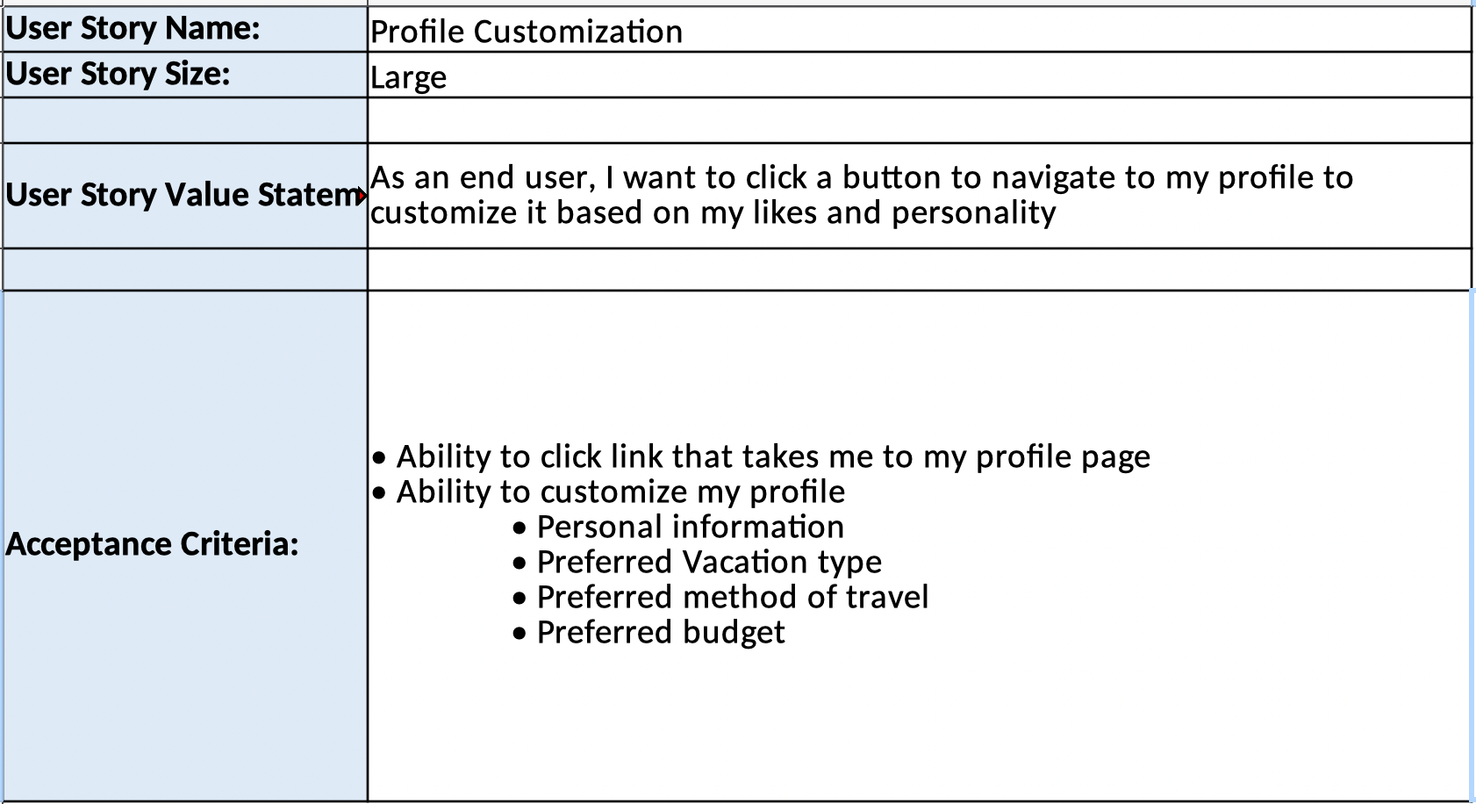
Attached is a user story the product owner crafted based on the requirements. The user story addresses what is expected, and the developer was able to transform the user story into a working piece of software. Tester was able to create test cases based on the acceptance criteria, and execute them to make sure the software passes quality check.
Developer
A developer converts the user story into a working piece of software. Other than participating in the scrum events, and creating a functioning software, the developer collaborates with the team members, participates in code reviews, communicates the progress etc. He is also responsible to maintain and update the software to improve performance, and fix bugs. In a Scrum team, developer is very flexible and makes changes to the software if requirement changes. He collaborates with the tester to find any gaps in the product and address them accordingly.
Tester
A tester works closely in a scrum team. A tester’s responsibility includes testing the software to make sure it meets the requirements. He creates and executes test cases, documents any findings, and communicates them to the developer and PO. Like a developer, the tester uses user story, especially the acceptance criteria to create test cases. If the test fails, the tester communicates the issue back to the developer so he can fix it.
In agile approach, every member of the team is constantly communicating with each other, so everyone is aware of where is the product stands. There is constant testing and development effort going on between the tester and developer, so if something breaks, the tester will be able to identify it promptly and developer can fix it. Similarly, the product owner is constantly communicating the product status to the stake holders, and receiving feedbacks. Below is a sample email from tester to the product to fill in some of the missing information on a user story, which the product owner was prompt in responding to.
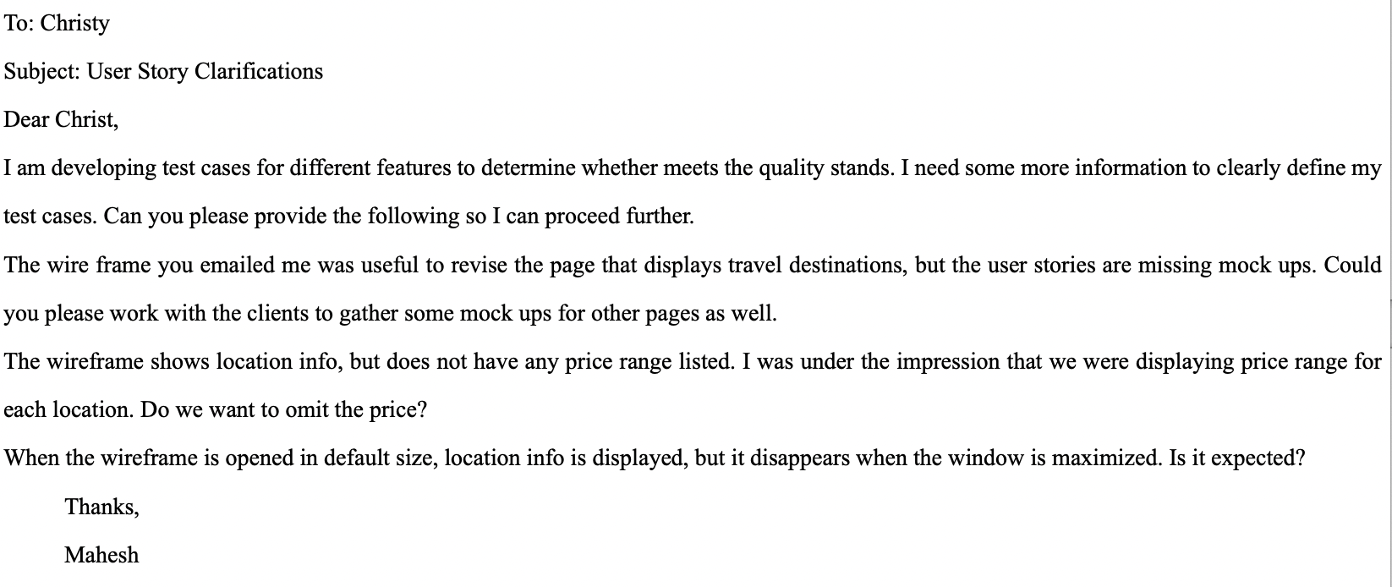
During the SNHU Travel project, requirement changed in the middle of the project. Instead of a list as proposed earlier, the stakeholders wanted a slideshow with a different theme of vacation. As soon as it was brought to the teams attention, and the product owner crafted user story for the proposed change. The product owner reprioritized other stories so the velocity of the team during the sprint was not affected. The developers, and testers were able to make changes as required, and the changes were delivered quickly and promptly. This is an example of how scaled agile framework approach helps team become flexible.
The Scrum Agile approach focuses on collaboration, communication and flexibility throughout the entire development cycle. These are all carried out via various scrum events such as planning, review and retro. During the sprint planning, team commits to work they need to work on a sprint. There are daily scrum during the sprint where each member of the team communicate their progress, so everyone is aware of where the project stands. At the end of each sprint, the team showcases completed work, and receives any feedbacks. The feedbacks are then converted into user stories, and prioritized for upcoming sprints. The team then talks about ways to improve, or any issues they faced in the sprint during the retro meeting. This is a safe place for everyone to talk about what could be done better to constantly improve. The Scum Agile framework not only focuses on improving the product but also the development team in every sprint. It encourages the team to adapt to changes, and to focus on delivering working software in small increments. Hence, teams can reduce risk, improve quality, and deliver software faster and more efficiently.

