Dashboard UD

View Offers
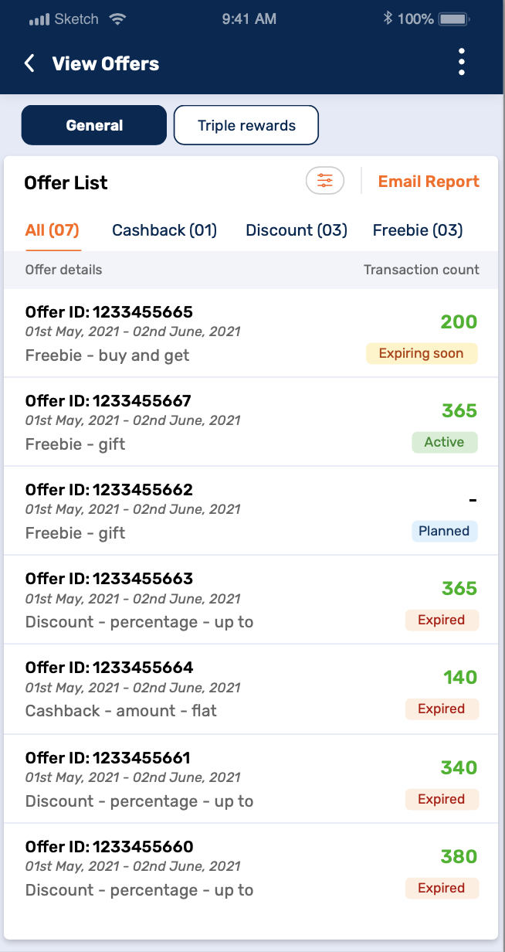
Note:
- Transaction count: Count of successful transactions during offer period (Real - time update).
  - Parent: Cumulative of all stores
  - Child: Only selected store transaction count
- Transaction count eligibility check
  - General
    - Transaction count in offer period irrespective of customer repetition having minimum purchase value as defined in the offer
  - Triple reward
    - Transaction count in offer period for a unique customer ID (Or mobile number) in a day having minimum purchase value through single instrument (UPI/PPI/EMI/CC/DC) as Rs. 1000
    - In case if reward points are redeemed & amount goes below Rs. 1000, Then customer won’t be considered as eligible for triple rewards.
Fields | Sample Value | Source DB
Offer ID | 1233455664 | ODS Database
Offer type | Cashback-amount-flat | ODS Database
Offer duration | 01st May, 2021 - 02nd June, 2021 | ODS Database
Offer status | Active | ODS Database
Transaction count | 140 | Real time API hit from ODS to PayTech against offer ID & Offer duration

Offer type
Two categories / tabs will be available for viewing the offers
- General
- Triple rewards

Offer list
Offer List will display the details of offers as
- Offer ID
- Offer validity
- Offer status
- Total Transaction count - NA
This will be the count of total successful transactions happened during the offer period.

Offer filters
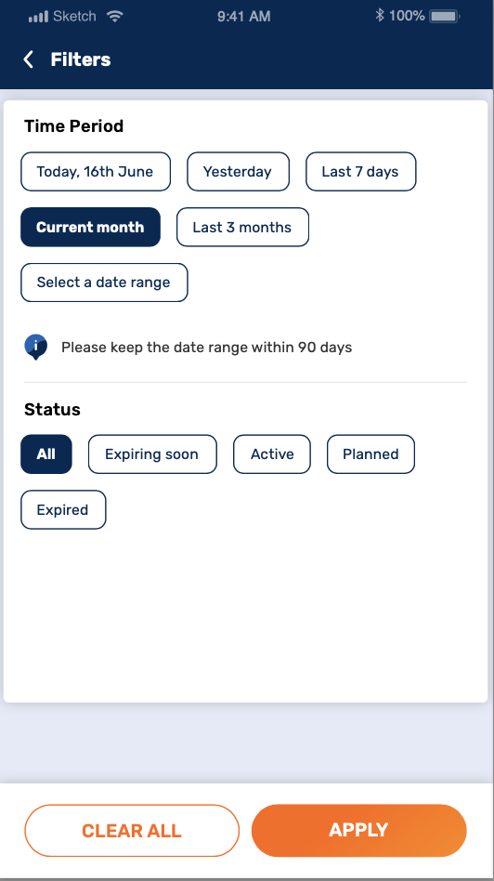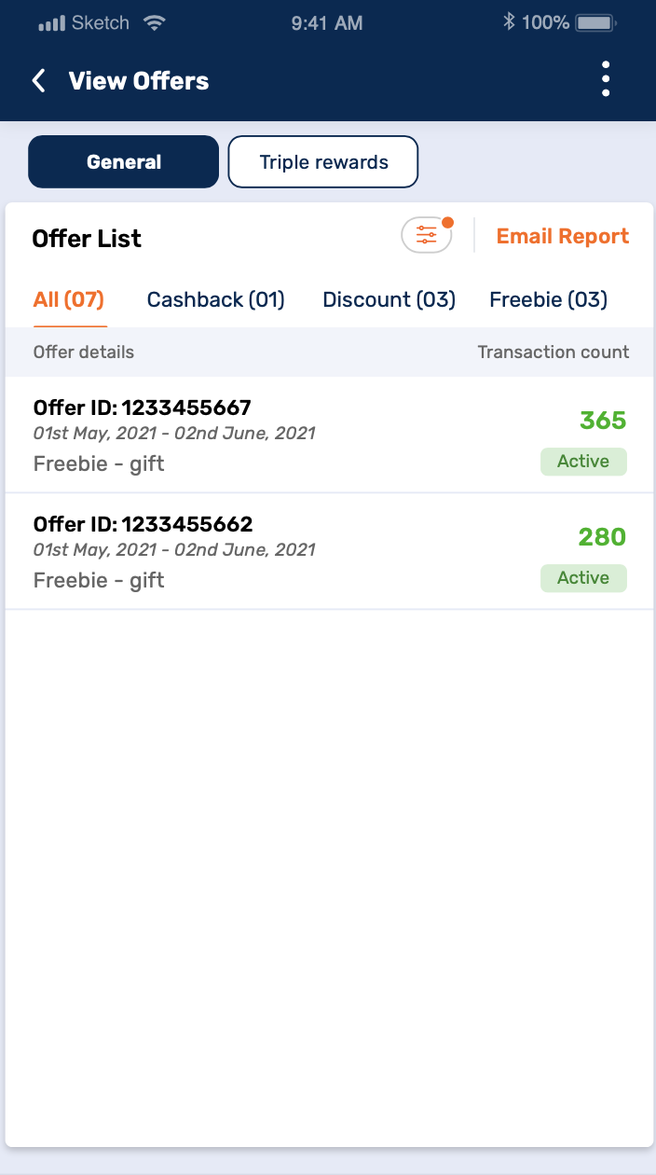
Offer Filter will display filters based on
- Time period
  - Today
  - Yesterday
  - Last 7 Days
  - Current month
  - Last 3 months
  - Customizable date range
- Merchant will be able to filter offer list only for period of 90 days at one time.

- Offer status
  - All
  - Active OR Expiring soon
  - Planned
  - Expired
Rules:
- If “All” filter is selected, rest all offer status should get deselected.
- If any other filter than “All” is selected, then allow to select multiple values under “Offer status”.

Offer status
Following can be the offer status
- Active
All offers that are ongoing and have Offer end date greater than that of current system date

OR

Expiring Soon
This offer status will reflect when difference between offer period and current system date will be <=4 Days

- Planned
All offers yet to be executed (between current system date and offer start date)

- Expired
All offers that have offer end date lesser than that of current system date
Note:
- The Offer list will be displayed in a sorted manner based on offer status as mentioned above.
- At a single point of time, only Active or Expiring soon offer can exist.
Create a stored procedure to display the data/result shown in View Offers tab as above based on filter selection: usp_GeneralReward_Get_ViewOffersDashboard

Merchant can select either General or Triple Reward as category

Customized date range for Period (Today, Yesterday, last 7 days etc)

Status of Offer (All, Active, Planned, Expired etc)
Proc Input Parameters:

@Status VARCHAR(50) NULL, - All/Active/Expiring Soon/Expired

@OfferCategory VARCHAR(30), General/Triple

@FromDate DATE, - creation from date

@ToDate DATE – creation to date

Sample Execution Calls:

EXEC [usp_GeneralReward_Get_ViewOffersDashboard] 'Expired','GENERAL','2025-11-20','2025-12-12'
EXEC [usp_GeneralReward_Get_ViewOffersDashboard] 'Planned','General','2025-11-01','2025-12-12'

Planned offers

Offer performance or store performance report will not exist for planned offers as the offer is yet not executed.

Active Offer
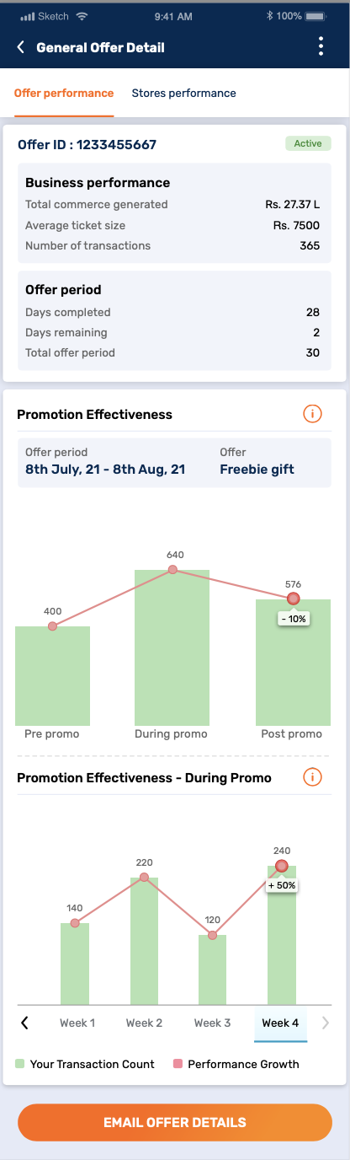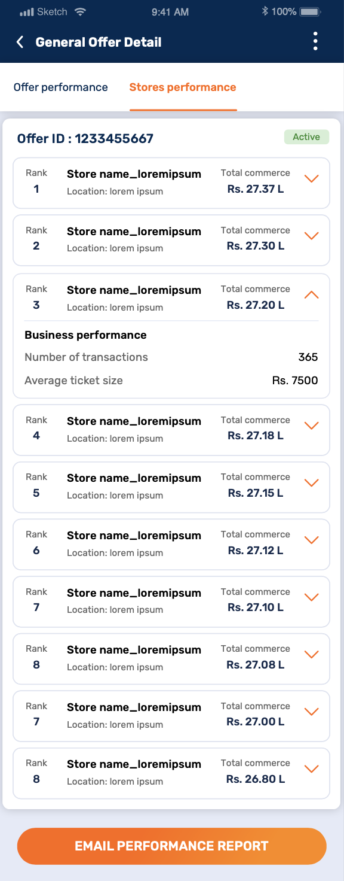
Detailed summary of the offer will be displayed. Two performance sections will be available as

Offer performance
- Offer ID
- Business Performance
  - Number of Transactions
Total transactions made done by Bajaj Customer using any channel of payment. (WEBPOS and Bajaj QR Code) during offer period
  - The transaction mentioned will reflect entries which will be governed on business level
Business | Phase 1 requirement
REMI/Payments | Both channels QR and all other available channels
Rest all other businesses | Transactions from QR channel only

  - Average Ticket Size
Average product purchase value of all transactions done by Bajaj Customers during offer period
Fields | Sample Value | Source DB
Transaction count | 40000 | Real time API hit from ODS to PayTech against offer ID & Offer duration
Average ticket size | 500 | Calculated field

- Offer Period (For active offers)
  - Days Completed
Difference between System current date and Offer Start date
  - Days Remaining
Difference between Offer End date and System current date
  - Total Offer period
Difference between Offer end date and Offer Start date
- Promotion Effectiveness Graph
  - Offer period
  - Offer type
  - Bar graph
To display the number of transactions basis
    - Pre promo
    - During Promo
    - Post Promo
Note: Transaction count is Total transactions made done by Bajaj Customer using any channel of payment. (WEBPOS and Bajaj QR Code) during offer period at Merchant counter
- E.g.: If an offer is run between 11th Jan -20th Jan, then
  - During Promo – is the offer period that is 11th Jan -20th Jan
  - Pre-promo – is the exact offer duration before Offer Start Date i.e., in above case 1st Jan -10th Jan
  - Post-Promo – is the exact offer duration after Offer Start Date i.e., in above case 11th Jan -20th Jan
- Growth Calculation
  - Pre-promo period transactions*100/During Promo period transactions
  - During promo period transactions*100/Post Promo period transactions
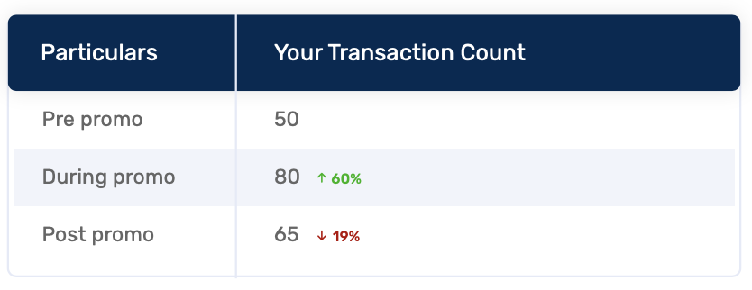
This growth % will be populated in form of a line graph. The table displayed is only for reference & will not be displayed on the UI.

Store performance

Email report
Email will be triggered from 3 screens
- View offers landing screen
This will trigger the email for detailed offer performance report (Based on unique offer IDs)
- Offer performance tab
This will trigger the email for detailed store performance report (Based on unique store IDs)
- Store performance tab
This will trigger the email for detailed store performance report (Based on unique store IDs)
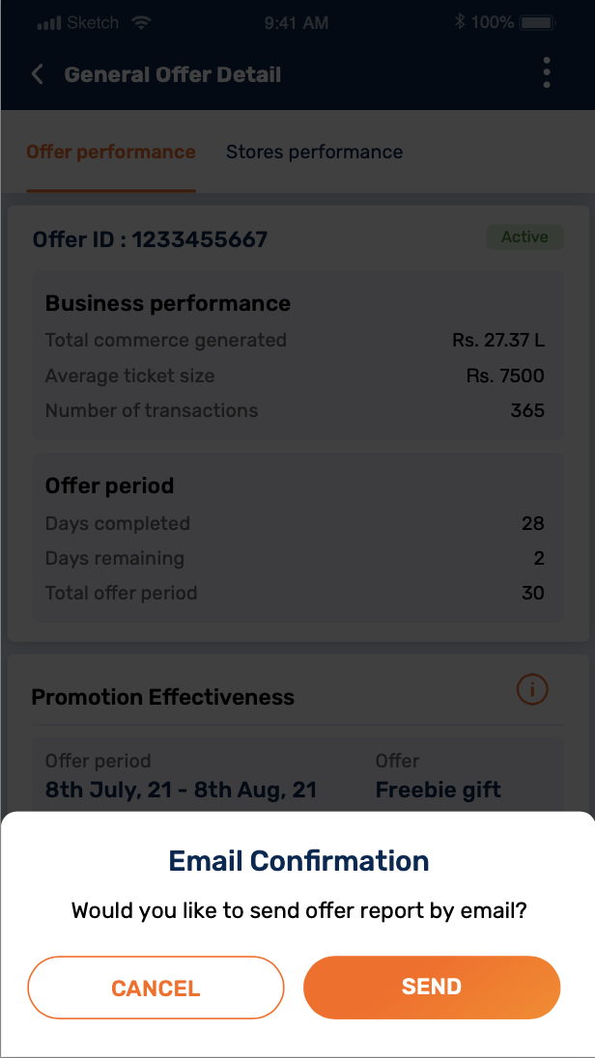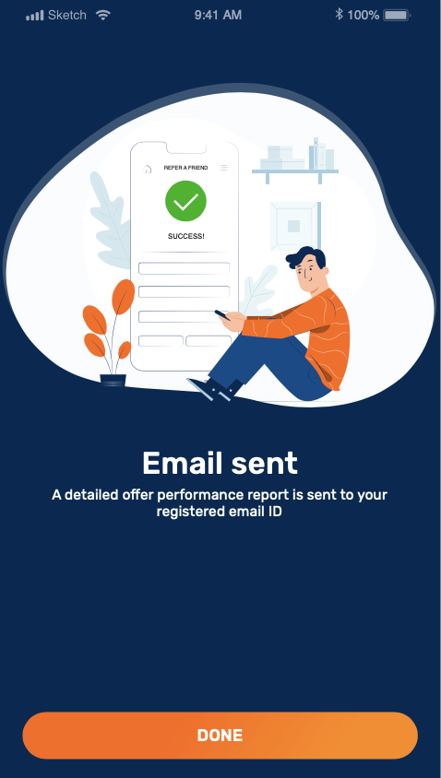
- An option to email the report will be provided to the merchant.
- On selecting email option, a prompt will be displayed (i.e., the pre confirmation). Once merchant selects ‘Send’, the mail will be triggered to the registered email ID of the merchant.
- Final confirmation screen to be displayed once Email is triggered.

Email Report Format
- General Offer – Offer Report
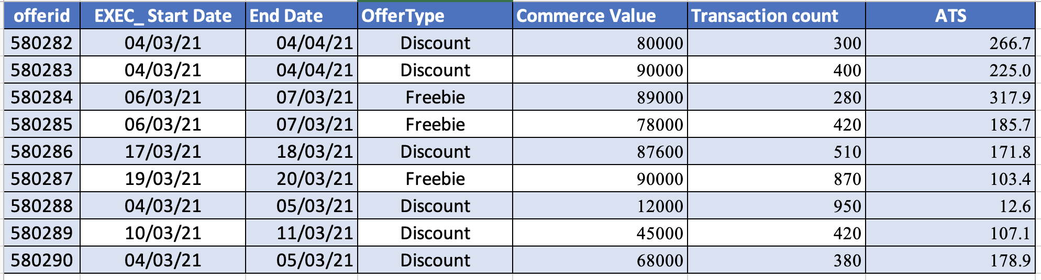
- General Offer – Store Performance Report
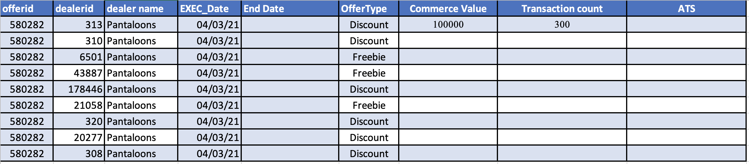
- Triple Reward – Offer Report
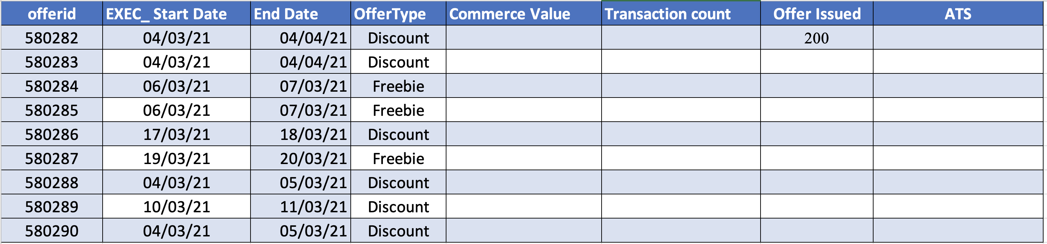
- Triple Reward – Store Performance Report
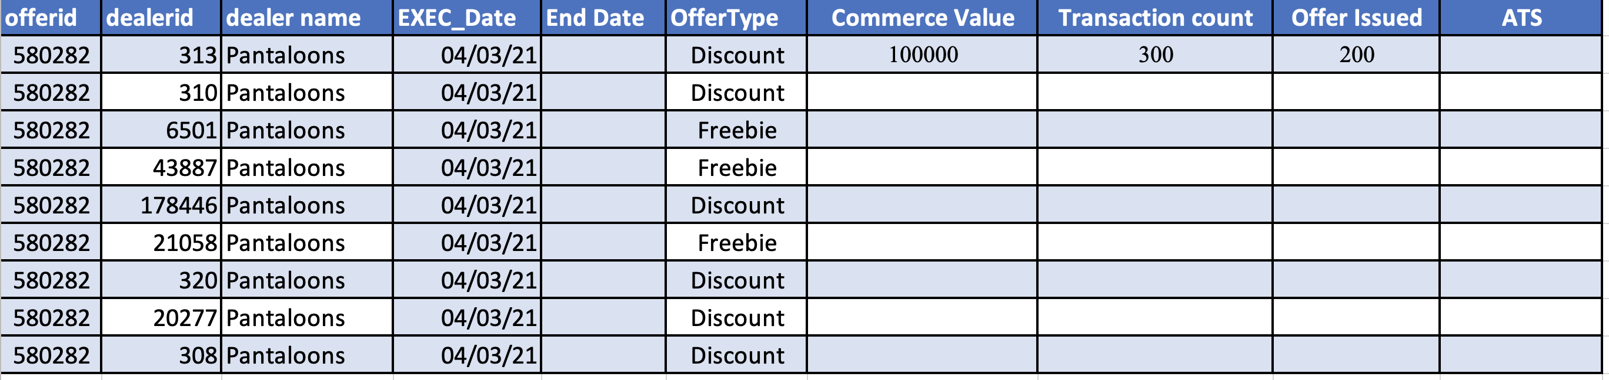

Dashboard & Analysis
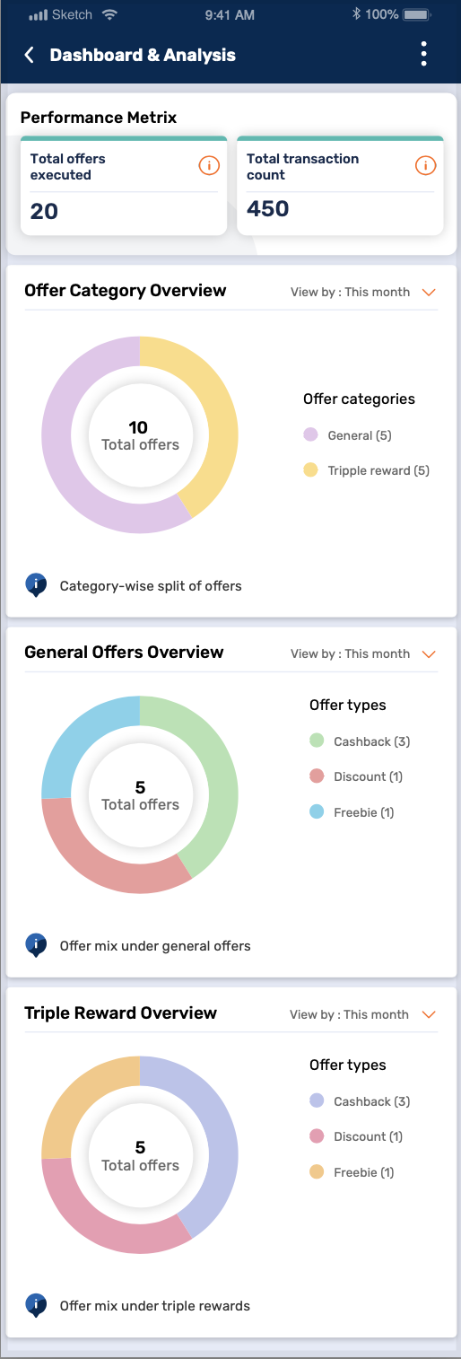

Create a stored procedure – usp_GeneralReward_Get_OfferDashboard
Which will calculate the offer dashboard data based on 2 filter selection.
- Offer Category 2) MonthFlag
Input parameters:
@OfferCategory VARCHAR(50) = NULL,
@MonthFlag INT -- '0' for Current Month, 1 for Previous month, 2 for last two month data
Sample Execution Call:
EXEC [usp_GeneralReward_Get_OfferDashboard] 'General',0
EXEC [usp_GeneralReward_Get_OfferDashboard] ‘Triple Rewards’, 1

Performance Matrix
- Total offers executed
Cumulative number of all offers executed in last 90 days by Merchant irrespective of offer category, offer type or offer status
- Total transaction count
Cumulative count of transactions done by Bajaj Customers during Merchant offer periods in last 90 days at their outlets.

Offer category overview
- Categorical classification of all offers executed till date namely General offers and Triple Reward offers.
- Mid-section of doughnut will contain count of total offers executed in last 90 days
- Graph Legend will contain categories and their respective count in Bracket
- Merchant can filter this graph by date selection of This month, last month and last 3 months

General offers overview
- Classification of all offer types under General category executed till date namely Cashback, Discount and Freebie.
- Mid-section of doughnut will contain count of total offers under General category in last 90 days.
- Graph Legend will contain Offer types and their respective count in Bracket
- Merchant can filter this graph by date selection of This month, last month and last 3 months

Triple reward overview
- Classification of all offer types under General category executed till date namely Cashback, Discount and Freebie.
- Mid-section of doughnut will contain count of total offers under Triple Reward category in last 90 days
- Graph Legend will contain Offer types and their respective count in Bracket
- Merchant can filter this graph by date selection of This month, last month and last 3 months

Data Fields
Fields | Logic | Source DB
Total Offers Executed  (In last 60 days) | To be counted basis offer ID (Total count of offer IDs) + Start date of the offer? | ODS database
Total Transaction Count | Sum of transaction count for all offer IDs in last 60 days (From current system date) | Real time API hit from ODS to PayTech against offer ID & Offer duration

TBD rules to be finalized.
- On hover / tap of any of the pie chart area, the rest of the area will become opaque. PFB screen for reference.
<UI Team to share the screen>
- Filter data to be discussed. Proposed to keep 2 options as-
  - Last 30 days
  - Last 60 days
Note: Currently, three filters are available i.e., This month, Last month, Last three months.
Problem statement: Let’s say it’s day 5th, the pie chart will not have enough data to plot in the pie chart. Hence recommended to keep data for last XX days. Also, for data to be fetched for last 90 days is going to be a heavy load, max recommended days to be kept as 60.

No offers available scenario
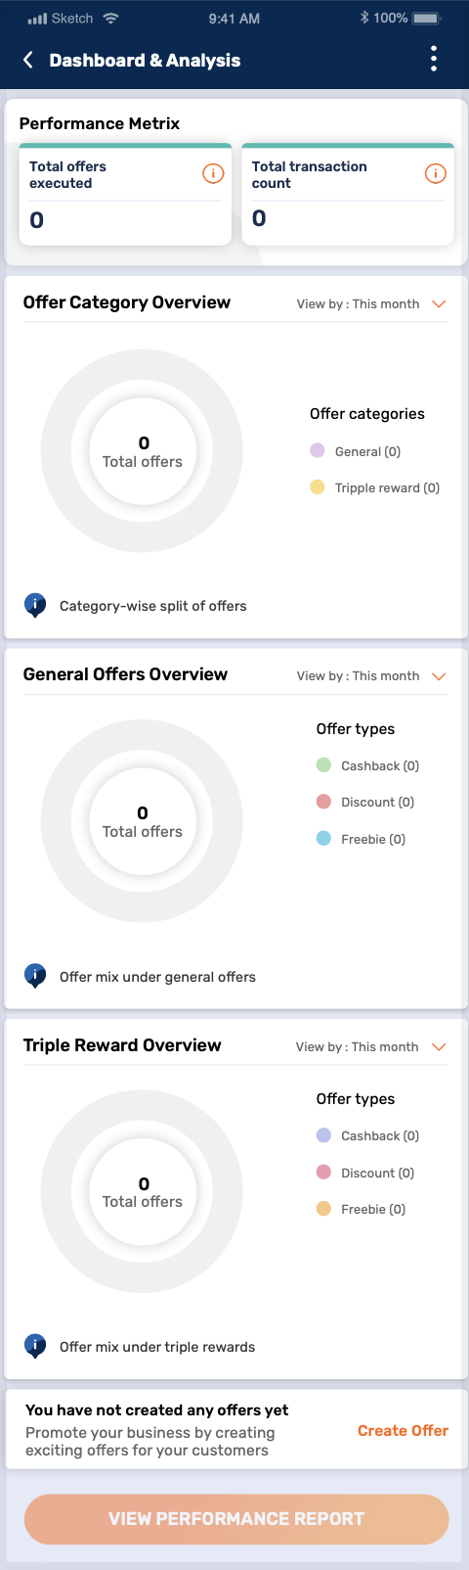
- “Create offer” to be promoted in case there are no offers available to plot analysis of. This tile needs to be placed at the top.
- “View performance report” CTA will be provided which will redirect to “View offers” screen. (As this screen is to be displayed under M1 App Reports & Dashboards → Campaign report. CTA will remain sticky on the screen.

