**IFTTT:**

IFTTT is an automation service that will enable you to connect services so that, when something happens with one service, a trigger goes off and an action takes place automatically on the other.

It enables one [**do the more repetitive tasks automatically**](https://www.makeuseof.com/tag/automate-microsoft-office-tasks-ifttt-recipes/).

First things first, you need to create an account with IFTTT. Head over to IFTTT and you will be greeted with the following screen:

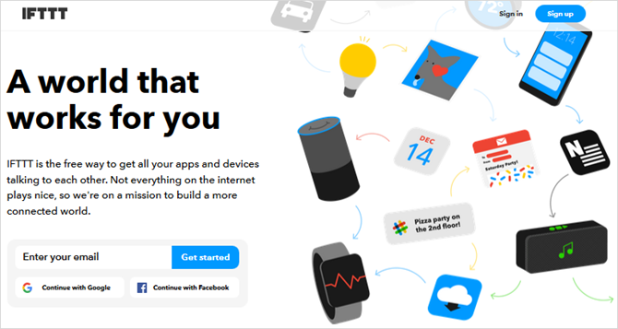

Then, when you click on **Sign up**, you have a few different options. You can create your account with Google, Facebook, or an email address and password.

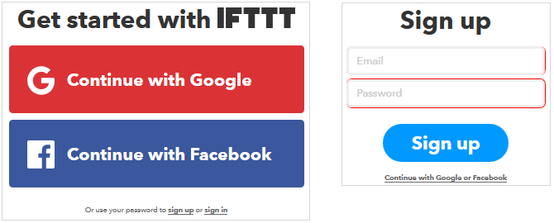

After a few seconds, you’re done and will be taken to the basic IFTTT information page. But, we mainly want to get right to the action by creating an Applet.

The first step is to click **My Applets** and then **New Applet**. Next, click the word **This**.

