The Linux can be configured by following the steps from https://github.com/AdhikariSaurabh/mxpbenchmarks/blob/master/mxplinuxsetup.doc

Booting up the ZedBoard :

1). If you are connected with the board using the USB-UART (serial port) then follow the following steps :

1) sudo minicom -s

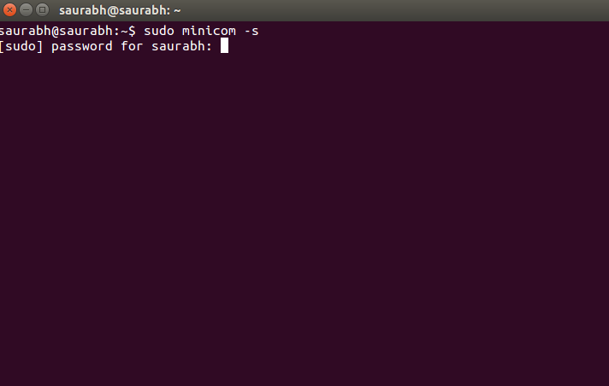

2). enter the system password and then a menu will come in front of you.

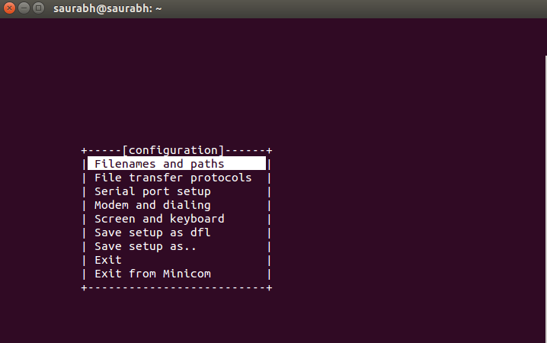

3). Select the serial port setup.
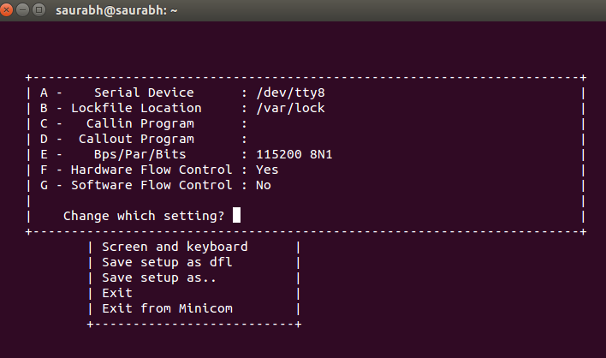

4). Change the A option to :

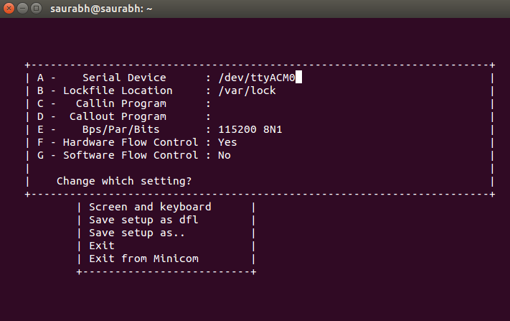

5). Once that is done exit from the menu.

This screen will appear :
stating the zynq >

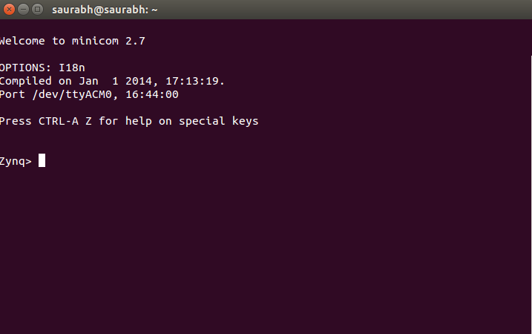

6). The environment variables are set in such a way that once you type run sdboot command in from of the zynq> , the booting automatically starts. Finally you will get the xillinux working on the ZedBoard with the mxp_init and mxp_probe appearing on the screen. Now u can access the MXP using the linux OS.

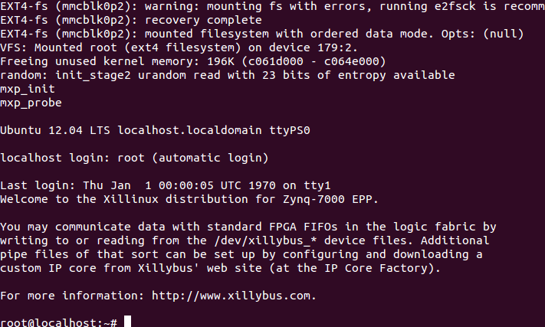

7). Now you can perform a ssh root@ip:

The board current ip is : 172.21.151.158

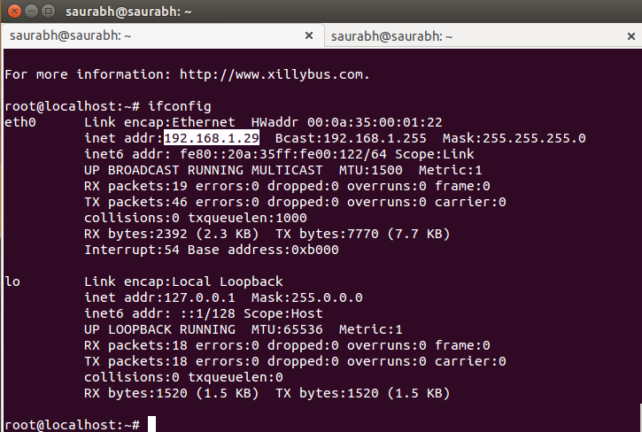
8).

