**REPORT**

In the experiment

lambda (λ) = 2 (was denoted by l)

dt = 0.1

When X was taken as 0% (normal case), the final error was considerably less and the error was found to be decreasing with time (error rate < 0) and we could retrieve the original image to the maximum clarity.

When X was 25%, the final error increased even though the error rate was negative for all three images (greater than when X was 0%) and the retrieved final image was less clear/comparable with the original image.

When X was 50% and 80%, the error increased with time (error rate > 0) and the final image couldn’t be retrieved. Error, error rate and clarity discrepancy were found to be more when x was 80%.

Hence rms increases with time after a particular X% of w (weight) = 0. Also, the final error increased with increase in W.

*RMS when x = 0*

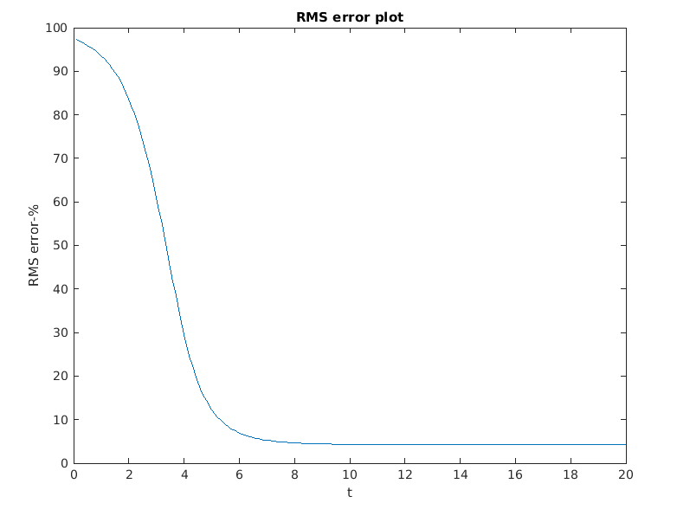

*RMS when x = 25%*

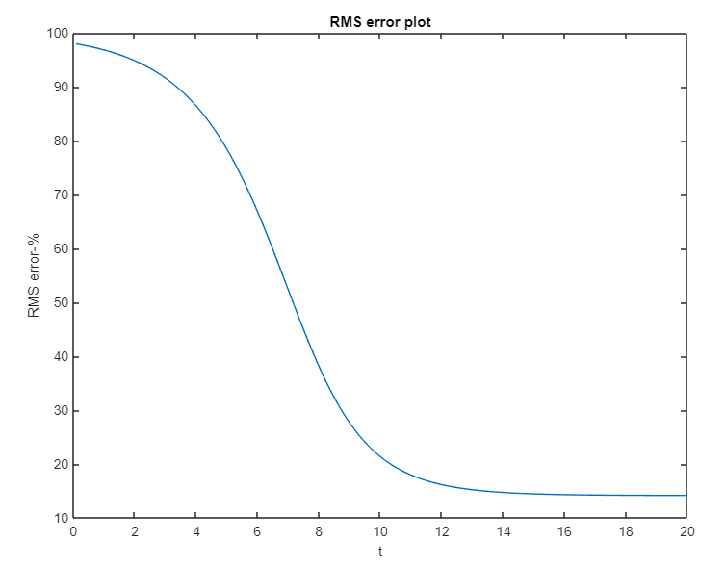

*RMS when x = 50%*

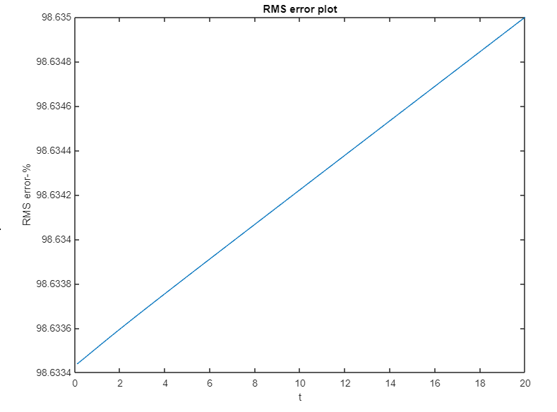

*RMS when x = 80%*

