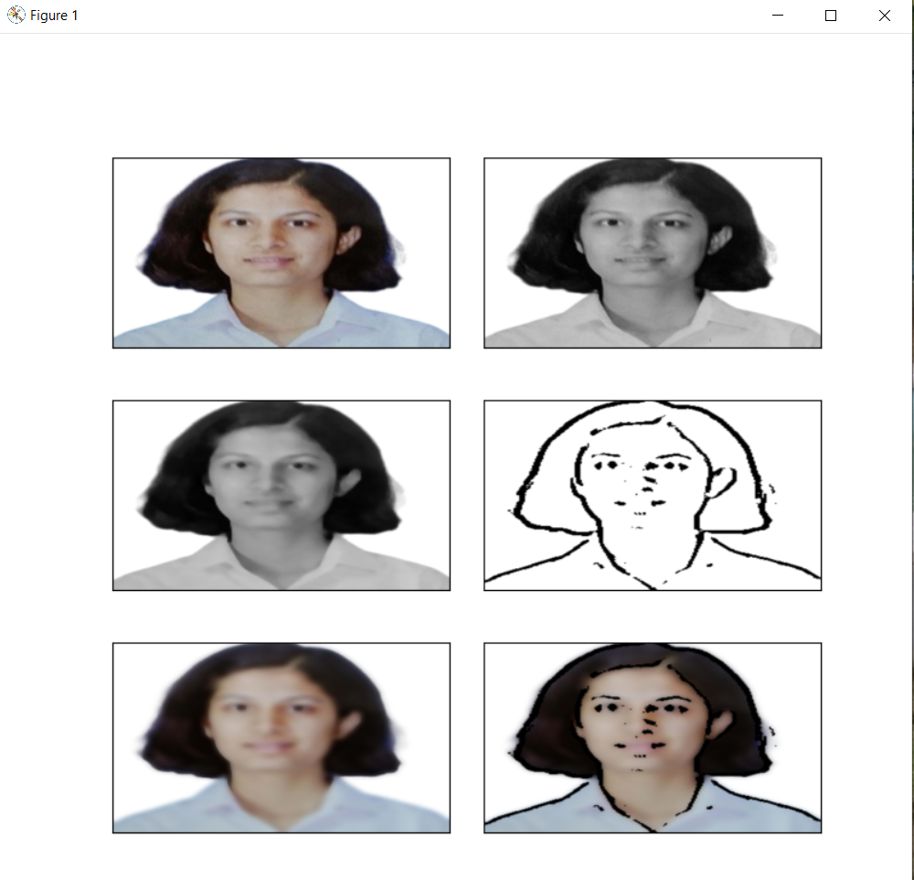

import cv2  
import easygui  
import numpy as np  
import imageio  
  
import sys  
import matplotlib.pyplot as plt  
import os  
import tkinter as tk  
from tkinter import filedialog  
from tkinter import *  
from PIL import ImageTk, Image  
  
top=tk.Tk()  
top.geometry('400x400')  
top.title('Cartoonify Your Image !')  
top.configure(background='white')  
label=Label(top,background='#CDCDCD', font=('calibri',20,'bold'))  
  
def upload():  
 ImagePath=easygui.fileopenbox()  
 cartoonify(ImagePath)  
  
  
def cartoonify(ImagePath):  
 # read the image  
 originalmage = cv2.imread(ImagePath)  
 originalmage = cv2.cvtColor(originalmage, cv2.COLOR_BGR2RGB)  
 # print(image) # image is stored in form of numbers  
  
 # confirm that image is chosen  
 if originalmage is None:  
 print("Can not find any image. Choose appropriate file")  
 sys.exit()  
  
 ReSized1 = cv2.resize(originalmage, (960, 540))  
 # plt.imshow(ReSized1, cmap='gray')  
  
 # converting an image to grayscale  
 grayScaleImage = cv2.cvtColor(originalmage, cv2.COLOR_BGR2GRAY)  
 ReSized2 = cv2.resize(grayScaleImage, (960, 540))  
 # plt.imshow(ReSized2, cmap='gray')  
  
 # applying median blur to smoothen an image  
 smoothGrayScale = cv2.medianBlur(grayScaleImage, 5)  
 ReSized3 = cv2.resize(smoothGrayScale, (960, 540))  
 # plt.imshow(ReSized3, cmap='gray')  
  
 # retrieving the edges for cartoon effect  
 # by using thresholding technique  
 getEdge = cv2.adaptiveThreshold(smoothGrayScale, 255,  
 cv2.ADAPTIVE_THRESH_MEAN_C,  
 cv2.THRESH_BINARY, 9, 9)  
  
 ReSized4 = cv2.resize(getEdge, (960, 540))  
 # plt.imshow(ReSized4, cmap='gray')  
  
 # applying bilateral filter to remove noise  
 # and keep edge sharp as required  
 colorImage = cv2.bilateralFilter(originalmage, 9, 300, 300)  
 ReSized5 = cv2.resize(colorImage, (960, 540))  
 # plt.imshow(ReSized5, cmap='gray')  
  
 # masking edged image with our "BEAUTIFY" image  
 cartoonImage = cv2.bitwise_and(colorImage, colorImage, mask=getEdge)  
  
 ReSized6 = cv2.resize(cartoonImage, (960, 540))  
 # plt.imshow(ReSized6, cmap='gray')  
  
 # Plotting the whole transition  
 images = [ReSized1, ReSized2, ReSized3, ReSized4, ReSized5, ReSized6]  
  
 fig, axes = plt.subplots(3, 2, figsize=(8, 8), subplot_kw={'xticks': [], 'yticks': []},  
 gridspec_kw=dict(hspace=0.1, wspace=0.1))  
 for i, ax in enumerate(axes.flat):  
 ax.imshow(images[i], cmap='gray')  
  
 save1 = Button(top, text="Save cartoon image", command=lambda: save(ReSized6, ImagePath), padx=30, pady=5)  
 save1.configure(background='#364156', foreground='white', font=('calibri', 10, 'bold'))  
 save1.pack(side=TOP, pady=50)  
  
 plt.show()  
def save(ReSized6, ImagePath):  
 #saving an image using imwrite()  
 newName="cartoonified_Image"  
 path1 = os.path.dirname(ImagePath)  
 extension=os.path.splitext(ImagePath)[1]  
 path = os.path.join(path1, newName+extension)  
 cv2.imwrite(path, cv2.cvtColor(ReSized6, cv2.COLOR_RGB2BGR))  
 I= "Image saved by name " + newName +" at "+ path  
 tk.messagebox.showinfo(title=None, message=I)  
  
upload=Button(top,text="Cartoonify an Image",command=upload,padx=10,pady=5)  
upload.configure(background='#364156', foreground='white',font=('calibri',10,'bold'))  
upload.pack(side=TOP,pady=50)  
  
top.mainloop()