DISA
Disaster Management System

Project Report
Group 10
Student ID | Name
28775 | H.P.G Dilina Mewan
29318 | Uduwana T.M
28994 | T.R.D.T Dulshan
28282 | K.A.A.T Kulasooriya

A Microservice-Based Disaster Response Platform
Spring Boot | React | RabbitMQ | PostgreSQL

Module-Development Of Enterprise Application II
Module Code-SE402.3
Module Leader-Mr.
Contents
1. Introduction 4
1.1 Project Objectives 4
1.2 Scope 4
1.3 Key Features 4
2. GIT Repository 5
2.1 Repository Structure 5
3. Application Architecture 6
3.1 High-Level Architecture Overview 6
3.2 Service Inventory 7
3.3 Event-Driven Communication (RabbitMQ) 7
3.4 Security Architecture 8
4. Backend — Microservices Detail 9
4.1 auth-service (Port 8081) 9
4.2 incident-service (Port 8083) 9
4.3 mission-service (Port 8086) 9
4.4 resource-service (Port 8089) 9
4.5 shelter-service (Port 8085) 9
4.6 assessment-service (Port 8087) 10
4.7 task-service (Port 8088) 10
4.8 personnel-service (Port 8084) 10
4.9 API Documentation 10
5. Frontend — React Application 11
5.1 Overview 11
5.5 Screenshots 11
6. Technology Stack 14
6.1 Backend Technologies 14
6.2 Frontend Technologies 14
7. Workload Matrix — Individual Contributions 15
7.1 Shared Responsibilities 15
8.1 Prerequisites 16
8.2 Quick Start — Full Stack (Recommended) 16
8.3 Run a Single Service (Testing / Development) 17
8.4 Local Development (Without Docker) 17
8.6 Stopping the Application 17

1. Introduction
DISA (Disaster Management System) is a microservice-based platform for coordinating disaster response. It connects emergency response teams, resource allocators, shelter managers, field assessors, and personnel so they can work together in real time during a disaster.
Monolithic disaster management tools break down under load and make it difficult to update one part without affecting everything else. DISA splits the platform into eight independent services, each with its own database. They communicate through RabbitMQ with no direct dependencies between them.

1.1 Project Objectives
- Provide a unified platform for incident reporting, mission management, and resource tracking
- Enable real-time event-driven coordination between emergency response teams
- Support role-based access control for Admins, Coordinators, Responders, and Volunteers
- Integrate AI-powered capabilities (Google Gemini) for damage classification and personnel matching
- Deliver a scalable, containerized architecture deployable on cloud infrastructure (Azure)

1.2 Scope
The system covers the complete lifecycle of disaster response:
- Incident Detection & Reporting: Field teams report incidents with severity classification
- Mission Coordination: Coordinators create and manage response missions linked to incidents
- Resource Management: Track and allocate physical resources (vehicles, supplies, medical kits)
- Shelter Operations: Register shelters and manage resident check-in/check-out
- Damage Assessment: Field responders submit Damage assessments and RabbitMQ will create tasks
- Task Tracking: Granular task assignment and completion tracking for all responders
- Personnel Management: Full responder profiles with skills, medical records, and AI task matching

1.3 Key Features
- 8 independent Spring Boot microservices with dedicated PostgreSQL databases
- Event-driven architecture using RabbitMQ topic exchange for loose coupling
- JWT-based authentication with role hierarchy (ADMIN > COORDINATOR > RESPONDER > VOLUNTEER)
- AI integration via Google Gemini API for damage classification and smart personnel-task matching
- Full Swagger/OpenAPI documentation on each service
- Containerized with Docker and Docker Compose for local and cloud deployment
- React 19 + TypeScript + Tailwind CSS frontend served via Nginx

2. GIT Repository
The complete source code for the DISA platform is hosted on GitHub. The repository contains all eight backend microservices, the React frontend, Docker Compose configurations, and deployment scripts.

GitHub Repository: https://github.com/Adhishtanaka/DISA-MICROSERVICE.git

2.1 Repository Structure
Directory / File | Description
backend/auth-service/ | JWT authentication, user registration & role management
backend/incident-service/ | Incident reporting & status lifecycle management
backend/mission-service/ | Response mission creation & team coordination
backend/resource-service/ | Physical resource tracking & critical-low alerts
backend/shelter-service/ | Shelter registration & resident check-in/out
backend/assessment-service/ | Damage assessments and automatically triggers tasks
backend/task-service/ | Task assignment, tracking & completion management
backend/personnel-service/ | Responder profiles, skills, medical records & AI matching
frontend/ | React 19 + TypeScript + Vite frontend application
frontend/docker-compose.yml | Full-stack deployment with shared PostgreSQL instance
Docker/ docker-compose.yml | Shared infrastructure: RabbitMQ message broker

3. Application Architecture
Each service in DISA is deployed independently and owns its own PostgreSQL database. Services communicate through REST HTTP calls for direct queries, or through RabbitMQ events for asynchronous notifications. The React frontend never calls backend services directly; all traffic goes through an Nginx reverse proxy.

3.1 High-Level Architecture Overview
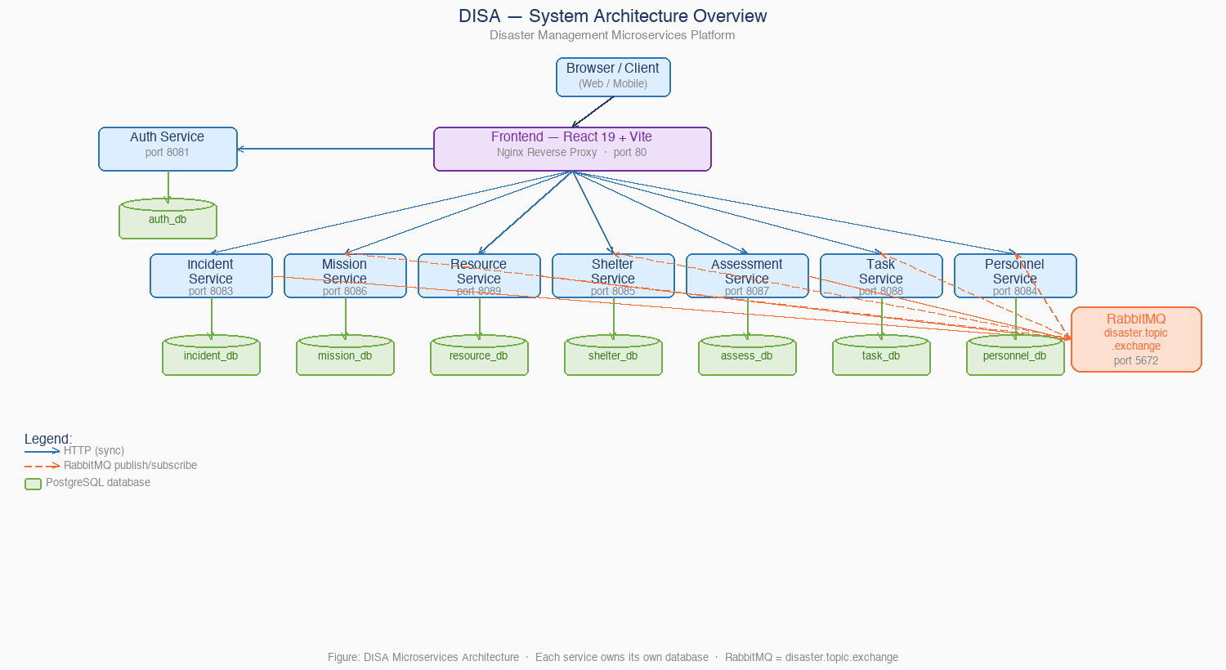
[ Browser / Client ] → [ Nginx Reverse Proxy / Frontend ] → [ 8 Backend Microservices ] → [ PostgreSQL DBs + RabbitMQ ]

3.2 Service Inventory
Service | Port | Database | Responsibility
auth-service | 8081 | auth_db | JWT tokens, user registration, role management
incident-service | 8083 | incident_db | Report/track disasters; publishes domain events
mission-service | 8086 | mission_db | Response missions triggered by incidents
resource-service | 8089 | resource_db | Track equipment/supplies; critical-low alerts
shelter-service | 8085 | shelter_db | Shelter capacity management & resident tracking
assessment-service | 8087 | assessment_db | Add Damage assessments and create tasks automatically
task-service | 8088 | task_db | Task assignment, tracking & auto-generation from assessments
personnel-service | 8084 | personnel_service | Responder profiles, skills, AI-powered task matching

3.3 Event-Driven Communication (RabbitMQ)
All asynchronous communication flows through a single RabbitMQ topic exchange (disaster.topic.exchange). Each consuming service has its own named, durable queue, so services consume messages independently without interfering with each other.

Routing Key | Publisher | Queue | Subscriber
incident.created | incident-service | mission.incident.created.queue | mission-service
incident.created | incident-service | shelter.incident.created.queue | shelter-service
incident.escalated | incident-service | mission.incident.escalated.queue | mission-service
resource.critical_low | resource-service | mission.resource.critical_low.queue | mission-service
assessment.completed | assessment-service | assessment.completed.queue | task-service
task.assigned | task-service | personnel.task.assigned.queue | personnel-service
user.registered | auth-service | personnel.user.registered.queue | personnel-service
personnel.status.changed | personnel-service | task.personnel.status.queue | task-service

3.4 Security Architecture
auth-service issues signed JWT Bearer tokens on login. Every other microservice validates incoming tokens independently via the /api/auth/validate endpoint, so there is no centralized gateway. The role hierarchy is:
- ADMIN — Full system access: manage all users, data, and system configuration
- COORDINATOR — Manage incidents, missions, resource allocation, and shelter setup
- RESPONDER — Execute tasks, submit field assessments, manage shelter residents
- VOLUNTEER — Read-only access to tasks, shelter availability, and incident summaries

4. Backend — Microservices Detail

4.1 auth-service (Port 8081)
auth-service is the authentication gateway for the platform. It issues HS256-signed JWT tokens that are valid across all microservices and stores user credentials with BCrypt-hashed passwords.

Key Endpoints:
- POST /api/auth/register — Register new user with role assignment
- POST /api/auth/login — Authenticate and receive JWT token
- GET /api/auth/validate — Token validation used by all other services
- GET /api/auth/profile — Retrieve authenticated user profile

4.2 incident-service (Port 8083)
incident-service is the primary event source for the platform. It manages the full incident lifecycle (REPORTED → ACTIVE → RESOLVED), publishes incident.created on creation, and publishes incident.escalated on severity escalation. Both events trigger automatic reactions in the mission and shelter services.

Event Publications:
- incident.created → Triggers mission stub creation + shelter pre-positioning
- incident.escalated → Triggers mission update for linked active missions

4.3 mission-service (Port 8086)
mission-service coordinates response missions linked to incidents. It supports five mission types: DELIVERY, RESCUE, EVACUATION, MEDICAL_TRANSPORT, and ASSESSMENT. It subscribes to three event types to react automatically to system state changes.

4.4 resource-service (Port 8089)
resource-service tracks physical resources (vehicles, medical kits, generators, water supplies) by type, quantity, and status. It publishes resource.critical_low events when stock falls below configurable thresholds so coordinators can arrange resupply before it affects operations.

4.5 shelter-service (Port 8085)
shelter-service manages temporary shelters with real-time capacity tracking. It handles occupancy through check-in and check-out endpoints and is automatically notified when incidents are created, so shelter resources can be pre-positioned near affected areas.

4.6 assessment-service (Port 8087)
assessment-service lets field responders submit damage assessments. then it publishes assessment. completed so task-service can auto-generate the corresponding tasks.

4.7 task-service (Port 8088)
task-service is the granular task tracker for all response operations. Tasks can be linked to incidents or missions, assigned to specific responders, and marked complete. It creates tasks automatically from assessment required-actions and publishes task.assigned to notify personnel-service of availability changes.

4.8 personnel-service (Port 8084)
personnel-service manages complete responder profiles: personal data, skills with proficiency levels, medical records (allergies, chronic conditions, medications), emergency contacts, and certification documents. It uses Google Gemini AI to match pending tasks to the best-suited available responder based on skills, location, and task requirements.

4.9 API Documentation
Every service exposes a Swagger UI endpoint for interactive API exploration and testing:
Service | Swagger UI URL
auth-service | http://localhost:8081/swagger-ui.html
incident-service | http://localhost:8083/swagger-ui.html
mission-service | http://localhost:8086/swagger-ui.html
resource-service | http://localhost:8089/swagger-ui.html
shelter-service | http://localhost:8085/swagger-ui.html
assessment-service | http://localhost:8087/swagger-ui.html
task-service | http://localhost:8088/api/v1/swagger-ui.html
personnel-service | http://localhost:8084/swagger-ui.html

5. Frontend — React Application

5.1 Overview
The DISA frontend is a single-page application built with React 19 and TypeScript, bundled by Vite. It communicates with all eight backend services through an Nginx reverse proxy, which also serves the static assets in production.

5.5 Screenshots

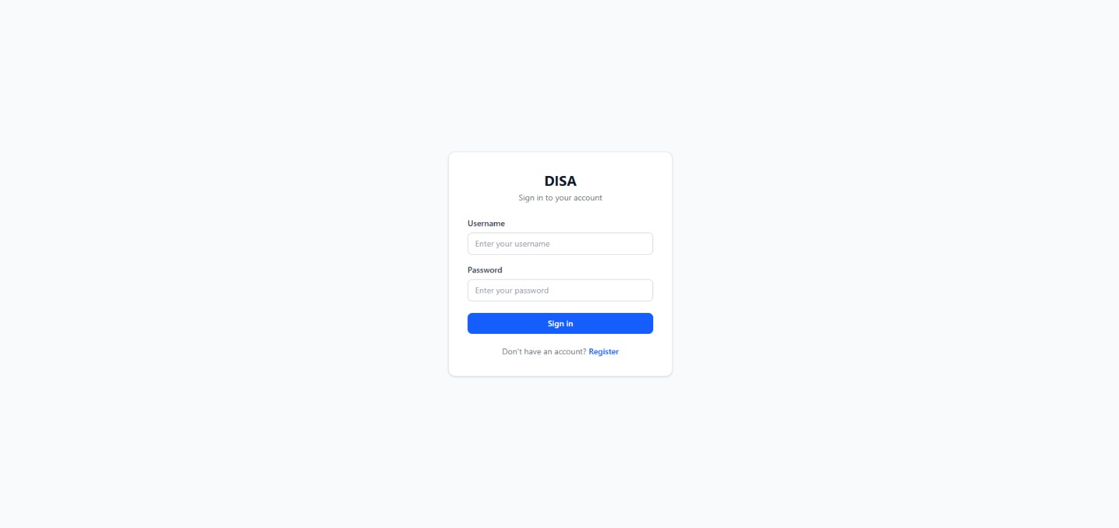
- Login

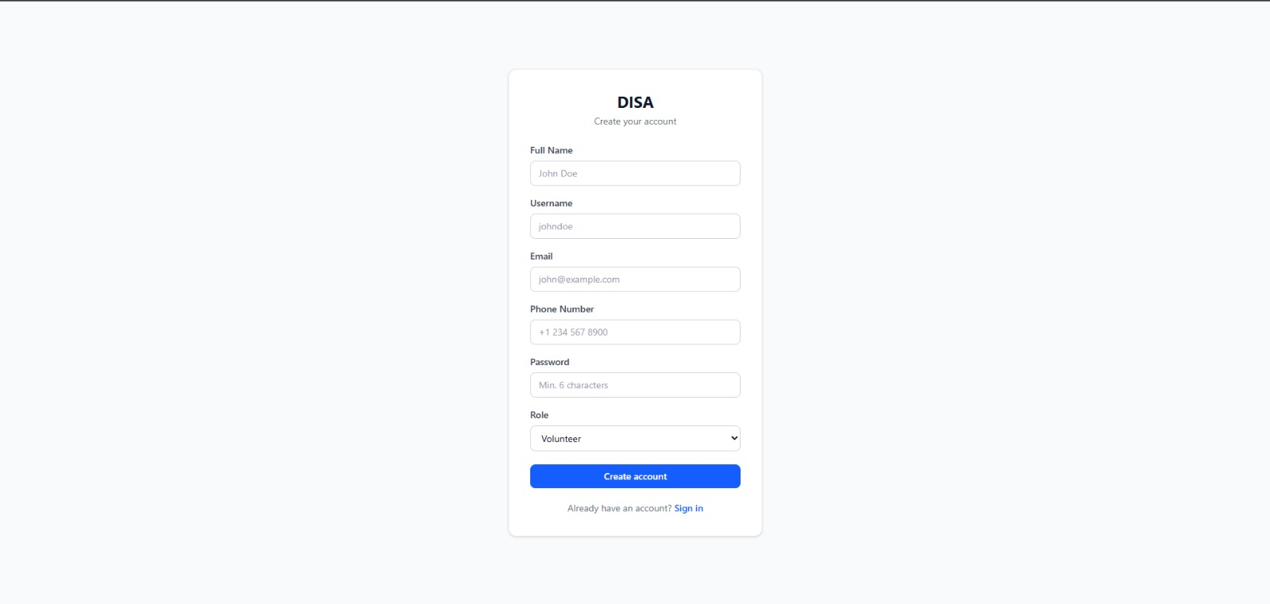
- Register

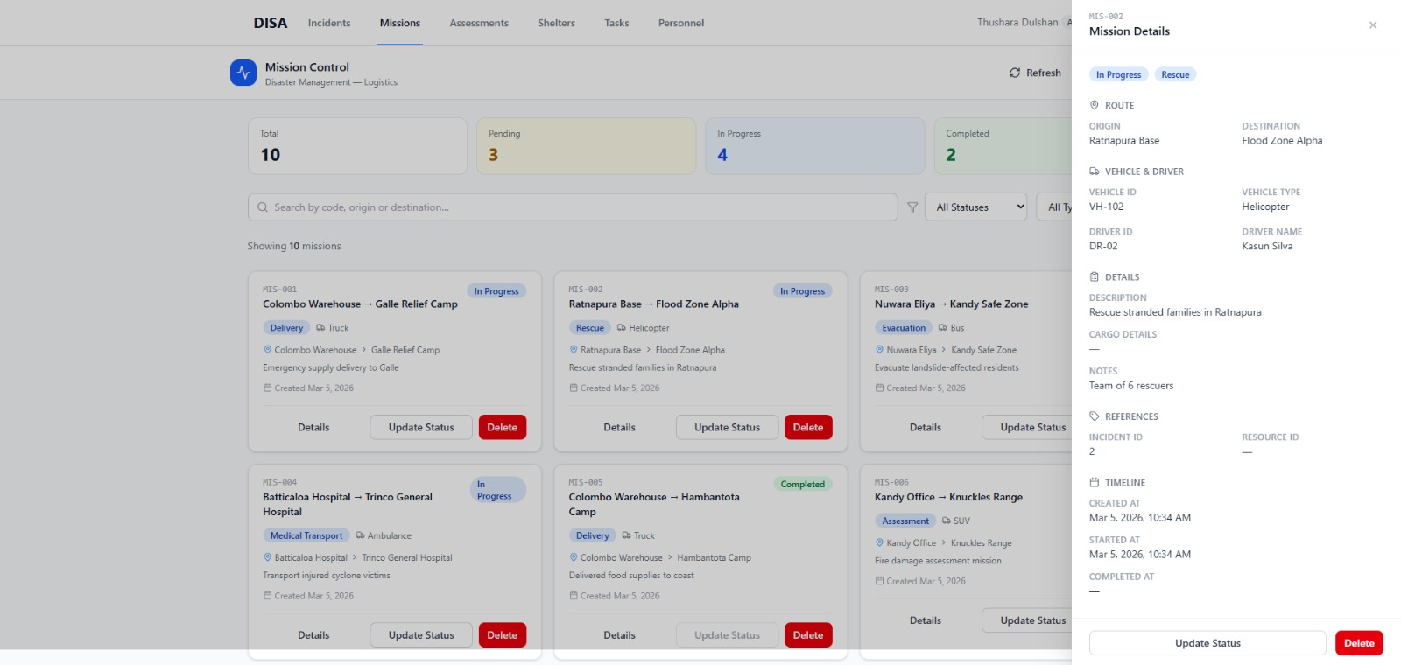
- Mission Service
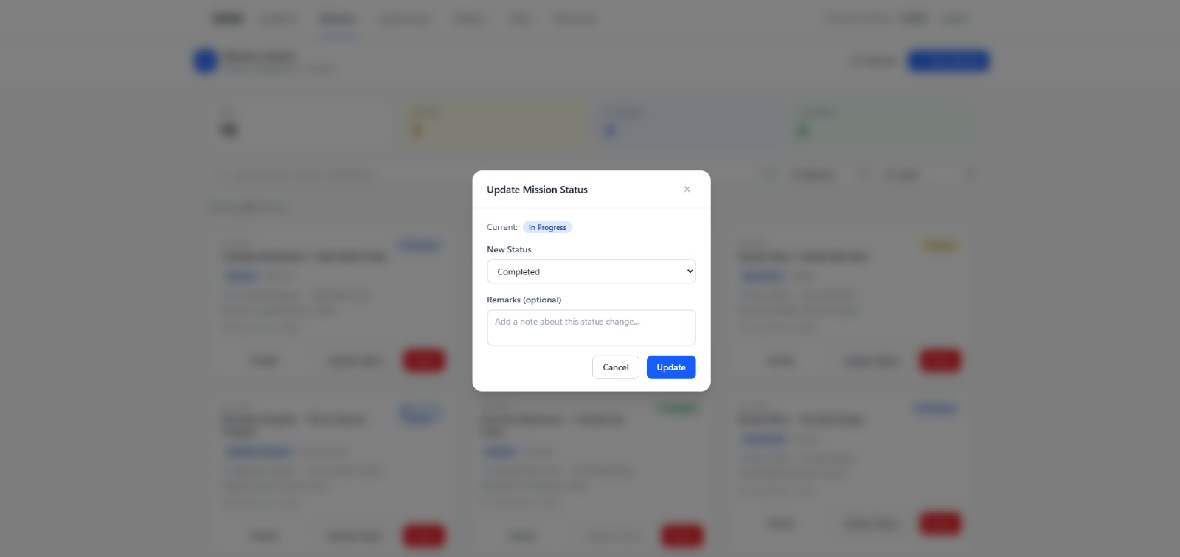

6. Technology Stack

6.1 Backend Technologies
Technology | Version | Usage
Java | 17 / 21 | Primary backend language (Java 17 on incident/resource/task/assessment services; Java 21 on auth/mission/shelter/personnel)
Spring Boot | 3.x – 4.0.x | Microservice framework with auto-configuration
Spring Security | 6.x | JWT Bearer token authentication & RBAC
Spring Data JPA | 3.x | ORM layer for PostgreSQL with Hibernate
Spring AMQP | 3.x | RabbitMQ messaging with topic exchange pattern
PostgreSQL | 16 | Relational database — one instance per service
RabbitMQ | 3.13 | AMQP message broker for async event streaming
Springdoc OpenAPI | 2.x | Auto-generated Swagger UI documentation per service
Google Gemini AI | API | AI damage classification & intelligent personnel matching

6.2 Frontend Technologies
Technology | Version | Usage
React | 19.x | UI library with concurrent rendering features
TypeScript | 5.x | Strongly-typed JavaScript for safe API contracts
Vite | Latest | Next-gen frontend build tool with ESM-first HMR
Zustand | Latest | Bear-bones state management for auth and global state
Axios | Latest | Promise-based HTTP client with JWT interceptors
Tailwind CSS | 4.x | Utility-first CSS with responsive breakpoints
Nginx | Latest | Production static file server + API reverse proxy

7. Workload Matrix — Individual Contributions
The table below lists each team member's contributions. Each microservice was owned end-to-end by its designated member, covering design, implementation, testing, and deployment.

Team Member | Assigned Service(s) | Key Responsibilities
K.A.A.T Kulasooriya | auth-service, task-service ,Frontend, RabbitMQ | Auth management, RabbitMQ topic exchange setup, Docker Compose, Task CRUD
Sakuni Sirimann | incident-service | Incident CRUD, status transitions, escalation logic, RabbitMQ publishing
H.P.G Dilina Mewan | mission-service | Mission management, event subscription, team/status tracking
Tanuj Malinda | resource-service | Resource tracking, quantity management, critical-low alert publishing
Janandhi | shelter-service | Shelter management, capacity tracking, check-in/out, event subscription
Nethmina | assessment-service | Damage assessment CRUD and event publishing
T.R.D.T Dulshan | personnel-service | Personnel profiles, skills/medical records, Gemini AI matching, RabbitMQ

7.1 Shared Responsibilities
Activity | Participants
System Architecture Design | All team members — joint design sessions
Docker Compose Configuration | All members — per-service compose files
Frontend Development | Member 1 (lead) + all members for their service's UI module
Azure Cloud Deployment | All members — each deployed their own service
RabbitMQ Integration | Members 2, 3, 4, 5, 6, 7, 8 (services with messaging)
Documentation & Testing | All team members
8. How to Run the Application

8.1 Prerequisites
Make sure the following tools are installed before you start:
- Docker >= 24.0 (docker --version)
- Docker Compose V2 (docker compose version — note: no hyphen)
- Git (git --version)
- Node.js >= 18 (for local frontend development only)
- Java 21 (for local backend development without Docker)

8.2 Quick Start — Full Stack (Recommended)
Run the full platform locally with a single command:

# 1. Clone the repository
git clone https://github.com/Adhishtanaka/DISA-MICROSERVICE.git
cd DISA-MICROSERVICE
# 2. Start the full stack
cd frontend
docker compose up --build -d
# 3. Wait ~2 minutes for all services to start
docker compose ps # verify all services are healthy

After startup, the following URLs will be available:
URL | Service
http://localhost | React Frontend Application
http://localhost:15672 | RabbitMQ Management UI (guest / guest)
http://localhost:8081/swagger-ui.html | Auth Service API Docs
http://localhost:8083/swagger-ui.html | Incident Service API Docs
http://localhost:8086/swagger-ui.html | Mission Service API Docs
http://localhost:8089/swagger-ui.html | Resource Service API Docs
http://localhost:8085/swagger-ui.html | Shelter Service API Docs
http://localhost:8087/swagger-ui.html | Assessment Service API Docs
http://localhost:8088/api/v1/swagger-ui.html | Task Service API Docs
http://localhost:8084/swagger-ui.html | Personnel Service API Docs

8.3 Run a Single Service (Testing / Development)
Each service is independently deployable with its own docker-compose.yml and sensible defaults — no .env file required:

# Example: run shelter-service standalone
cd backend/shelter-service
docker compose up --build -d
# Check logs
docker compose logs shelter-service --tail=20
# Open Swagger UI at: http://localhost:8085/swagger-ui.html
# Stop when done
docker compose down

8.4 Local Development (Without Docker)
- Start the infrastructure containers (PostgreSQL + RabbitMQ) from any service directory:

docker compose up postgres rabbitmq -d

- Run a backend service locally with Maven:

cd backend/incident-service
./mvnw spring-boot:run

- Run the frontend dev server (hot reload at http://localhost:5173):

cd frontend
npm install
npm run dev # Available at http://localhost:5173

8.6 Stopping the Application
# Stop all services and remove containers
docker compose down
# Stop and remove all data volumes (clean slate)
docker compose down -v

