**RhythmicTunes**

**Music Streaming Application**

**Team:**

|  |  |
| --- | --- |
| **Name** | **Email id** |
| ADHITHAN R | [**adhithan.r01@gmail.com**](mailto:adhithan.r01@gmail.com) |
| ASWIN E | [**michealacchu007@gmail.com**](mailto:michealacchu007@gmail.com) |
| AROON M | [**sanjayaroon@gmail.com**](mailto:sanjayaroon@gmail.com) |
| PARTHIBAN T | [**hhanish0@gmail.com**](mailto:hhanish0@gmail.com) |

**Introduction**

**RhythmicTunes: Your Melodic Companion**

RhythmicTunes is a React-based music streaming application designed to provide a seamless and intuitive listening experience. With features like personalized playlists, offline listening, and robust search capabilities, it caters to music enthusiasts of all kinds.

RhythmicTunes aims to redefine music streaming with a focus on user experience and modern web technologies.

**Target Audience**

* **Music Enthusiasts:** People who are passionate about discovering and listening to a wide variety of music.
* **Casual Listeners:** Users who enjoy curated playlists and trending songs without much customization.
* **Commuters and Travelers:** Individuals who benefit from offline listening features.
* **Fitness and Workout Enthusiasts:** Users who need energetic playlists for workouts.
* **Students and Professionals:** Those who seek focus or study playlists during work or study sessions.

**Goals and Objectives**

* Create a user-friendly interface
* Provide comprehensive music streaming capabilities
* Utilize a modern tech stack for performance and efficiency

**Key Features**

* **Song Listings:** Display details such as title, artist, genre, and release date.
* **Playlist Creation:** Allow users to create and manage playlists.
* **Playback Control:** Enable play, pause, skip, and volume control.
* **Offline Listening:** Allow song downloads for offline access.
* **Search Functionality:** Implement advanced search for songs, artists, and albums.

**Prerequisites**

* Node.js and npm
* React.js
* HTML, CSS, and JavaScript
* Version Control (Git)
* Development Environment (VS Code, Sublime Text, or WebStorm)

**Project Structure**

rhythmic-tunes/

│── src/ # Main application source code

│ ├── components/ # Reusable UI components

│ ├── pages/ # Page components (Songs, Favorites, Playlist)

│ ├── App.js # Main app component

│ ├── index.js # Entry point

│── public/ # Static assets

│── db/ # JSON database for local data storage

│── package.json # Project dependencies & scripts

│── README.md # Documentation

**Project Flow:**

* Setup: Install necessary tools and libraries.
* Development: Configure routes, fetch data, and manage state.
* Execution: Run the React app and JSON server.

**Data Flow Diagram:**

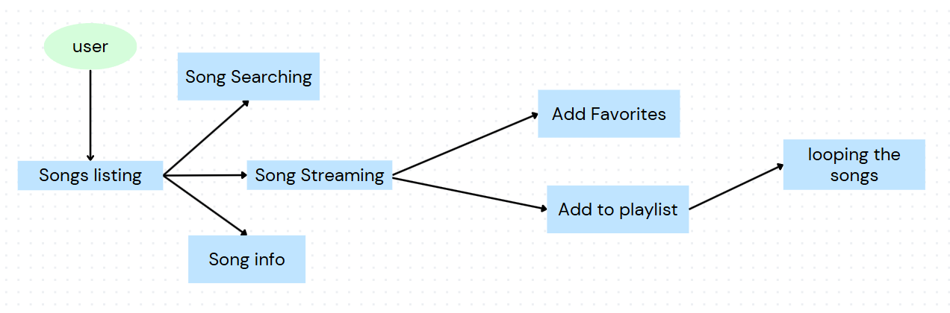

**Technical Architecture:**

* **Frontend:** Built with React.js for a dynamic and responsive UI.
* **Backend:** JSON server for API and data management.
* **Data Fetching:** Axios for API requests.
* **Routing:** React Router DOM for navigation.
* **State Management:** useState and useEffect hooks.
* **Styling:** Bootstrap and Tailwind CSS.

**Best Practices:**

* **Component Reusability: Build modular and reusable components.**
* **Code Organization: Maintain a clean and logical folder structure.**
* **API Error Handling: Implement try-catch blocks for API calls.**
* **Performance Optimization: Use lazy loading and React.memo.**
* **Security: Sanitize user inputs and secure API endpoints.**

**Project Screenshots:**

**Home Screen:** Displays featured songs and playlists.

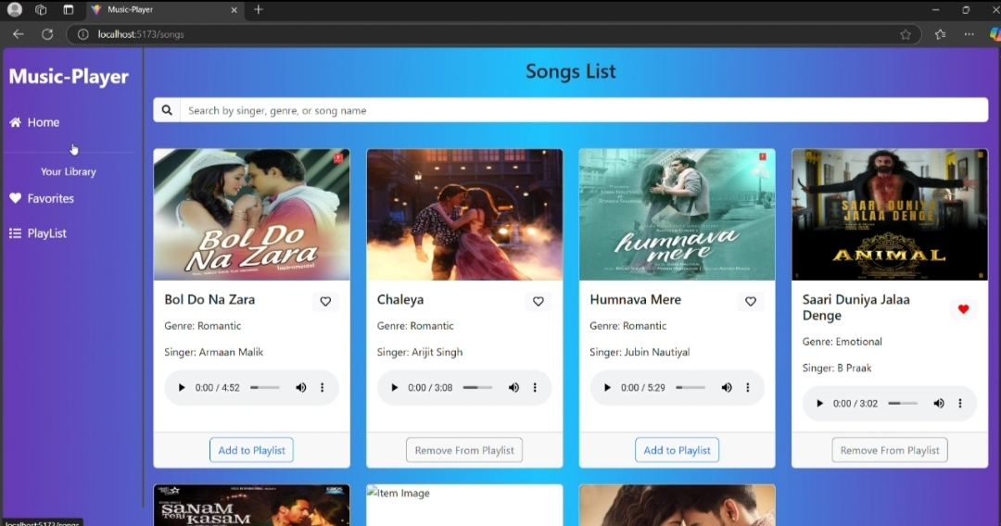

**Playlist Screen:** Shows user-created playlists with options to add or remove songs.

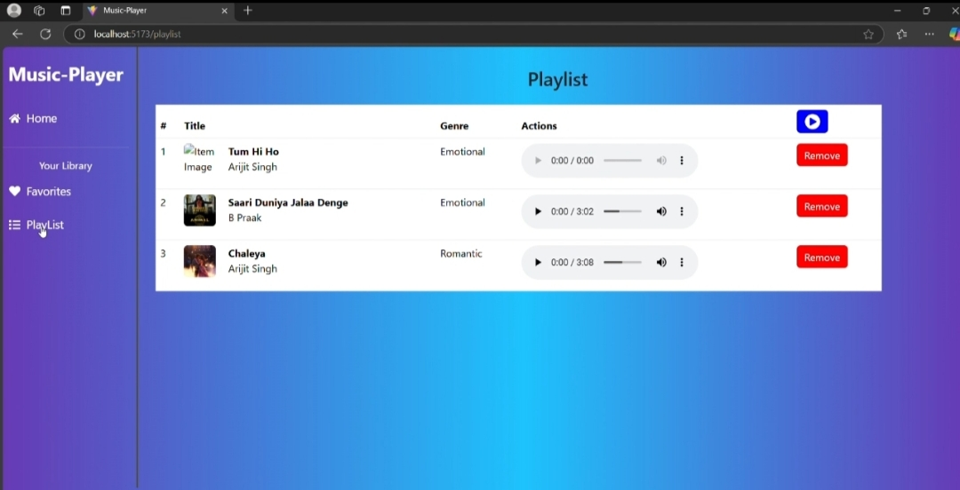

**Favorites Screen:** Lists songs marked as favorites by the user.

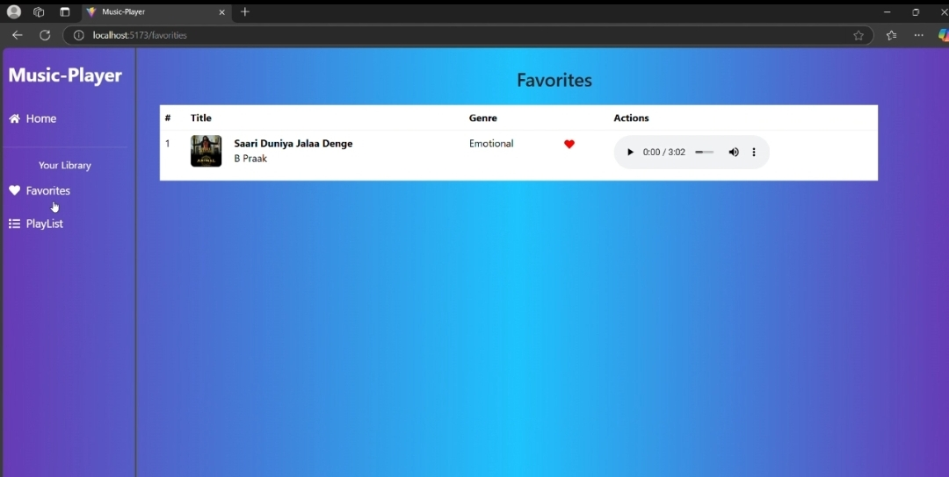

**Resources and References:**

* React Documentation: [react.dev](https://react.dev/learn/installation)
* Axios Documentation: [axios-http.com](https://axios-http.com/docs/intro)
* React Router: [reactrouter.com](https://reactrouter.com/en/main/start/tutorial)
* Bootstrap: [react-bootstrap](https://react-bootstrap-v4.netlify.app/getting-started/introduction/)
* Node.js and npm**:** [nodejs.org](https://nodejs.org/en/download/)