EDA Interpretations
NASA CMAPSS Turbofan Engine Dataset
Predictive Maintenance — Remaining Useful Life (RUL) Prediction

1. Dataset Overview
The CMAPSS FD001 training dataset contains 20,631 rows and 26 columns across 100 unique engines, with zero missing values. Each row represents one operational cycle of one engine. All 26 columns are fully populated, making this a clean dataset with no imputation required.
Key figures at a glance:
Metric | Value | Note
Total Rows | 20,631 | Engine-cycle observations
Total Columns | 26 | Before feature removal
Unique Engines | 100 | Independent lifecycles
Missing Values | 0 | No imputation needed
Data Types | 22 float64, 4 int64 | All numeric — ML ready
Operational Settings
Setting 1 and Setting 2 are near-zero with tiny standard deviations (0.002 and 0.0003 respectively), indicating FD001 is a single operating condition dataset. Setting 3 is completely constant at 100.0 across all rows. This means operating conditions introduce no meaningful variance — all engines run under essentially identical conditions, simplifying the modeling task compared to multi-condition subsets (FD002–FD004).

2. Engine Lifecycle Distribution
Each engine runs from a healthy state until failure. The number of cycles before failure varies significantly across engines, reflecting real-world variability in component durability.
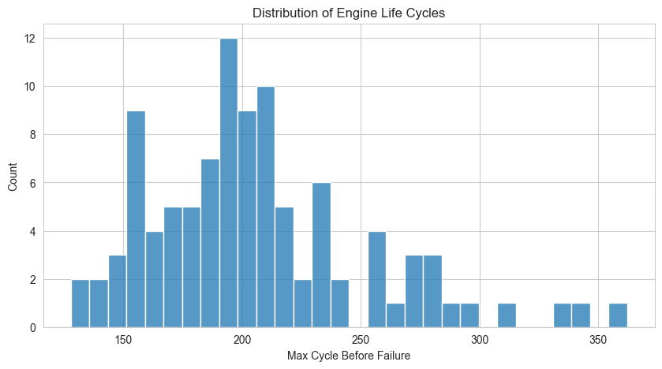
Figure 1 — Distribution of Engine Life Cycles (max cycle before failure per engine)
Statistics:
Metric | Value | Interpretation
Mean Lifespan | 206.3 cycles | Typical engine lasts ~206 cycles
Min Lifespan | 128 cycles | Shortest-lived engine in dataset
Max Lifespan | 362 cycles | Longest-lived engine — nearly 3× the minimum
Range | 234 cycles | Wide spread indicates real degradation variability
What the histogram tells us:
- The distribution is right-skewed — most engines cluster between 150–220 cycles, with a long tail extending to 362 cycles.
- The mode (most common lifespan) falls around 190–210 cycles, creating a clear central peak.
- A small group of engines (roughly 10–12) survive well beyond 250 cycles, forming the right tail — these are "outlier-long" engines that may have been manufactured with better tolerances or operated more gently.
- This variability is important: a model that only learned a fixed RUL from the mean would fail badly on short-lived (128-cycle) and long-lived (362-cycle) engines. The model must learn degradation rate, not just average lifespan.

3. RUL — Construction, Distribution, and Clipping
RUL is computed as: RUL = max_cycle_for_engine − current_cycle. At the first cycle, RUL equals the total lifespan. At the final cycle before failure, RUL = 0.

3a. RUL Distribution — Before Clipping
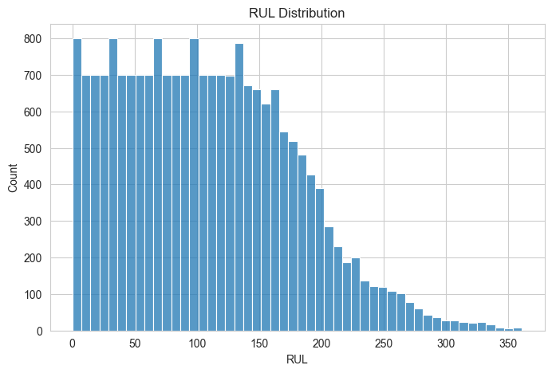
Figure 2 — RUL Distribution before clipping (raw, unmodified)
The raw RUL distribution is left-skewed with a near-uniform spread from 0 to ~150, then a gradual tail extending to ~360. This shape arises naturally: every cycle from 0 to max_cycle is equally represented, but longer-lived engines contribute observations at higher RUL values. The distribution being dense at low RUL values (0–150) reflects the fact that all 100 engines contribute observations in that range, while only the longest-lived engines contribute data points above 250.

3b. RUL Clipping at 125
A threshold of RUL = 125 cycles is applied. Any RUL value above 125 is capped at 125. This is a standard technique in CMAPSS literature grounded in the following reasoning:
- Early in an engine's life, degradation signals are not yet detectable in the sensor data — the engine behaves identically whether it has 300 or 126 cycles remaining.
- Predicting specific high RUL values (e.g., RUL = 287) from early-life sensor readings would be noisy and unreliable. The model cannot distinguish "very healthy" states from each other.
- Capping at 125 focuses the model on the actionable regime — the window where degradation is actually progressing and where maintenance decisions matter most.
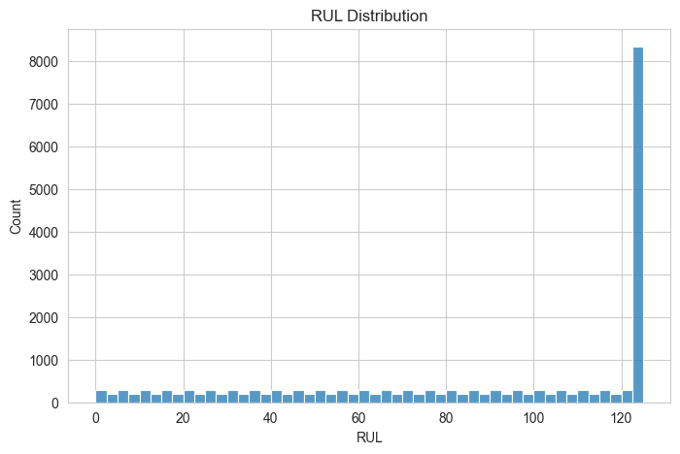
Figure 3 — RUL Distribution after clipping at 125
After clipping, the large spike at RUL = 125 (approximately 8,300 rows) represents all early-life observations that were collapsed to the cap. The remaining bins (0–124) are roughly uniform at ~200–300 observations each. This is expected and intentional.
Post-clipping statistics:
Statistic | Value | Interpretation
Mean RUL | 86.8 cycles | Average observation is ~87 cycles from failure
Std Dev | 41.7 cycles | High spread — diverse degradation stages present
Median (50th pct) | 103 cycles | Over half of observations still above RUL = 100
75th Percentile | 125 cycles | Top 25% are all capped at the threshold
Min RUL | 0 cycles | Final cycle before failure present in data
Max RUL | 125 cycles | Confirmed cap applied correctly

4. Dead Sensor Detection and Removal
Seven sensors were identified as constant across all 20,631 rows — they carry zero information about engine degradation and would only add noise to any model.
Identified dead sensors:
Sensor | Constant Value | Physical Meaning
setting_3 | 100.0 | Altitude/condition — fixed for FD001 subset
T2 | 518.67 | Total temperature at fan inlet — no degradation signal
P2 | 14.62 | Total pressure at fan inlet — ambient, unchanged
epr | 1.3 | Engine pressure ratio — fixed operating point
farB | 0.03 | Burner fuel-air ratio — held constant
Nf_dmd | 2388 | Demanded fan speed — fixed setpoint
PCNfR_dmd | 100.0 | Demanded corrected fan speed — fixed setpoint

Example: P2 — A Dead Sensor
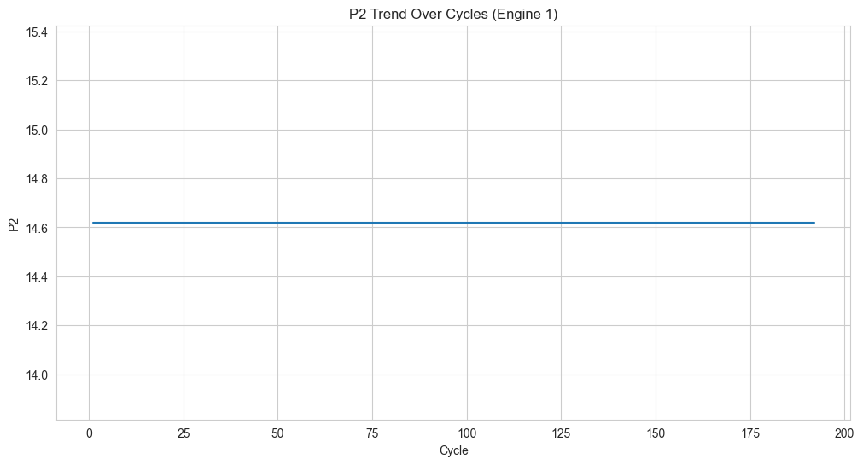
Figure 4 — P2 sensor over 192 cycles for Engine 1 (perfectly flat — zero information)
P2 flatlines at exactly 14.62 across all 192 cycles for Engine 1 — and identically for every other engine. Including this in a model would waste a feature slot and potentially confuse tree-based models by generating uninformative splits. All 7 dead sensors were dropped, reducing the dataset from 26 to 19 columns.

5. Active Sensor Trend — Ps30 (Static Pressure at HPC Outlet)
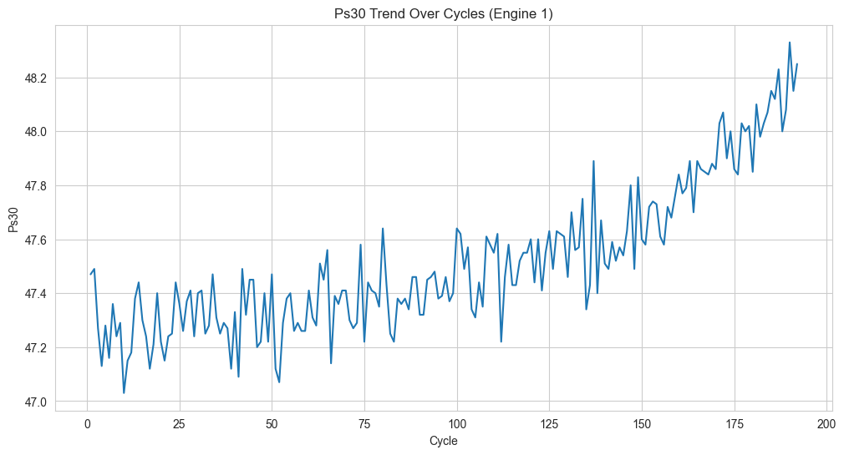
Figure 5 — Ps30 trend over 192 cycles for Engine 1 (clear upward degradation trend)
Ps30 shows the hallmark signature of a meaningful degradation sensor: a noisy but clearly increasing trend over the engine's life. Key observations:
- Cycle 1–80 (early life): Ps30 oscillates tightly between 47.1 and 47.6 — the engine is healthy and readings are stable with only random noise.
- Cycle 80–130 (transition): The oscillations begin shifting upward, with readings increasingly crossing 47.5 and the floor of the noise band rising.
- Cycle 130–192 (late degradation): A clear monotonic upward trend emerges. By the final cycles, Ps30 reaches 48.2–48.4, roughly 1.5–2% above its baseline — a statistically meaningful shift.
- This pattern — noise on top of a drifting mean — is exactly why rolling mean and rolling slope features were engineered. The rolling mean captures the rising baseline; the rolling slope captures the acceleration of that rise near end-of-life.
Ps30's correlation with RUL is −0.78 (the strongest negative correlation in the dataset), which is consistent with this visual: as Ps30 rises, RUL falls. This sensor is the single best raw predictor of remaining life in FD001.

6. Correlation Analysis — Sensors vs. RUL

6a. Before Dead Sensor Removal
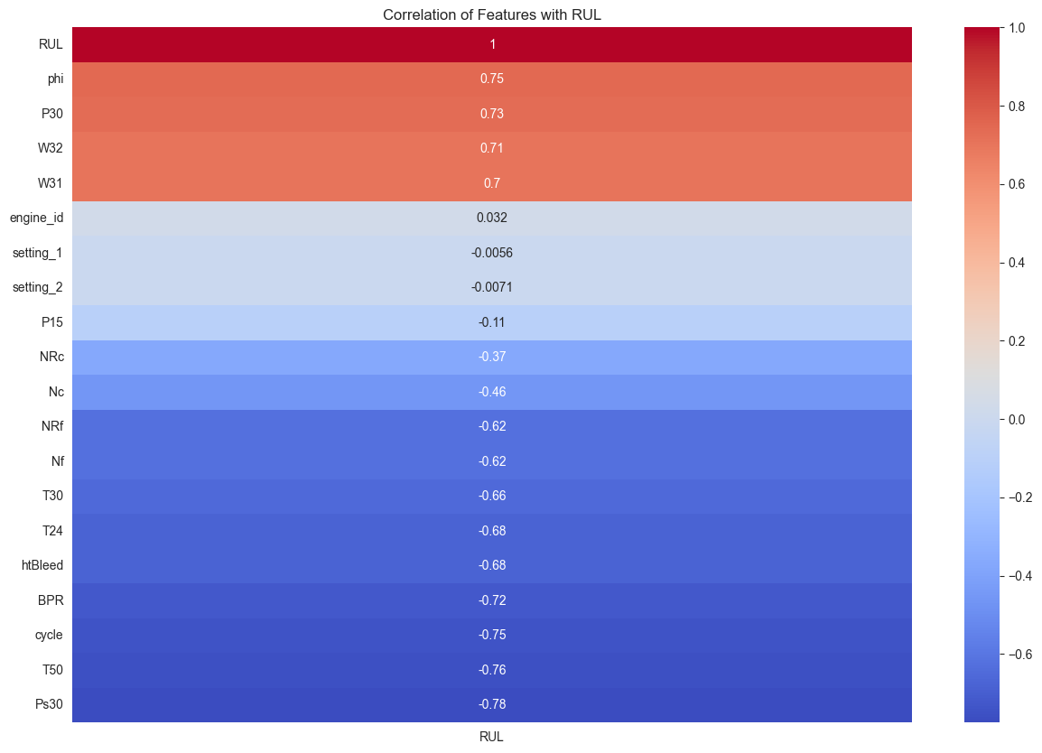
Figure 6 — Correlation of all features with RUL (including constant sensors)

6b. After Dead Sensor Removal (Clean View)

Figure 7 — Correlation of remaining features with RUL (dead sensors removed)
The two heatmaps are visually identical in values because constant features have undefined or zero correlation — their removal does not alter the other correlations. However, the clean version (Figure 7) is the operationally relevant one. Key interpretations:
Strong Negative Correlations (as engine degrades, RUL falls):
Sensor | Correlation | Physical Interpretation
Ps30 | −0.78 | Static pressure at HPC outlet — rises with blade wear; strongest predictor
T50 | −0.76 | Total temp at LPT outlet — rises as turbine efficiency drops
cycle | −0.75 | Direct proxy for lifecycle progress — expected strong relationship
BPR | −0.72 | Bypass ratio — changes as engine thermodynamics shift with wear
htBleed | −0.68 | Bleed enthalpy — indicates combustor/turbine health degradation
T24 | −0.68 | Total temp at LPC outlet — rises with compressor degradation
T30 | −0.66 | Total temp at HPC outlet — reflects compressor work increase
Nf / NRf | −0.62 | Fan speed signals — reflect rotational dynamics under wear
Strong Positive Correlations (as values rise, remaining life is higher):
Sensor | Correlation | Physical Interpretation
phi | +0.75 | Ratio of fuel flow to Ps30 — high when engine is thermally efficient (healthy)
P30 | +0.73 | Total pressure at HPC outlet — higher when compressor is healthy
W32 | +0.71 | Coolant bleed flow — reflects cooling system capacity in healthy state
W31 | +0.70 | Coolant bleed flow — correlated with W32, same pattern
Near-Zero / Uninformative Features:
- engine_id (+0.032): Expected — engine ID is just a label, not a physical measurement.
- setting_1 (−0.006) and setting_2 (−0.007): Near-zero correlation, consistent with FD001 being a single-condition dataset. These settings barely vary.
- P15 (−0.11): Weak but non-zero — likely borderline useful.
Key Takeaway:
The strongest predictors cluster around thermodynamic efficiency metrics — temperatures (T24, T30, T50) and pressures (P30, Ps30). As engines degrade, internal temperatures rise and pressure distributions shift due to blade erosion, tip clearance growth, and fouling. This is physically coherent: the sensor correlations directly reflect the thermodynamic degradation pathway of a turbofan engine.
A model trained on these features is learning genuine physics, not spurious patterns — which gives confidence that predictive accuracy will generalize beyond this specific dataset.

7. EDA Summary — What We Learned
Finding | Action Taken
7 sensors are perfectly constant (dead) | Dropped — reduce noise and dimensionality
FD001 is single operating condition | No condition-based grouping needed
Engine lifespans vary widely (128–362 cycles) | Model must learn rate, not just average duration
RUL early-life labels are unreliable | Clip RUL at 125 — focus on actionable window
Ps30, T50, T24, phi are top predictors | Prioritize these in feature engineering
Degradation is gradual and noisy | Rolling mean + rolling slope features are essential
All sensors are numeric, no missing values | No imputation or encoding required — clean pipeline

