Processed Dataset EDA — Interpretations
NASA CMAPSS FD001 — Post Feature Engineering Validation
Predictive Maintenance | Remaining Useful Life (RUL) Prediction

1. Processed Dataset Shape & Quality
After feature engineering, the processed dataset contains 18,531 rows and 207 columns. The reduction from 20,631 raw rows is expected: rolling windows require a warm-up period, so the first 21 cycles of every engine are dropped (no valid rolling statistics exist yet). All 100 engines are retained and zero missing values are present.

Metric | Raw Dataset | Processed Dataset
Rows | 20,631 | 18,531 (−2,100 warm-up rows)
Columns | 26 | 207 (engineered features added)
Missing Values | 0 | 0 (confirmed clean)
Engines | 100 | 100 (all retained)
Min Cycle per Engine | 1 | 22 (first 21 cycles dropped)

The jump from 26 to 207 columns reflects the systematic expansion from four feature engineering families applied to each active sensor: rolling mean, rolling slope, rolling std, and delta. Despite this large expansion, the pipeline remains fully clean with no nulls.

2. RUL Distribution — Processed Dataset
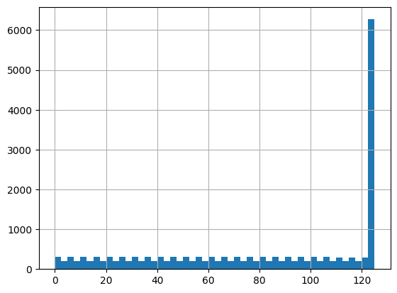
Figure 1 — RUL distribution in the processed dataset (clipped at 125)
The RUL distribution is structurally identical to the raw clipped distribution, confirming the preprocessing pipeline is internally consistent. The dominant spike at RUL = 125 represents roughly 6,200 observations — all early-life cycles where an engine has more than 125 remaining cycles, collapsed to the cap. The 0-to-124 range shows a near-uniform spread of around 150-300 observations per bin.
The spike is smaller here (~6,200) than in the raw dataset (~8,300) because the 21-cycle warm-up drop removed rows that were all from early lifecycle — high cycle offset from start means high raw RUL — and those rows would have all been capped at 125. The shape is preserved; only the scale of the spike changed, exactly as expected.

RUL Zone | Approx. Count | Interpretation
RUL = 125 (capped) | ~6,200 | Early-life — degradation not yet visible in sensor signals
RUL 1-124 (active zone) | ~12,200 | Degradation progressing — the model's primary learning region
RUL = 0 | ~100 | One terminal observation per engine at point of failure

3. Feature Correlation with RUL — Engineering Impact

3a. Top Negative Correlations (strongest predictors of RUL decline)
The table below shows the 15 features most negatively correlated with RUL. Rolling mean features dominate the top positions, consistently outperforming their raw sensor counterparts. This directly validates the feature engineering strategy.

Feature | Corr. | Type | Insight
htBleed_rolling_mean | -0.813 | Engineered | Strongest overall predictor — smoothed bleed enthalpy captures sustained thermal degradation better than any raw sensor
T30_rolling_mean | -0.809 | Engineered | HPC outlet temp trend — rolling mean removes cycle noise and reveals the true slow drift of compressor degradation
BPR_rolling_mean | -0.804 | Engineered | Bypass ratio trend — persistent shifts in BPR signal thermodynamic deterioration across the lifecycle
T50_rolling_mean | -0.799 | Engineered | LPT outlet temp trend — one of the highest raw correlators; the smoothed form improves it further
T24_rolling_mean | -0.798 | Engineered | LPC outlet temp trend — rolling mean lifts the raw correlation from -0.68 all the way to -0.80
Ps30_rolling_mean | -0.792 | Engineered | Static pressure trend — the best raw predictor (Ps30 at -0.778) gets an additional +0.014 lift from smoothing
Ps30 | -0.778 | Raw sensor | Best raw predictor overall — already strong without any engineering
Ps30_rolling_mean_slope | -0.778 | Engineered | Rate of Ps30 change — captures the acceleration of pressure rise that occurs near end-of-life
T50 | -0.759 | Raw sensor | Strong raw signal — LPT outlet temperature rises as turbine efficiency drops
T50_rolling_mean_slope | -0.735 | Engineered | Degradation velocity for T50 — adds directional information beyond the static level of the sensor
BPR | -0.724 | Raw sensor | Bypass ratio raw — already a good predictor even before smoothing
cycle | -0.718 | Index | Direct lifecycle proxy — strong but a label, not a physical degradation signal
BPR_rolling_mean_slope | -0.691 | Engineered | Rate of bypass ratio change — captures late-life acceleration of thermodynamic shifts
htBleed | -0.683 | Raw sensor | Raw bleed enthalpy — rolling mean boosts this from -0.683 to -0.813, the largest absolute lift
T24 | -0.683 | Raw sensor | LPC outlet temp — raw form; significantly amplified by rolling mean feature engineering

3b. Rolling Mean vs Raw Sensor — Engineering Lift
Every sensor improves in correlation after smoothing. The gains are largest for T30 and htBleed, which are inherently noisy sensors where cycle-to-cycle variance was masking the underlying degradation trend. Ps30 shows the smallest gain because it was already the cleanest raw signal.

Sensor | Raw Corr. | Rolling Mean Corr. | Lift
T30 | ~-0.66 | -0.809 | +0.149
htBleed | -0.683 | -0.813 | +0.130
T24 | -0.683 | -0.798 | +0.115
BPR | -0.724 | -0.804 | +0.080
T50 | -0.759 | -0.799 | +0.040
Ps30 | -0.778 | -0.792 | +0.014

4. Multicollinearity Heatmap — Feature Interaction Structure
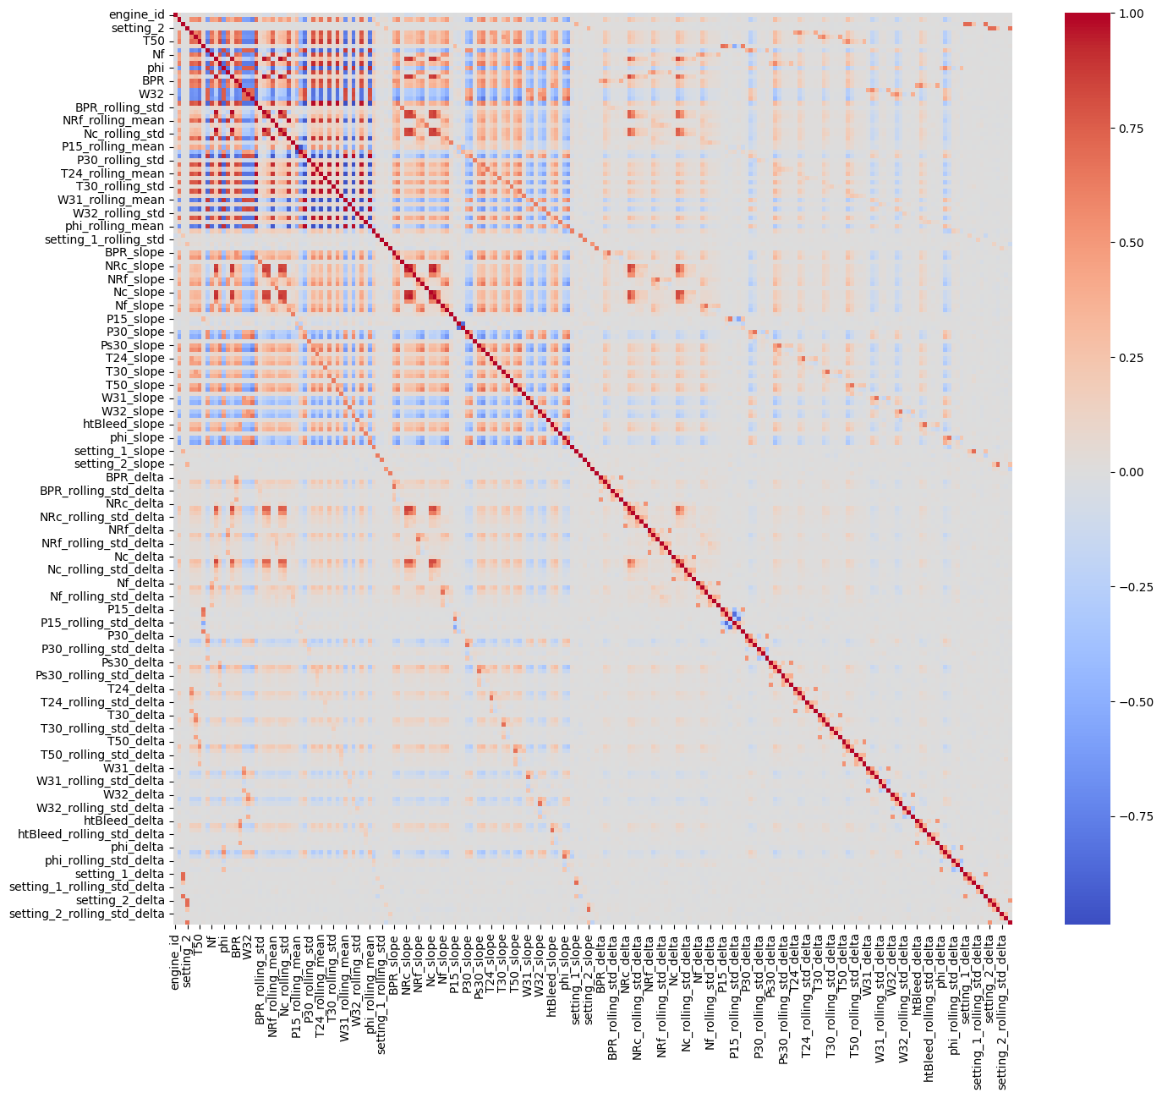
Figure 2 — Full 207x207 feature correlation matrix across all engineered features
This heatmap shows the correlation structure of the entire processed feature space. Three structurally distinct blocks are visible, each with different implications for model design.

4a. Top-Left Block — Raw Sensors (High Mutual Correlation)
The upper-left region covering raw sensors (T50, Nf, phi, BPR, W32 and their rolling means) shows strong red and blue cross-correlations. These sensors are physically coupled: compressor temperatures all rise together as the engine degrades, and fan speed metrics move together via mechanical spool linkage. This is expected from turbofan thermodynamics.
- Implication: linear models would struggle here due to redundant raw features. XGBoost is robust to this — it selects the best split from correlated features without being destabilised.

4b. Middle Band — Slope Features (Moderate Correlation)
The slope feature block shows moderate correlations with both the raw sensor block and itself. Slope features capture the rate of change, which is partially decorrelated from the level. This semi-independence means slope features act as additive predictors rather than redundant duplicates of their corresponding raw sensors.

4c. Bottom-Right Region — Delta Features (Near-Zero Cross-Correlation)
The delta feature block is predominantly light grey — near-zero correlation with all other feature families. Delta features (cycle-over-cycle differences) are nearly orthogonal to rolling means and slopes because they capture high-frequency instability rather than slow-drifting degradation trends.
- This near-zero cross-correlation is a strong positive: delta features add complementary signal about short-term sensor instability without introducing any redundancy.

4d. Model Fit Assessment
The three-block structure confirms that XGBoost is the appropriate model for this feature space. It can draw on all three semi-independent feature families, handle within-block multicollinearity gracefully via its split-selection mechanism, and exploit the near-orthogonal delta features as tiebreakers in ambiguous degradation stages. A linear model would require explicit PCA or regularisation to handle this same structure.

5. Processed EDA Summary
Finding | Implication
18,531 rows after 21-cycle warm-up drop | Expected artifact of rolling windows — no data integrity issue
207 columns from 26 raw features | Rich, multi-scale feature space covering level, trend, velocity, and instability
Zero missing values post-engineering | Clean pipeline — no imputation required before modelling
Rolling means outperform raw sensors (up to +0.149 lift) | Feature engineering validated — noise smoothing extracts genuine predictive signal
htBleed_rolling_mean is the #1 predictor at -0.813 | Bleed enthalpy trend is the strongest single indicator of remaining life
Slope features add independent signal (+0.06 to +0.08) | Degradation velocity is a meaningful complement to degradation level
Delta features are near-orthogonal to other families | Short-term instability adds complementary signal without redundancy
Strong within-block multicollinearity in raw/rolling features | Confirms XGBoost over linear models for this feature space
RUL distribution shape preserved from raw preprocessing | Preprocessing pipeline is internally consistent and correct

