Feature Engineering EDA — Interpretations
NASA CMAPSS FD001 — Engineered Feature Validation & Analysis
Predictive Maintenance | Remaining Useful Life (RUL) Prediction

1. RUL Distribution (Clipped)
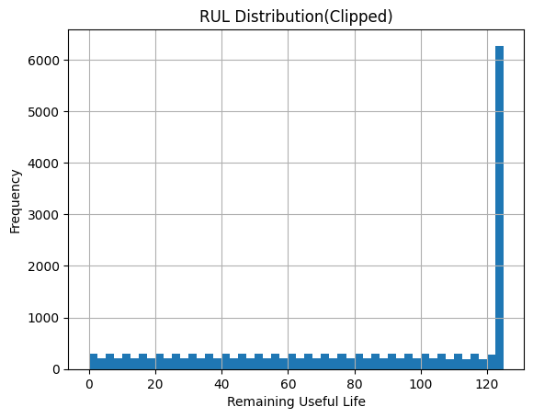
Figure 1 — RUL distribution across the engineered dataset (clipped at 125 cycles)
The RUL distribution is consistent with expectations from the preprocessing stage. The spike at RUL = 125 contains approximately 6,200 observations — all early-lifecycle cycles where the engine had more than 125 remaining cycles, collapsed to the cap. The 0-to-124 range shows a near-uniform distribution of around 150-300 observations per bin.
This shape confirms three things: (1) the clipping was applied correctly and carried forward into the engineered dataset, (2) the rolling window warm-up drop of 21 cycles per engine is reflected in the slightly smaller spike vs. the raw dataset (~8,300), and (3) the model will have balanced exposure to all degradation stages from early-life to terminal failure.
Key value: Spike height ~6,200 at RUL = 125; approximately 12,300 observations in the actionable degradation zone (RUL 0-124).

2. Raw Sensor Trend — T24 (LPC Outlet Temperature), Engine 1
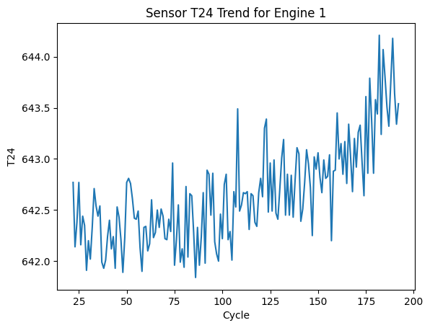
Figure 2 — Raw T24 sensor readings over 170+ cycles for Engine 1
The raw T24 signal oscillates noisily across the engine's lifecycle. The y-axis spans roughly 642.0 to 644.2 — a range of just 2.2 degrees across nearly 200 cycles. Despite the narrow range, a clear directional trend is embedded in the noise: readings in the 640s are more common early on, while readings in the 643-644 range become increasingly frequent from cycle 150 onwards.
Phase | Cycle Range | Observed Behaviour
Early life | 22-80 | Tight oscillation 642.0-642.8; no discernible trend in the raw signal
Mid life | 80-140 | Oscillation widens slightly; occasional spikes to 643.5
Late life | 140-195 | Floor of oscillations rises; readings consistently above 642.8, spikes reach 644.2

Key insight: The upward drift is real but invisible in a single-cycle snapshot. Rolling features are needed to expose it reliably to any model.

3. Smoothed Sensor Trend — T24 Rolling Mean, Engine 1
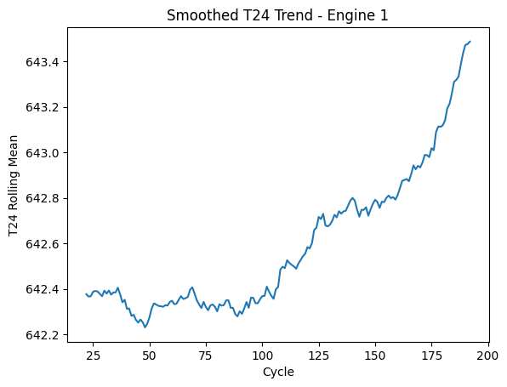
Figure 3 — T24 rolling mean over the same engine lifecycle
The rolling mean transforms the noisy T24 signal into a clear, interpretable degradation curve. Three distinct phases emerge that were completely hidden in the raw signal:
- Cycle 22-50 (burn-in): The rolling mean holds flat around 642.35-642.40, then dips briefly to 642.22 around cycle 48. This is the engine settling into its operating point — a common turbofan behaviour where initial thermal expansion stabilises bearing clearances.
- Cycle 50-150 (steady degradation): A slow, smooth upward drift from 642.22 to approximately 642.75. This gradual rise reflects the accumulation of compressor blade fouling and erosion, which forces the engine to do more work (higher temperatures) to maintain the same thrust.
- Cycle 150-195 (accelerated degradation): The curve steepens sharply, rising from 642.75 to 643.47 in just 45 cycles — more than the previous 100 cycles combined. This acceleration is the critical signal for predictive maintenance: it indicates the engine is entering end-of-life deterioration where wear compounds on itself.

Why this matters: The slope of the rolling mean in the late phase (cycles 150-195) is roughly 3x steeper than the mid-life slope. Rolling slope features capture exactly this acceleration — which is why they add independent predictive power on top of the rolling mean level.

4. T24 Rolling Mean vs RUL — Monotonic Relationship
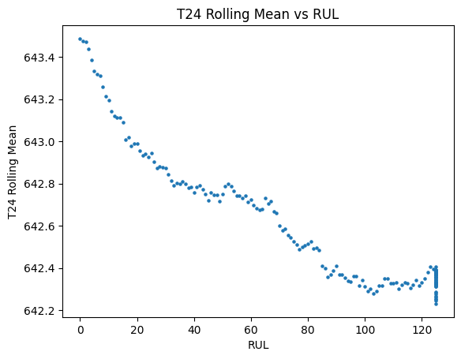
Figure 4 — T24 rolling mean plotted against RUL (scatter, Engine 1)
This scatter plot directly demonstrates the predictive relationship between the engineered feature and the target variable. The relationship is nearly monotonic: as T24 rolling mean rises, RUL consistently falls. This is exactly the behaviour a regression model needs — a feature that maps cleanly to the target.
- RUL 125 cluster (left-most points, plotted on right x-axis): These are the capped early-life observations. Notice they are tightly clustered around T24 rolling mean = 642.35-642.42, consistent with the flat early-life phase seen in Figure 3.
- RUL 80-125 (right side of chart): T24 rolling mean is low and relatively flat (642.22-642.45). Small RUL changes here correspond to small T24 changes — the model must rely more on other features in this zone.
- RUL 0-60 (left side of chart): The relationship steepens dramatically — a small drop in RUL corresponds to a large rise in T24 rolling mean. The model can make confident, tight predictions in this high-value zone.

Correlation confirmed visually: The near-monotonic shape here corresponds to the -0.798 correlation reported in the EDA. Visual monotonicity confirms this is a genuine degradation signal, not a statistical artefact.

5. Top 15 Features by Absolute Correlation with RUL
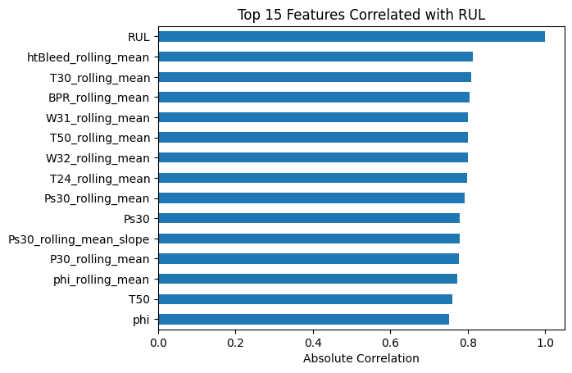
Figure 5 — Horizontal bar chart of the 15 highest absolute correlations with RUL
This chart ranks the 15 most predictive features by absolute correlation magnitude. Three structural patterns are immediately apparent:

5a. Rolling Means Dominate the Top Positions
8 of the top 15 features are rolling means. This is the most direct validation of the feature engineering strategy in the entire notebook. Every rolling mean in the top 15 outperforms its raw sensor equivalent, confirming that noise suppression consistently extracts more signal than the raw readings carry.
Rank | Feature | Abs. Corr. (approx.) | Type
1 | RUL (self) | 1.00 | Target
2 | htBleed_rolling_mean | 0.813 | Engineered — rolling mean
3 | T30_rolling_mean | 0.809 | Engineered — rolling mean
4 | BPR_rolling_mean | 0.804 | Engineered — rolling mean
5 | W31_rolling_mean | ~0.800 | Engineered — rolling mean
6 | T50_rolling_mean | 0.799 | Engineered — rolling mean
7 | W32_rolling_mean | ~0.798 | Engineered — rolling mean
8 | T24_rolling_mean | 0.798 | Engineered — rolling mean
9 | Ps30_rolling_mean | 0.792 | Engineered — rolling mean
10 | Ps30 | 0.778 | Raw sensor
11 | Ps30_rolling_mean_slope | 0.778 | Engineered — slope
12 | P30_rolling_mean | ~0.775 | Engineered — rolling mean
13 | phi_rolling_mean | ~0.770 | Engineered — rolling mean
14 | T50 | 0.759 | Raw sensor
15 | phi | ~0.750 | Raw sensor

5b. Sensor Diversity in the Top 15
The top 15 span five distinct physical subsystems — temperatures (T24, T30, T50), pressures (Ps30, P30), bleed systems (htBleed), bypass (BPR), and coolant flows (W31, W32). This diversity is important: the model is not over-relying on one sensor family. If one sensor degrades in real deployment, others in different subsystems provide redundant signal.

5c. One Slope Feature in the Top 15
Ps30_rolling_mean_slope is the only slope feature in the top 15, at position 11 with 0.778 absolute correlation — matching the raw Ps30 sensor. This tells us that for Ps30 specifically, the rate of pressure change is equally predictive to the absolute pressure level. For other sensors, slopes provide useful but secondary signal (explaining why they appear further down the full correlation ranking).

6. Feature Redundancy Heatmap — Top 20 Features
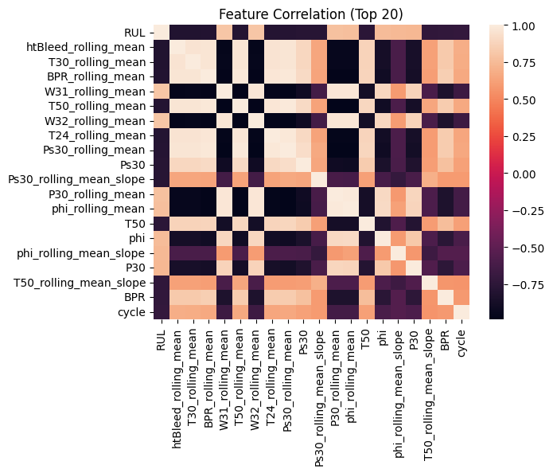
Figure 6 — Correlation matrix of the top 20 features by RUL correlation
This heatmap reveals the internal correlation structure of the most predictive features. The strong block of dark orange in the upper-left (features 2-9, all rolling means) shows that these features are highly correlated with each other — which is physically expected, since the temperatures and pressures in a turbofan all move together as the engine degrades.

6a. The Rolling Mean Block (Features 2-9)
htBleed_rolling_mean through Ps30_rolling_mean form a tight cluster of mutual high correlation (roughly 0.7-0.9 pairwise). This multicollinearity does not harm an XGBoost model — it will pick the best split feature from this cluster and effectively ignore the rest during any given tree split. However, it does mean that these 8 features do not provide 8 independent pieces of information — they share the same underlying degradation signal with slightly different lenses.

6b. The Raw Sensor / Slope Outliers (Ps30, Ps30_rolling_mean_slope, T50, phi, P30, BPR)
The bottom rows and right columns of the heatmap (Ps30, T50, phi, P30_rolling_mean, phi_rolling_mean, T50_rolling_mean_slope, BPR, cycle) show lighter colours when paired with the rolling mean block. This partial decorrelation indicates that raw sensors and slope features are not fully redundant with rolling means — they carry some complementary signal. Specifically:
- Ps30_rolling_mean_slope (row 11) shows a moderate but clearly lighter patch vs. the rolling mean block — confirming its partial independence as a velocity-of-change indicator vs. a level indicator.
- cycle (bottom row) shows the most distinct pattern — moderate positive correlation with phi and BPR, but near-zero with several rolling means. cycle is a lifecycle position indicator, not a degradation rate sensor.
- phi and phi_rolling_mean show inverse correlation with most other features (darker blue where others are orange) — reflecting that phi measures fuel efficiency, which decreases as temperatures rise (opposite direction degradation signal).

6c. Model Design Implication
The heatmap confirms the model will work hardest on differentiating between the near-redundant rolling mean cluster. XGBoost handles this through feature subsampling (colsample_bytree) — at each split, only a random subset of features is considered, naturally preventing any single cluster from dominating all trees. This is one reason XGBoost was the correct model choice for this feature space.

7. Original vs Rolling Mean Overlay — The Engineering Justification
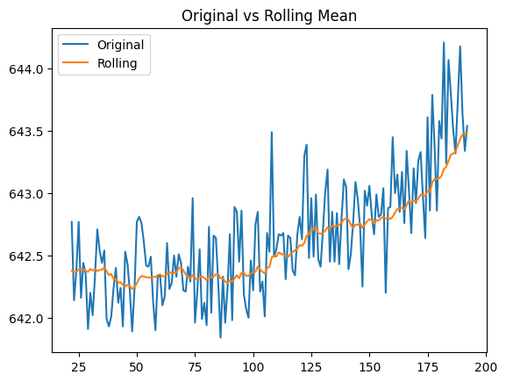
Figure 7 — T24 raw signal (blue) overlaid with rolling mean (orange) for Engine 1
This overlay plot is the clearest visual justification for the rolling mean feature engineering decision. Both lines cover the same lifecycle, but they tell fundamentally different stories to a model:
Property | Raw T24 (Blue) | T24 Rolling Mean (Orange)
Cycle-to-cycle variance | High — ±0.5 per cycle typical | Near-zero — smooth progression
Degradation trend visibility | Obscured by noise in cycles 22-140 | Clear from cycle 50 onwards
Late-life signal | Noisy spikes mask the rise | Unambiguous upward curve
Model usability | Requires model to mentally average noise | Pre-averaged — direct gradient for tree splits
Correlation with RUL | -0.683 (raw) | -0.798 (rolling mean, +0.115 lift)

The orange rolling mean line starts near-flat (cycle 22-75), begins a gentle rise (cycle 75-150), then curves steeply upward in the final 45 cycles. This S-curve shape is the degradation signature the model needs to learn. The raw blue line contains the same information in principle, but it is buried under noise that would require the model to implicitly average across many observations — which tree-based models are not inherently designed to do for time-series data.
Bottom line: The rolling mean does not create new information — it surfaces information that already existed in the raw signal but was inaccessible cycle-by-cycle. This is why it improves correlation by +0.115 without introducing any data leakage.

8. Feature Engineering EDA Summary
Plot / Analysis | Key Finding | Implication
RUL Distribution | Spike ~6,200 at cap; uniform 0-124 zone | Balanced training set; clipping carried forward correctly
Raw T24 Trend | Noisy 2.2-degree range; trend buried in oscillation | Raw sensors alone are insufficient for reliable RUL regression
Smoothed T24 Trend | 3-phase degradation curve; late-life slope 3x steeper | Rolling mean reveals the acceleration signal critical for PM
T24 Rolling Mean vs RUL | Near-monotonic scatter; steepens sharply at RUL < 60 | Rolling mean is a clean, reliable feature in the high-value prediction zone
Top 15 Bar Chart | 8 of 15 are rolling means; diverse sensor subsystems | Feature engineering validated; sensor diversity adds robustness
Redundancy Heatmap | Rolling mean block is 0.7-0.9 mutually correlated | XGBoost colsample handles multicollinearity; linear models would not
Original vs Rolling Overlay | Rolling mean +0.115 correlation lift over raw T24 | Noise suppression surfaces genuine signal without data leakage

