

**SCHOOL OF COMPUTER ENGINEERING**

|  |  |
| --- | --- |
| Course: Web programming  Lab Slot: L37+L38+L51+L52 | |
| Digital Assessment: Javascript Practice | **Date: 12/2/2025** |
| Name of the Student: Adhithya Singa Narendran | **Regd. No. 23BKT0146** |

------------------------------------------------------------------------------------------------------------------------

**Worksheet-4**

**1)Button Click**

**Html**

<!--1) Write a JavaScript program that creates a button and add a click event

listener to log a message when it's clicked.-->

<!DOCTYPE html>

<html>

<head>

    <title>Button Click Event</title>

    <link rel="stylesheet" type="text/css" href="q1.css">

    <script type="text/javascript" src="q1.js"></script>

</head>

<body>

    <button id="Button" class="Button">Click the Button</button>

</body>

</html>

**CSS**

.Button{

    width:150px;

    height:30px;

    background-color: lightblue;

}

**Javascript**

document.addEventListener("DOMContentLoaded", function() {

    document.getElementById("Button").addEventListener("click", printClicked);

    function printClicked() {

        console.log("Button Clicked");

    }

});

**Webpage**

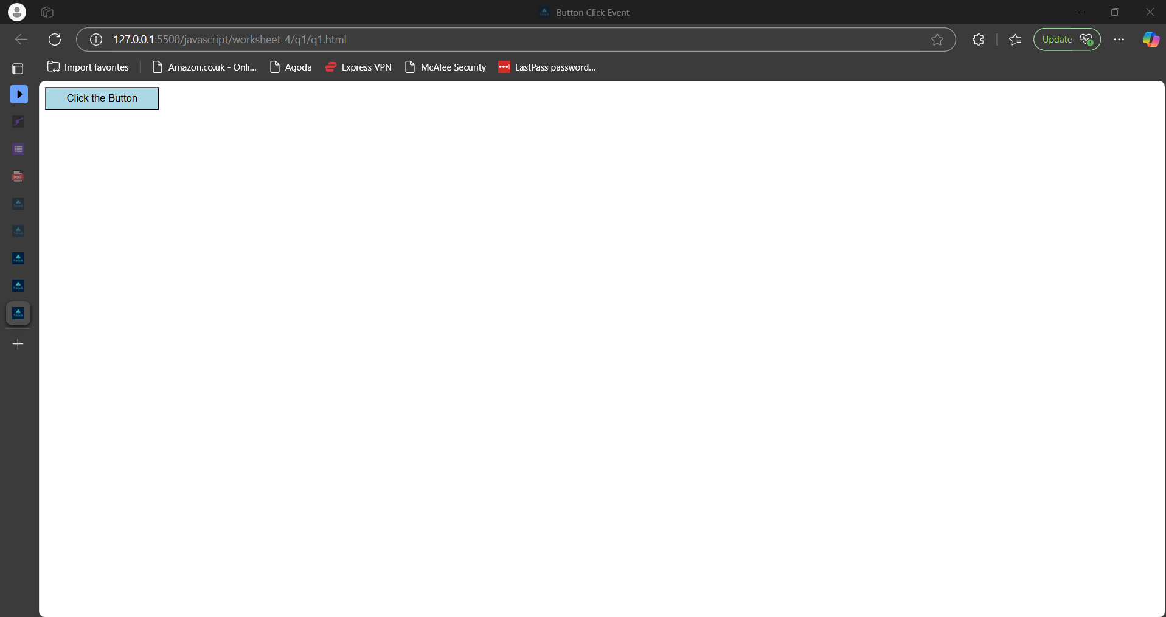

**When the button is clicked, it is showed in console log which is viewed by inspecting the page**

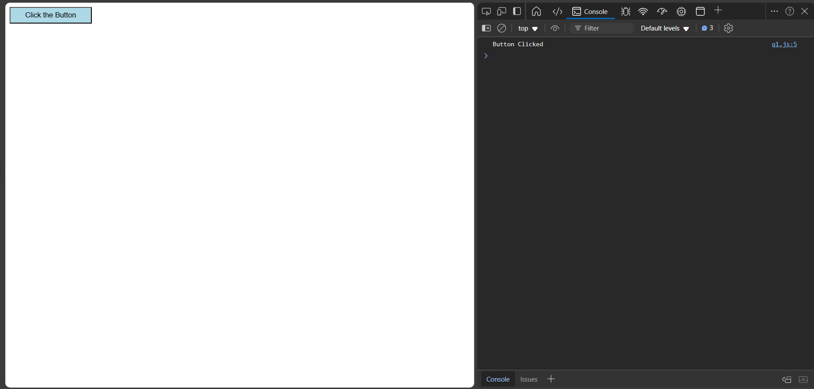

**2)Dropdown Menu**

**Html**

<!--2) Write a JavaScript program to create a dropdown menu that shows and

hides its options when clicked.-->

<!DOCTYPE html>

<html>

<head>

    <title>Dropdown Menu</title>

    <link rel="stylesheet" type="text/css" href="q2.css">

    <script type="text/javascript" src="q2.js"></script>

</head>

<body>

    <div class="dropdown">

        <button onclick="changeDropdown()">Dropdown</button>

        <div id="Dropdown" class="dropdown-content">

            <a href="#">Link 1</a>

            <a href="#">Link 2</a>

            <a href="#">Link 3</a>

        </div>

    </div>

</body>

</html>

**CSS**

.dropdown-content {

    display: none;

    background-color: #eae9e9;

    width: 150px;

}

.dropdown-content a {

    color: black;

    padding: 15px 15px;

    text-decoration: none;

    display: block;

}

.dropdown-content a:hover {

    background-color: #bebebe;

}

.dropdown-content.show {

    display: block;

}

**Javascript**

function changeDropdown() {

    document.getElementById("Dropdown").classList.toggle("show");

}

window.onclick = function (event) {

    if (!event.target.matches('.dropdown button')) {

        var dropdowns = document.getElementsByClassName("dropdown-content");

        for (var i = 0; i < dropdowns.length; i++) {

            var openDropdown = dropdowns[i];

            if (openDropdown.classList.contains('show')) {

                openDropdown.classList.remove('show');

            }

        }

    }

}

**Webpage**

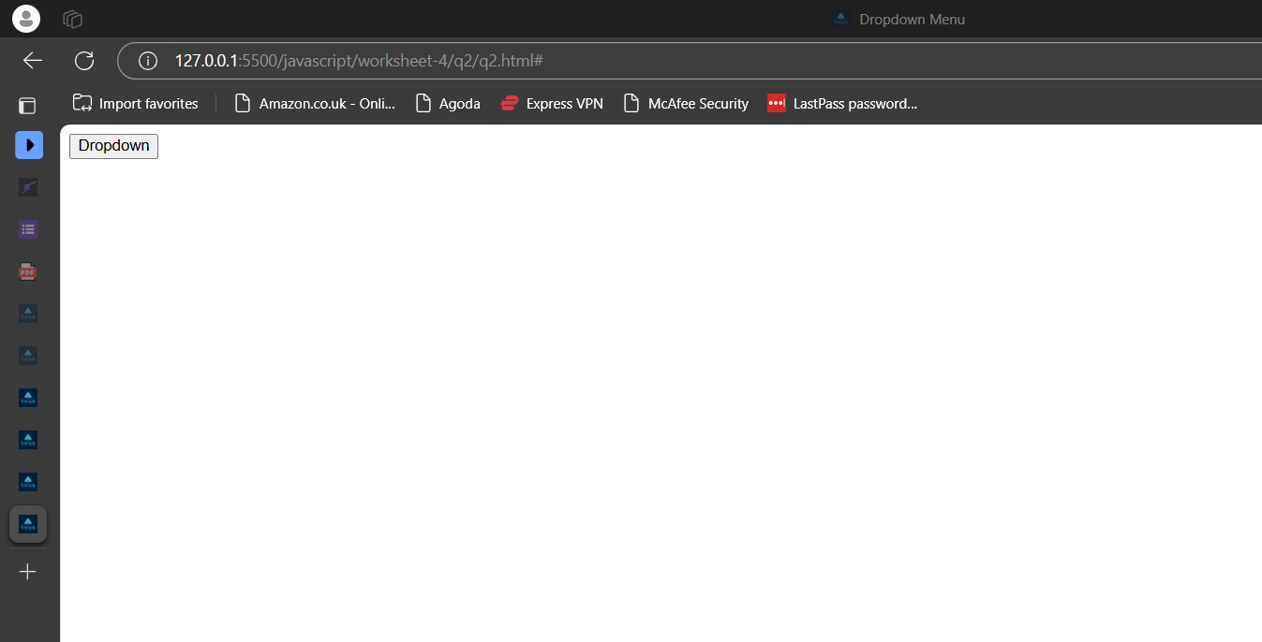

**When the dropdown button is clicked, it shows the menu options below it and vanishes if we click again outside or the dropdown button again(toggle)**

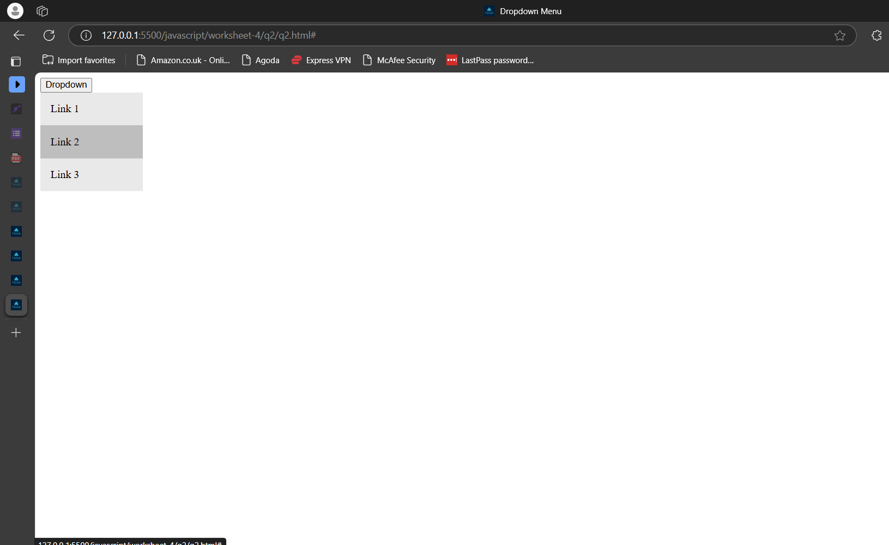

**3)Mouse In and Out**

**Html**

<!-- 3) Write a JavaScript function that changes the background color of an

element when a mouse enters it. -->

<!DOCTYPE html>

<html>

<head>

    <title>Change Background Color</title>

    <link rel="stylesheet" type="text/css" href="q3.css">

    <script type="text/javascript" src="q3.js"></script>

</head>

<body>

    <div id="changeColor" class="defaultColor">

        <h1>Changing Background Color</h1>

    </div>

</body>

</html>

**CSS**

.defaultColor {

    width: 200px;

    height: 150px;

    background-color: green;

}

**Javascript**

document.addEventListener("DOMContentLoaded", function () {

    document.getElementById("changeColor").addEventListener("mouseover", function () {

        this.style.backgroundColor = "red";

    });

    document.getElementById("changeColor").addEventListener("mouseout", function () {

        this.style.backgroundColor = "green";

    });

});

**Webpage**

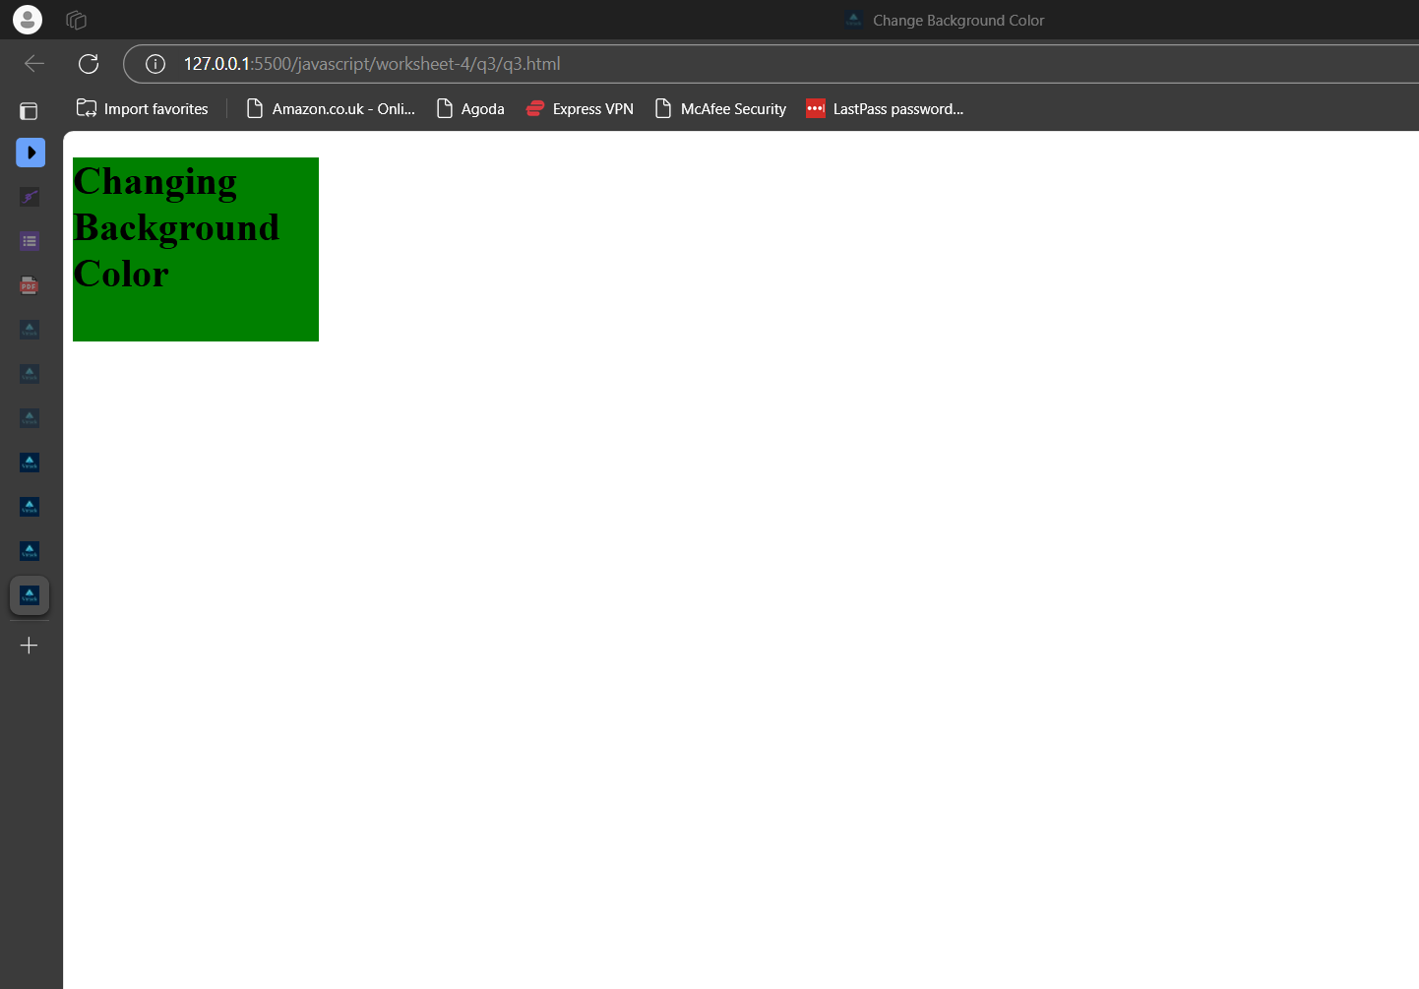

**When the mouse hovers in over the element, the background changes to red and if the mouse comes out of the element ,it reverts back to green.**

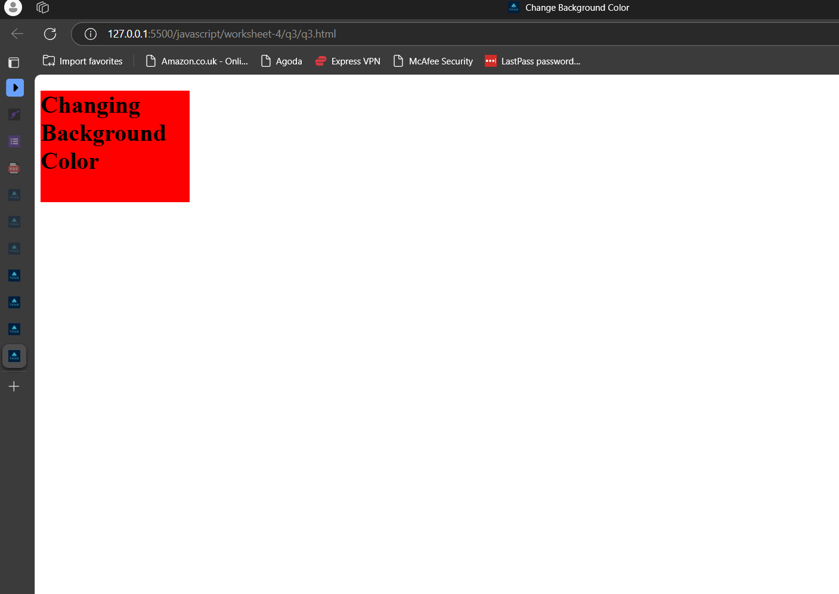

**4)Form validation**

**Html**

<!-- 4) Write a JavaScript program that implements a "form" validation that

displays an error message if a required field is left empty when

submitting the form. -->

<!DOCTYPE html>

<html>

<head>

    <title>Form Validation</title>

    <script src="q4.js"></script>

    <link rel="stylesheet" type="text/css" href="q4.css">

</head>

<body>

    <form id="RegisterForm" onsubmit="validateForm()">

        <label for="name">Name:</label>

        <input type="text" id="name" name="name">

        <div id="nameError" class="error"></div>

        <label for="email">Email:</label>

        <input type="email" id="email" name="email">

        <div id="emailError" class="error"></div>

        <input type="submit" value="Submit">

    </form>

</body>

</html>

**CSS**

.error {

    color: red;

    padding-bottom: 20px;

}

**Javascript**

document.addEventListener('DOMContentLoaded', function() {

    document.getElementById('RegisterForm').addEventListener('submit', function(event) { //event refers to the submit event

        if (!validateForm()) {

            event.preventDefault(); //prevent the form from submitting

        }

    });

});

function validateForm() {

    var name = document.forms["RegisterForm"]["name"].value;

    var email = document.forms["RegisterForm"]["email"].value;

    var nameError = document.getElementById("nameError");

    var emailError = document.getElementById("emailError");

    var isValid = true;

    if (name == "") {

        nameError.textContent = "Name is required";

        isValid = false;

    } else {

        nameError.textContent = "";

    }

    if (email == "") {

        emailError.textContent = "Email is required";

        isValid = false;

    } else {

        emailError.textContent = "";

    }

    return isValid;

}

**Webpage**

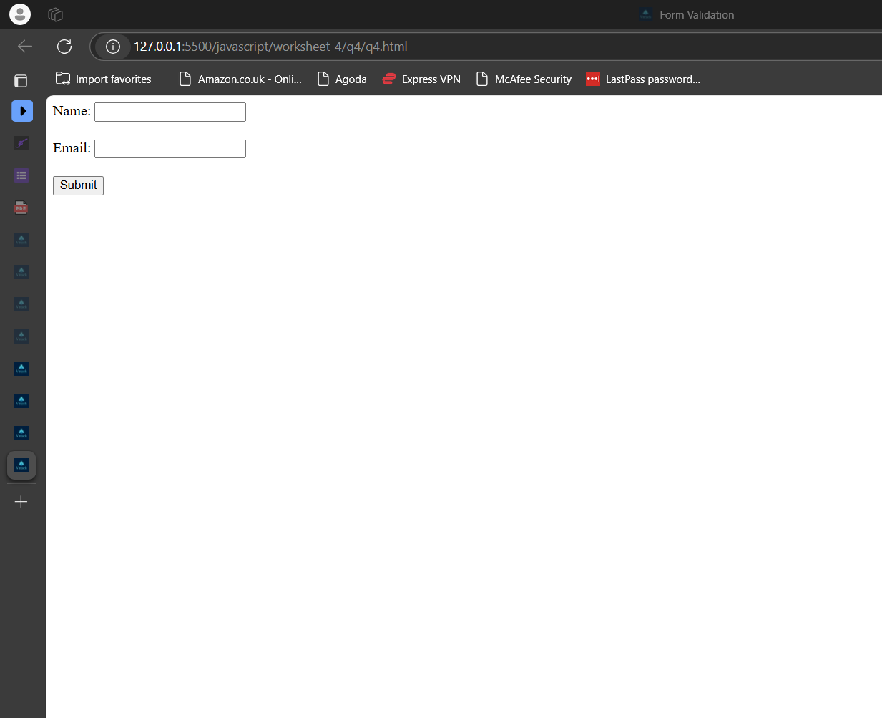

**When we try to submit a form with some empty field ,it doesn’t submit and shows the error message adjacent to it.**

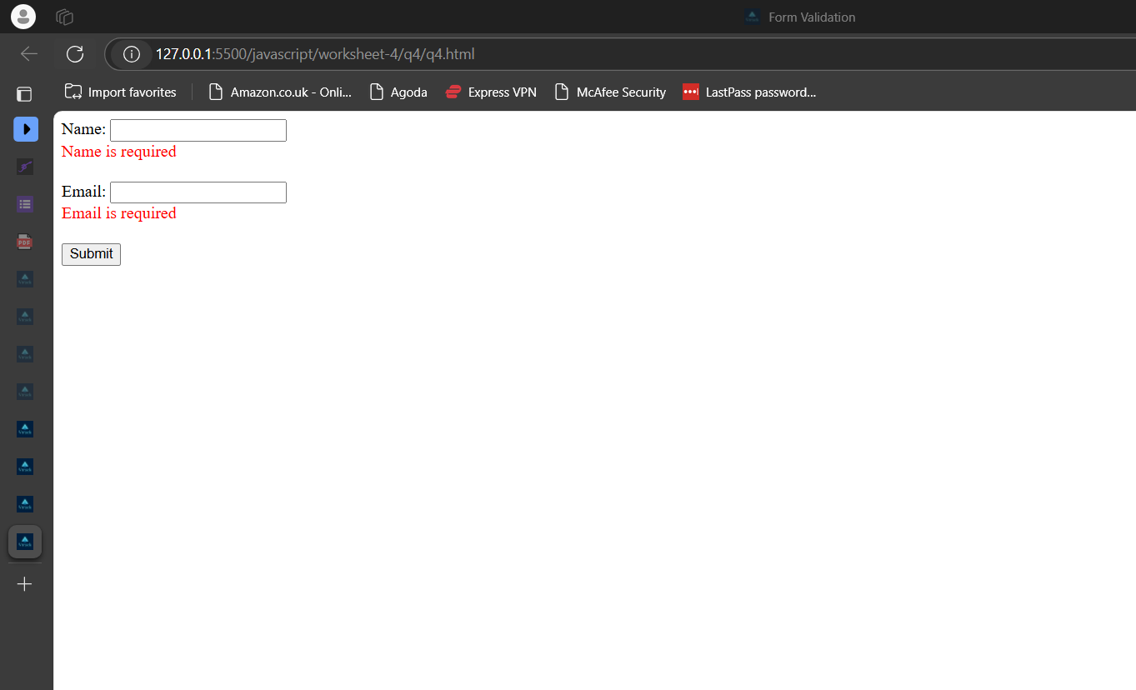

**5)Toggle Switch**

**Html**

<!-- 5) Write a JavaScript program to implement a toggle switch that changes

its state when clicked. -->

<!DOCTYPE html>

<html>

<head>

    <title>Toggle Switch</title>

    <link rel="stylesheet" type="text/css" href="q5.css">

    <script type="text/javascript" src="q5.js"></script>

</head>

<body>

    <div id="toggleSwitch" class="switch">

        <div class="ball" id="ball"></div>

    </div>

</body>

</html>

**CSS**

.switch {

    width: 50px;

    height: 25px;

    background: gray;

    border-radius: 25px;

    position: relative;

}

.ball {

    width: 20px;

    height: 20px;

    background: white;

    border-radius: 50%;

    position: absolute;

    top: 2px;

    left: 3px;

}

**Javascript**

document.addEventListener("DOMContentLoaded", function () {

    var toggleSwitch = document.getElementById("toggleSwitch");

    var ball = document.getElementById("ball");

    let isActive = false;

    toggleSwitch.addEventListener("click", function () {

        isActive = !isActive;

        if (isActive) {

            toggleSwitch.style.background = "blue";

            ball.style.left = "27px";

        }

        else {

            toggleSwitch.style.background = "gray";

            ball.style.left = "3px";

        }

    });

});

**Webpage**

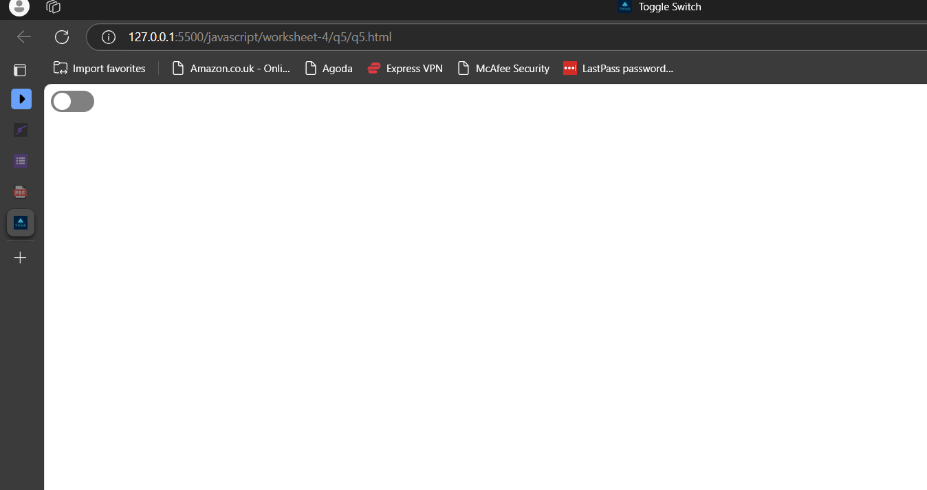

**When you click on that slide ball, it switches on and if you click again ,it reverts back to the initial state.**

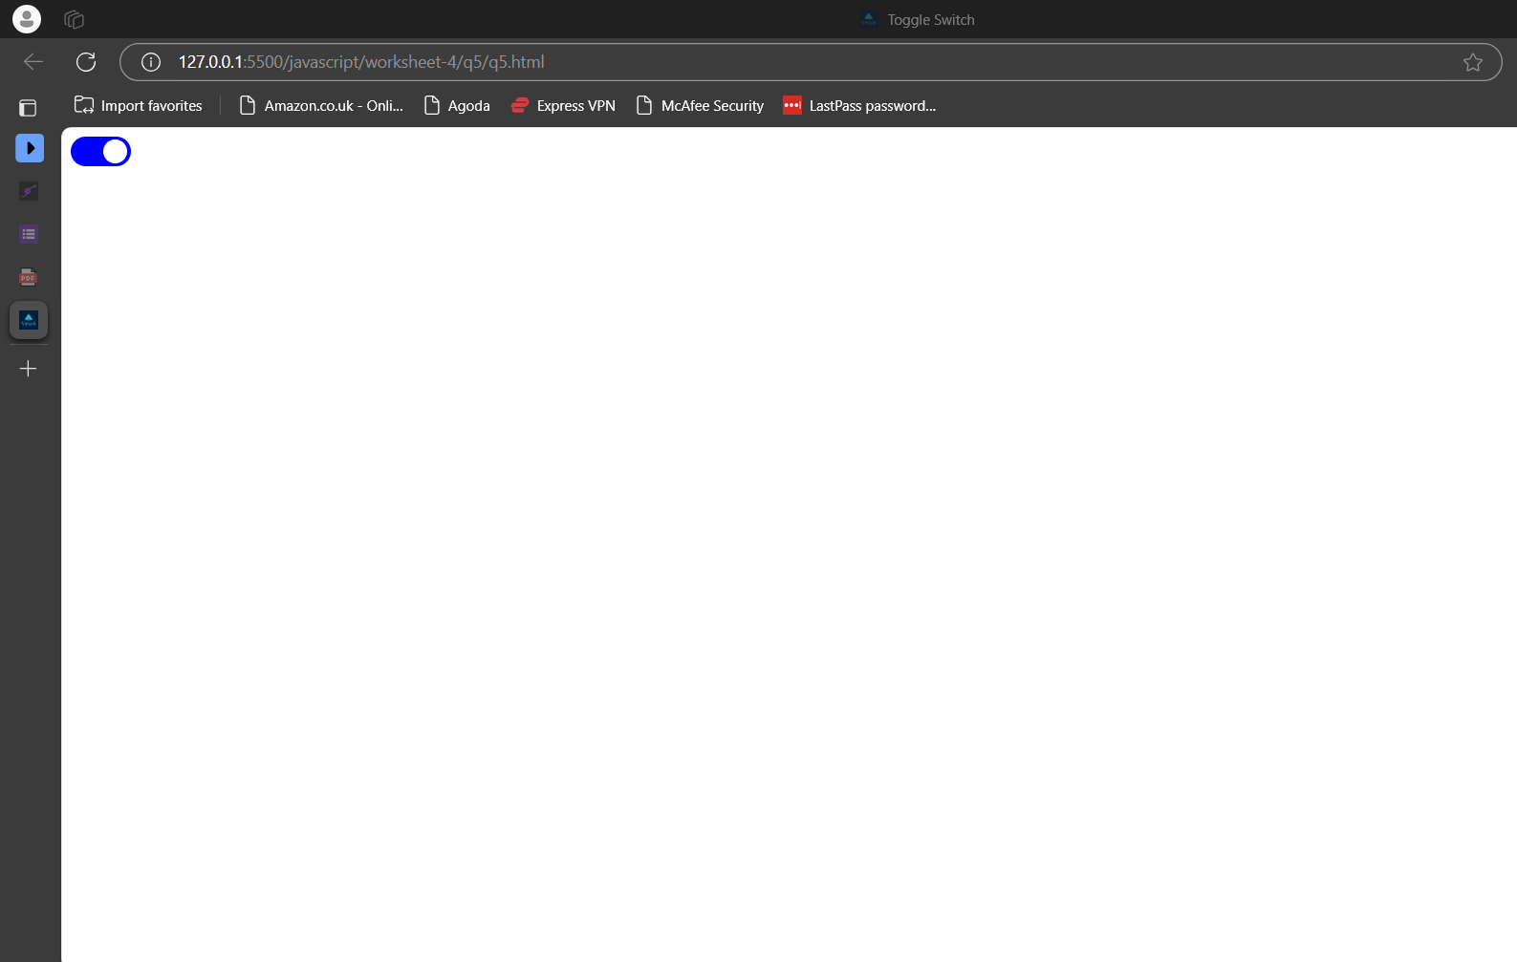

**6)DoubleClick**

**Html**

<!-- 6) Write a JavaScript function that listens for a double click on an element

and performs a specific action. -->

<!--Double click changes background of element to red and again double click goes to default-->

<!DOCTYPE html>

<html>

<head>

    <title>Double Click</title>

    <link rel="stylesheet" type="text/css" href="q6.css">

    <script type="text/javascript" src="q6.js"></script>

</head>

<body>

    <div id="default-element" class="default-element">Double Click Me</div>

</body>

</html>

**CSS**

.default-element{

    padding: 10px;

    border: 1px solid black;

    width: 200px;

    text-align: center;

}

**Javascript**

document.addEventListener('DOMContentLoaded', function () {

    let isRed = false;

    function changeColor() {

        var element = document.getElementById('default-element');

        if (isRed) {

            element.style.backgroundColor = '';

        } else {

            element.style.backgroundColor = 'red';

        }

        isRed = !isRed;

    }

    document.getElementById('default-element').addEventListener('dblclick', changeColor);

});

**Webpage**

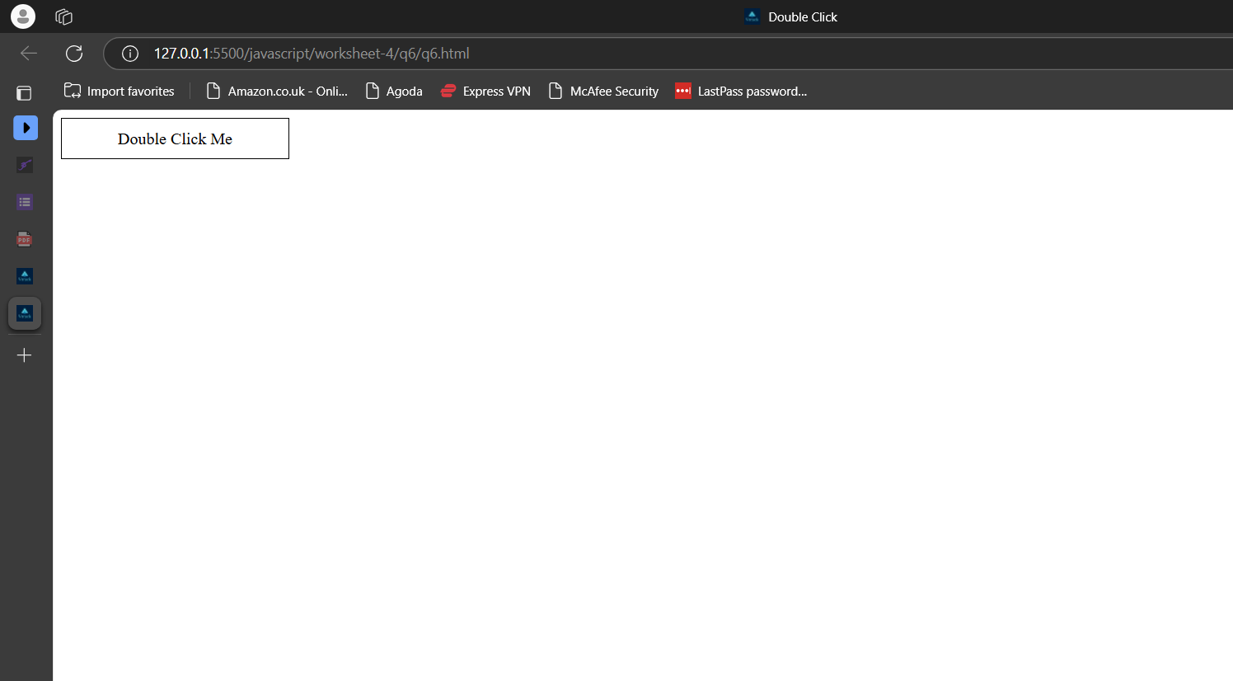

**When you double click the element, the background of the element changes to red and if you double click again, it resets to initial state.**

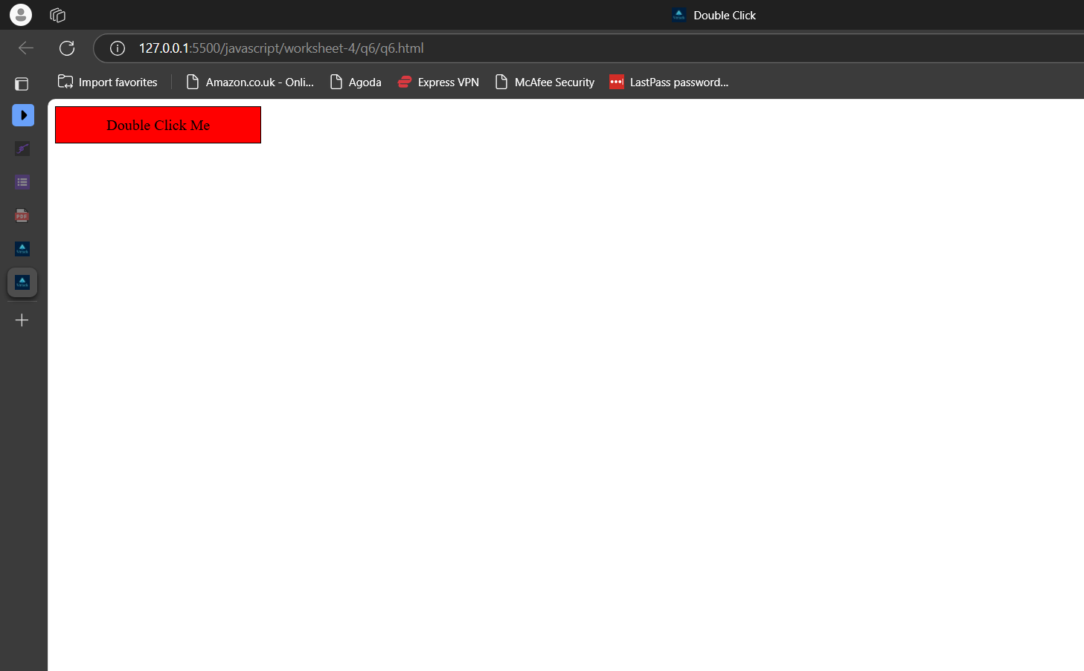

**7)Drag and Drop**

**Html**

<!-- 7) Write a JavaScript program to implement drag-and-drop functionality to

allow users to reorder items in a list. -->

<!DOCTYPE html>

<html>

<head>

    <title>Drag and Drop</title>

    <link rel="stylesheet" type="text/css" href="q7.css">

    <script src="q7.js"></script>

</head>

<body>

    <div class="dragDrop">

        <div draggable="true">Item 1</div>

        <div draggable="true">Item 2</div>

        <div draggable="true">Item 3</div>

        <div draggable="true">Item 4</div>

        <div draggable="true">Item 5</div>

    </div>

</body>

</html>

**CSS**

.dragDrop {

    border: 1px solid black;

    padding: 10px;

    max-width: 150px;

}

.dragDrop div {

    padding: 10px;

    margin: 10px;

    max-width: 100px;

    border: 1px solid black;

}

**Javascript**

document.addEventListener('DOMContentLoaded', function () {

    var draggedItem = null;

    var items = document.querySelectorAll('.dragDrop div');

    for (var i = 0; i < items.length; i++) {

        items[i].addEventListener('dragstart', function (event) {

            draggedItem = event.target; // store the dragged item

        });

        items[i].addEventListener('dragover', function (event) {

            event.preventDefault();

        });

        items[i].addEventListener('drop', function (event) {

            event.preventDefault();

            if (draggedItem !== event.target) {

                var temp = draggedItem.innerHTML;

                draggedItem.innerHTML = event.target.innerHTML;

                event.target.innerHTML = temp; // swap the innerHTML of the two elements

            }

        });

    }

});

**Webpage**

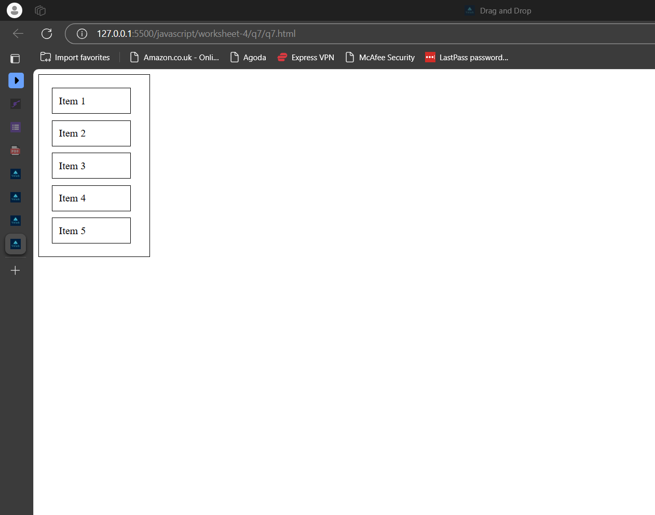

**We can drag and drop items and rearrange the list**

