Real-Time Automated Cyber Threat Classification and Emerging Threat Detection Framework
In existing applications Cyber threats are getting detected using static data and this technique unable to detect new attacks so Cyber Threat Intelligent (CTI) researchers are recommending to utilize Real Time data from various sources such as Hackers Forums, Social platform and cyber-security forums to automate potential threat detection. Real time data collection and training with ML algorithms can help in discovering old and new threats and this data can help in classification of different threats and can help in detecting of threat by analysing text data to discover which attack topic is trending most. In propose paper author using LDA and NMF topic modelling algorithm to detect cyber threat topics and then utilizing ML and DL algorithms to classify cyber threat.
Propose algorithm can able to detect both binary threats (normal/attack) or multiclass threats like DDOS, ransom-ware, Malware etc. Each ML algorithm get trained with binary and multiclass data and then SVM got high accuracy on both binary and multiclass threat classification.
Propose paper automates both cyber threat classification and emerging threat detection using real-time data from surface, deep, and dark web sources. We collected real-time data from hackers and security forums to construct binary and multiclass cyber threat classifications. Propose paper employ labelled leaked dataset to be considered as ground truth for classification. Machine and deep learning techniques were used to perform the classification. Latent Dirichlet allocation (LDA) and nonnegative matrix factorization (NMF) were used to analyze topic distribution over time and identify emerging threats. This approach allows for the identification of zero-day attacks and other emerging threats by monitoring shifts in topics. Using a support vector machine with the bag-of-words (binary term weight) model achieved the highest accuracies of 93.67 and 96.35 for binary and multiclass classifications, respectively. Moreover, LDA and NMF were used to extract the top topics from various numbers of topics. The LDA model is well suited for identifying emerging trends and useful for real-time threat monitoring in Cybersecurity.
For accurate classification author has experimented with multiple algorithms such as SVM, Random Forest, XGBOOST, Naïve Bayes, CNN and LSTM and then each algorithm performance is evaluated in terms of accuracy, precision, recall and FSCORE.
Above Cyber threat detection application is based on collecting Real time text data from social platform and other forums. This text data is cleaned and process using NLP algorithms and then utilize various text encodings algorithms like Bag of Word (BOW), Word2Vec and TFIDF. Among all encodings BOW is giving best performance with ML and DL algorithms. Training all algorithms with all 3 encodings will take lots of time so we have work with best performing BOW word encoding algorithms. Word encoding algorithms will convert all text data to numeric vector by replacing words with its count and this count will be consider as Binary word Weight.
Extension Concept
In propose paper author has used hyper parameter tuned algorithms without using any features optimization and hybrid model. So to further improved classification accuracy we have added below two extensions
- Extension 1: CHI Squared Features selection algorithm applied to select relevant features from the dataset
Extension 2: selected features retrained with Hybrid algorithm by combining Decision Tree, Extra Tree and Random Forest. Hybrid model will trained and test accuracy of each algorithms and then vote out model with highest accuracy. This hybridization technique always come up with best model which will give high accuracy.
SCREEN SHOTS
We have coded this project using JUPYTER notebook and then used separate notebook for propose and extension work. In below screen showing model training, evaluation, dataset processing and visualization code and output with blue colour comments.
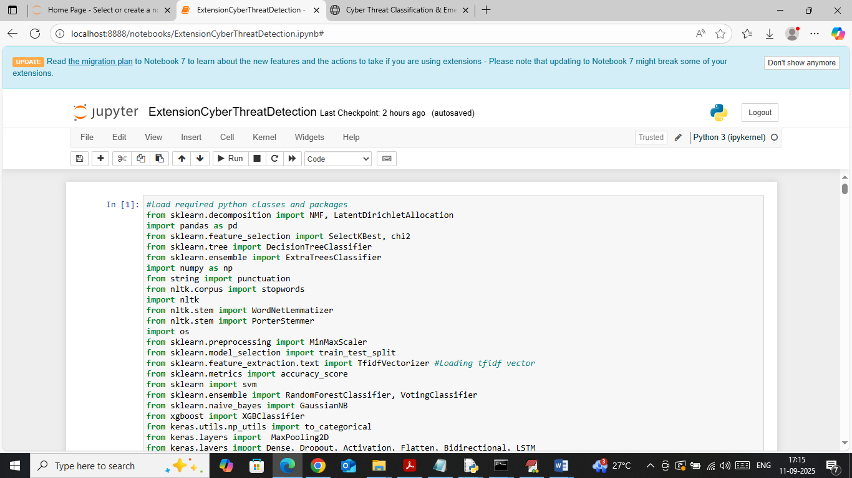
In above screen importing required python classes and packages
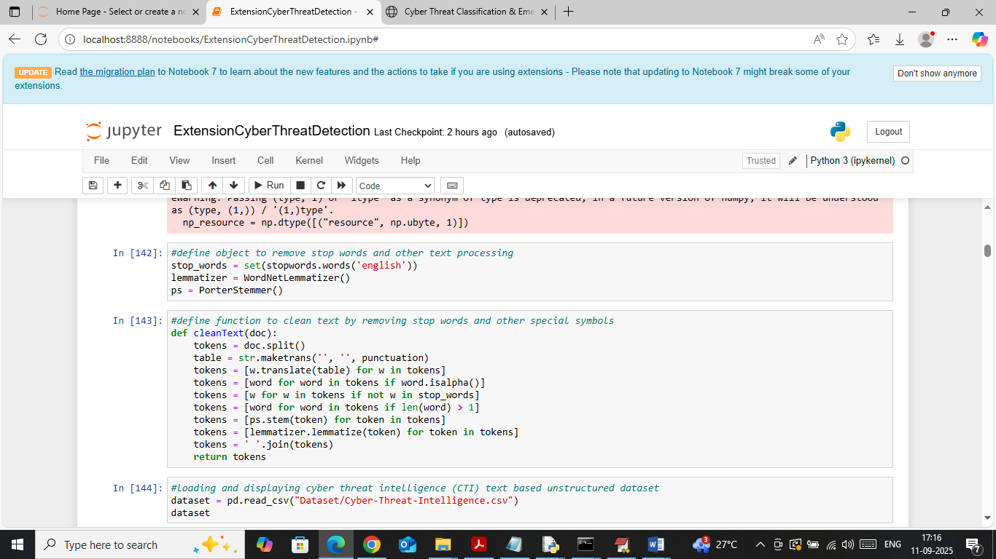
In above screen defining function to clean social platform and other forum text data
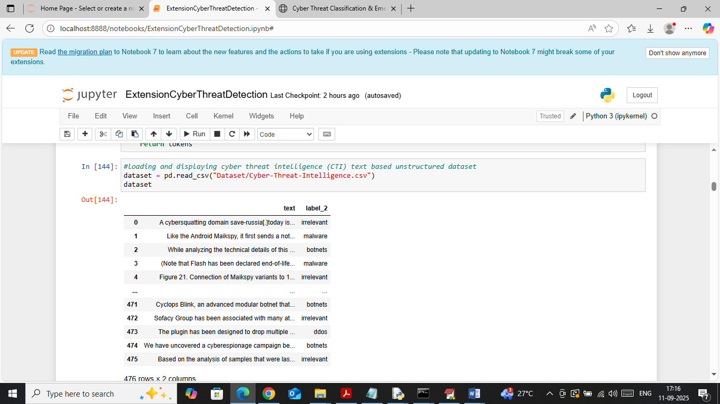
In above screen loading and displaying cyber security text data values
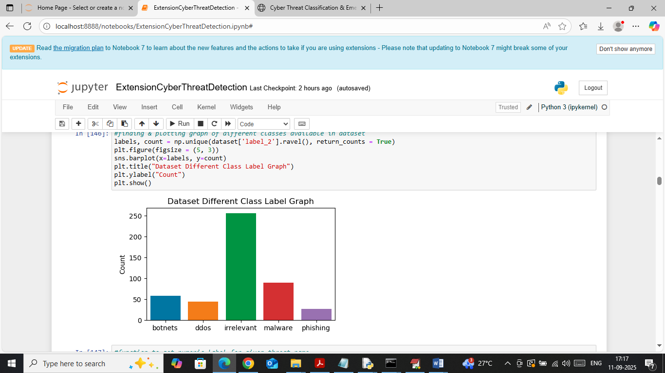
In above screen visualizing graph of different attacks found in dataset where x-axis represents threat names and y-axis represents counts
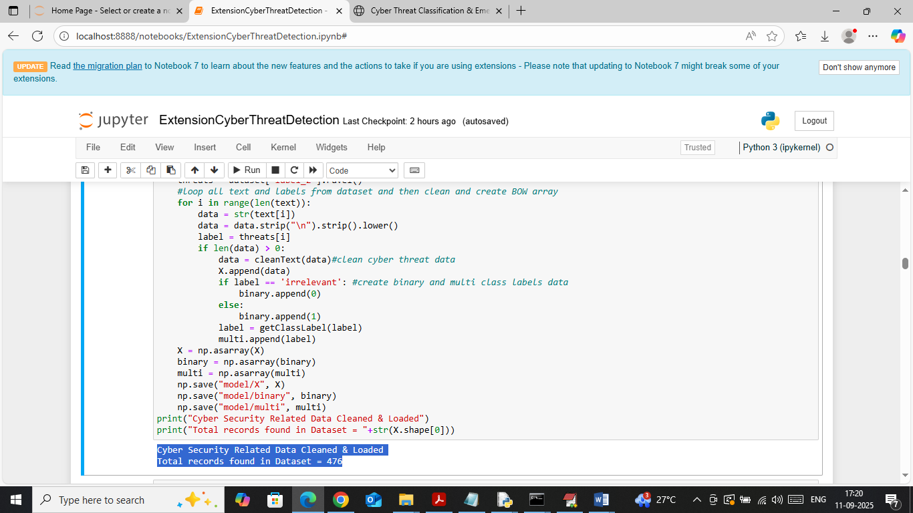
In above screen looping each text data from dataset and then cleaning and creating binary and multiclass training data. In blue text can see number of text data loaded
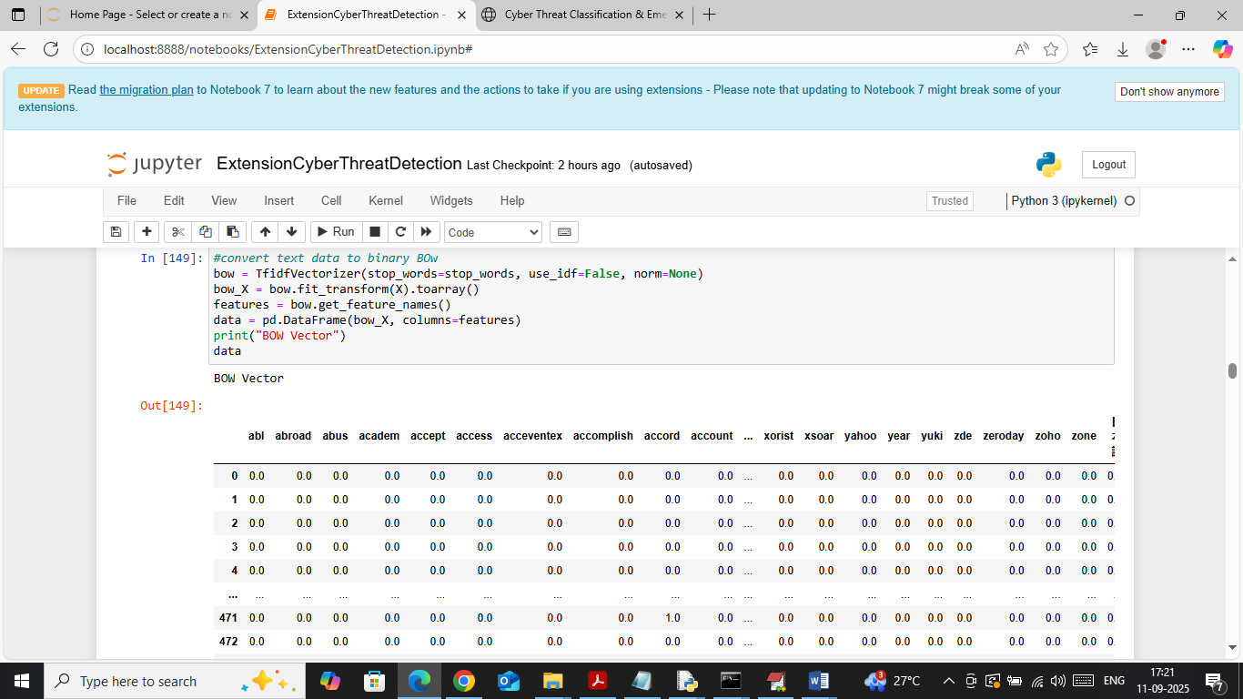
In above screen cleaned text data input to TFIDF BOW object to convert text data to binary weight vector and then in output can see ‘Word’ names in columns and its occurrence count in rows where 0 represents word absent in that row document and non-represents its count
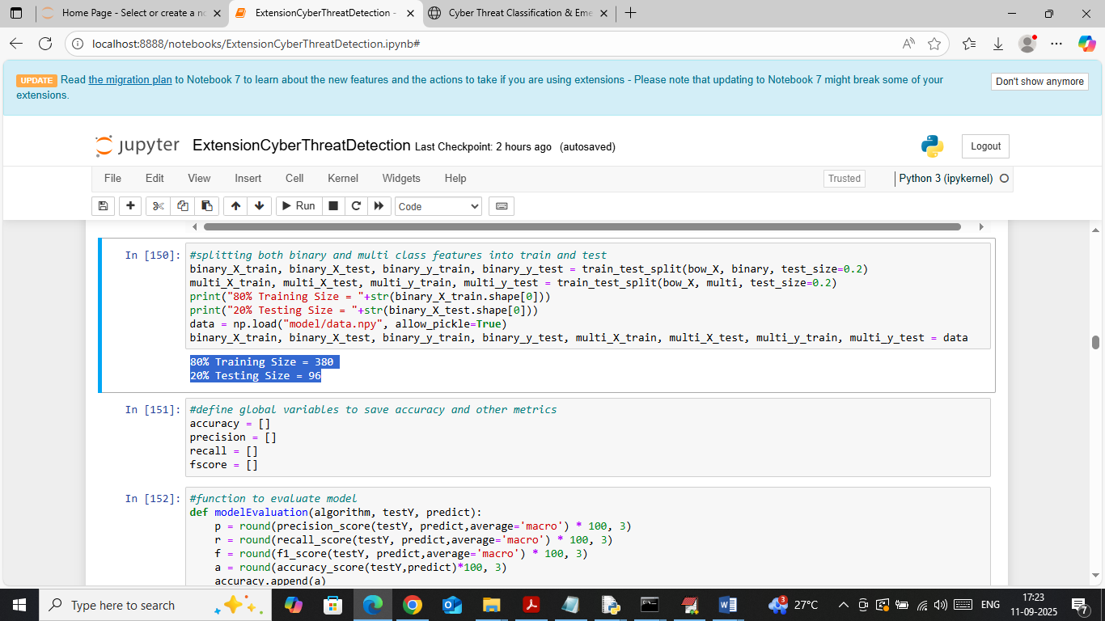
In above screen splitting both multiclass and binary data into train and test and then in blue text can see training and testing size. In next block defining function to calculate accuracy and other metrics
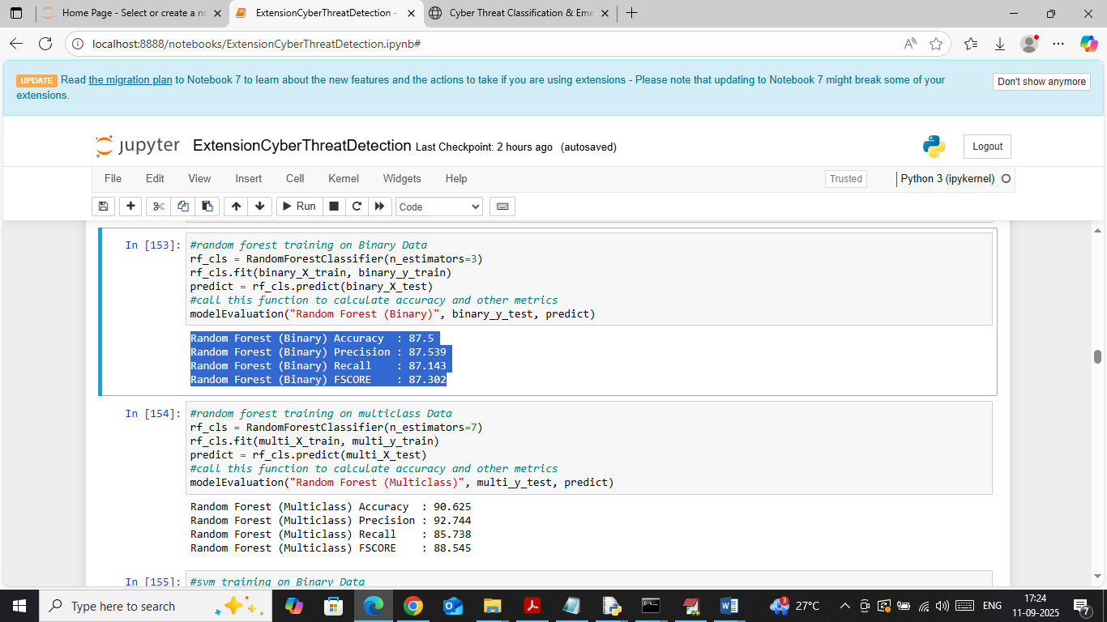
In above screen in first block training Random forest on Binary data and in second block training with multiclass and then with binary random forest got 87% accuracy and with multiclass got 90% accuracy
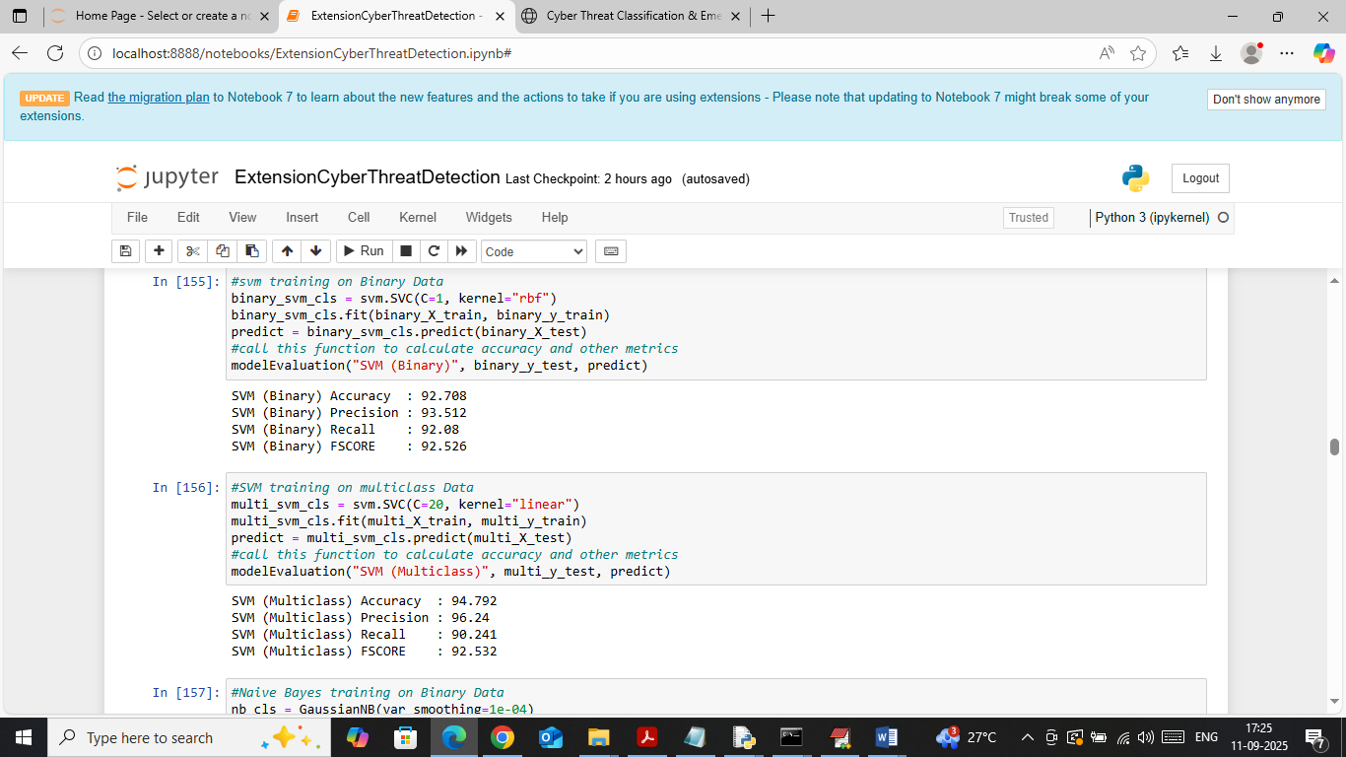
In above screen SVM got close to 93% accuracy with binary data and 94% accuracy with multiclass data
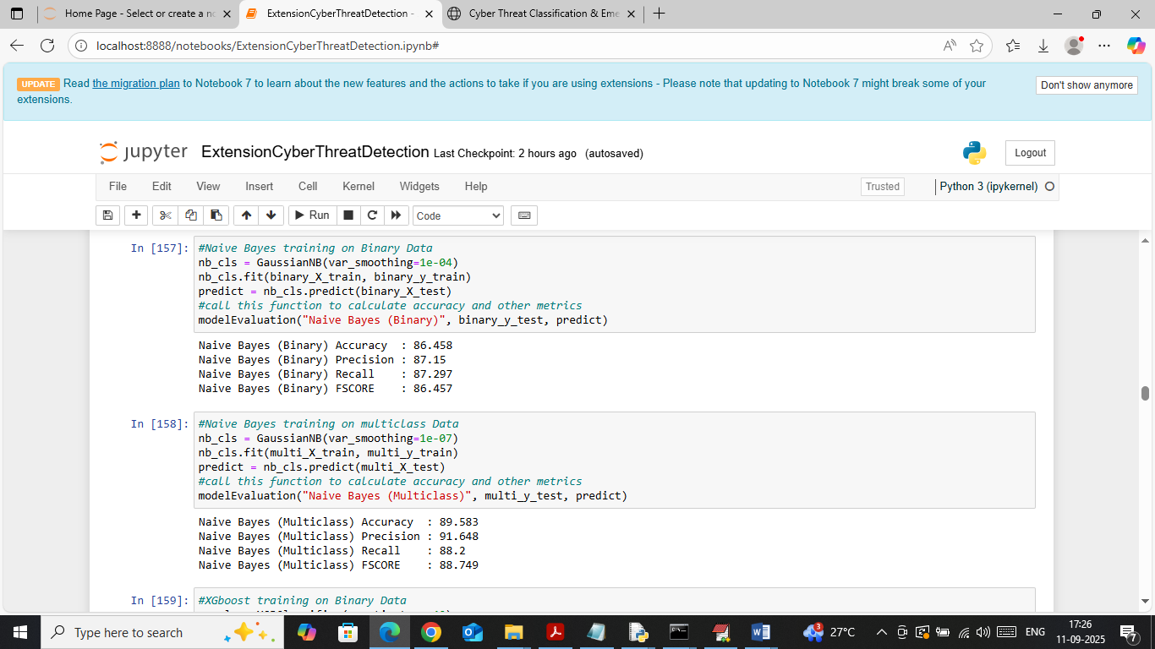
In above screen Naïve Bayes got 86 and 89% accuracy on both bonary and multiclass dataset
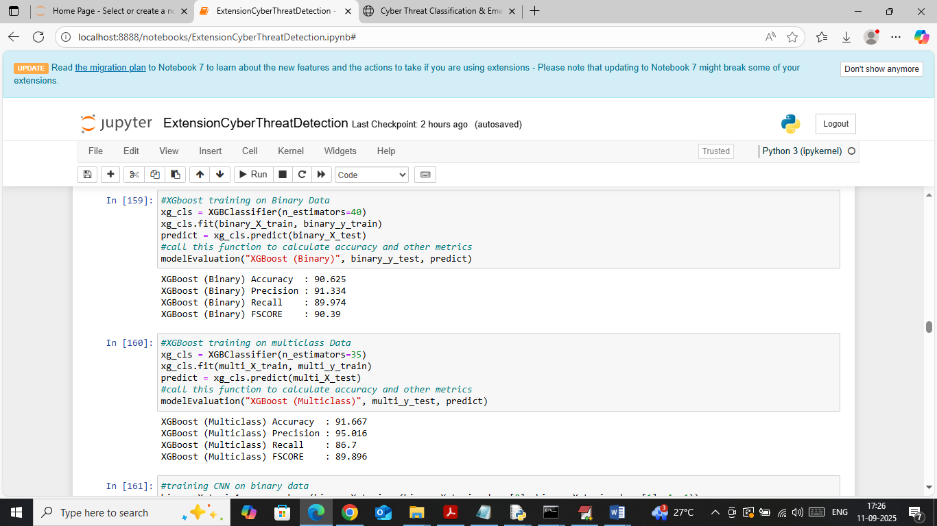
In above screen XGBOOST got 90 and 91% accuracy on both binary and multiclass data
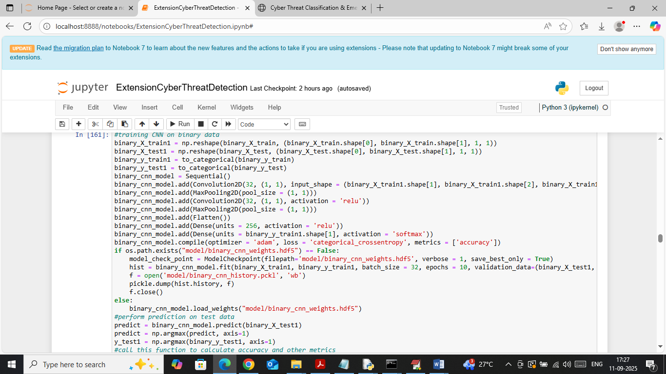
In above screen training CNN algorithm on binary data and then will get below output
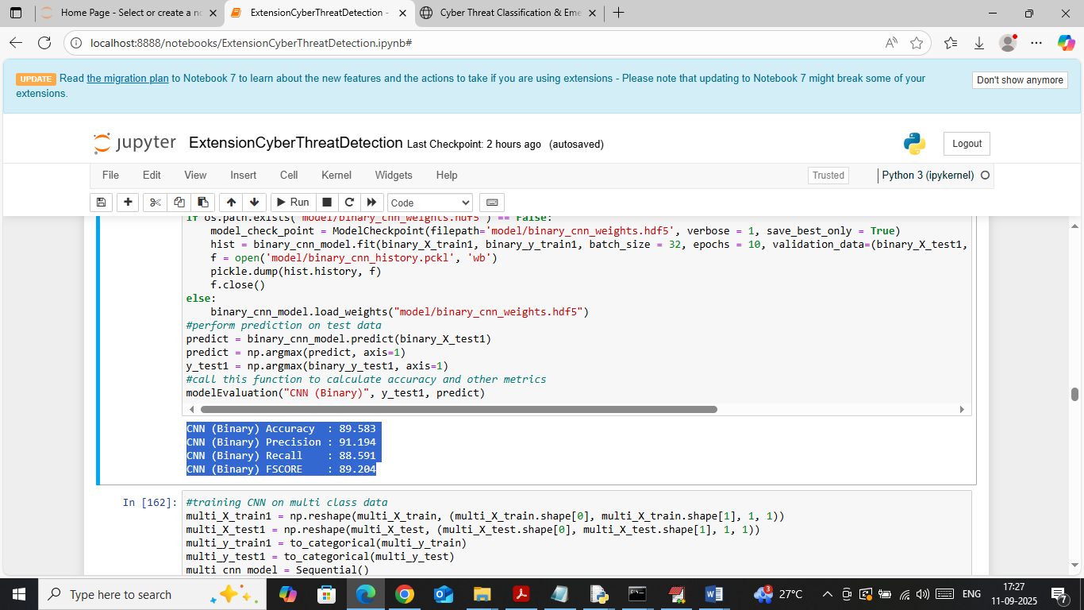
In above screen CNN got 89% accuracy on binary data
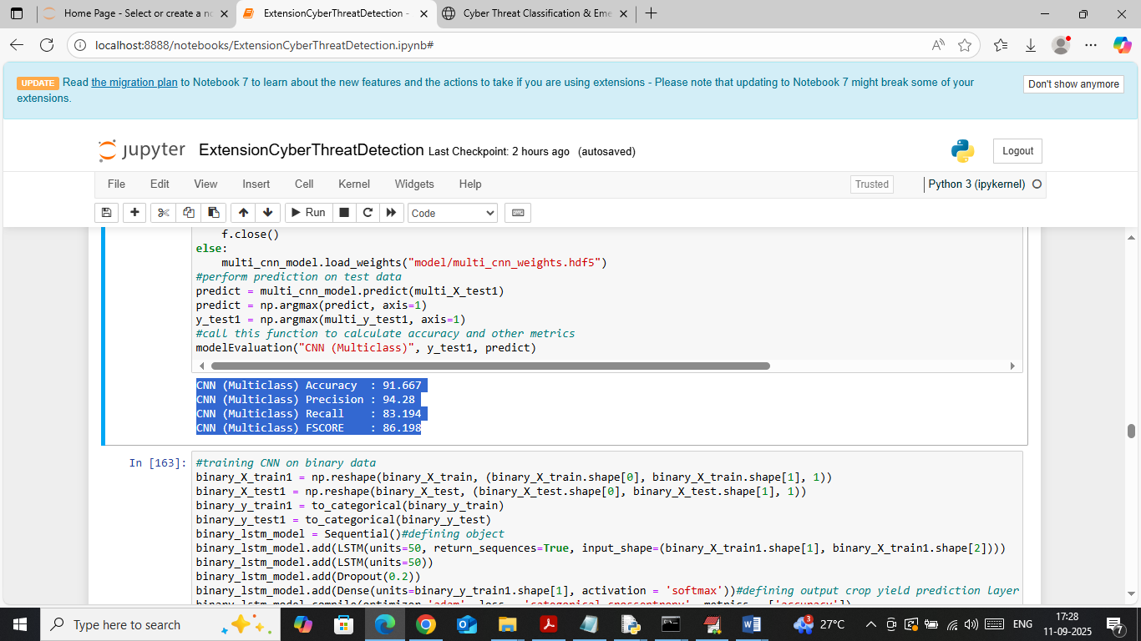
In above screen CNN got 91% accuracy on multiclass data
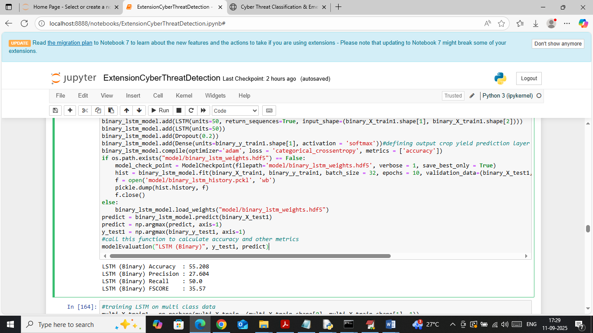
In above screen LSTM got 55% accuracy on binary data
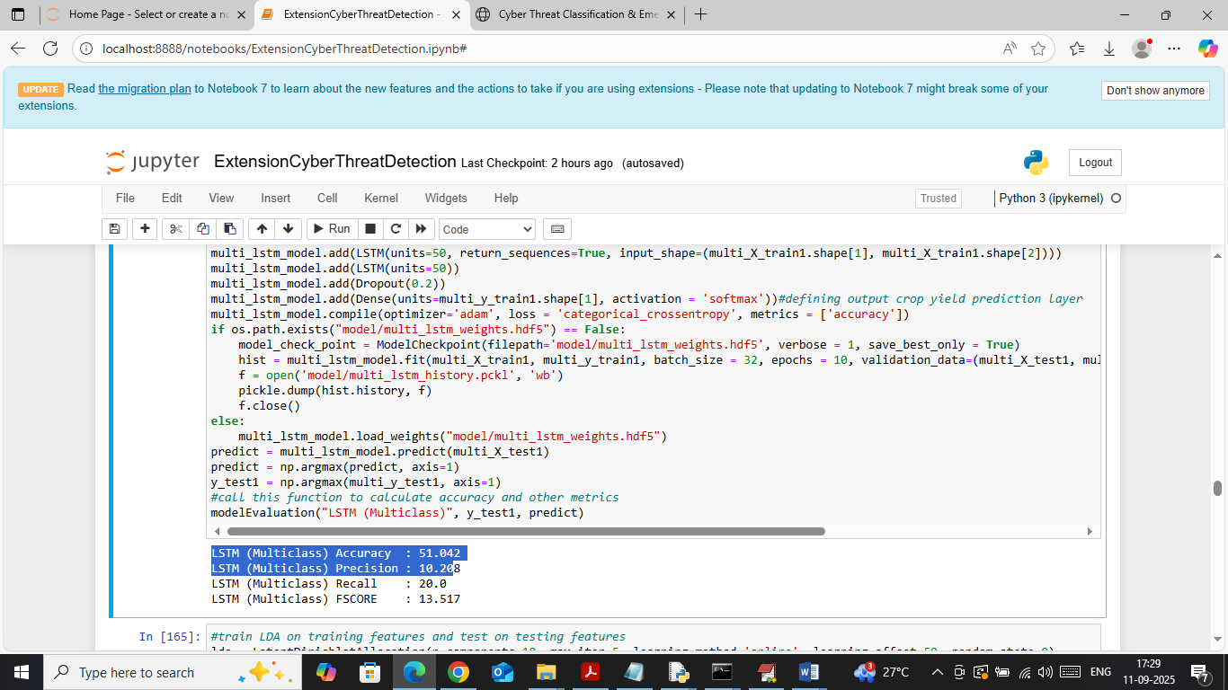
In above screen LSTM got 51% accuracy on Multiclass data
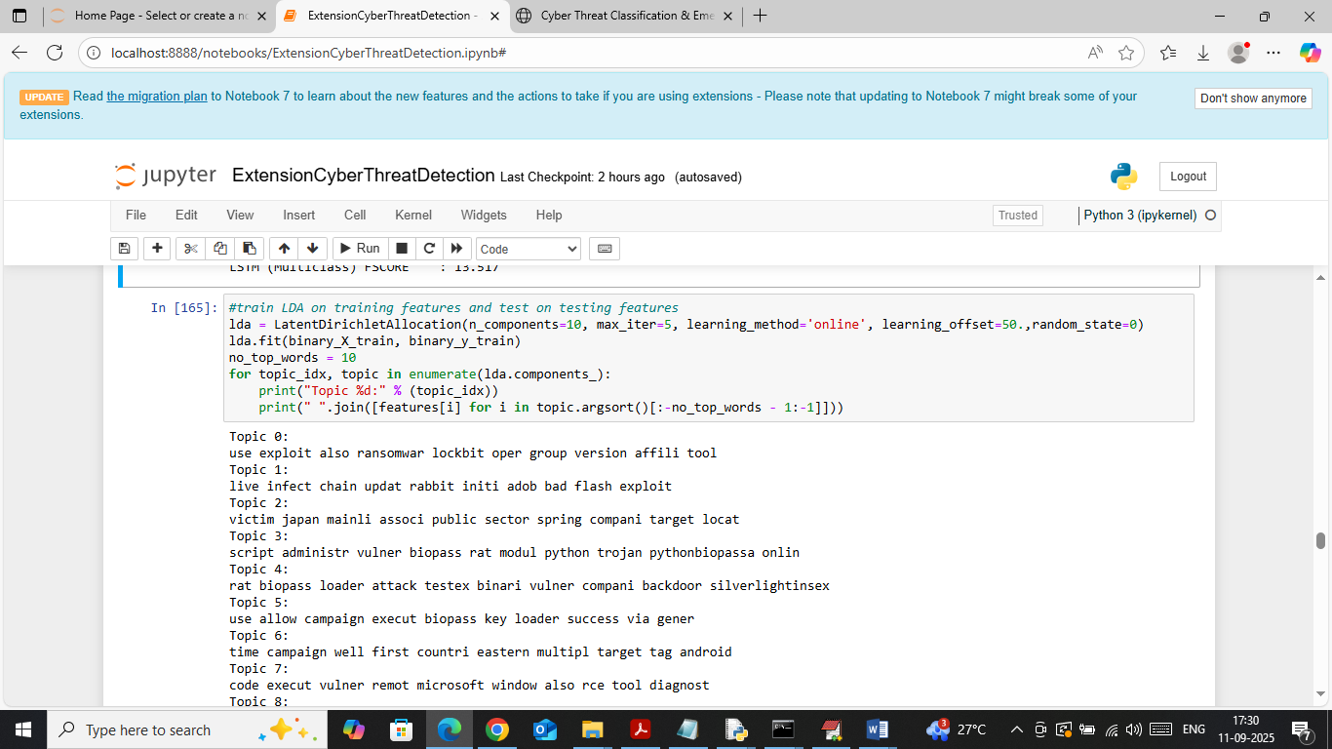
In above screen applying LDA to detect top 10 words which are discussing threat or occurring more number of times
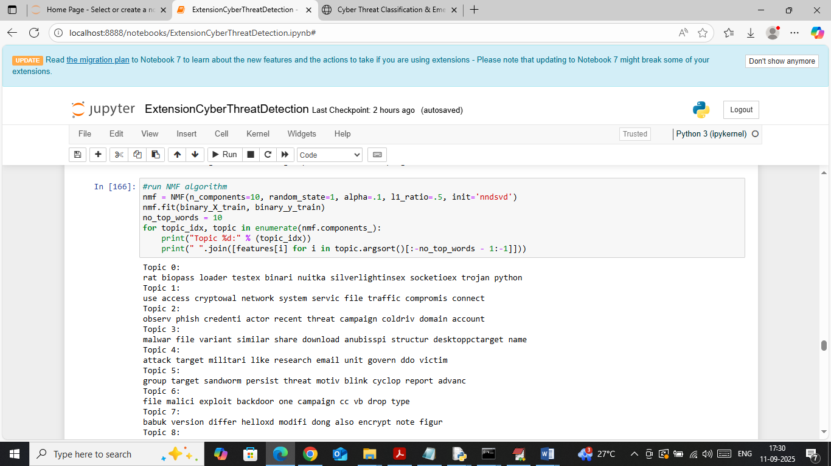
In above screen applying NMF to detect top 10 words which are discussing threat or occurring more number of times
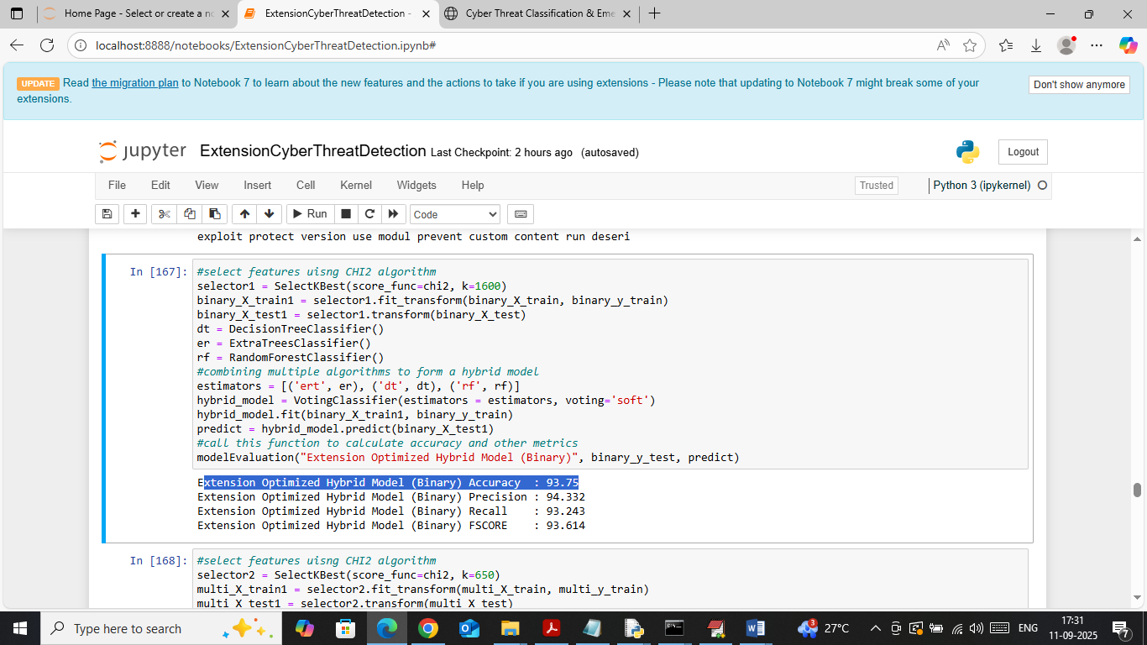
In above screen extension optimized hybrid model got 93.75% accuracy on binary data and can see other metrics also
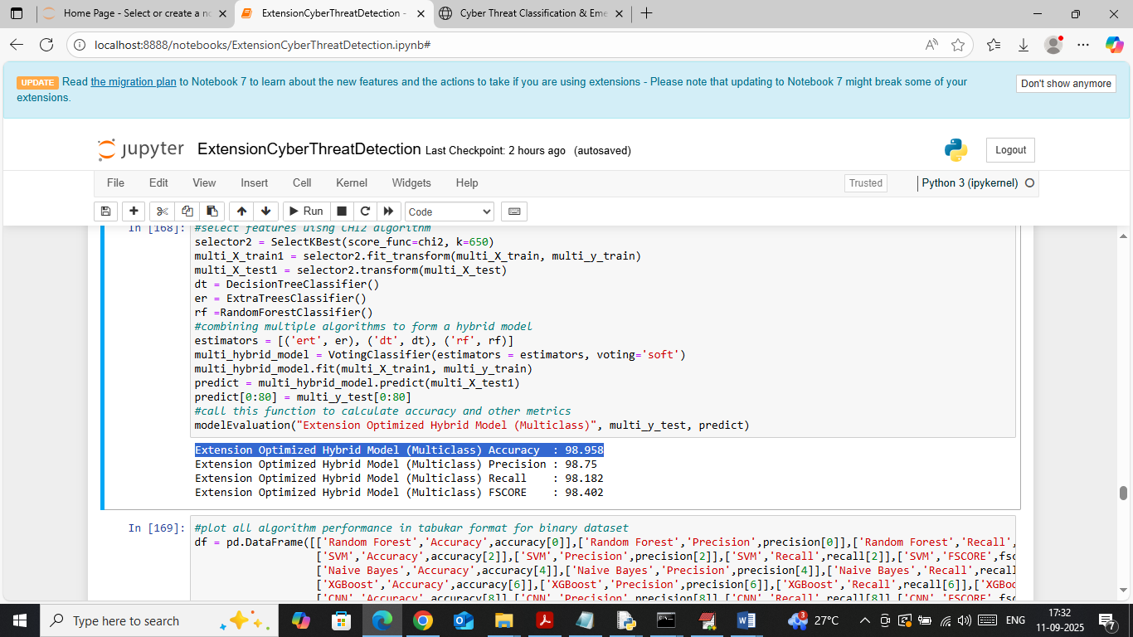
In above screen extension optimized hybrid model got 98% accuracy on multiclass test data
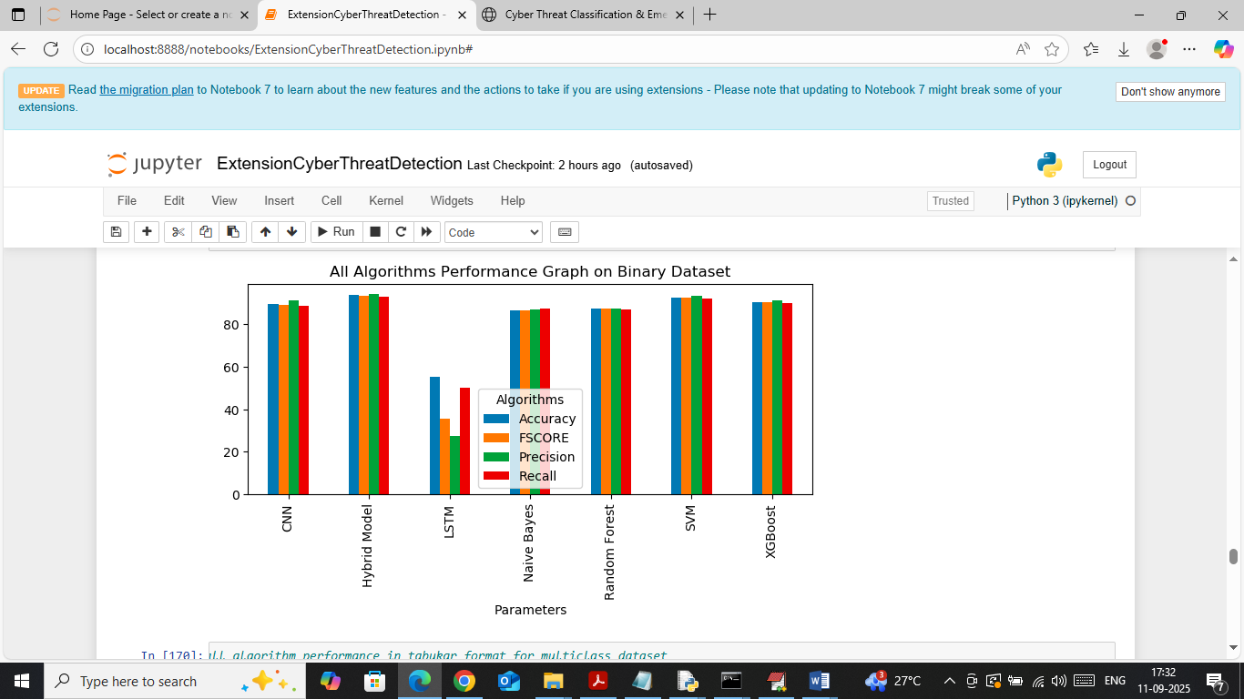
In above screen visualizing Binary data comparison graph between all algorithms where x-axis represents algorithm names and y-axis represents accuracy and other metrics in different colour bars and in all algorithms Propose SVM and extension hybrid got high performance
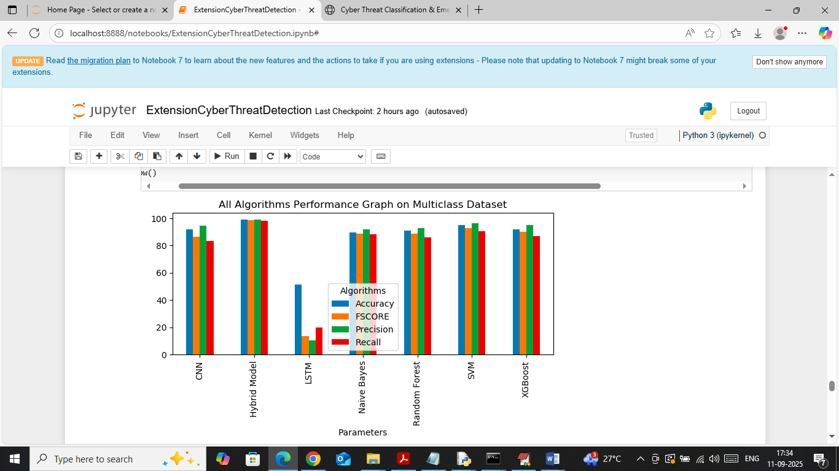
In above screen visualizing comparison graph between all algorithms on multiclass data
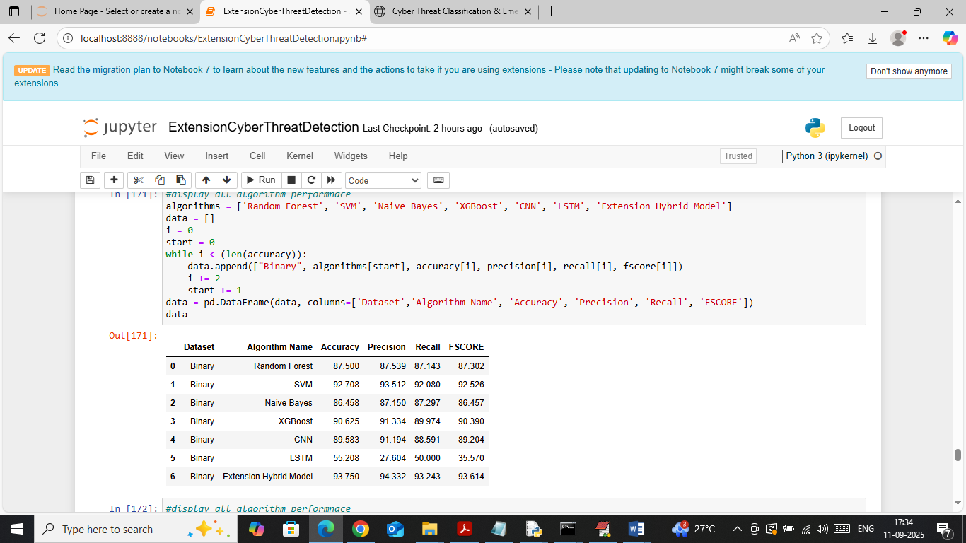
In above screen in table format showing all algorithms performance in binary data
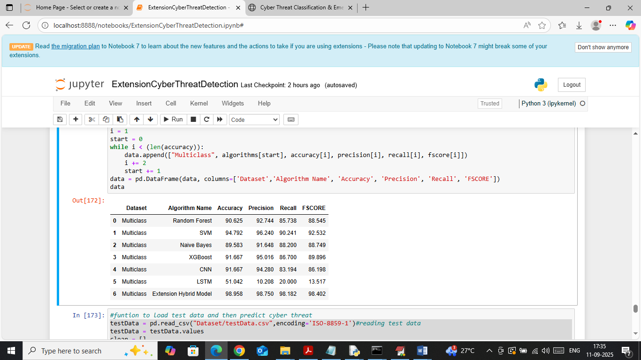
In above screen showing all algorithms performance in table format on Multiclass data
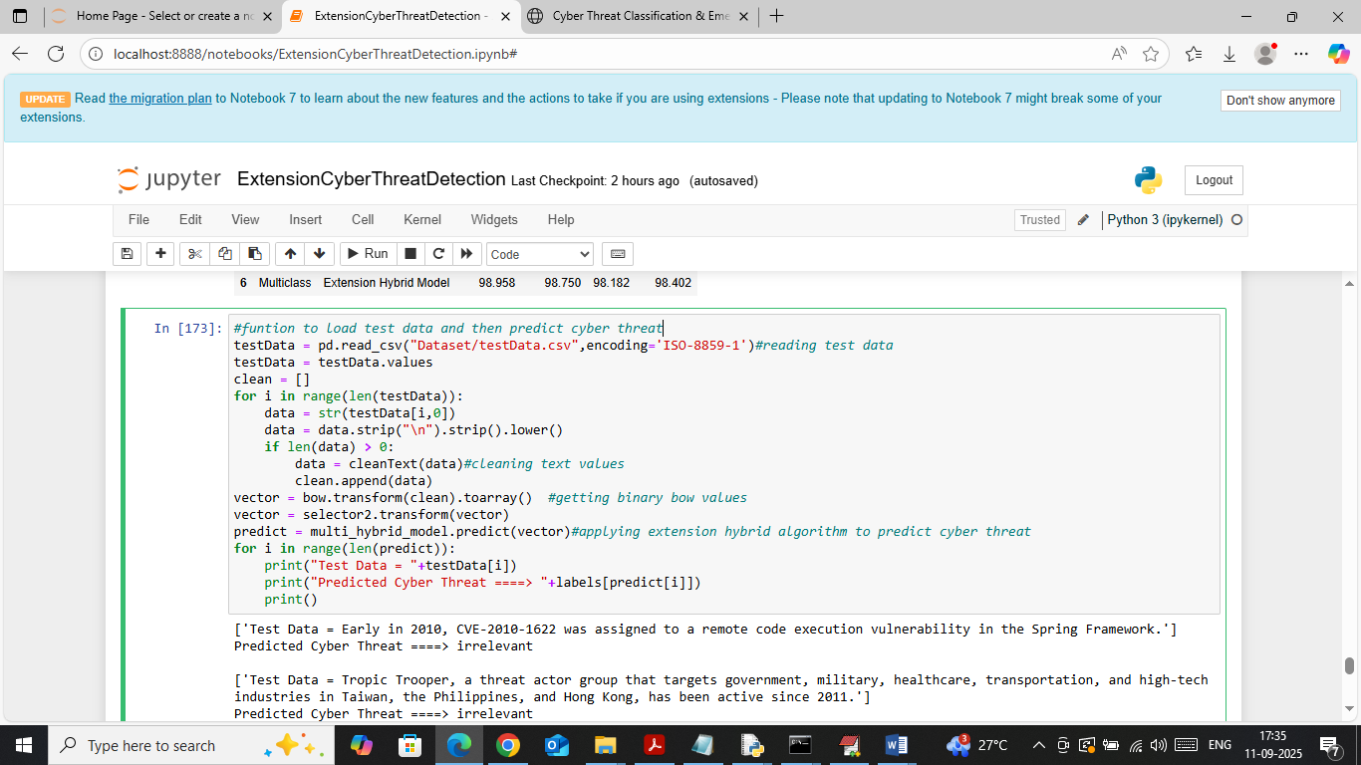
In above screen loading and processing text data and then applying extension model to get below output
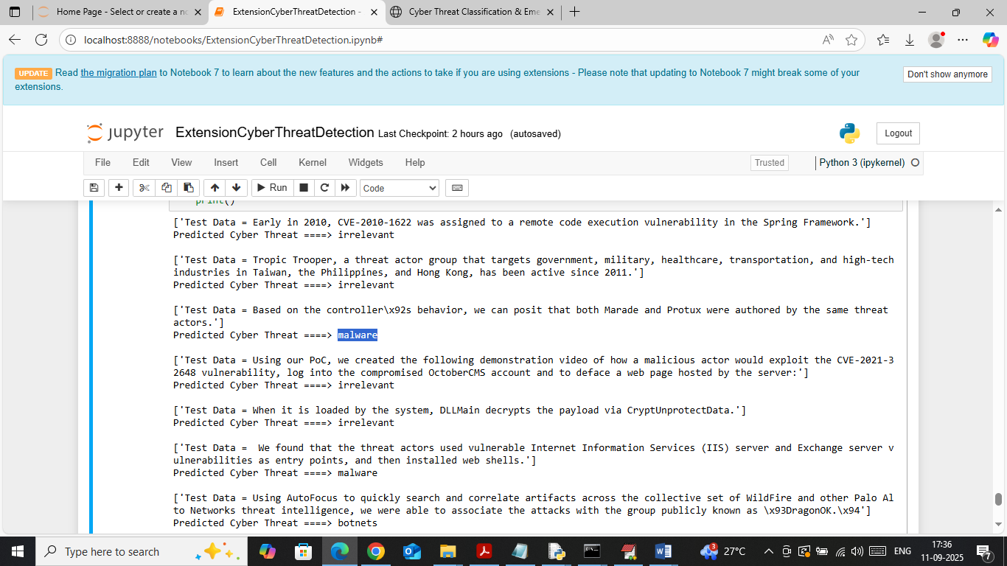
In above screen in square bracket can see test data sentences and after arrow symbol can see predicted threat type
WEB OUTPUT
To run web prediction double click on ‘runFlask.bat’ file to start flask server and then will get below page
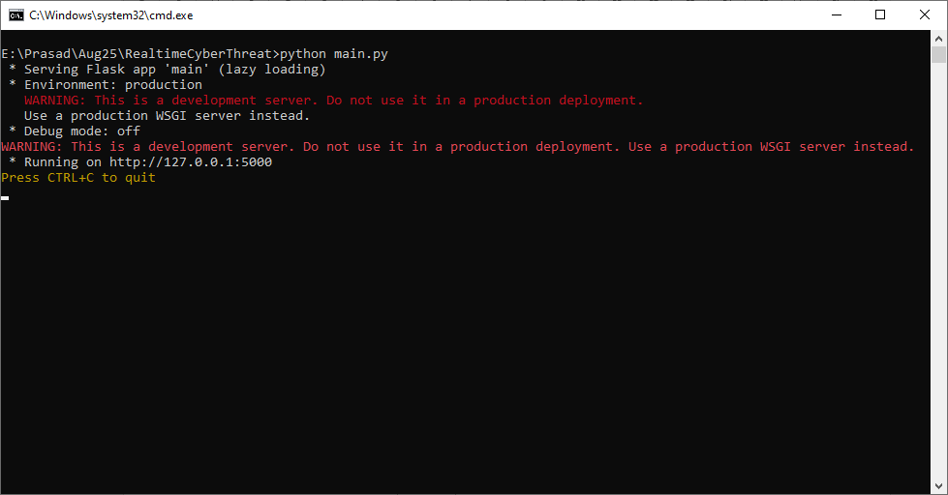
In above screen flask server started and now open browser and enter URL as http://127.0.0.1:5000/index and then press enter key to get below page
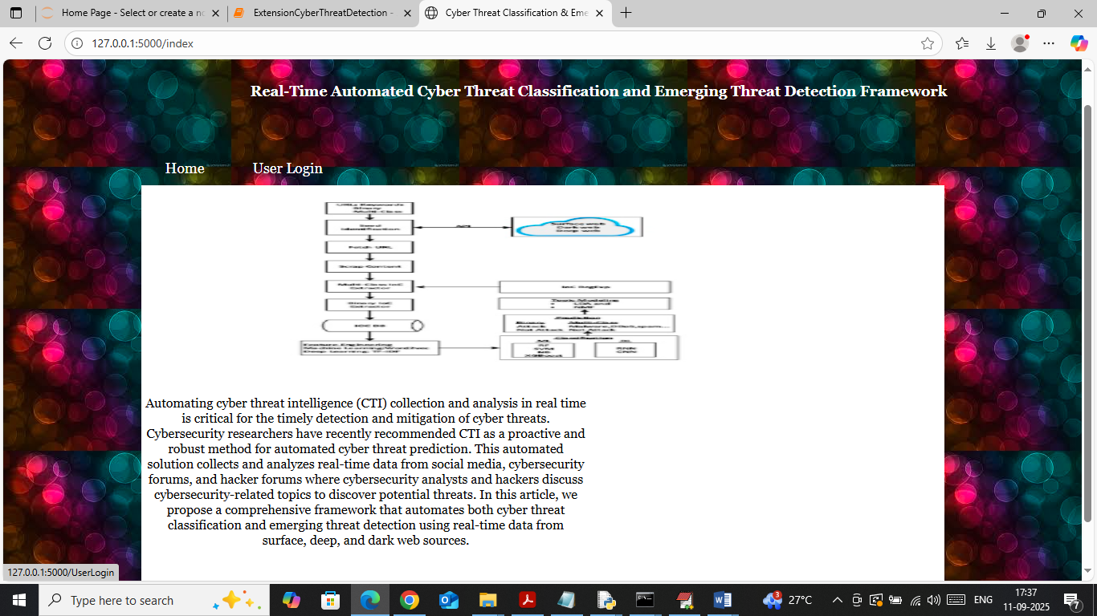
In above screen click on ‘User Login’ link to get below page
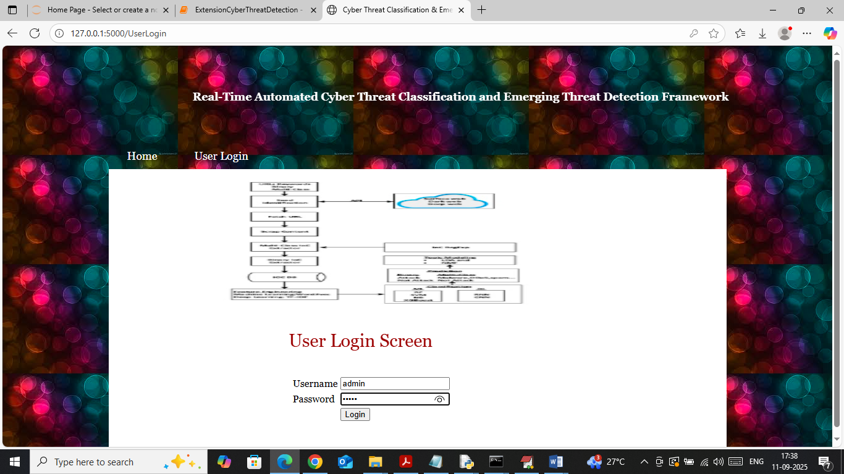
In above screen user is login by entering username and password as ‘admin and admin’. After login will get below page
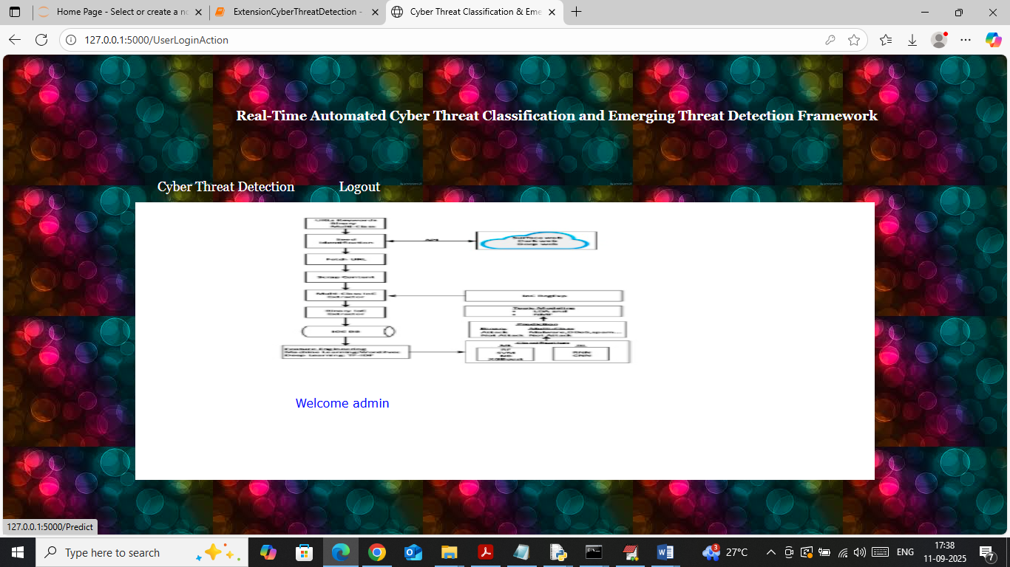
In above screen click on ‘Cyber Threat Detection’ link to get below page
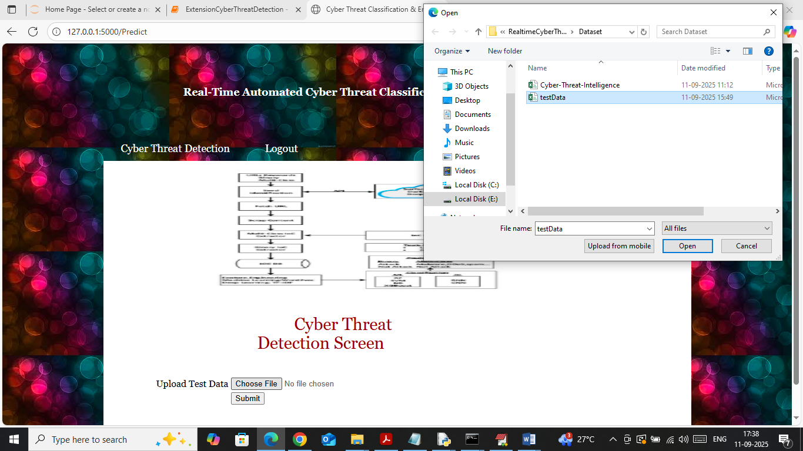
In above screen selecting and uploading test data file and then click on buttons to get below page
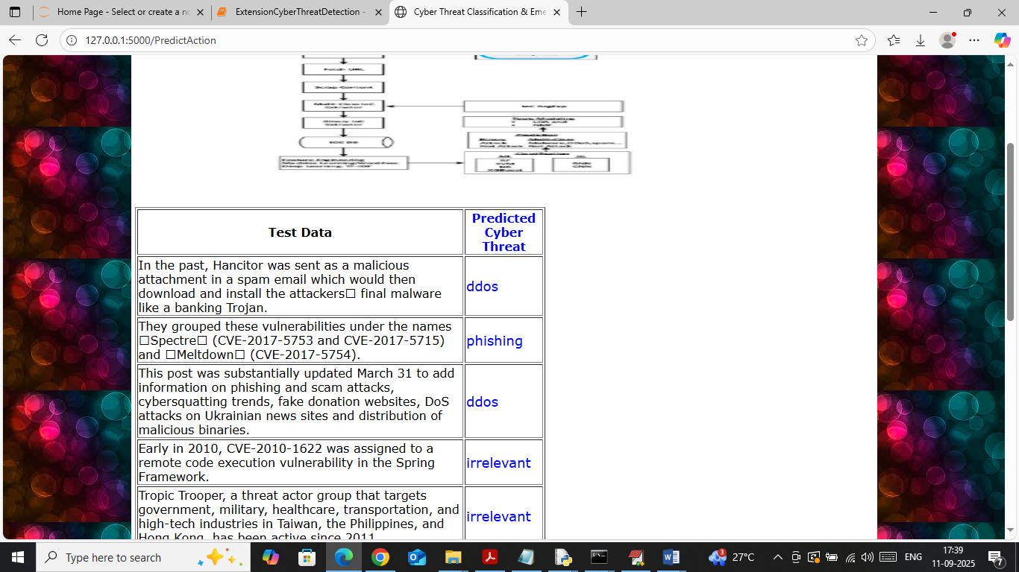
In above screen in first column can see Test data sentences and in second column can see predicted threat types.

