- JavaScript Fundamentals:

Variables
➤ var, let, const
- var: Function-scoped, hoisted (older, avoid using).
- let: Block-scoped, can be reassigned.
- const: Block-scoped, cannot be reassigned (constant).
Example:
Var a=5;
Let b=7;
Const c=19;

b = 15;(Valid)
c = 25;(Error: const cannot be reassigned)

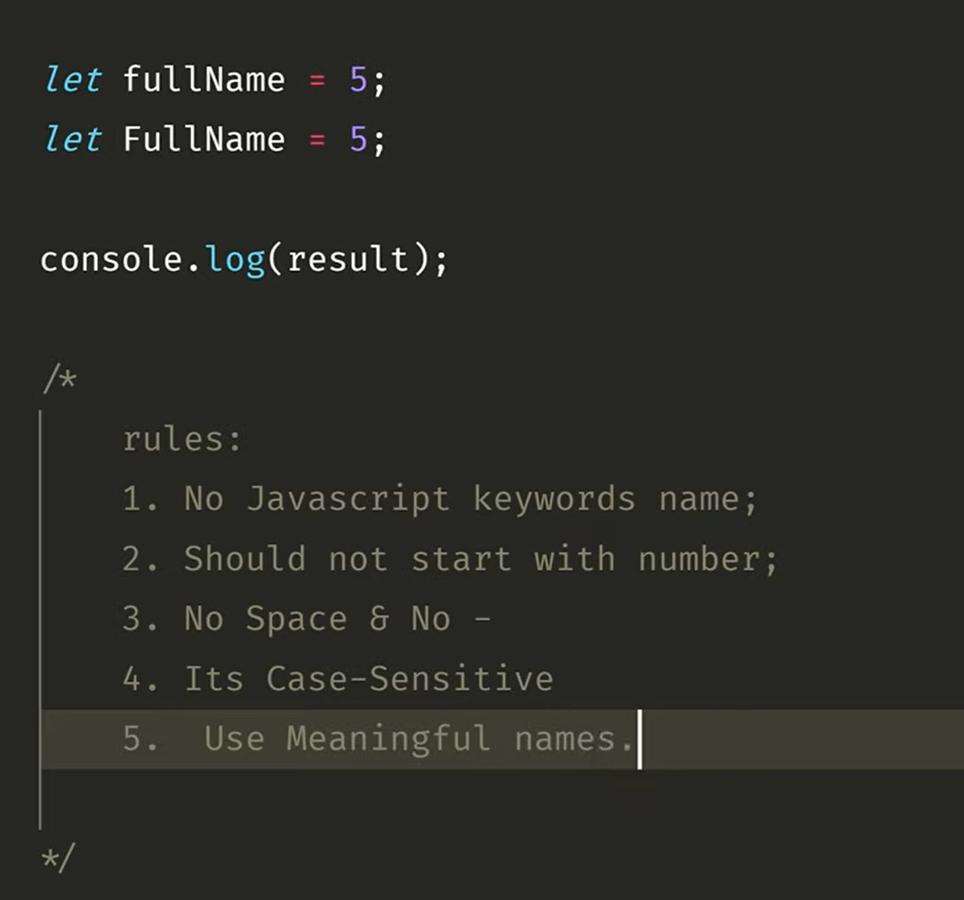

Data Types

➤ JavaScript has 7 primitive types:
- String: Text
Ex:let name = "Alice";
- Number: Integer or float
Ex:let age = 25;
- Boolean: true or false
let isOnline = true;
- Object: Collection of key-value pairs
let user = { name: "Bob", age: 30 };
- Array: Ordered list of items
let fruits = ["Apple", "Banana", "Mango"];
- Null: Intentional absence of any value
let salary = null;
- Undefined: Declared but not assigned
let job;
console.log(job); // undefined

Operators:

Arithmetic Operator:
let x = 10, y = 3;
console.log(x + y); // 13
console.log(x - y); // 7
console.log(x * y); // 30
console.log(x / y); // 3.33

Comparison Operators:

console.log(5 == '5'); // true (value only)
console.log(5 === '5'); // false (value + type)
console.log(5 != 6); // true
console.log(10 > 5); // true

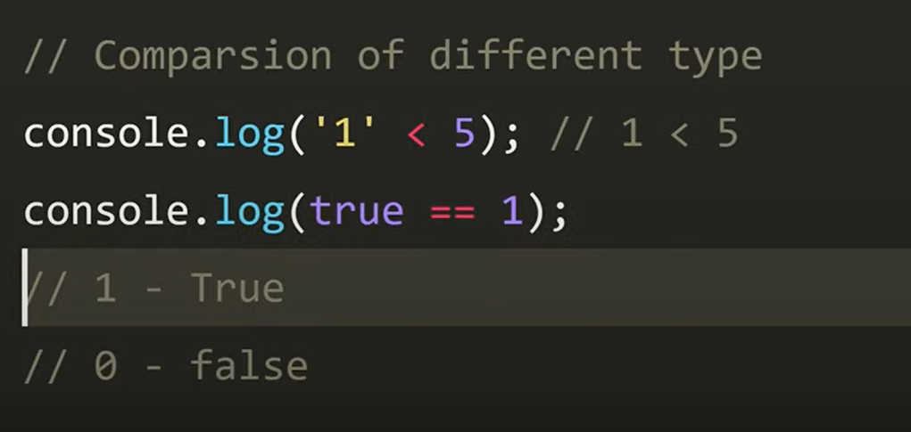

Logical Operators:
let a = true, b = false;
console.log(a && b); // false (Logical AND)
console.log(a || b); // true (logical OR)
console.log(!a); // false (Logical NOT)

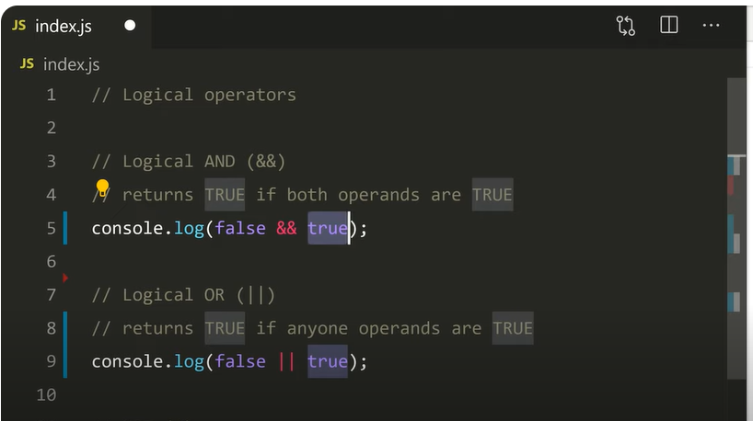

If, else if, else:
let score = 85;
if (score >= 90) {
console.log("A Grade");
} else if (score >= 75) {
console.log("B Grade");
} else {
console.log("C Grade");

Switch:

let day = 2;
switch(day) {
case 1: console.log("Monday");
break;
case 2: console.log("Tuesday");
break;
default: console.log("Other Day");
}

LOOPS:

While Loop:

let i = 0;
while (i < 3) {
console.log(i);
i++;
}
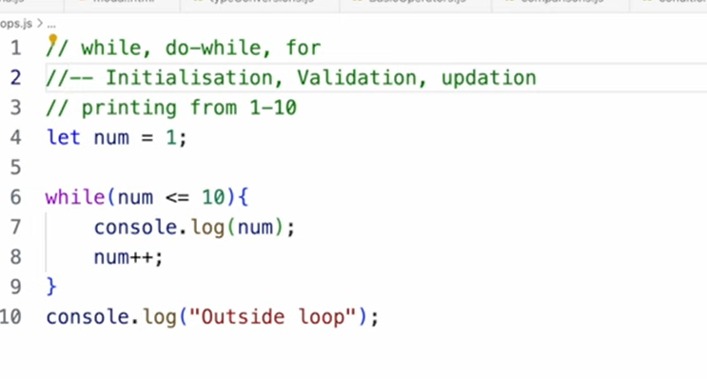

DO WHILE Loop:(Exit Control Loop)
The do...while loop is a type of loop that executes the code block once before checking the condition.
Even if the condition is false, the loop will run at least one time.
let j = 0;
do {
console.log(j);
j++;
} while (j < 2);

FOR Loop:
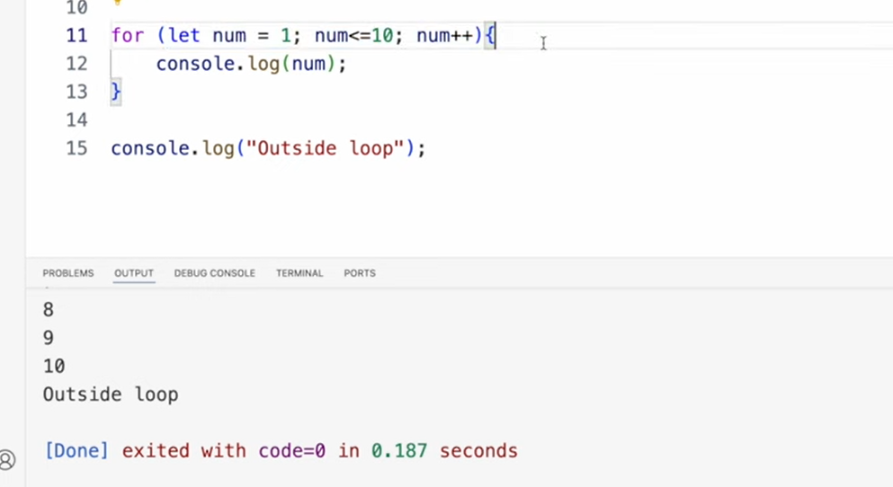
Ternary Operator:
The ternary operator is a one-line if-else statement. It's called "ternary" because it uses three parts.

let age = 20;
let access = age >= 18 ? "Allowed" : "Denied";
console.log(access) // "Allowed"

Loop Type | Condition Checked | Runs At Least Once? | Best For
for | Before each loop | No | Known number of iterations
while | Before each loop | No | Unknown number of iterations
do...while | After each loop | ✅ Yes | Run once before checking

Function :
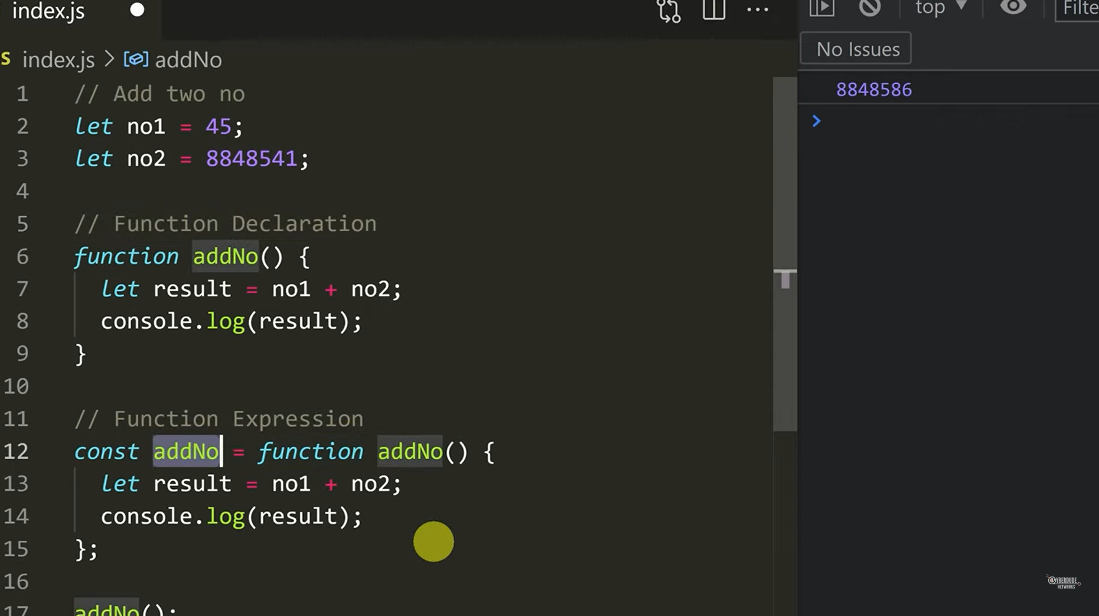
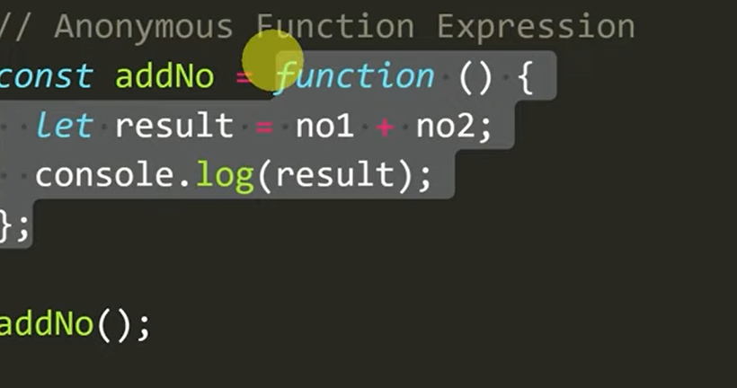

Arrow Function:
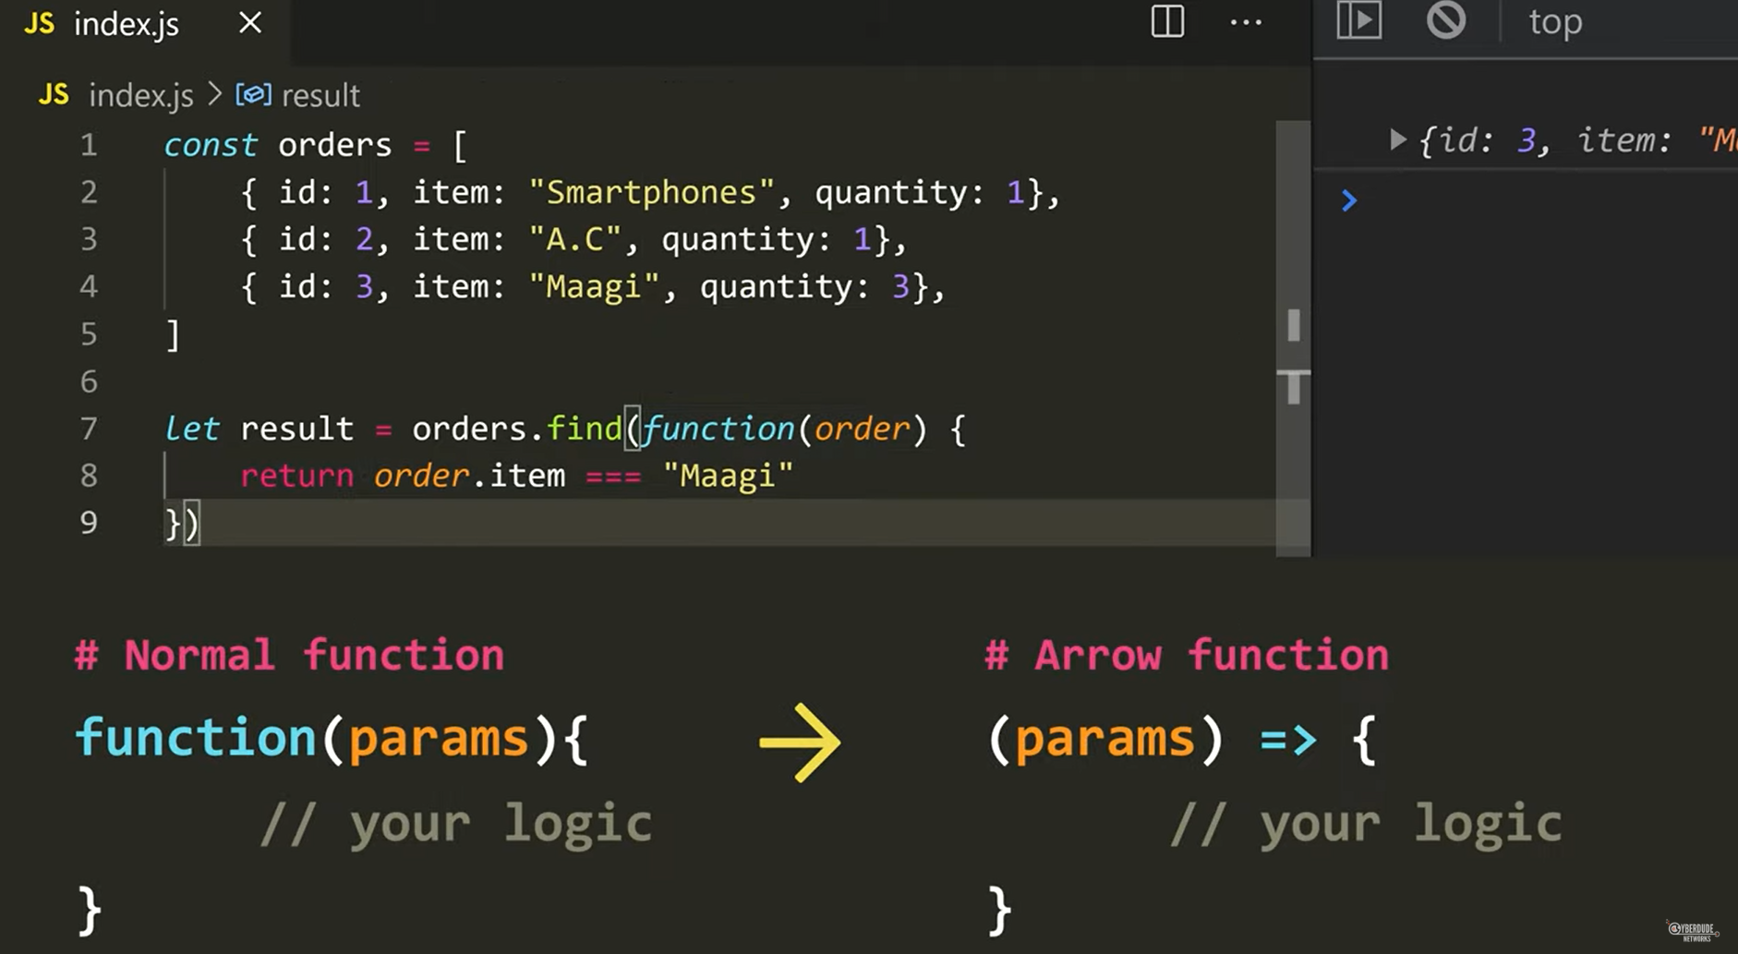
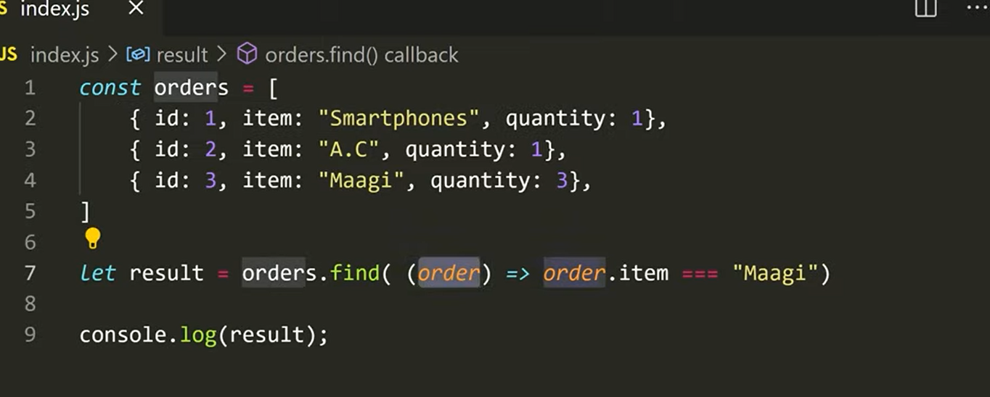
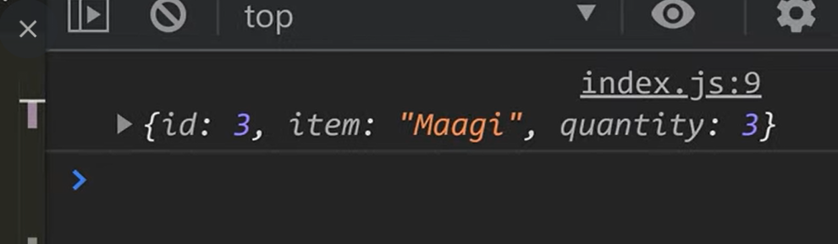

CALL BACK:
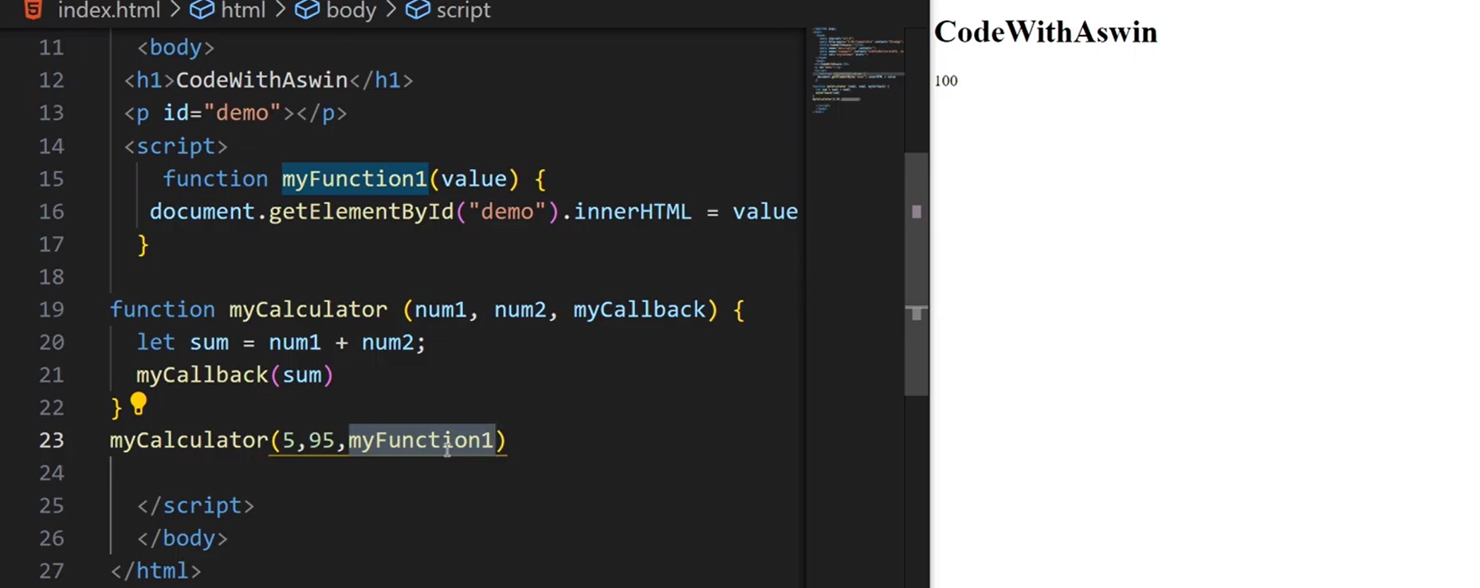

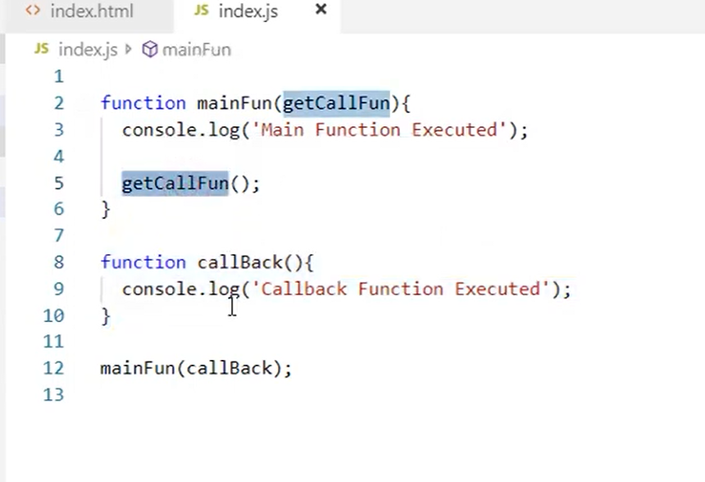

What is Browser Storage?
Browser storage allows your website to save data in the user's browser, so it can remember things even after refreshing or reopening the page.1.Cookies
- Small pieces of data stored in the browser.
- Sent to the server with every HTTP request.
- Can be used for login sessions, user tracking, etc.
- Can be set to expire at a certain time.
Example in JavaScript:
document.cookie = "username=Adhithya; expires=Fri, 25 Jul 2025 12:00:00 UTC";

2.Local Storage
- Stores data in the browser permanently (until manually cleared).
- Data stays even after closing the tab or browser.
- Can store up to ~5MB of data.
- Easy to use for storing user settings or tokens.
Example:
localStorage.setItem("name", "Adhithya"); // Save
let name = localStorage.getItem("name"); // Get
localStorage.removeItem("name"); // Remove

3️. Session Storage 🧾
- Similar to Local Storage, but clears when the tab is closed.
- Good for temporary data like current page state.
- Also allows up to ~5MB.
Example:
sessionStorage.setItem("theme", "dark");
let theme = sessionStorage.getItem("theme");
sessionStorage.removeItem("theme");

UNDERSTANDING WEB ARCHITECTURE:

🖥️ Client-Server Architecture Overview

📌 What is it?
The Client-Server Architecture is a design pattern in computing where clients (like web browsers or mobile apps) interact with servers (powerful computers or services) to request and receive data.
How it works:
- Client: Sends a request (e.g., user clicks "Get Data")
- Server: Receives the request, processes it, and sends back a response
- Client: Receives and displays the data to the user

💡 Real-world Analogy:
- Client: A waiter taking your order (browser/app)
- Server: The kitchen that cooks your food (backend/database)
- Response: The waiter brings your food back to your table

🔗 Components:
Component | Role
Client | User-facing interface (e.g., web browser)
Server | Processes requests, contains logic, connects to databases
Database | Stores data used by the server

🔌 What is an API?

📌 API = Application Programming Interface
An API is a set of rules that lets different software systems talk to each other.

📦 Example:
You use an API when:
- Your frontend app fetches weather data from a weather server
- A login form sends your email/password to the backend
fetch("https://api.weather.com/data")
.then(response => response.json())
.then(data => console.log(data));

Key Types of APIs:
Type | Use Case
REST API | Web apps (HTTP methods: GET, POST, PUT, DELETE)
GraphQL API | Flexible querying (used by Facebook)
WebSocket API | Real-time communication (chat apps)

🎨 Difference Between Frontend and Backend Development
Feature |  | Frontend | Backend
📍 What it is | Part of the app users see & interact with |  | Part of the app that runs on the server
👀 Example | Buttons, forms, layout, animations |  | API, database, authentication, business logic
🛠️ Technologies | HTML, CSS, JavaScript, React, Vue, Angular |  | Node.js, Express, Django, PHP, Java, Python
⚡ Role | Handles UI/UX and user interaction |  | Handles data, logic, security, database
🔄 Communication | Sends requests to APIs (backend) |  | Receives frontend requests, sends responses

🔁 Real-life Example (Login Form):
Step | Frontend | Backend
1. User enters email/password | Input field UI
2. Clicks "Login" button | Sends API request | Validates credentials
3. Gets response | Displays "Welcome" or error | Sends back token or error

✅ Summary
Topic | Summary
Client-Server Architecture | Client sends requests, server responds with data
API | Interface that lets apps talk to each other
Frontend vs Backend | Frontend is what users see, backend is the logic behind the scenes
HTTP Methods:

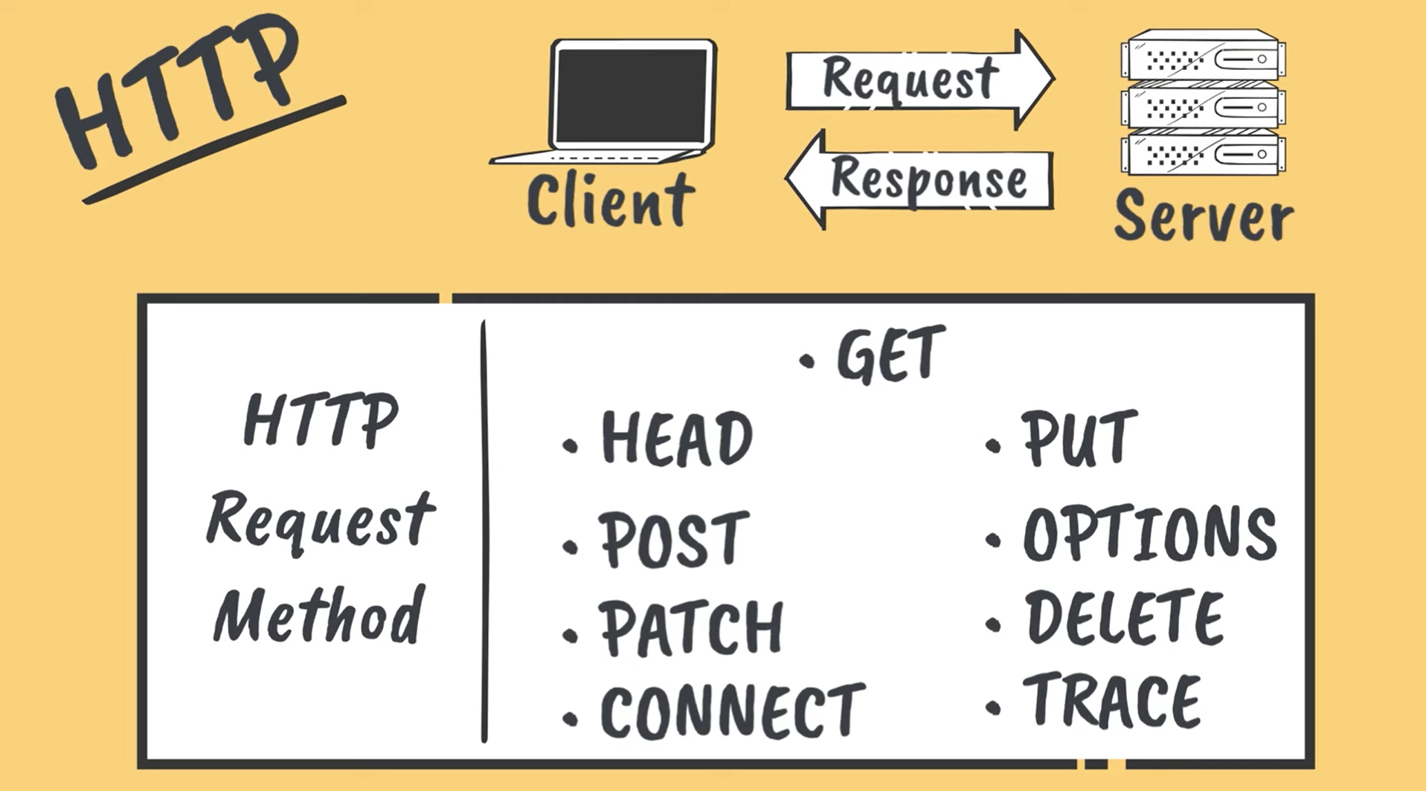

GET REQUEST:
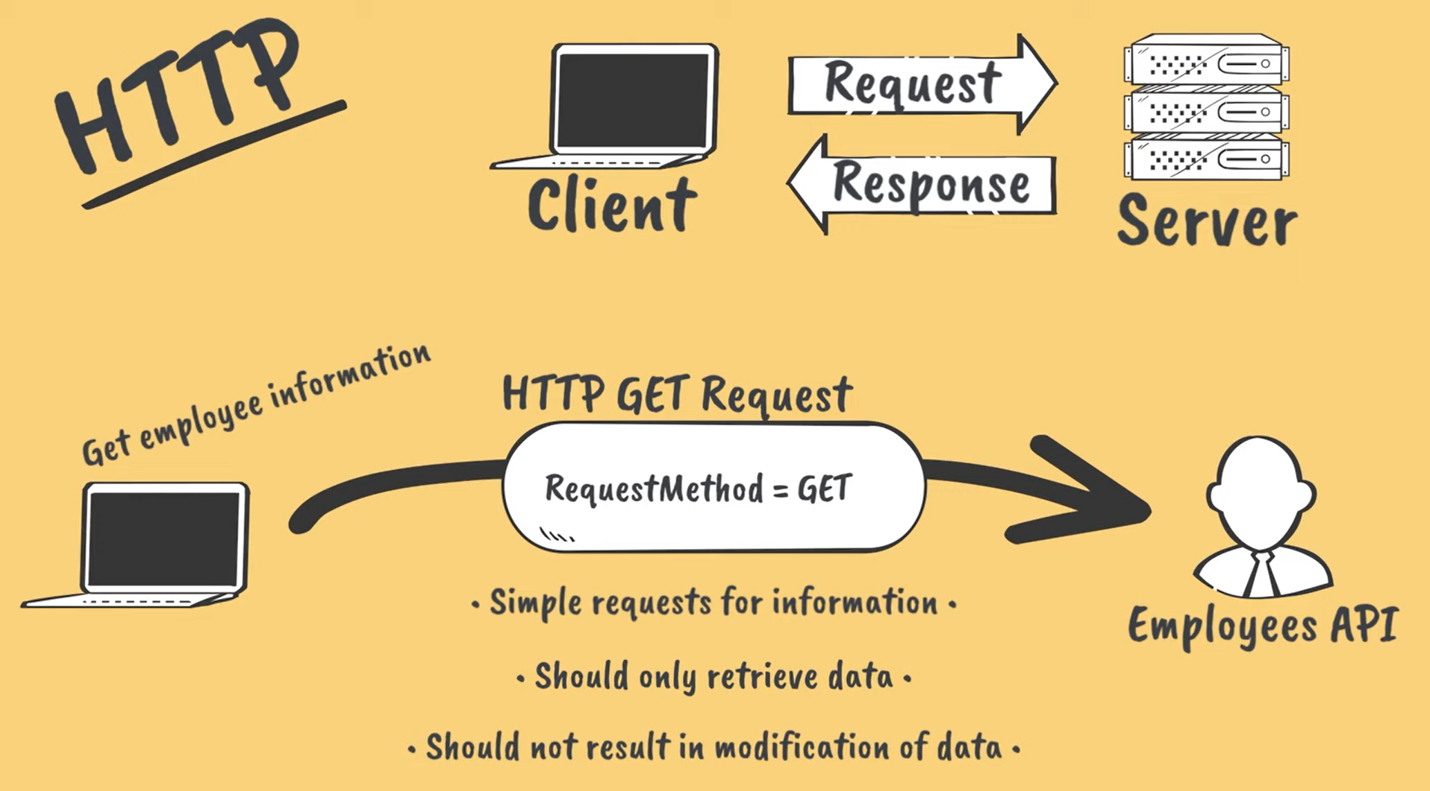

POST Request:
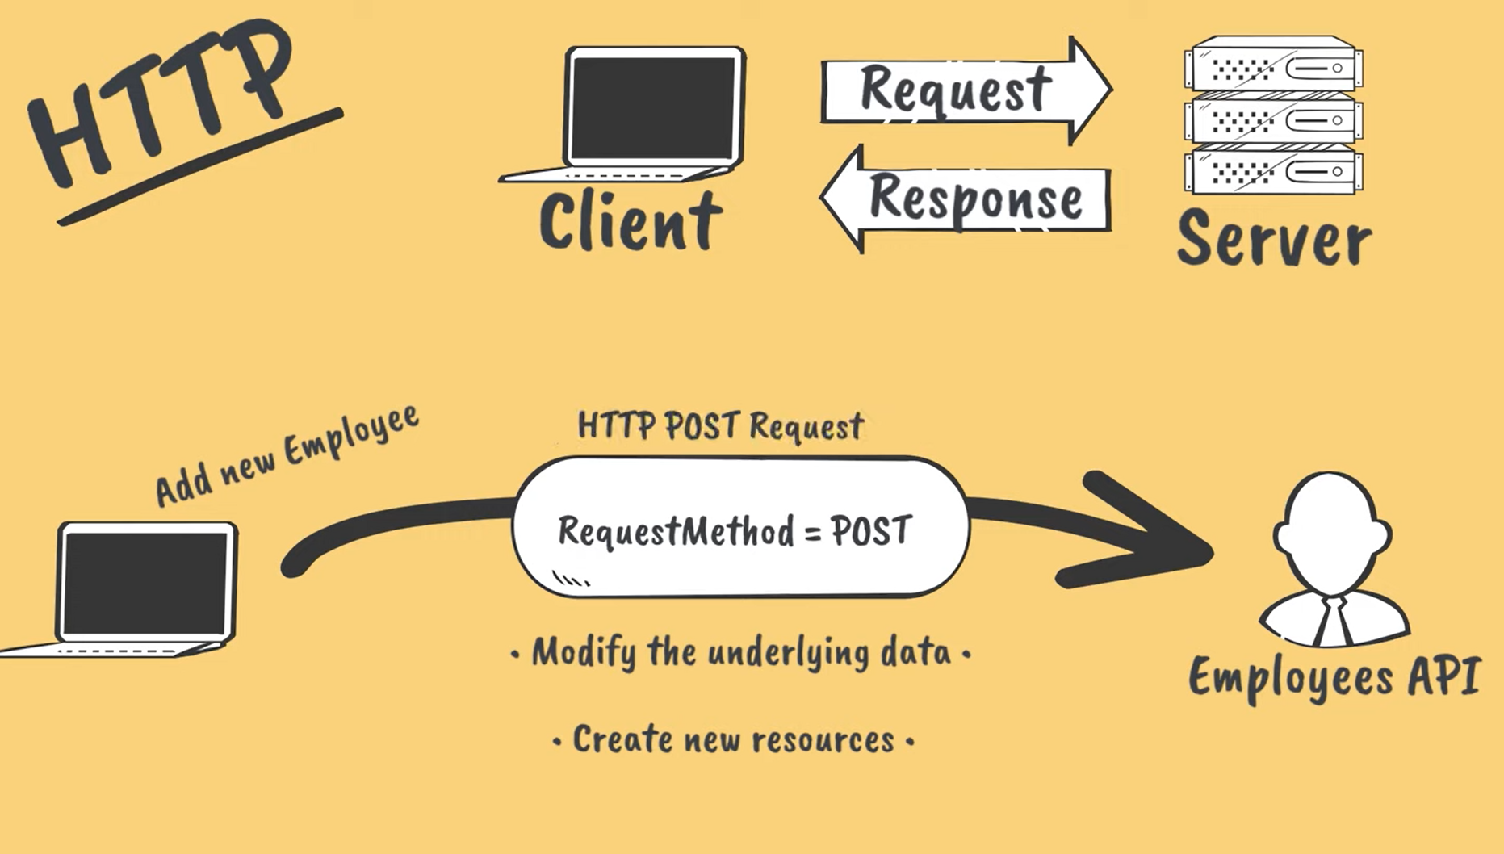
PUT Request:
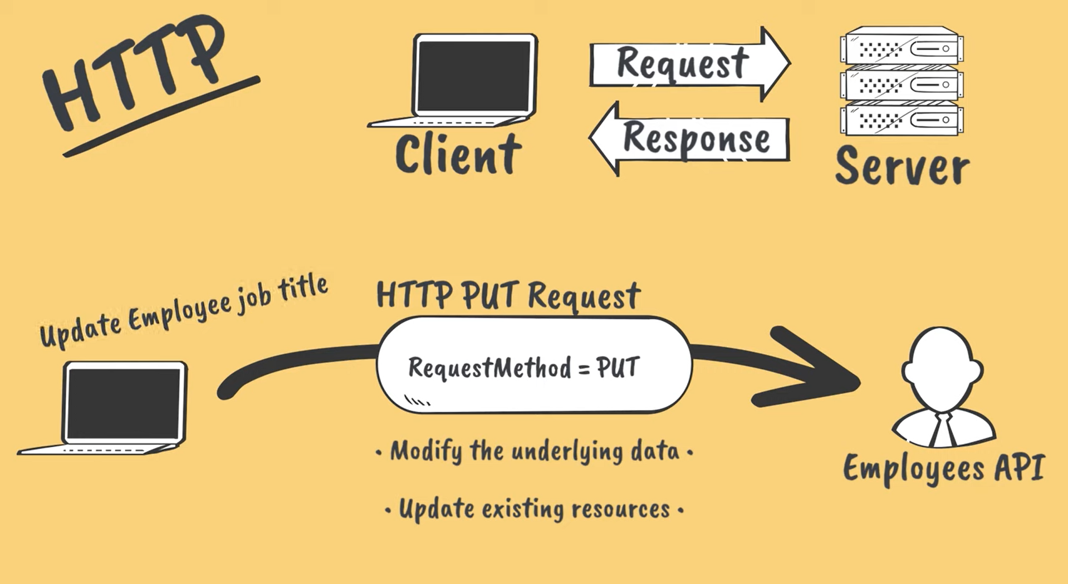
DELETE Request:
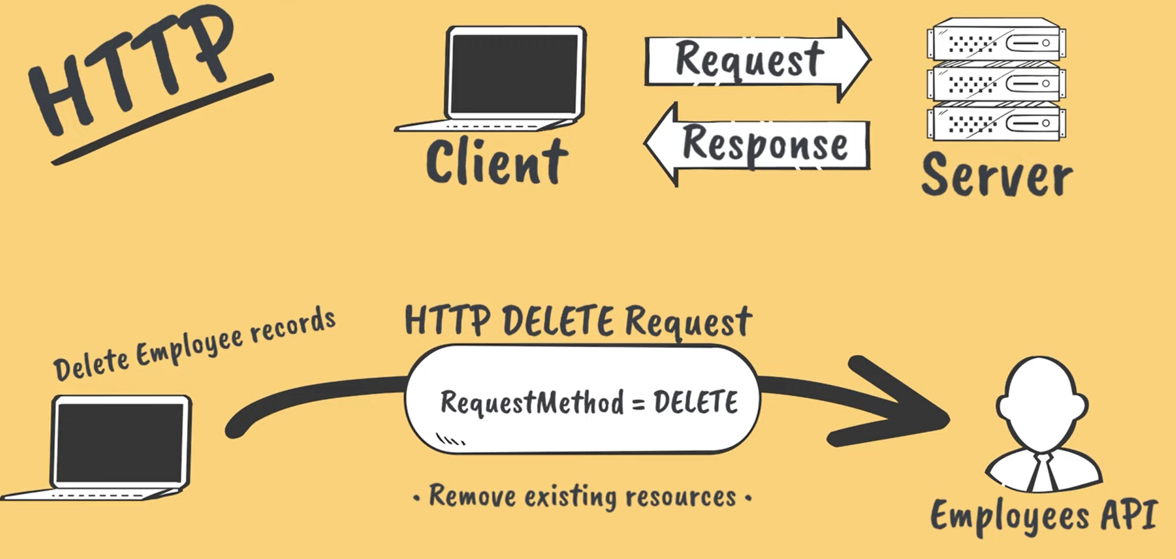
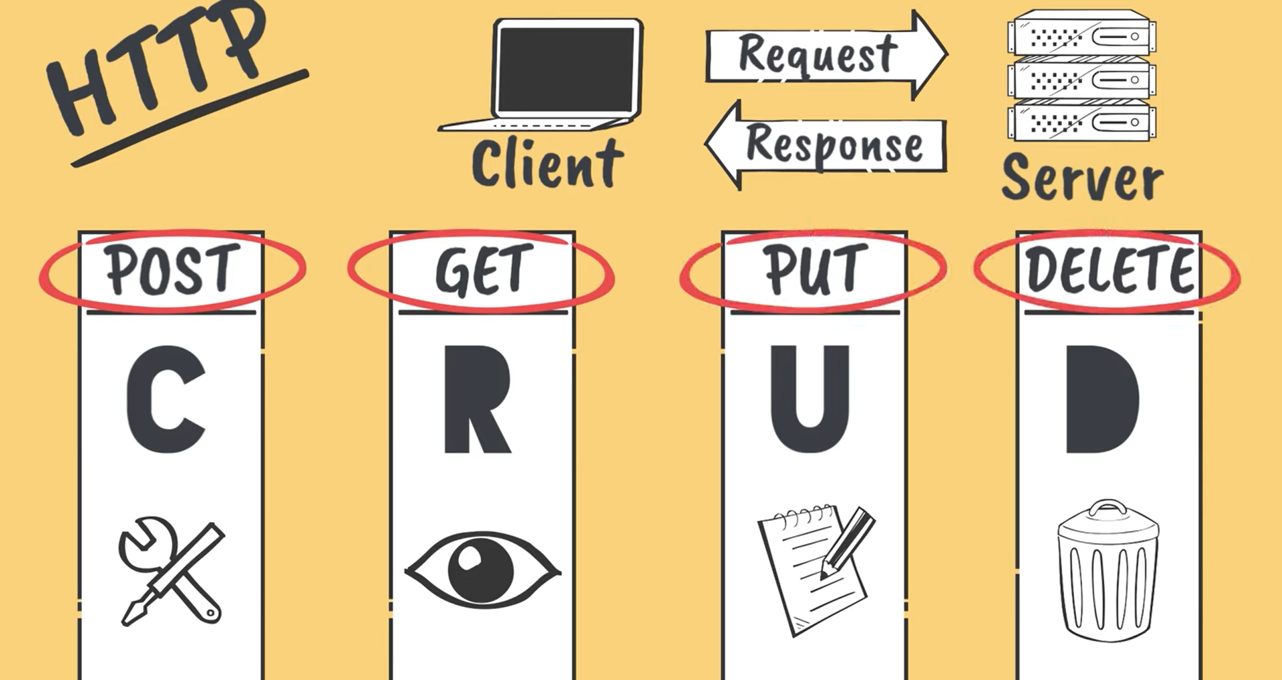

Express Js:
Implementation of MVC:
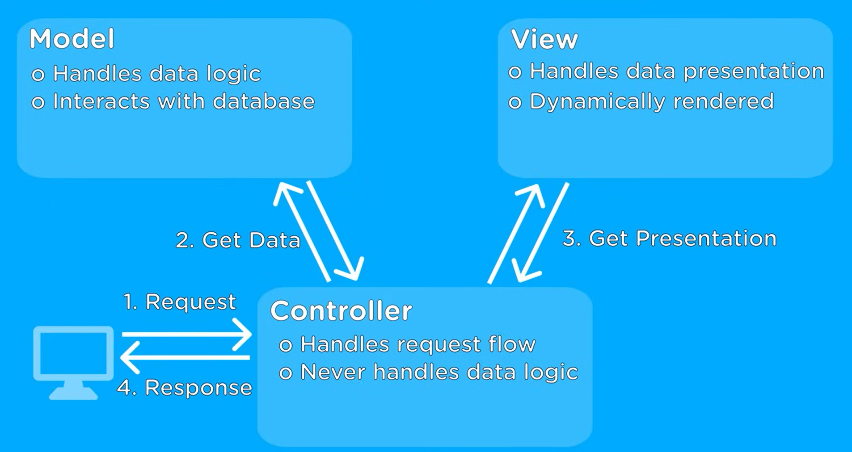
Example:
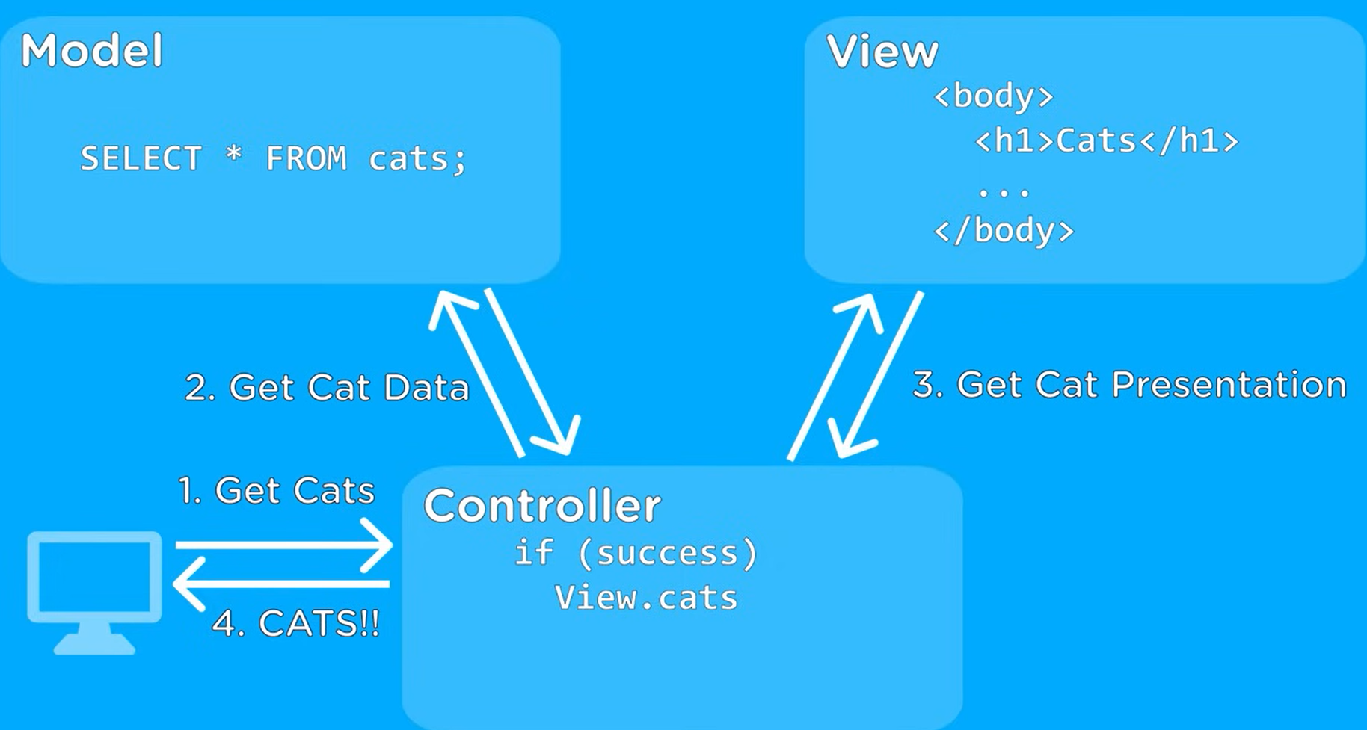
Example(if error occurs):
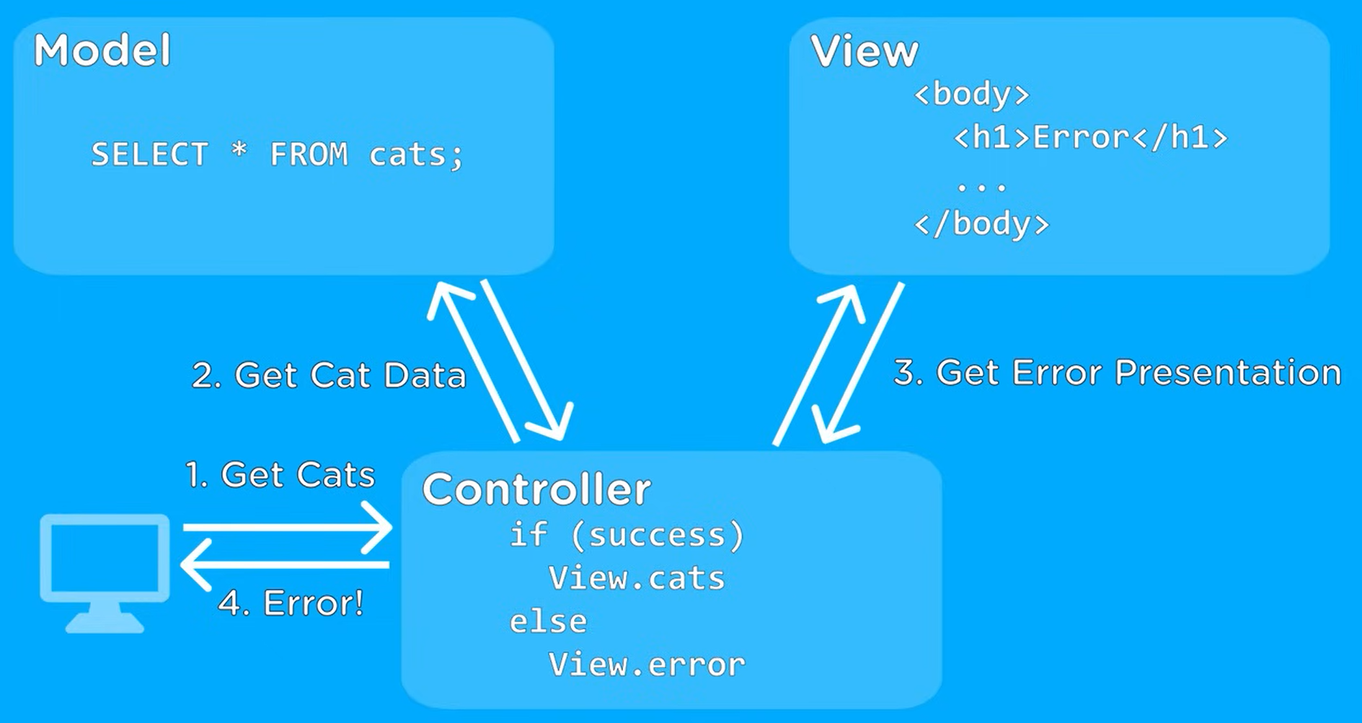
EXPRESS Middle Ware:
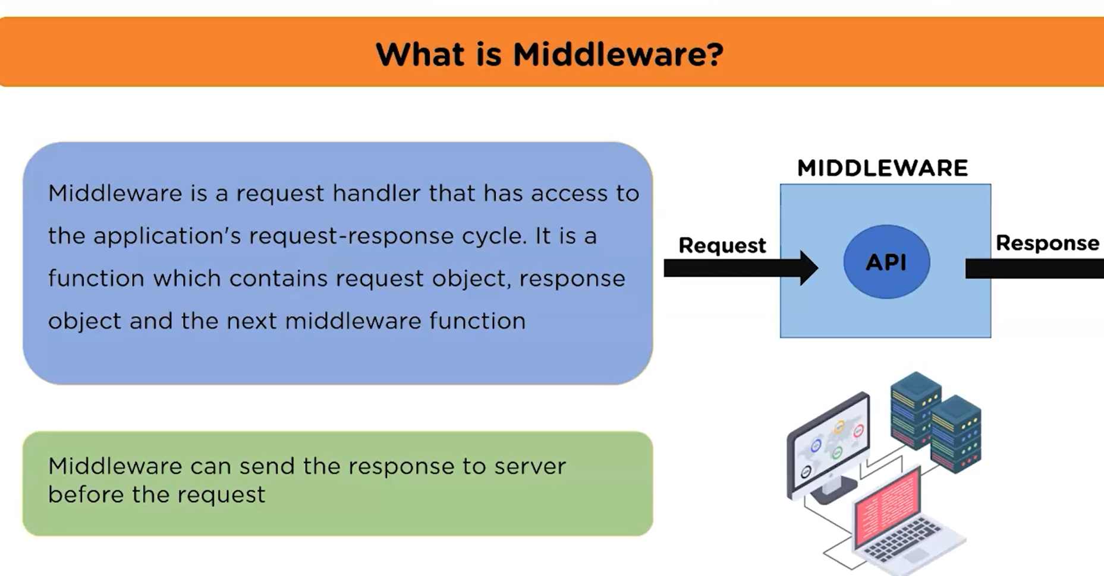
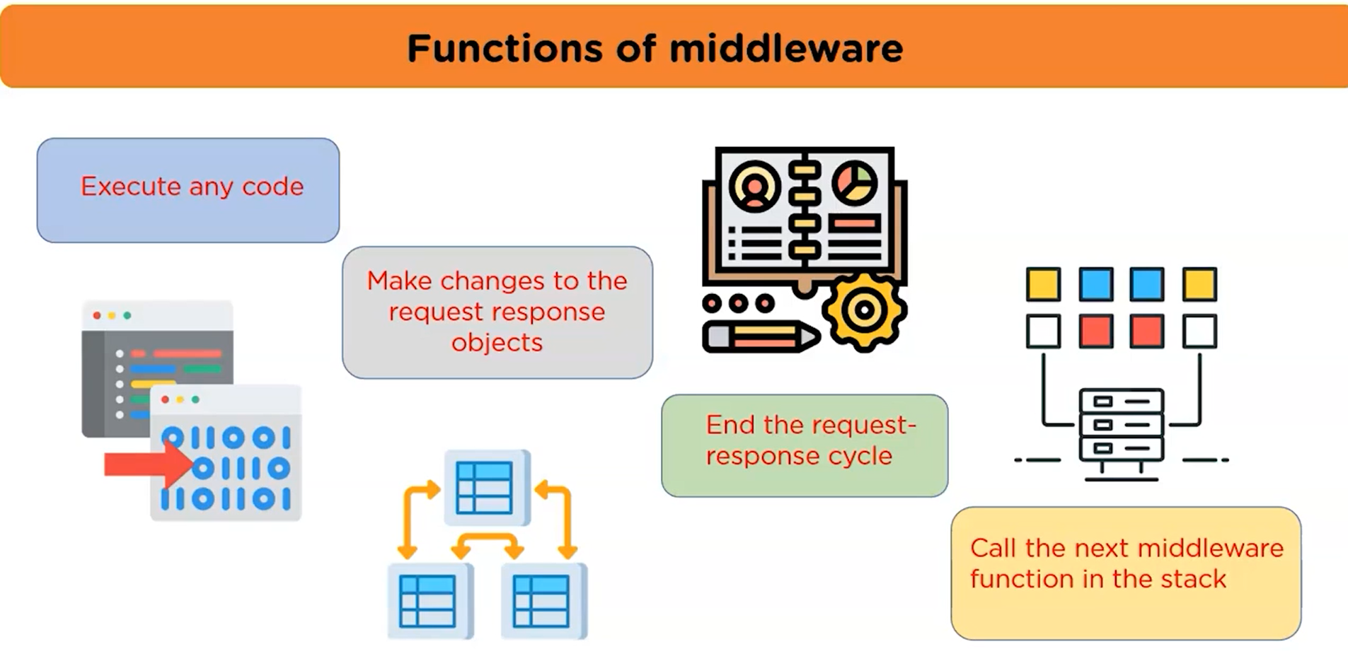

ERROR Handling and Validation:
Real-World Example: User Registration API:
Let’s say you’re building a website where users register. You want to:
- ✅ Check if their name, email, and age are valid.
- ❌ If something is wrong, show a clear error message.
- 🔐 Prevent server from crashing if an error happens.
We will do validation and error handling together using Express.js.

Final Output You Want
If everything is OK:

{
"message": "User registered successfully",
"data": {
"name": "John",
"email": "john@gmail.com",
"age": 22
}
}
If input is wrong:
{
"errors": [
{ "msg": "Name is required" },
{ "msg": "Valid email is required" },
{ "msg": "Age must be 18 or older" }
]
}

Step-by-Step Guide:

1. Setup Project
Open terminal and run:
mkdir user-api
cd user-api
npm init -y
npm install express express-validator

2. Create index.js File
Paste this full code:
const express = require('express');
const { body, validationResult } = require('express-validator');

const app = express();
app.use(express.json()); // Allow JSON data

// ✅ Route to register a user

app.post(
'/register',
[
body('name').notEmpty().withMessage('Name is required'),
body('email').isEmail().withMessage('Valid email is required'),
body('age').isInt({ min: 18 }).withMessage('Age must be 18 or older'),
],
(req, res) => {
const errors = validationResult(req);

// ❌ If validation fails

if (!errors.isEmpty()) {
return res.status(400).json({ errors: errors.array() });
}

// ✅ If all good

const user = req.body;
res.status(201).json({ message: 'User registered successfully', data: user });
}
);

// Error handling middleware (runs if something breaks)

app.use((err, req, res, next) => {
console.error('Error:', err.stack);
res.status(500).json({ error: 'Something went wrong on the server!' });
});

// ✅ Start server

app.listen(3000, () => {
console.log('Server running at http://localhost:3000');
});
How to Test:
Use a tool like Postman, or a frontend form to test the route:

🔸 Send POST to: http://localhost:3000/register

Body (valid input):
{
"name": "Adhithya",
"email": "ad@gmail.com",
"age": 21
}

You get:

{
"message": "User registered successfully",
"data": {
"name": "Adhithya",
"email": "ad@gmail.com",
"age": 21
}
}

Body (invalid input):

{
"name": "",
"email": "wrong-email",
"age": 15
}
You get:

{
"errors": [
{ "msg": "Name is required", "param": "name" },
{ "msg": "Valid email is required", "param": "email" },
{ "msg": "Age must be 18 or older", "param": "age" }
]
}

Recap in Simple Words:

Feature | What It Does
express.json() | Allows reading req.body
express-validator | Checks if the data is correct
validationResult | Collects errors if any exist
res.status(400) | Sends error response to user
Error middleware | Catches server errors safely

This is how professional APIs work:
- They check every input (so your app doesn’t crash).
- They give users clear error messages.
- They log internal problems safely.

Database Integration with Express:
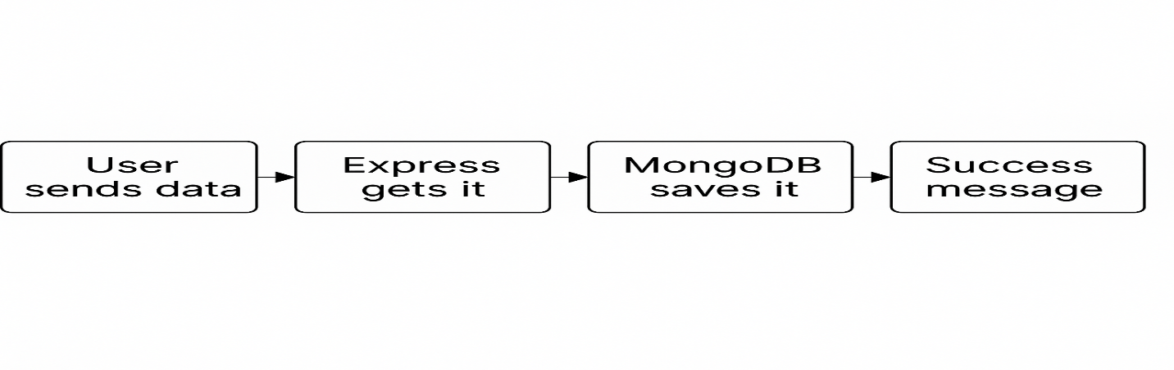
Integrating a database with Express.js involves connecting your application to a database system like MongoDB, MySQL, or PostgreSQL. This allows you to store, retrieve, and manage data within your application. The process typically involves installing a database-specific Node.js driver, establishing a connection, and then using the driver's methods to interact with the database.
Introduction to MongoDB:
MongoDB is a NoSQL database that stores data in a flexible, JSON-like format called documents. Unlike traditional databases (SQL), MongoDB does not use tables and rows — instead, it uses collections and documents. This makes it easier and faster to store, read, and update data, especially for web and mobile apps.
KEY Points:
- MongoDB stores data as documents (like objects).
- Documents are grouped into collections (like folders).
- It’s used for web apps, APIs, mobile apps, etc.
- Works great with Node.js and Express.js.

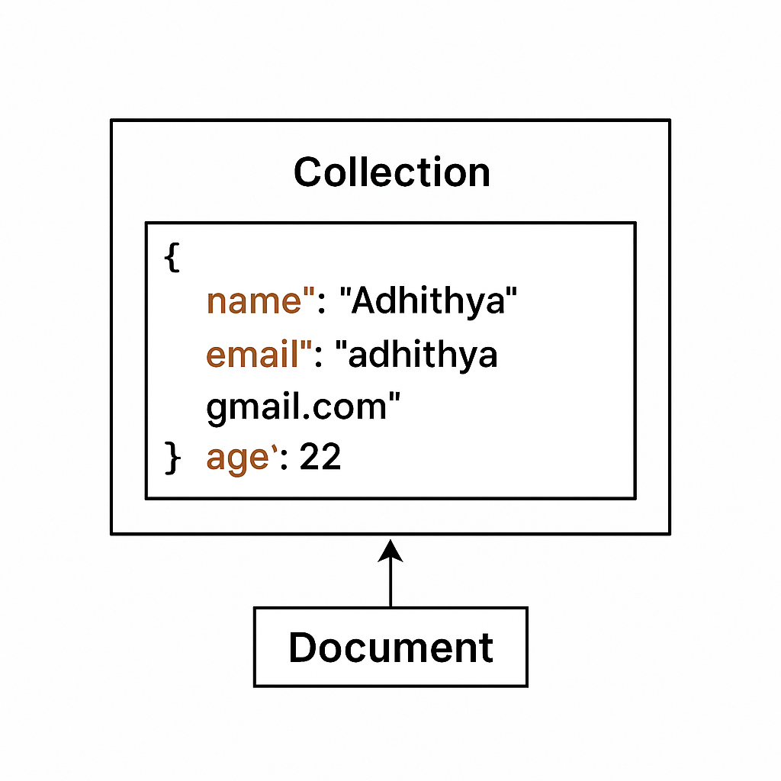
Using Mongoose for MongoDB Object Modeling:
Mongoose is a tool that helps your Node.js + Express app connect to a MongoDB database and easily manage data like users, products, etc.
It lets you:
- Define how your data should look (like name, email, age)
- Save data to MongoDB
- Get data from MongoDB

Schema Creation:
In Mongoose, a schema is used to define the structure of the data you want to store in MongoDB. It acts like a blueprint that tells MongoDB what fields a document should have and what type of data each field should contain. For example, if you are creating a user database, your schema might include fields like name, email, and age. You define this using new mongoose.Schema() and then create a model from it using mongoose.model(). This model is what you’ll use to create, read, update, and delete data in your database

CRUD Operations:
CRUD means Create, Read, Update, and Delete — the 4 main things we do with data. Using Mongoose in an Express app, we can manage data in MongoDB easily.
EX:
Create → Add new user, Read → Get users from DB, Update → Change user info,
Delete → Remove user

Validation and Middleware:

In Express.js, validation means checking the data before using it — like making sure a user entered a name or typed a valid email. This helps prevent mistakes or wrong data from going into your database.
Middleware is a function that runs in the middle — before your main route does its work. It can check things like the input (validation), if the user is logged in (authentication), or just print something (like logging). For example, when someone registers, middleware can check the details first, and if everything is okay, it goes to the part where we save it.

Simple Example Flow:
- User sends form ➡️
- Middleware checks data ➡️
- If valid, save to DB ➡️
- If not valid, send error

Tools & Best Practices

1.API Testing Using Postman
Postman is a tool to test your backend API without building a frontend. You can send GET, POST, PUT, and DELETE requests to your Express routes. For example, if you have a /login API, you can send { "email": "test@gmail.com", "password": "1234" } through Postman and check the response. It shows status codes, errors, and returned data. This helps you debug and confirm your backend is working before connecting it to the UI.
2.Version Control with Git and GitHub
Git helps you save your code in steps so you can go back anytime. GitHub is an online place to store and share your code.
For example, after adding a new feature, run git commit -m "added register route" and push it to GitHub. This keeps your project backed up and allows you to work with a team. It's also required when deploying your backend online.

3.Deployment on Render or Similar Platforms
Render allows you to host your Express backend online for free. After pushing your code to GitHub, you can connect it to Render, and it creates a live URL like https://my-api.onrender.com. This means your API can be used by your frontend, mobile app, or even Postman from anywhere in the world. It’s simple, beginner-friendly, and supports auto-updates from GitHub.

4.Writing Clean and Maintainable Code
Writing clean code means using proper names, indentation, and organizing your files.
For example, instead of writing everything in index.js, split logic into routes/, models/, and controllers/ folders. Avoid repeating code and always write comments for clarity. Clean code makes your project easier to fix, grow, and understand — especially when working in a team.

5.Basic Security Practices for Backend Development
Backend security means keeping your app safe from hackers and bad input. You should use a .env file to hide secrets (like database passwords), and use express-validator to check inputs like email or password. Also, use helmet middleware to block common attacks.
Example: never send errors like "Database crashed" to the user — always return safe, generic messages.

Advanced Topics:

1.Pagination and Filtering:
Pagination helps you show data in smaller parts, like showing 10 users at a time instead of all 100 at once. This makes your app faster and easier to use. Filtering helps users search or narrow down data, like showing only users with the name "Adhithya" or products in a "Books"category. Both are used with URL queries like ?page=1&limit=10&name=Adhithya.

2.File Uploads and Management
Sometimes users need to upload files, like photos, resumes, or documents. In Express, we use a tool called multer to handle these uploads. It lets your backend receive the file and save it on your server or in the cloud.
For example, when a user uploads a profile picture, multer helps store that image and link it to the user’s profile.

3.Rate Limiting and Security Enhancements:
Rate limiting protects your backend by limiting how many times a user can send requests in a short time (like 100 requests in 15 minutes). This stops bots and spammers from crashing your server. You can use tools like express-rate-limit and helmet to improve security. Also, using a .env file keeps passwords and private info safe.

4.Logging and Monitoring:
Logging means keeping track of what’s happening in your app — like who visited, what went wrong, or when something failed. It’s like a diary for your server. You can use tools like morgan or winston to log requests and errors. Monitoring tools like Sentry help you watch for bugs in real-time, so you can fix them quickly.

