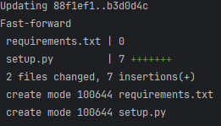
TASK 1: GitHub repo link - https://github.com/Adhithyan-Ramadoss/DSSS_FAU_WS_24_25.git
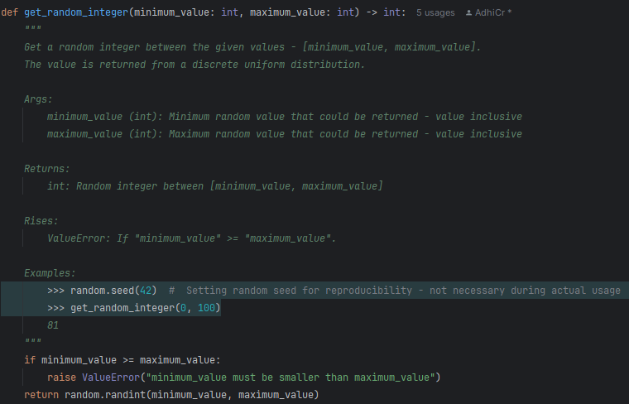
TASK 3:
$ git merge code_cleanup

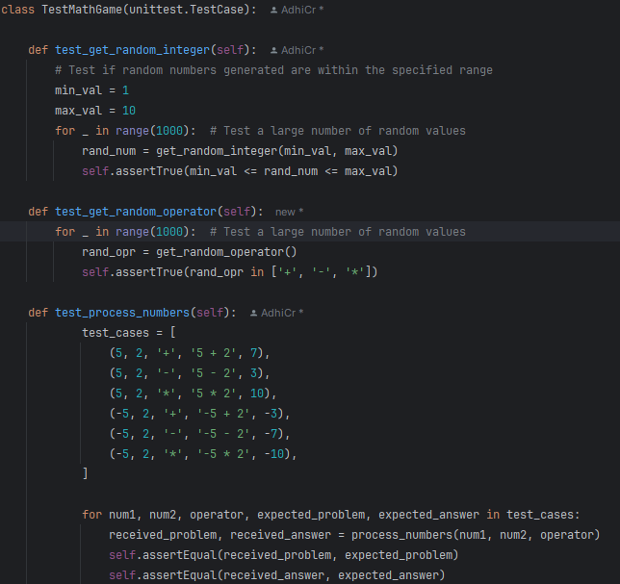

TASK 4:

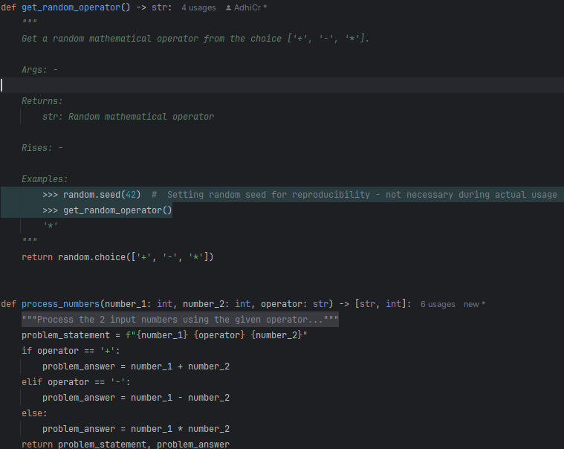

TASK 5:

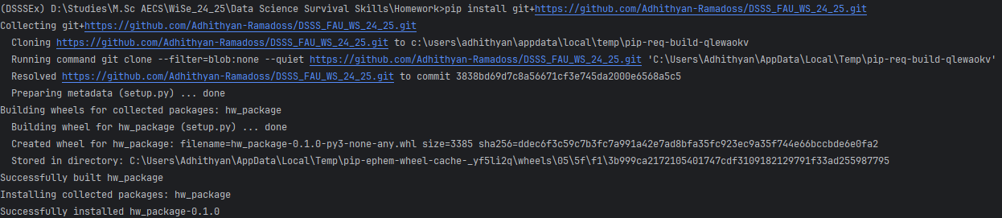

Name: Ramadoss, Adhithyan; Matriculation Number: 22322010; IdM: um41adoh

