**Comic**

**Bookstore**

**By Adhrika Pai ☺**



**Primary Line of Business:** Comic book selling

Comic Bookstore is a bookstore that provides comic books from all over the world to the local community for borrowing for 14 days.  Comic bookstore company has many business processes that help the company achieve its goals.  Two of the business processes are signing out books and reminding our customers to return the borrowed books. We notify our customers when the date is near by sending an email and we call the customers after the date has passed to remind them to return as well as informing them about their late return charges.

The sign outs of books can be done by two methods; self-checkout and sign out at the front desk with a help of a librarian. For book sign-out process, the data we acquire is the book ID, name of book signed out (corresponding with the book ID), Customer ID to indicate who signed it out, date of book sign-out, and date of return. The date of return is determined by the calculation of adding 14 days to the sign out date.

The customer reminding process needs the data of the due dates of all the signed-out books, which will help us identify which book is near the due date and which book is passed the due date. And to remind our customer, we need their information, of course. So, we have gathered all the information we may need in each of the two different reminding processes (nearby date and passed date) and have created a report of it to display all the necessary information.

**ACCESS OBJECTS**

The use of access has made our business processes much more efficient and increases productivity in our business.

The following is a breakdown of all the access objects we have created:

**TABLES**

1. **CUSTOMERS**

A table which includes the Customer ID, FirstName, LastName, Address, Email, PhoneNo:, City, State, PostalCode, and Country of the customers who have taken books from the Comic Bookstore. The phone number, customer’s ID, and the first and last name fields have been masked to their appropriate format.

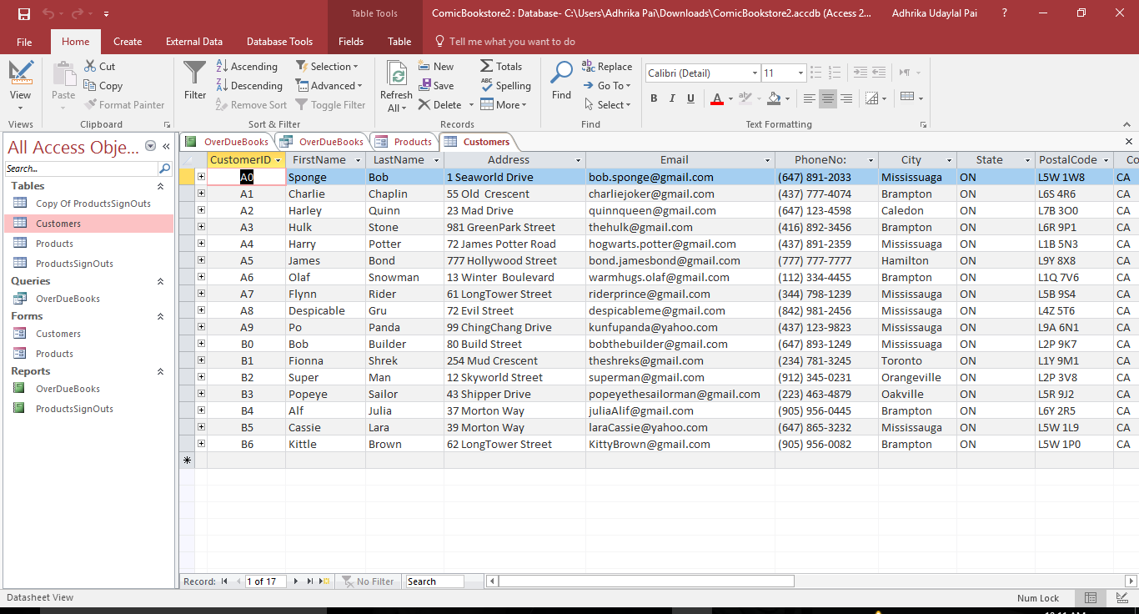

1. **PRODUCTS**

A table which includes the BookID, BookName, Author, No. of InitialCopies, No. of SignOuts (#SignOuts) and the No. of copies available in the bookstore(#Available). The No. of copies available is a calculated field which returns the difference between the number of copies signed out and the number of initial copies.

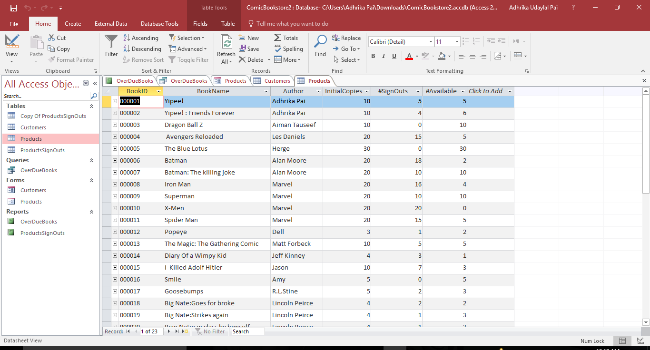

1. **PRODUCT SIGN OUTS**

A table consisting of the books that have been signed out by the customers. It contains the BookID, BookName, CustomerID, the date of sign out of the book (SignOutDate), the due date to return the book (DueDate). We have made access calculate the due date by adding 14 days to the sign out date. The Book name field has a lookup for the user to select the right book by selecting the correct book ID that corresponds.

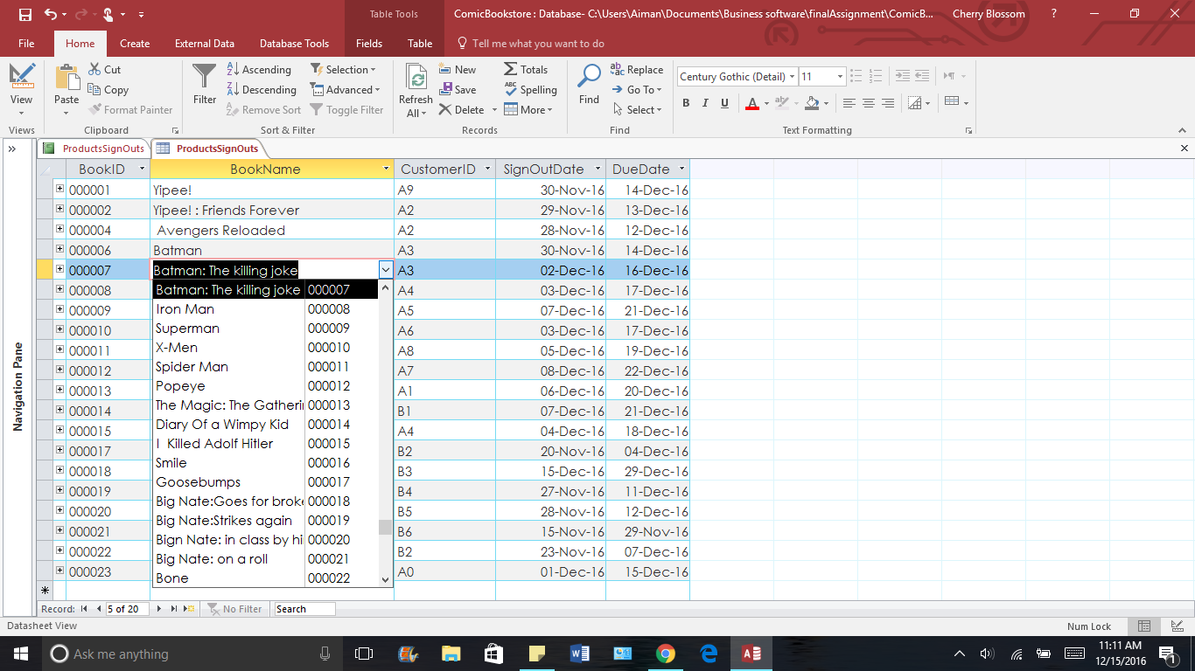

**FORMS**

1. **CUSTOMERS**

A form that displays the details of each of our customers taken from the customer table.

There is also sub-form which presents the list of all the books that the customer has signed out, and other information about the sign out like the due date of the books and this records turns red if the due date is passed. In such a case, the customer will be charged fine and this way we also know which customers don’t return books on time.

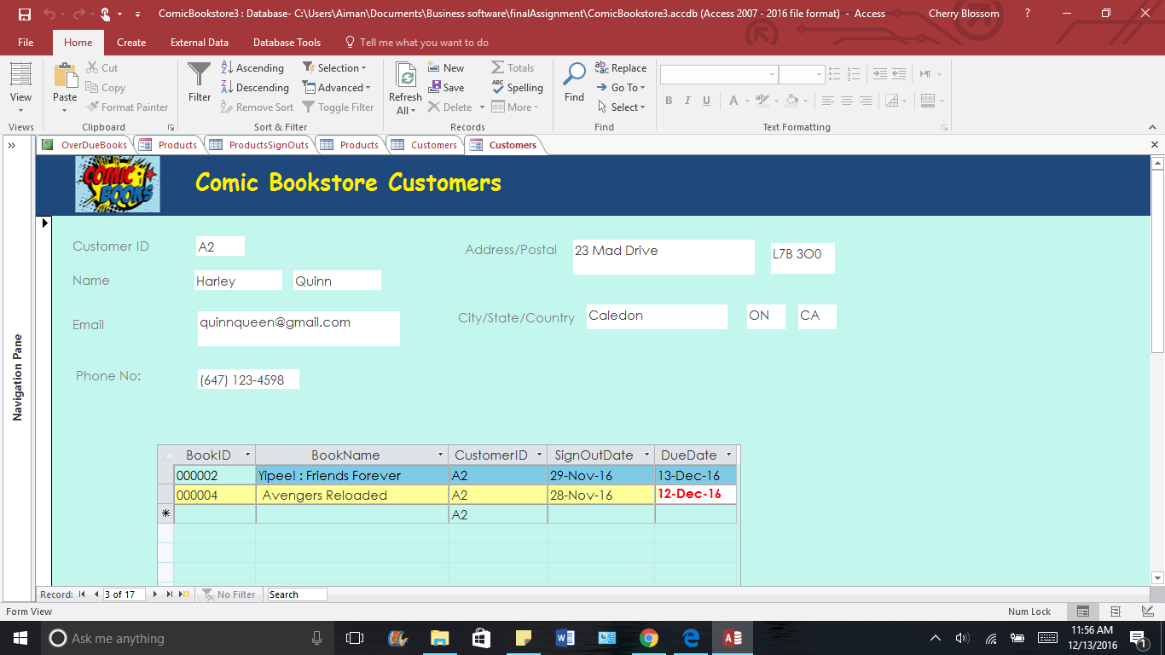

1. **PRODUCTS**

A form which displays the data taken from the products table and as well as a sub form which shows the customers who have signed out that particular book.

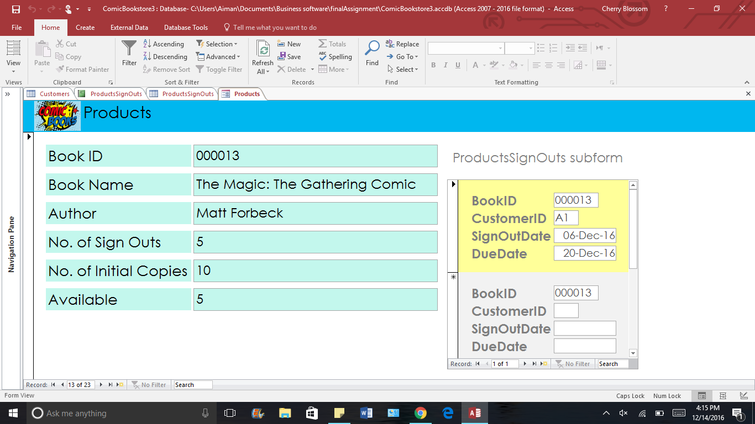

**REPORTS**

1. **OVERDUE BOOKS**

A report that shows the list of the customers who owe late return charge for the books that they have taken and not returned them back. This report shows the Names of the customers, their Phone no.’s, the Name of the books, the due dates, No. of the days it’s late and the charges due. This report is based on the results of a select query named “OVERDUE BOOKS” which is explained later in this document.

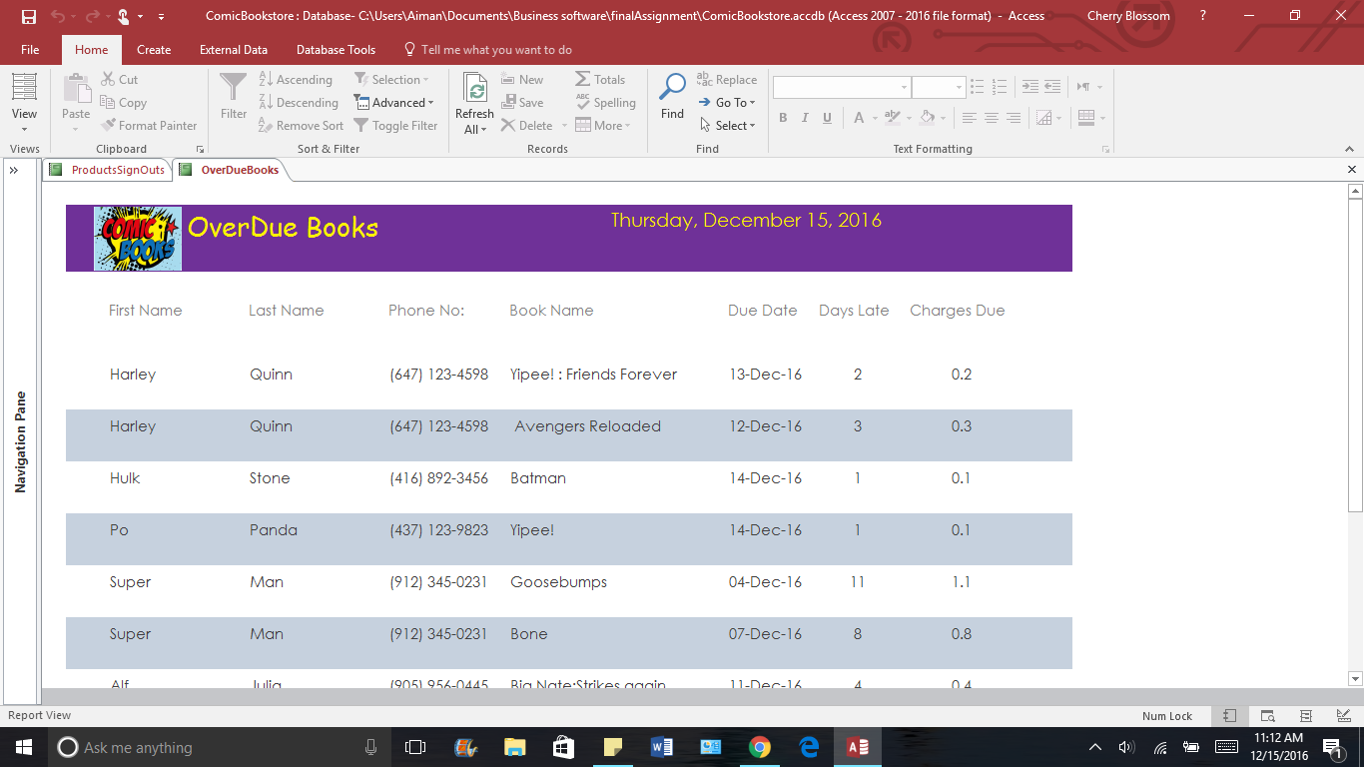

1. **PRODUCTS’ SIGN OUTS**

A report that shows the books signed out from November 15th to December 15th along with the customer who signed it out, the sign out date and the due dates. The due date record turns blue if the due date is nearby (2 days away from today) for our email reminding process.

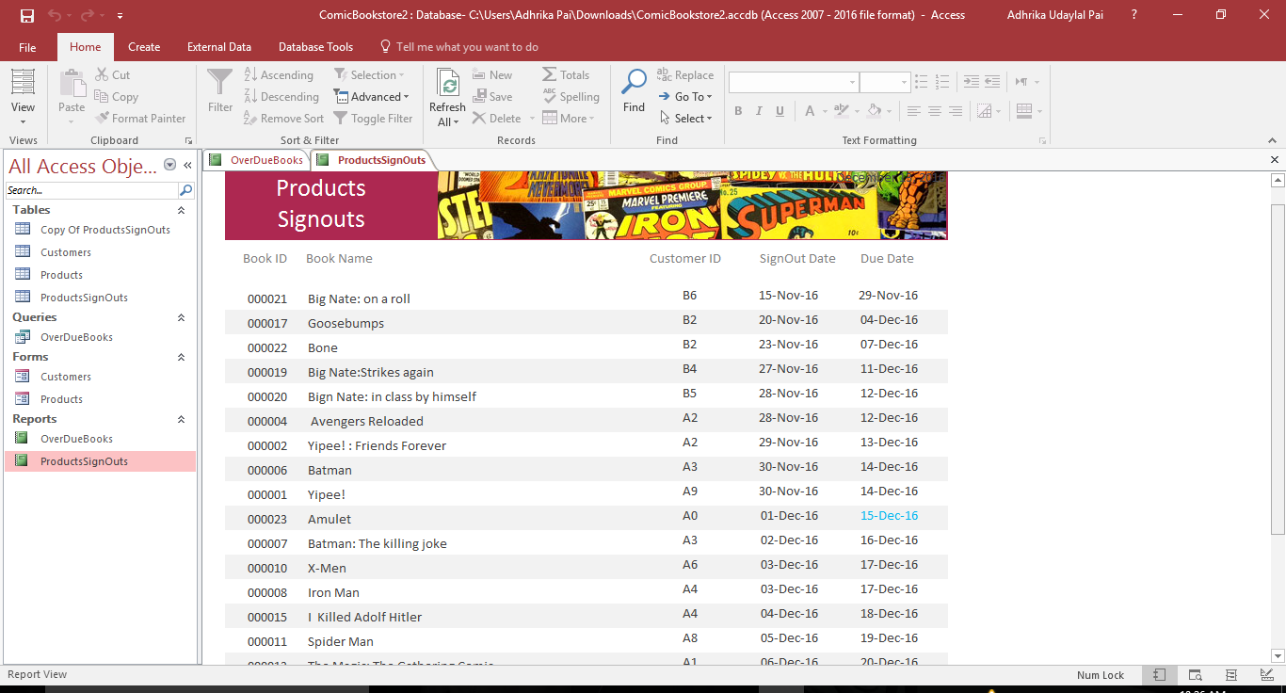

**QUERIES**

1. **OVERDUE BOOKS**

A select query of all the books that are overdue. This query also displays the information about the customer who borrowed it as well. This query is used to calculate the number of late days and the charges for each overdue book. All this information is used for the customer reminding process.

