**SYST16529 – BUSINESS SOFTWARE SYSTEMS**

**INSTRUCTOR: Paym Bergson**

**MIDTERM ASSIGNMENT**

**NAME: Adhrika Udaylal Pai**

**STUDENT NO: 991451940**

**Yipee!!**

**Primary Line of Business:** Comic book publishing

*“Creativity is contagious! Pass it on.”* – Albert Einstein. ‘***YIPEE!!***’, gives every other artist a chance to volunteer their ideas and amaze the readers.

***YIPEE!!*** is currently one of the leading comic book publishers in North America with a sole office in Toronto, Canada and no sub divisions.

Visual story telling is a best way to make kids read more. Enjoying the journey to another world, understanding the characters, cherishing the language used are what makes reading fun! Every parent would love to raise their kids as good readers. And that is why we chose to make comics for kids like them to both enjoy and learn from the stories.

This is a start-up company by Adhrika Pai. Her desire to draw cartoons and read more lead to this whole new concept of story telling known as visual story telling. The company started on her sole interest and built to be a big empire. It was founded to bring out creativity in children, to make them read more and understand more. The company's customers mainly include parents of tiny tots where they can introduce them to the world of visual story telling. We wish to improve the company and start subdivisions in all the continents and introduce children everywhere to visual story telling. We also wish to bring comic books in all the vernacular languages in other countries.

**Company Strategy**

* The purpose of the company is to be a one of the top comic book publishers by providing better services, being customer friendly and excite the readers.
* The vision is to provide the best services that tops the hopes of our comic enthusiasts.
* The mission statement is to encourage kids to read, understand more and make them more creative.
* The core values are
  + We believe in treating our customers with love, respect and faith
  + We grow through creativity, imagination and innovation

**Contact details**

**Business Address**:  28 Dutch Crescent, Brampton, Ontario – L6Y3V8

**Website**: www.yipee.ca

**Phone**:  +1 (437)-777-4072, +1 (289)-654-5717

**Fax**: +1 (437)-777-4072

**Email**: [paiadh@yipee.ca](mailto:paiadh@yipee.ca) , [lakais@yipee.ca](mailto:lakais@yipee.ca) , [prematul@yipee.ca](mailto:prematul@yipee.ca)

**Departments**

**The company mainly consists of 6 units:**

• Creative unit

• Pre-press production

• Circulation and subscription

• Marketing and sales

• Finance and accounts

• Administration and HR

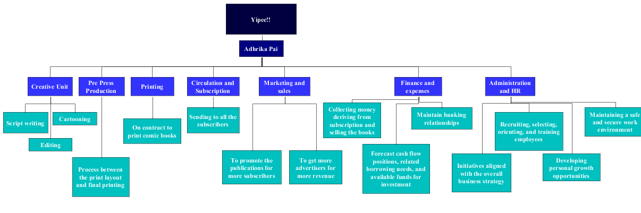

**Departments and salaries**

The salaries depend on the years of experience one has with their career:

1. The **creative unit** brings out innovative and inspiring ideas. This team does

* Script writing
* Cartooning
* Editing

and turns it into comic books so the kids can understand better even if they find hard to read. The main targeted audience is kids from 7 years to 13 years old.

The script-writers, writes a script, and then it is passed on to the cartoonists to draw and turn the story into visuals, and then the editors make the necessary changes in the story as well as the cartoons, and once the editing is done, it is given for pre-press production

*Pay scale (per annum)*: For the beginners, we pay them $40,000 - $50,000 and for those who are experienced for more than 5 years, $54,000 - $68,000 would be their salary.

1. **Marketing and sales** takes care of the promotion and subscription of the publications. This team also brings in advertisements which adds up to the revenue. The marketing and sales manager, his/her duty is to advertise and promote the ‘***YIPEE!!***’ comics to every reader out there. Their responsibilities are

* Promoting the comics
* Determining the annual sales strategies
* Advertising the comics
* Handling social media and public relations
* Monitoring the performance
* Managing the advertisements and marketing

This department also uploads the comic to the website and gives all the comic enthusiasts a chance to see and enjoy, to advertise in all asocial networking sites.

*Pay scale (per annum)*: $45,000 - $70,000 would be the salary range for the beginners and $72,000 - $95,000 for the experienced (5 years or more).

1. As every company has staff, it also needs an **administration and HR** department to manage and organise the staff. This department tends to recruit people who are talented and apt for the position they are applying for, determines the wages and salary reports etc. Their goals are to

* Promote values
* Enable business success through designing the jobs
* Recruitment of the talented
* Training & development of employees
* Facility services.

*Pay scale (per annum)*: The salary ranges from $48,000 - $63,000 for beginners and $68,000 - $96,000 for those who have experience 5 years or more.

**Finance**

To cover up gaps between daily expenses, accounts, wages etc.…and to maximize the potential of the company, the company took a working capital loan of $10,000,000 and was repaid back when the company started to have profits and was no longer needing any funds which in turn complemented the line of credit. To get a working capital loan, a collateral was needed because the bank needed assurance that this company would pay back. And to make the investment costs minimal, Adhrika had to make her personal savings a great asset for this company, another $150,000.

In the start, that is, on 17th August, the loan of $10,000,000 was received for the start-up and on 19th August, $5,300 was spent for the office equipment’s, to purchase inventory, advertising and to pay the rent on account. The first set of books were sold for $5,000 and on credit, received $6,000 on 25th August.



**Use case narrative and diagrams**

Online Subscription

A registered user subscribing to the new series of ‘YIPEE!!’ comics, online

|  |  |  |
| --- | --- | --- |
| **Scenario** | The registered user subscribing the ‘YIPEE!!’ comics, online | |
| **Triggering event** | The user opening the website to subscribe | |
| **Actors** | User, Computer, Online payment service, Sales manager | |
| **Related use cases** | Selecting, Subscribing | |
| **Stakeholders** | User, Publisher | |
| **Pre-condition** | The user should have an account for online subscription and proper payment method (credit/debit) configured in the account. | |
| **Post-condition** | On successful subscription, that is when the user’s transaction is approved, the copy of series will be accessible through the website. On unsuccessful subscription, that is the user’s transaction is declined, the copy of series will not be accessible. | |
| **Flow of events** | **Actor** | **System** |
| 1. The user opening the website to subscribe 2. The user selecting the new series of the comics 3. The payment is initiated through online transaction and the inventory is updated. | 1. When the user opens the website, he/she is asked to login. 2. After logging in, the list of the new series comes up and the user selects the desired and the payment option comes up 3. A) The user confirms the subscription and the payment is initiated.   B) The user gets a confirmation letter; inventory gets updated and the user starts receiving the latest copy. |
| **Exception** | * If system 2 fails, that is the user fails to login with proper credentials, the user will be asked to login again. * If system 3A fails, that is the transaction gets declined, the website loads back to the subscription page showing error. | |

**The online subscription system**

When the user logins with the registered username and password, the new series of the ‘***YIPEE!!***’ comics shows up and he/she selects the one desired. Whilst confirming the subscription for the same, the user must confirm the payment option(credit/debit) and give proper information for the payment and if the transaction is approved, the user gets to access the latest copy of the series (which the user subscribed)

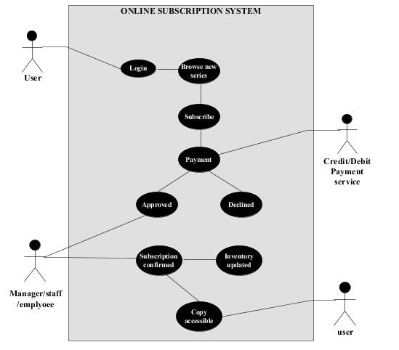

**Activity diagram**

**An activity diagram showing the process of buying the book**

When a customer goes to a bookstore to buy the new series of the ‘***YIPEE!!***’ comics, he/she looks for the latest copy and if not found, asks the seller for the same. After the seller checks, if it’s available, then the customer pays for the comic, either by credit/debit or cash. If either the debit/credit transaction doesn’t work or insufficient money in cash, the customer must leave the store.

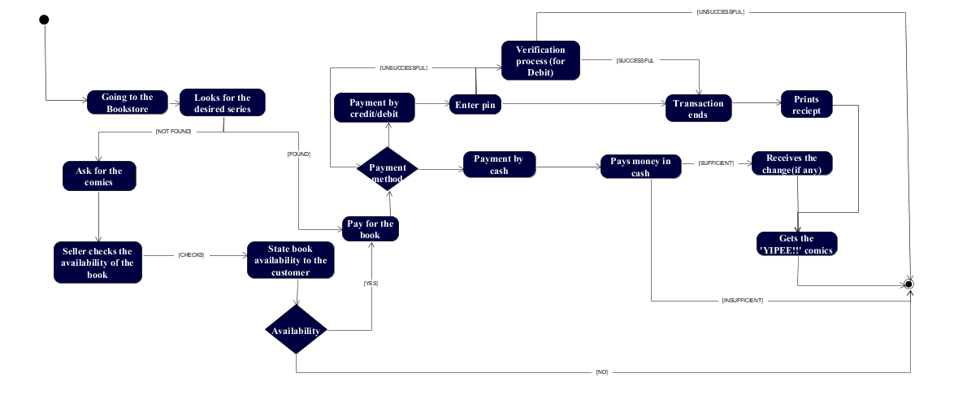

**References**:

This is in reference to the Week 1 assignment we had, that is to start up a business (submitted on Sept 12,2016), in which mine was the ‘YIPEE!!’ comics.

* **For pay scale:**

1. <http://www.payscale.com/research/CA/Job=Editor/Salary/1746d3a1/Toronto-ON>
2. <http://www.payscale.com/research/CA/Job=Marketing_Manager/Salary/502a5823/Toronto-ON>
3. <http://www.payscale.com/research/CA/Job=Human_Resources_(HR)_Manager/Salary/9db75f18/Toronto-ON>

2 business processes:- 1. Signing out books

2.Reminding the customers to return the book/pay their charges on late books.

( green – returned, yellow – reaching the due date, red – passed the due date)