1. CREATE DATABASE
MongoDB Query:
use Students

2. CREATE COLLECTION
MongoDB Query:
db. create Collection("students")
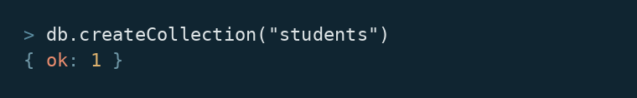
3. INSERT 50 STUDENTS
MongoDB Query:
db. students. Insert Many([ ])
{roll:1, name:"Ishita", age:19,marks:95,city:"Meerut"},
{roll:2, name:"Rehan", age:18,marks:56,city:"Mathura"},
{roll:3, name:"Kavya", age:19,marks:70,city:"Jhansi"},
{roll:4, name:"Devansh", age:18,marks:63,city:"Meerut"},
{roll:5, name:"Riya", age:19,marks:98,city:"Amritsar"},
{roll:6, name:"Mohit", age:20,marks:60,city:"Jaipur"},
{roll:7, name:"Simran", age:19,marks:82,city:"Noida"},
{roll:8, name:"Yash", age:19,marks:56,city:"Agra"},
{roll:9, name:"Pooja", age:20,marks:68,city:"Jhansi"},
{roll:10, name:"Arjun", age:18,marks:87,city:"Ludhiana"},
{roll:11, name:"Neelam", age:20,marks:56,city:"Amritsar"},
{roll:12, name:"Tushar", age:19,marks:67,city:"Amritsar"},
{roll:13, name:"Bhavya", age:18,marks:81,city:"Jhansi"},
{roll:14, name:"Kunal", age:19,marks:83,city:"Jaipur"},
{roll:15, name:"Diksha", age:20,marks:72,city:"Delhi"},
{roll:16, name:"Rajat", age:18,marks:65,city:"Indore"},
{roll:17, name:"Manvi", age:19,marks:76,city:"Mathura"},
{roll:18, name:"Aryan", age:18,marks:64,city:"Moradabad"},
{roll:19, name:"Kritika", age:20,marks:76,city:"Meerut"},
{roll:20, name:"Sahil", age:19,marks:60,city:"Bhopal"},
{roll:21, name:"Ritika", age:18,marks:61,city:"Lucknow"},
{roll:22, name:"Gaurav", age:19,marks:77,city:"Ludhiana"},
{roll:23, name:"Nandini", age:20,marks:71,city:"Noida"},
{roll:24, name: "Vedika", age:19,marks:57,city:"Patna"},
{roll:25, name: "Naman", age:18,marks:64,city:"Chandigarh"},
{roll:26, name: "Sakshi", age:20,marks:78,city:"Meerut"},
{roll:27, name: "Ayaan", age:19,marks:84,city:"Ludhiana"},
{roll:28, name: "Priyal", age:18,marks:86,city:"Ludhiana"},
{roll:29, name: "Shivam", age:19,marks:56,city:"Ranchi"},
{roll:30, name: "Anandita", age:20,marks:82,city:"Jaipur"},
{roll:31, name: "Devraj", age:18,marks:78,city:"Ludhiana"},
{roll:32, name: "Kashvi", age:19,marks:90,city:"Indore"},
{roll:33, name: "Utkarsh", age:20,marks:80,city:"Aligarh"},
{roll:34, name: "Mahima", age:18,marks:58,city:"Meerut"},
{roll:35, name: "Rachit", age:19,marks:62,city:"Bhopal"},
{roll:36, name: "Saanvi", age:20,marks:64,city:"Meerut"},
{roll:37, name: "Kartikeya", age:18,marks:65,city:"Ranchi"},
{roll:38, name: "Vanshika", age:19,marks:86,city:"Ghaziabad"},
{roll:39, name: "Ranveer", age:20,marks:79,city:"Ludhiana"},
{roll:40, name: "Ishani", age:19,marks:87,city:"Mathura"},
{roll:41, name: "Aarav", age:18,marks:91,city:"Aligarh"},
{roll:42, name: "Trisha", age:20,marks:79,city:"Agra"},
{roll:43, name: "Nikhil", age:19,marks:58,city:"Jaipur"},
{roll:44, name: "Avani", age:18,marks:58,city:"Aligarh"},
{roll:45, name: "Sarthak", age:20,marks:58,city:"Aligarh"},
{roll:46, name: "Meher", age:19,marks:73,city:"Mathura"},
{roll:47, name: "Dhruv", age:18,marks:59,city:"Ranchi"},
{roll:48, name: "Aisha", age:20,marks:94,city:"Meerut"},
{roll:49, name: "Vihaan", age:19,marks:92,city:"Noida"},
{roll:50, name: "Ridhima", age:18,marks:61,city:"Ludhiana"}
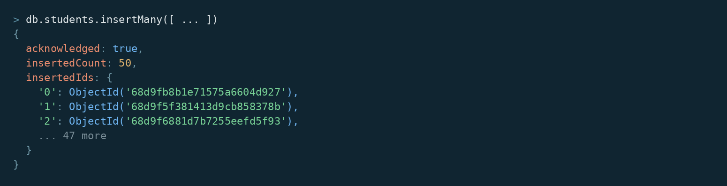

4. DISPLAY ALL STUDENTS
MongoDB Query:
db. students. Find ()
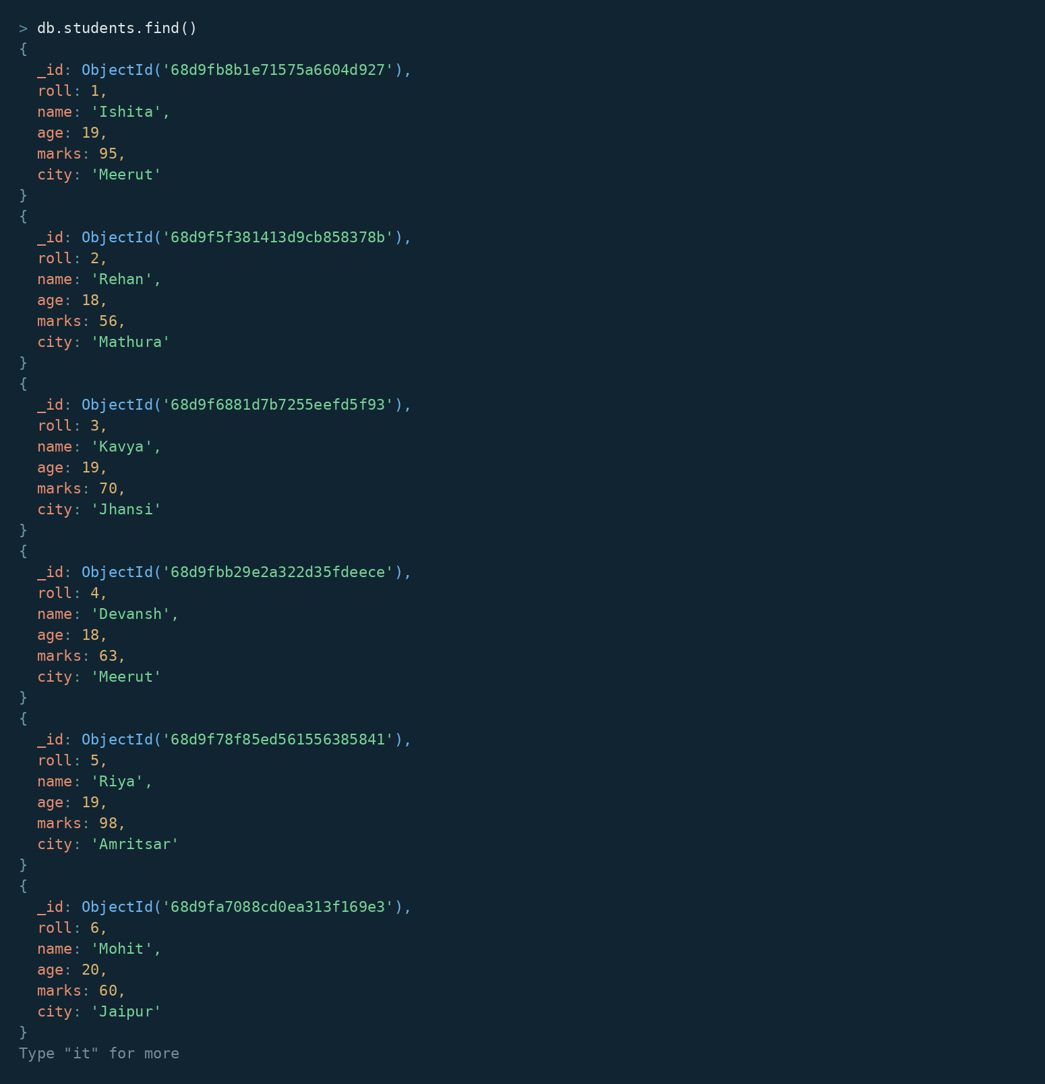
5. EQUAL TO — $eq
MongoDB Query:
db. students. Find ({marks: {$eq: 88}})

6. GREATER THAN — $gt
MongoDB Query:
db.students.find({marks: {$gt: 85}})
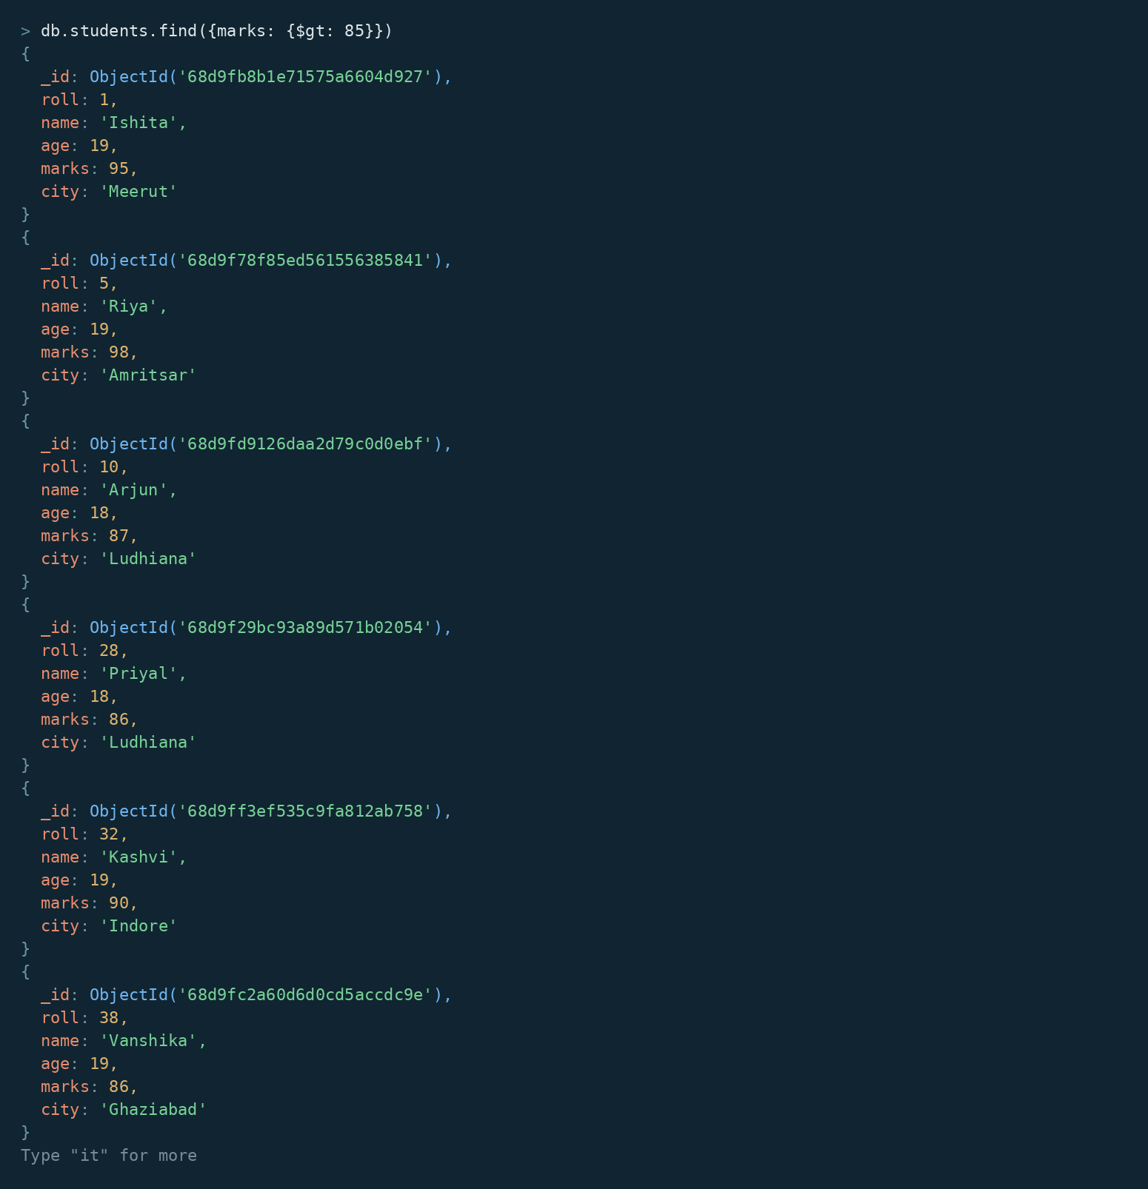

7. LESS THAN — $lt
MongoDB Query:
db. students. find ({marks: {$lt: 60}})

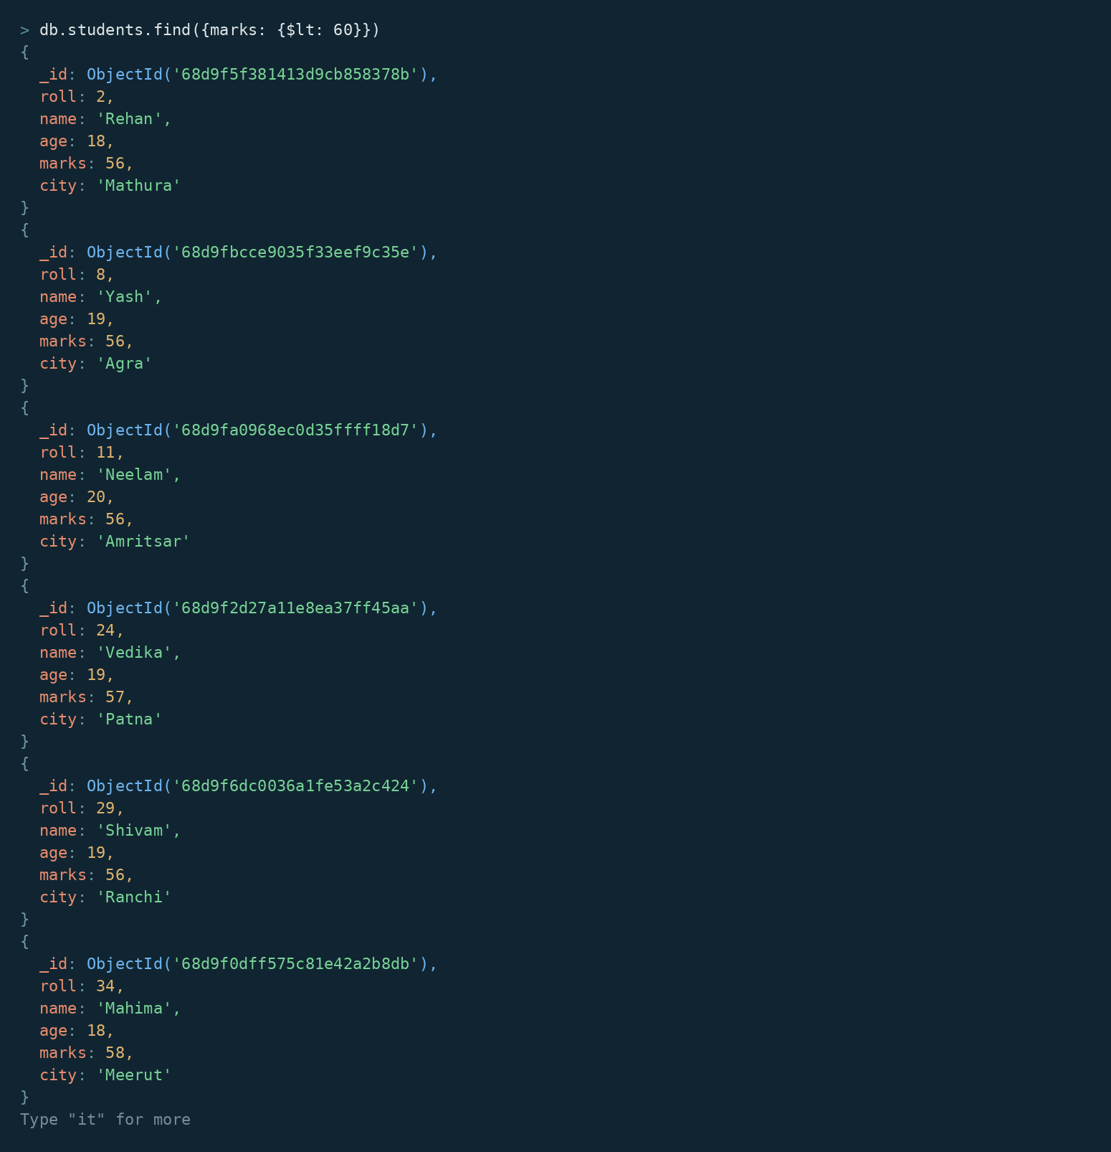
8. GREATER THAN OR EQUAL TO — $gte
MongoDB Query:
db. students. find({marks: {$gte: 90}})

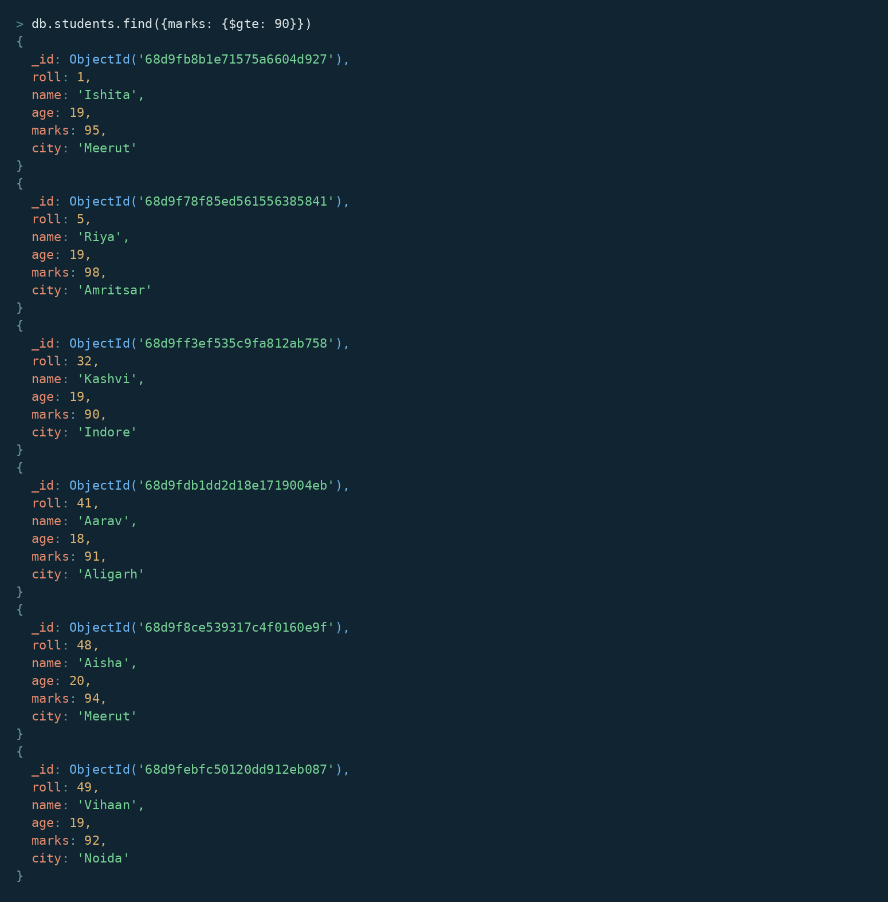

9. LESS THAN OR EQUAL TO — $lte
MongoDB Query:
db. students. find({marks: {$lte: 70}})

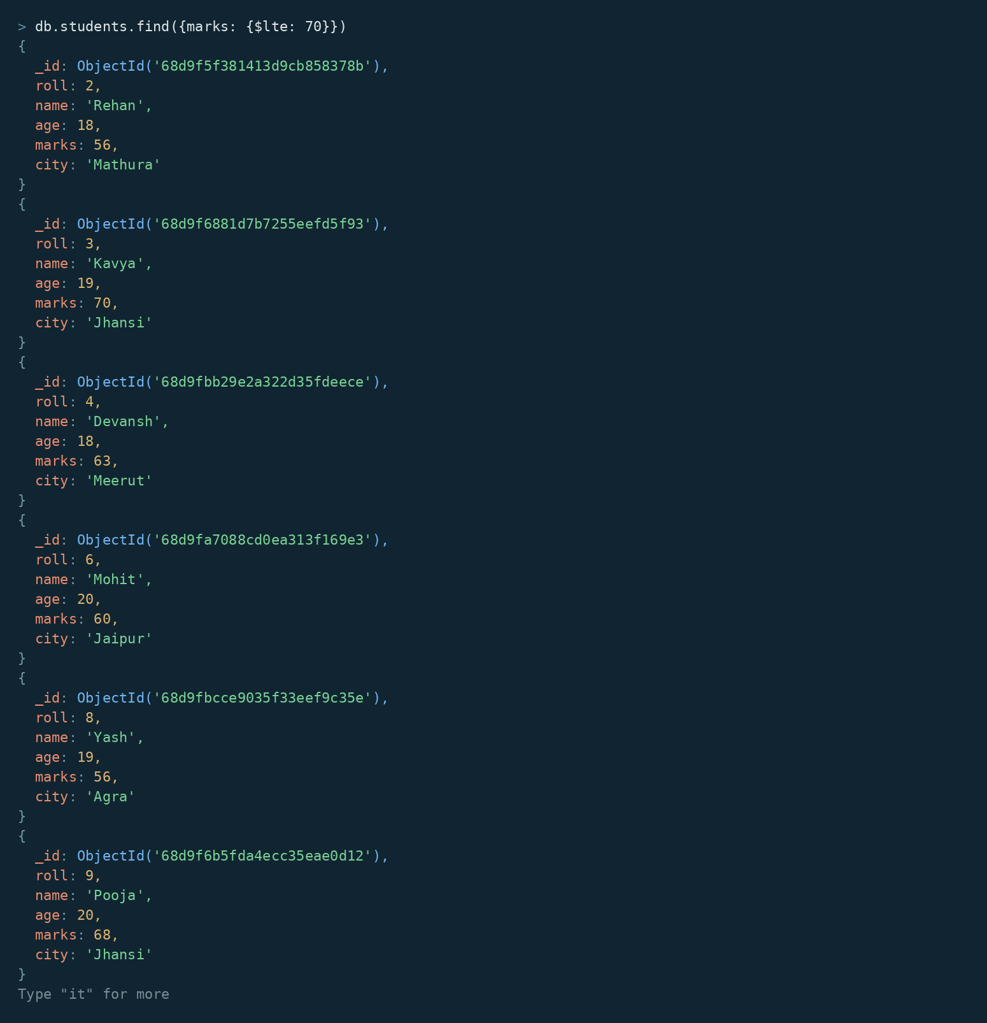

10. UPDATE OPERATION
MongoDB Query:
db.students.updateOne(
{roll:5},
{$set:{marks:95}}
)

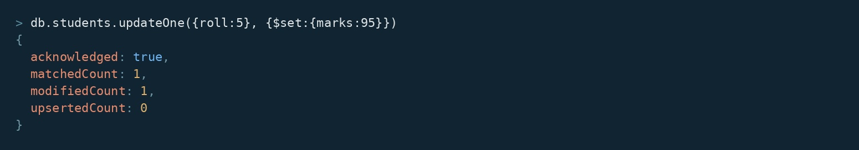

11. DELETE ONE OPERATION
MongoDB Query:
db.students.deleteOne({roll:10})

12. DELETE MANY OPERATION
MongoDB Query:
db.students.deleteMany({
marks: {$lt:60}
})

13. AND OPERATION — $and
MongoDB Query:
db. students. find({
$and:[
{marks:{$gt:80}},
{age:19}
]
})
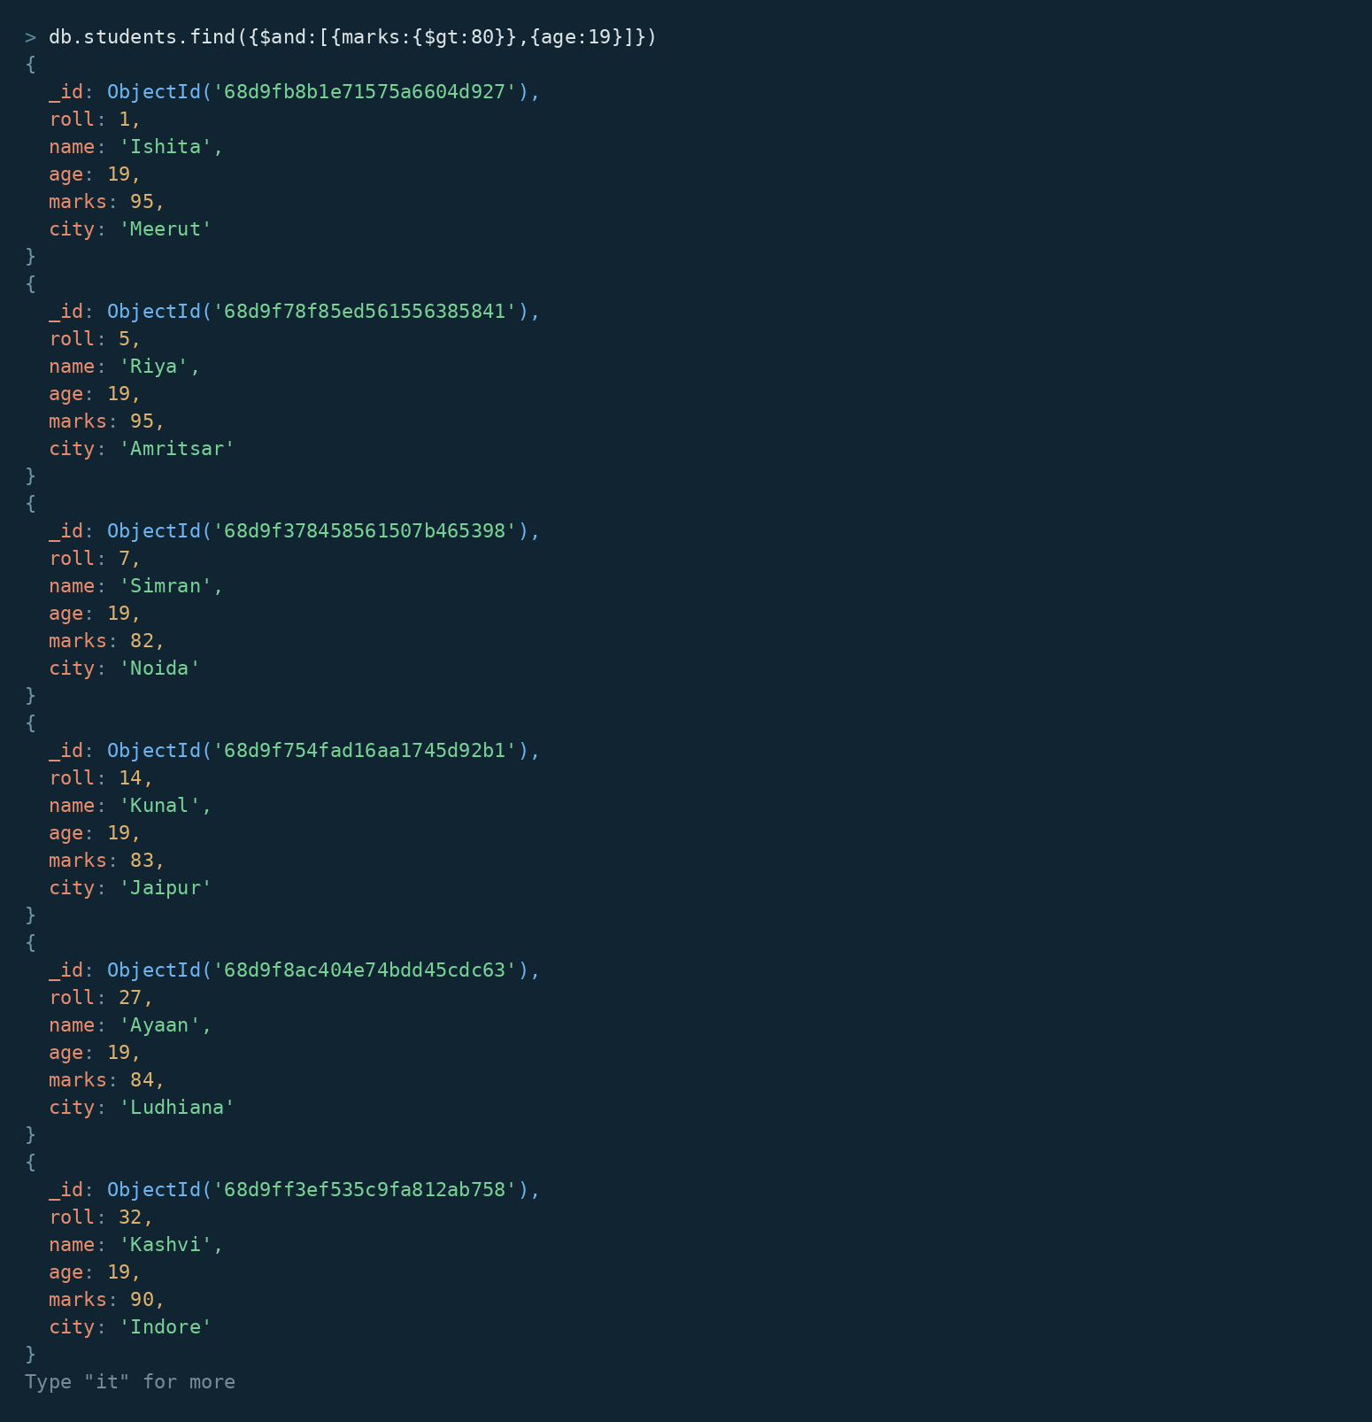
14. OR OPERATION — $or
MongoDB Query:
db.students.find({
$or:[
{city:"Lucknow"},
{city:"Kanpur"}
]
})
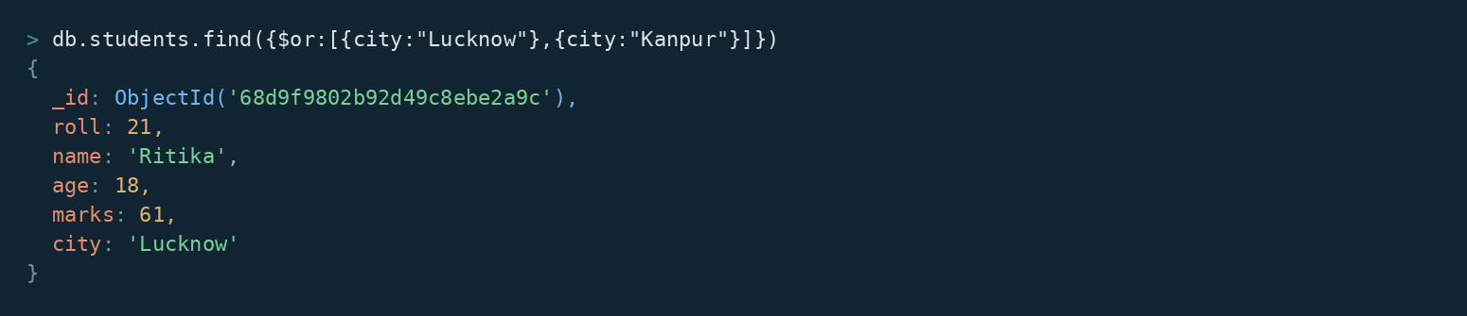

15. SORT OPERATION
A.MongoDB Query:
db. students. find (). sort({marks : 1})
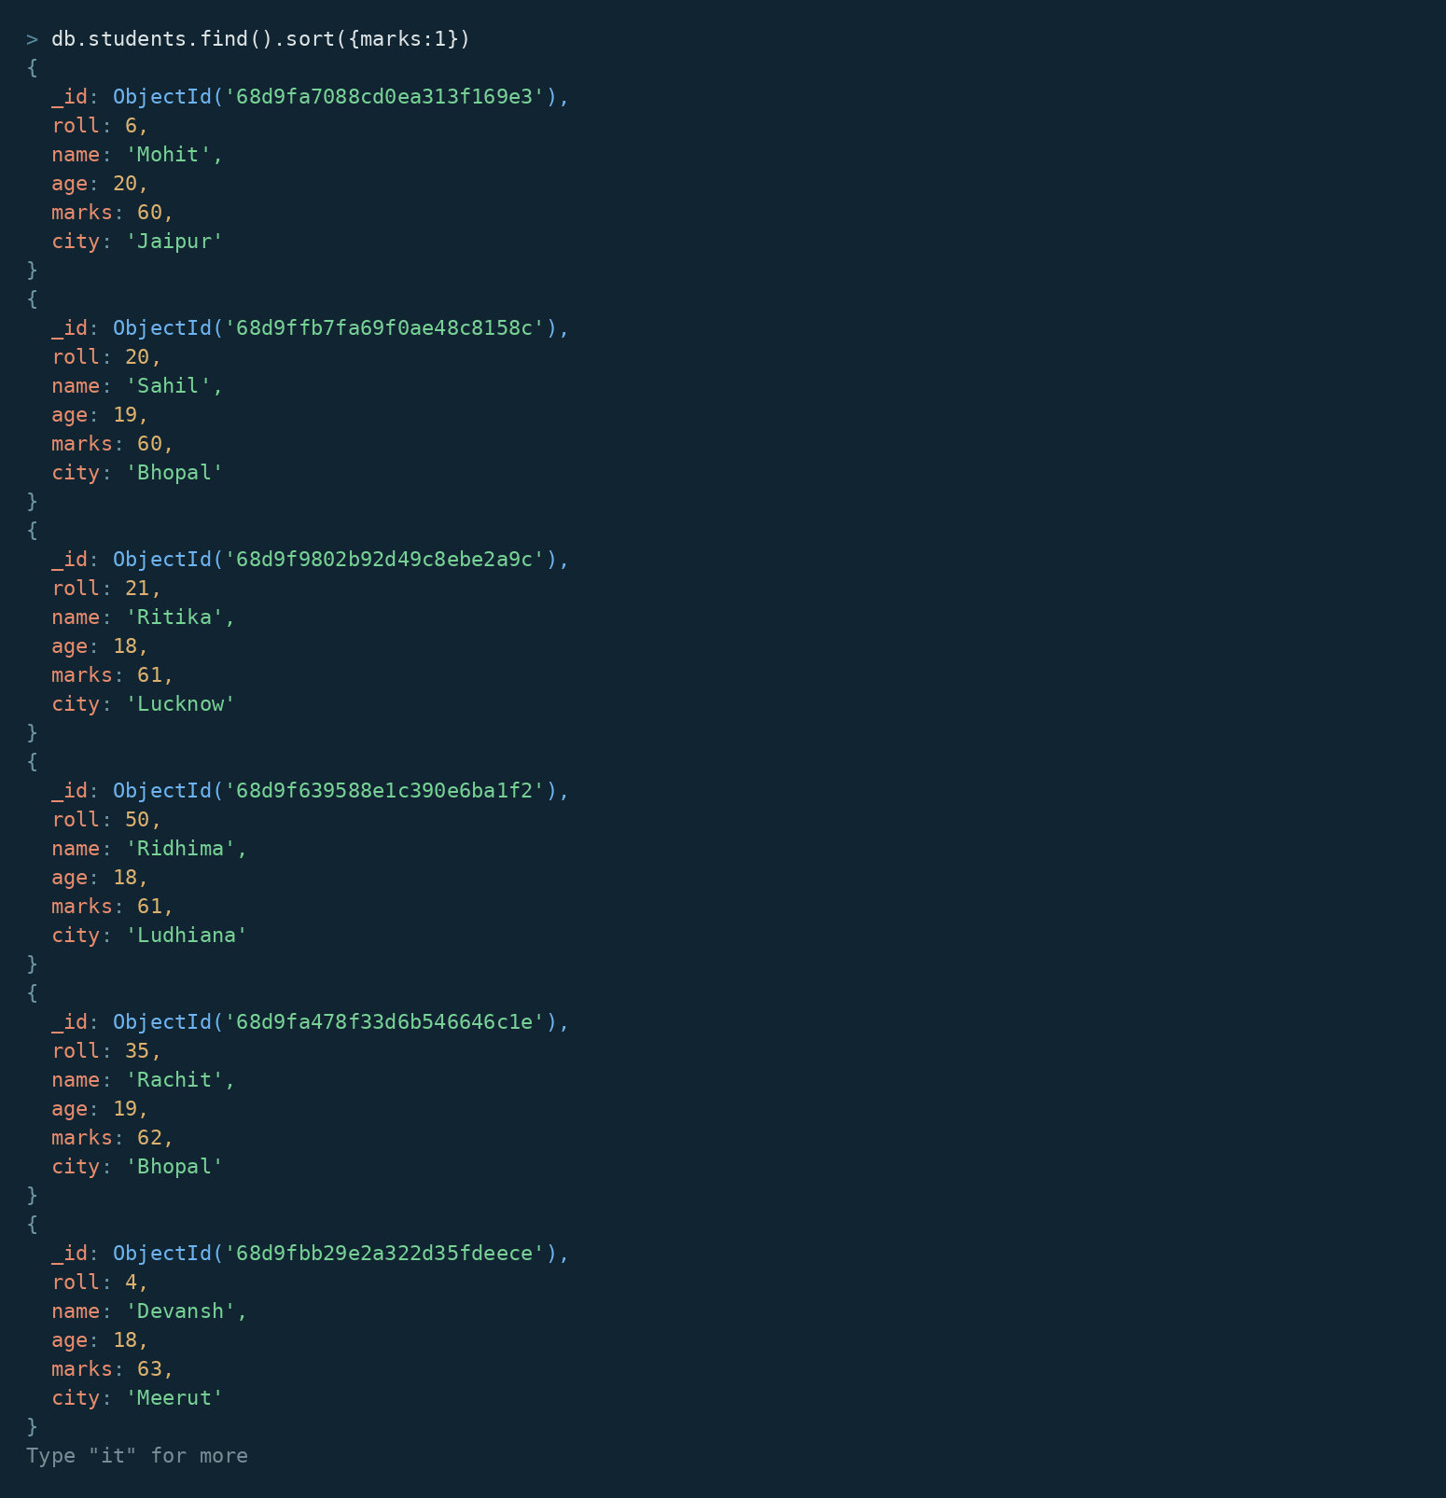

B. MongoDB Query:
db. students. find (). Sort ({marks: -1})
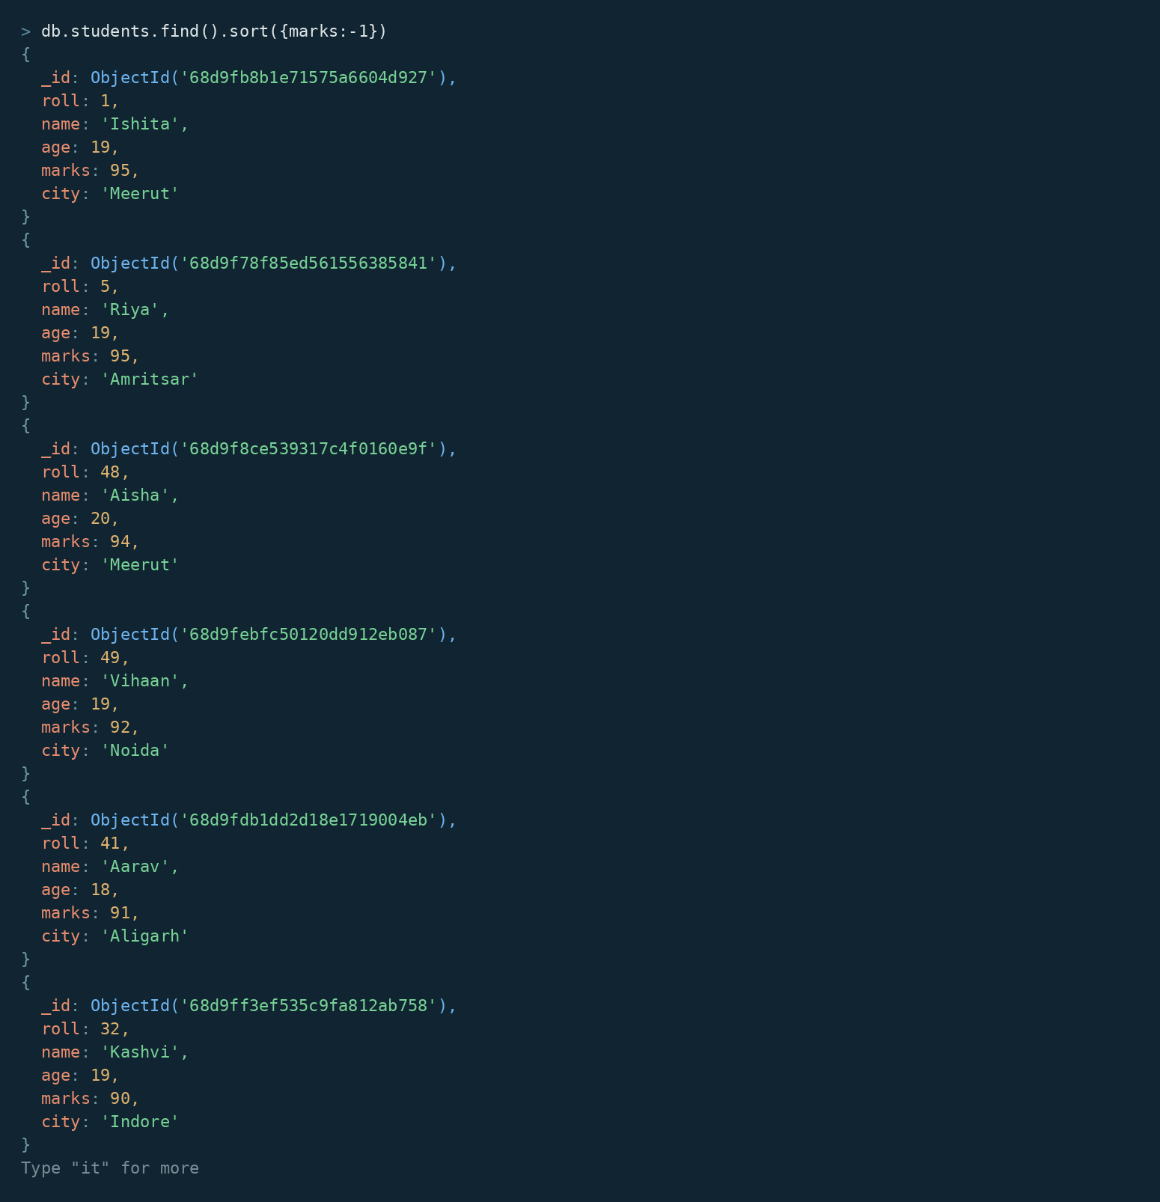
16. LIMIT OPERATION
MongoDB Query:
db. students. find (). limit (5)

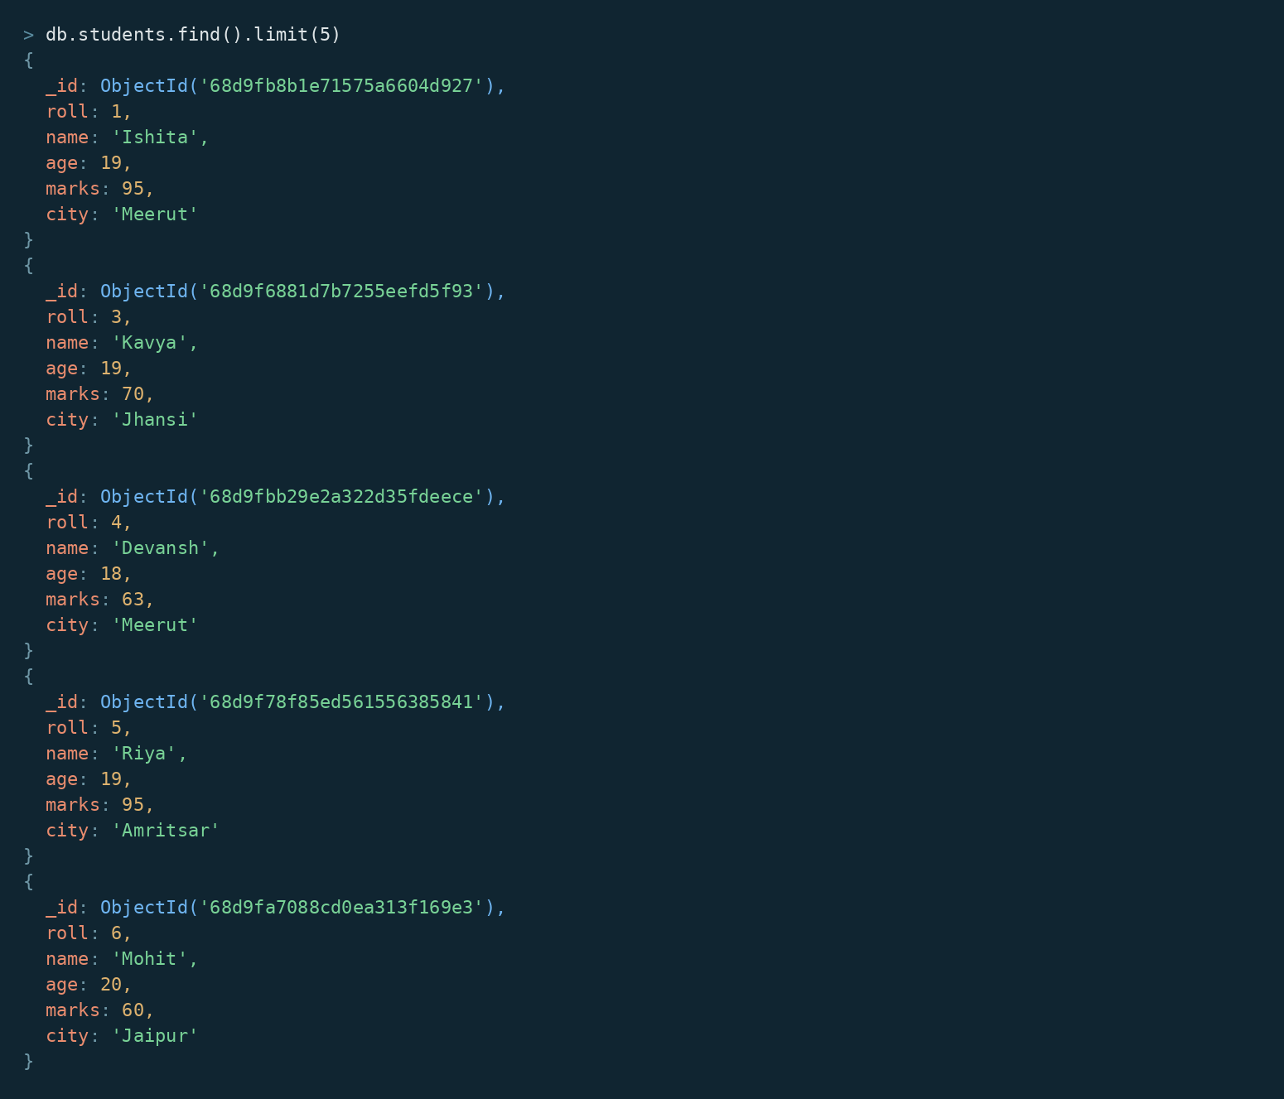

17. SEARCH BY CITY
MongoDB Query:
db.students.find({city:"Lucknow"})
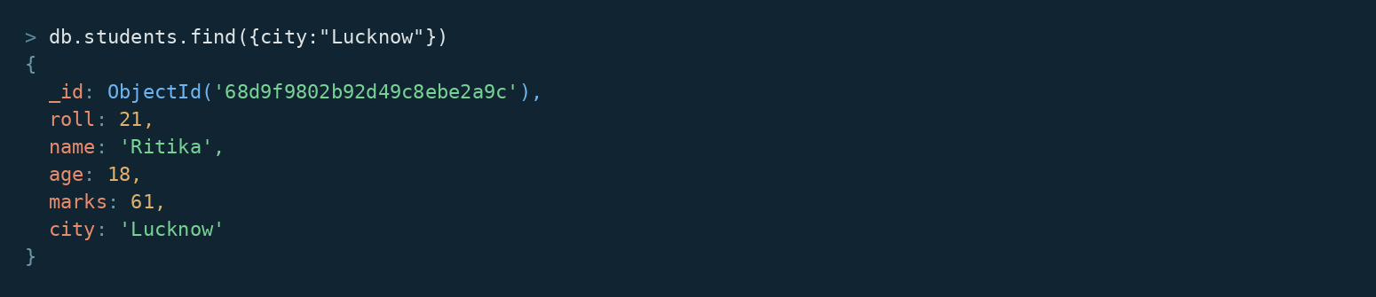

18. COUNT DOCUMENTS
MongoDB Query:
db. students. count Documents ()
