VANTAGE
Game Design Document
“Get in. Fight up. Get out.”
Author | Adhurim Thaqi
Course | Level & World Design (I.BA_LWD), HSLU, HS26
Genre | Third-person shooter (single level)
Engine | Unity 6 (6000.0.58f2, URP), C#
Repository | https://github.com/AdhurimThaqi/vantage-level-world-design
Version | 1.0, Final Submission

Copyright Information
VANTAGE is a student project developed by Adhurim Thaqi as part of the Level & World Design module (I.BA_LWD) at HSLU (Hochschule Luzern), HS26. The game concept, the level and world design, the tower and the world (modelled in Blender), the player character and the gameplay and editor C# code are the work of the author, developed with the help of AI (Claude). The course template, animations, coins and enemy models are third-party assets and are listed in the Asset List appendix.

Version History
Version | Date | Author | Changes
0.1 | Oct 2026 (4.10.) | Adhurim Thaqi | Level & World Design Concept: premise, mechanics scope, level structure, space/event/emotion, storytelling, procedural part, guidance, lighting, performance
0.5 | Oct 2026 (14.10.) | Adhurim Thaqi | Mid-project update after the lecturer's feedback: the new three-floor tower with a helipad, one gate type per level, coins, checkpoints
0.8 | Oct 2026 (21.10.) | Adhurim Thaqi | After the presentation: sentries and the warning ring, intro flyover
1.0 | Oct 2026 (29.10.) | Adhurim Thaqi | Final GDD: core loop, prototype iterations, interesting choices, balancing, juiciness, gamestate visualisation, design patterns, user testing

Table of Contents
Copyright Information 2
Version History 2
Table of Contents 3
Game Overview 7
Game Concept 7
Feature Set 7
Genre 7
Target Audience 7
Game Flow 8
Look and Feel 8
Number of locations 8
Number of levels 8
Number of NPC's 9
Number of weapons 9
Gameplay and Mechanics 10
Gameplay 10
Game Progression 10
Mission/challenge Structure 10
Puzzle Structure 10
Objectives 10
Play Flow 10
Mechanics 10
Physics 10
Movement 10
Objects 11
Actions 11
Combat 11
Economy 11
Screen Flow 11
Screen Flow Chart 11
Screen Descriptions 11
Game Options 12
Replaying and Saving 12
Cheats and Easter Eggs 12
Story, Setting and Character 13
Story and Narrative 13
Back story 13
Plot Elements 13
Game Progression 13
License Considerations 13
Cut Scenes 13
Game World 13
General look and feel of world 13
Area #1, The Tower 13
Area #2, The Military Base 13
Characters 14
Character #1, The Player 14
Character #2, The Soldier (Enemy) 14
Character #3, Drones, Turrets, the Heavy Robot and the Boss 14
Character #4, The Sentries and the Deserter 14
Levels 15
Level #1, The Ground Floor 15
Synopsis 15
Introductory Material 15
Objectives 15
Physical Description 15
Map 15
Critical Path 16
Encounters 16
Level Walkthrough 16
Closing Material 16
Level #2, The Armory 17
Synopsis 17
Objectives 17
Physical Description 17
Map 17
Critical Path 18
Encounters 18
Level Walkthrough and Closing Material 18
Level #3, The Destroyed Floor 18
Synopsis 18
Objectives 18
Map 19
Critical Path 19
Encounters 19
Closing Material 19
Finale, The Helipad 20
Interface 21
Visual System 21
HUD - What controls 21
Menus 21
Rendering System 21
Camera 21
Lighting Models 21
Control System 21
Audio 22
Music 22
Sound Effects 22
Help System 22
Artificial Intelligence 23
Opponent AI 23
Enemy AI, Soldiers 23
Alert propagation, enemies interacting with each other 23
Drones and turrets 23
Heavy robot and boss 23
Sentries 23
Non-combat Characters 23
Friendly Characters 23
Support AI 23
Player and Collision Detection 23
Pathfinding 24
Technology 25
Target Hardware 25
Development hardware and software 25
Development procedures and standards 25
Game Engine 25
Network 25
Scripting Language 25
Game Art 26
Concept Art 26
Style Guides 26
Characters 26
Environments 26
Equipment 27
Cut scenes 27
Miscellaneous 27
Design Process and Iterations 28
Core Loop Diagram 28
Micro loop, moment to moment 28
Macro loop, per level 28
Meta loop, across levels 28
Prototype, Iteration 1: Blockout watchtower 28
Prototype, Iteration 2: Six-storey command tower 28
Prototype, Iteration 3: Three floors and a helipad (current) 28
Interesting Choices 28
Balancing 29
Juiciness 29
Gamestate Visualisation 30
Design Patterns 30
User Testing 31
Playtest Session 1, Oct 7 (own playtest, command tower) 31
Playtest Session 2, Oct 14–16 (own playtest, new tower) 31
Presentation feedback, Oct 21 31
Playtest Session 3, Oct 26 (own playtest, logged) 31
Planned Playtest Session 4, peers 31
Management 32
Detailed Schedule 32
Budget 32
Risk Analysis 32
Localization Plan 32
Test Plan 32
Appendices 33
Asset List 33
Art 33
Sound 33
Music 33
Voice 33

Game Overview

Game Concept
VANTAGE is a third-person shooter level. A military command tower stands in a training base in a forested valley. The base was overrun, the tower's top floor is half destroyed, and soldiers, drones, turrets and a heavy combat robot hold it. The player arrives unarmed in front of the entrance, picks up a pistol lying by the doors and steps inside, and the alarm goes off: the shutter slams down, the siren wails and the whole ground floor comes for them. From there they fight up through three floors and a finale on the helipad, where a boss waits; when it falls, a helicopter comes in and takes them out.
The name stands for the tower itself: a vantage point over the valley, held by an enemy who sees everything from above, and the place the player has to take from them. The sentries on top of the tower watching the ground make the idea playable.

Feature Set
- Third-person cover shooter movement: run, crouch, take cover, vault, roll (course template)
- Three levels and a finale, each with its own kind of gate: a lockdown, a key, a rifle-only robot and a kill door, a boss
- Alarm trap on the ground floor (a trigger or a security camera that can be shot first): shutter, siren, red lights, every enemy hunts the player
- Two weapons found in the level: a weak pistol outside the entrance, a rifle in the level 2 Armory
- Enemy mix: soldiers, drones and turrets that telegraph their shots, a heavy robot only the rifle can hurt, a charging boss mech
- A boundary with a reason: two sentries on the top of the tower enforce a warning ring around it (warning shots, then hits)
- A 19-second skippable intro flyover that doubles as the mission briefing
- Seeded enemy placement: soldiers are drawn from authored markers per play (the procedural part)
- Five hidden coins off the critical path, an end screen with time, deaths, coins and three achievements
- Per-level checkpoints with a safe restart (on the stairs below the level, gun drawn, 3 s of protection)
- HUD with the goal of the moment, enemy pips, minimap with the warning ring
- Playtest logging, performance capture and an automated playtest bot

Genre
Third-person shooter, built as one linear level. The structure borrows from tower-climb action games (each floor a set piece with a gate) while the module's focus keeps the weight on layout, pacing and guidance rather than on systems.

Target Audience
Age range | 16 and above (military setting, gunfire, no gore)
Primary audience | Players who enjoy third-person action and cover shooters
Secondary audience | Players who like short, finishable runs (10 to 15 minutes) with something to replay for (coins, no deaths, time)
Platform | PC (Windows)

Game Flow
A run starts with the intro flyover over the base and the tower. The player takes control at the tower's entrance, grabs the pistol and walks in, which springs the trap. Level 1 is a lockdown loop through rooms A to C, the West Wing and the turret hallway; clearing it opens the stairs. On level 2 the player takes the rifle from the Armory and the key from the Office desk and turns the key in the slot by the stairwell gate. Level 3 opens room by room: the indoor soldiers, then the robot room and the breach into the destroyed open area, the two outside patrols, the SE room and the heavy robot. The outside stairs lead to the helipad: two soldiers, then the boss. Its death brings the helicopter and the end screen. Dying restarts the current level.

Look and Feel
A grounded, slightly stylised military look: concrete, metal and asphalt (Poly Haven textures) on the author's own Blender tower, low-poly soldiers, a golden-hour sun low in the south-west. Inside, the alarm turns the ground floor red; higher up, daylight falls through the blown-out walls of level 3, and the helipad is fully open to the sky and the valley. Lighting rises with height so that the emotional curve and the light move together.
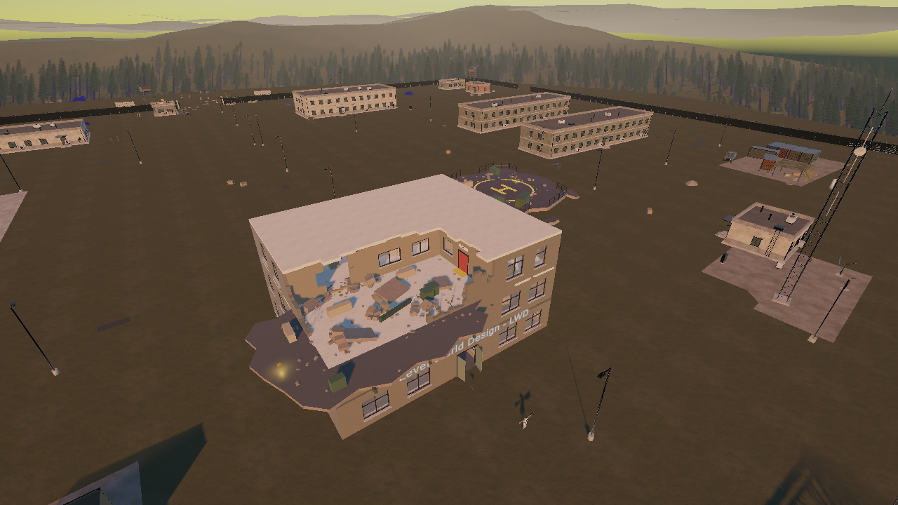
Figure 1: The tower in the military base: the destroyed top floor with the broken slab, the helipad beside it, the base and the forested valley around.

Number of locations
One location: the tower, with four distinct spaces (ground floor, Armory floor, destroyed floor, helipad), set in a 1 km military base the player can see and walk in, but which the sentries keep them out of.

Number of levels
Three levels and a finale, all implemented and playable from start to end.

Number of NPC's
Enemies only: level 1 five soldiers and a turret; level 2 five soldiers, two turrets, two drones; level 3 indoor soldiers, two outside patrols and the heavy robot; finale two soldiers and the boss. Plus two sentries on the top and a scripted deserter in the intro. No friendly NPCs.

Number of weapons
Two: a pistol (outside the entrance) and a rifle (the level 2 Armory). The template's grenade and melee are available too. The second weapon is a pacing tool, not a feature: it is a power spike just before the hardest floor, and the robot on level 3 only takes rifle damage.

Gameplay and Mechanics

Gameplay

Game Progression
Level 1 (Ground floor): survive a lockdown with only a pistol. Level 2 (Armory): find the rifle and the key under fire. Level 3 (Destroyed floor): clear the rooms in the order the doors allow and destroy the rifle-only robot. Finale (Helipad): clear the platform and kill the boss. Damage per enemy hit rises from 6 (level 1) to 7 (level 2) and 8 (level 3 and finale).

Mission/challenge Structure
- Primary: open each level's gate (kill everything, insert the key, clear the rooms and the patrols, kill the boss).
- Primary: reach the helipad and survive the boss for the extraction.
- Rule: stay at the tower; leaving it brings warning shots, then hits.
- Optional: find the five coins, finish without dying, finish under 15 minutes (achievements on the end screen).

Puzzle Structure
No abstract puzzles. Each gate is a small spatial puzzle under fire: on level 1 the only way on is the loop through rooms A to C because the left corridor door stays locked during the lockdown; on level 2 the key and the slot are in different rooms; on level 3 the door order (rooms, robot room, breach, patrols, SE room, exit) has to be read from the space; the robot teaches that the pistol is not enough.

Objectives
Objective | How it is shown
Grab the pistol | Intro caption and a HUD banner until the player is armed
Clear the floor (lockdown) | HUD goal LOCKDOWN · CLEAR THE FLOOR, enemy pips, red light and siren until the floor is clear
Insert the key | The key floats and glows on the desk; the slot is the only [E] prompt in the game
Destroy the machine | HUD goal; the robot answers pistol hits with “You need a better gun”
Reach the helipad | HUD goal, the HELIPAD sign over the exit door, the pad seen in the intro

Play Flow
See the Core Loop Diagram in the Design Process chapter for the micro, macro and meta loops.

Mechanics

Physics
Unity physics with character controllers from the course template. Shots are ray casts against shared masks (VantagePhysics.Solid and Sight). Hits arrive as OnHit messages. Stairs are walked on smooth invisible ramps that Setup builds over every flight, because the template character cannot step up ledges.

Movement
Mode | Input | Use case
Walk / run | WASD, Left Shift | Default traversal; running to cross open ground
Crouch | Left Ctrl (hold) | Smaller target, behind low cover
Take cover | Space near a wall or prop | The core defensive move; about 80 tower props have covers
Vault / climb | Space facing a low obstacle | Over barricades and crates
Roll | Double-tap a direction | Leave a bad position quickly

Objects
Weapons: the pistol (outside the entrance) and the rifle (Armory), picked up by walking into them. Key and key slot: the key floats, spins and glows on the Office desk and flies into the player's hands; the slot shows the key turning and its lamp going from red to green. Doors: route doors stand open; locked doors, the maintenance shutter and the red stair gate open by their condition. Security camera: sweeps Room A with a visible cone, springs the trap after 0.6 s of sight, can be shot. Coins: five, collected by walking into them.

Actions
- Move, run, crouch, take cover, vault, roll
- Aim (right mouse), shoot (left mouse), reload (R), switch weapon (1/2/3)
- Grenade (hold G), melee (F)
- Use the key slot (E)
- Skip the intro (any key), play again (Enter)

Combat
Cover-based gunfights. Soldiers fire bursts with a 0.7 s pause and 3.5° aim error, so a soldier in the open needs a few seconds to bring the player down. Drones and turrets telegraph each shot with a glowing eye. The heavy robot and the boss are armoured: only the rifle hurts them; the boss also charges after a one-second wind-up. The player has 100 HP with delayed regeneration up to 60 %.

Economy
No currency. Ammunition is the only resource the player manages; coins are a score for exploration, shown on the end screen.

Screen Flow

Screen Flow Chart
Play -> Intro (skippable) -> Level 1 -> Level 2 -> Level 3 -> Finale -> Extraction -> End screen -> [Enter] -> new run
Any level -> death -> death screen (3 s) -> restart of the current level

Screen Descriptions
Intro: letterboxed flyover with a kicker and a caption per shot. HUD: level and name, enemy pips, goal of the moment and coins at the top centre; health bottom left; weapon and ammo bottom right; minimap top left; messages, aimed-at enemy health and the [E] prompt in the centre. Death screen: fades in, then the level restarts. End screen: “THE TOWER IS SILENT”, time, deaths, coins and achievements.

Game Options
No options menu in the current build; quality levels come from Unity's quality settings. Planned: audio volume and mouse sensitivity.

Replaying and Saving
No save files: a run lasts 10 to 15 minutes. Run state (checkpoint, found weapons, coins, dead sentries, deaths, start time) survives the reload after a death. Enter on the end screen starts a new run. Enemy placement changes with the seed every play, so replays differ.

Cheats and Easter Eggs
No cheats for players. For testing, -vantageSeed N replays a given enemy layout, and the playtest hotkeys (F1 overlay, F8 mark, F9 performance capture, F10 occlusion toggle) are available in Play mode.

Story, Setting and Character

Story and Narrative

Back story
The command tower watched over a military training base in a forested valley. The base was overrun; whoever took it holds the tower and treats anyone who comes near as a target. The player is sent in alone to take the tower back, floor by floor, and get out from the helipad. The story is kept minimal: it justifies the space, and the space tells the rest.

Plot Elements
- The tower is on lockdown: walking in sets off the alarm.
- The top floor was blown open in the fighting; daylight comes through the breach.
- Sentries on the top shoot anyone who walks away (the intro shows a deserter being shot).
- A machine guards the helipad; a helicopter waits for the signal.

Game Progression
Each floor moves up and gets harder: more enemy types, more damage per hit, wider spaces, and a new kind of gate.

License Considerations
No licensed IP. Third-party assets are listed in the appendix; their licences must be checked for commercial use before any release.

Cut Scenes
Two. The intro (19 s, skippable, once per run): the approach to the tower; a deserter walks out past the safe zone, gets a warning shot and is shot by the slab sentry (“Rule: stay at the tower”); up to that sentry (“Objective: fight up through three floors”); the helipad (“Objective: reach the helipad”); down into the player's camera (“First: grab the pistol”). The extraction: after the boss dies the helicopter flies in over the valley and the camera pulls back. Both go through one shared cinematic system that takes the camera and input and gives them back.

Game World

General look and feel of world
A 1 km forested valley built in Blender: hills, a fenced military base with headquarters, barracks, garages, vehicle pads, guard towers and roads, and the tower on a plot in the middle. Real trees and props stand within 220 m of the tower; beyond, low-poly far conifers and a thinned horizon forest. The base is the backdrop: the warning ring keeps the player near the tower, and from the helipad the base and the forest open up.

Area #1, The Tower
Three floors and a helipad on a broken balcony beside the top floor. Every floor differs in volume and engagement distance: close and mid range around corners (ground floor), mid range across a long hall with drones overhead (Armory), rooms then exposed outside ground (destroyed floor), open with no walls (helipad).

Area #2, The Military Base
Walkable and in the enemies' NavMesh, but guarded by the sentries' warning ring: free up to 15 m past the tower plot, warning shots to 35 m, hits beyond or after 5 s in the band.
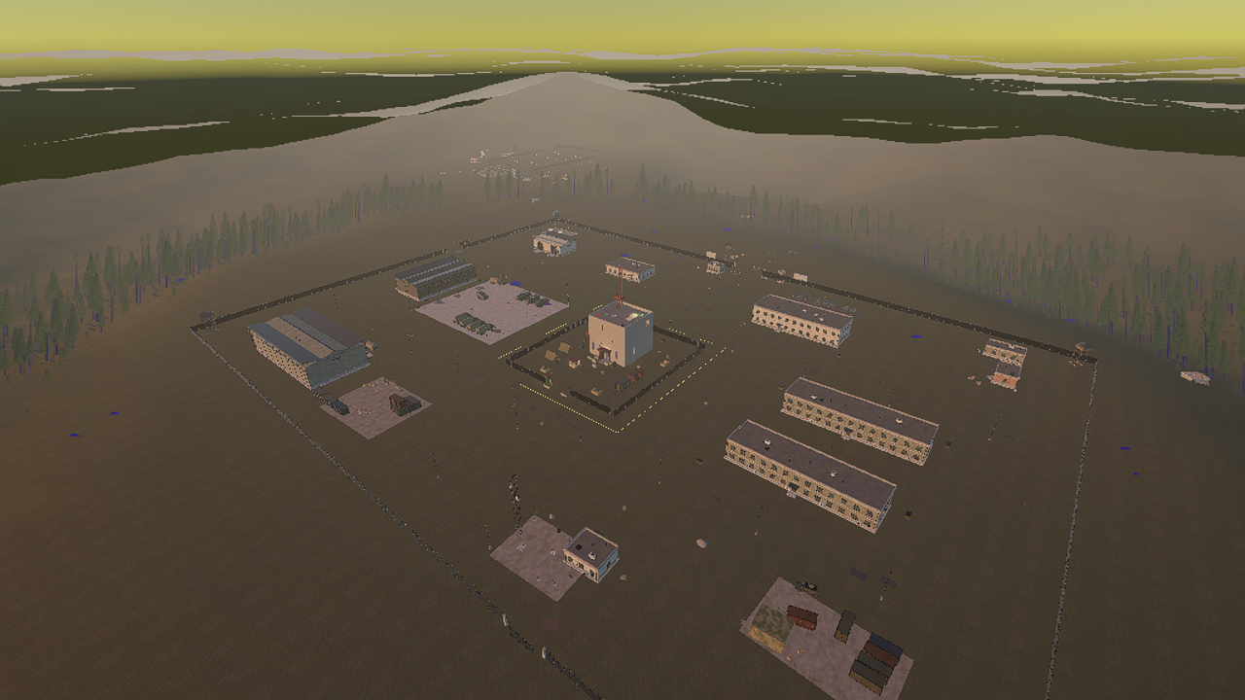
Figure 2: The valley and the military base around the tower, built in Blender.

Characters

Character #1, The Player
The author's own avatar (made with Avaturn, exported from Blender) on the template's third-person rig: it keeps the template's animations, guns, holsters and hit boxes. 100 HP, delayed regeneration to 60 %. Starts unarmed.

Character #2, The Soldier (Enemy)
The template's cover-shooter AI wearing the Asset Store Low Poly Soldiers body. Tuned to stand and fight: guards its room, never retreats, hunts the player during the alarm or when only the last enemies are left.

Character #3, Drones, Turrets, the Heavy Robot and the Boss
Drones and turrets telegraph each shot with a glowing eye. The heavy robot (level 3, placeholder model) and the boss (the ISO Mech from the Asset Store, with idle, walk and death animations) are armoured and only take rifle damage; the boss charges.

Character #4, The Sentries and the Deserter
Two sentries patrol the rim of the broken slab and of the helipad platform and enforce the warning ring. The deserter is a scripted soldier in the intro who demonstrates the rule.

Levels

Level #1, The Ground Floor

Synopsis
A lockdown. The player walks in with a pistol and the building closes around them.

Introductory Material
The intro names the first objective; the HUD repeats “Grab the pistol” until the player picks it up just outside the entrance.

Objectives
- Survive the lockdown.
- Kill all five soldiers and the hallway turret.

Physical Description
Entrance and checkpoint, rooms A to C, a guard hall, the West Wing, the security office and the turret hallway. During the lockdown the maintenance shutter blocks the way to the stairs and the left corridor door is locked, so the only way on is the loop on the right.

Map
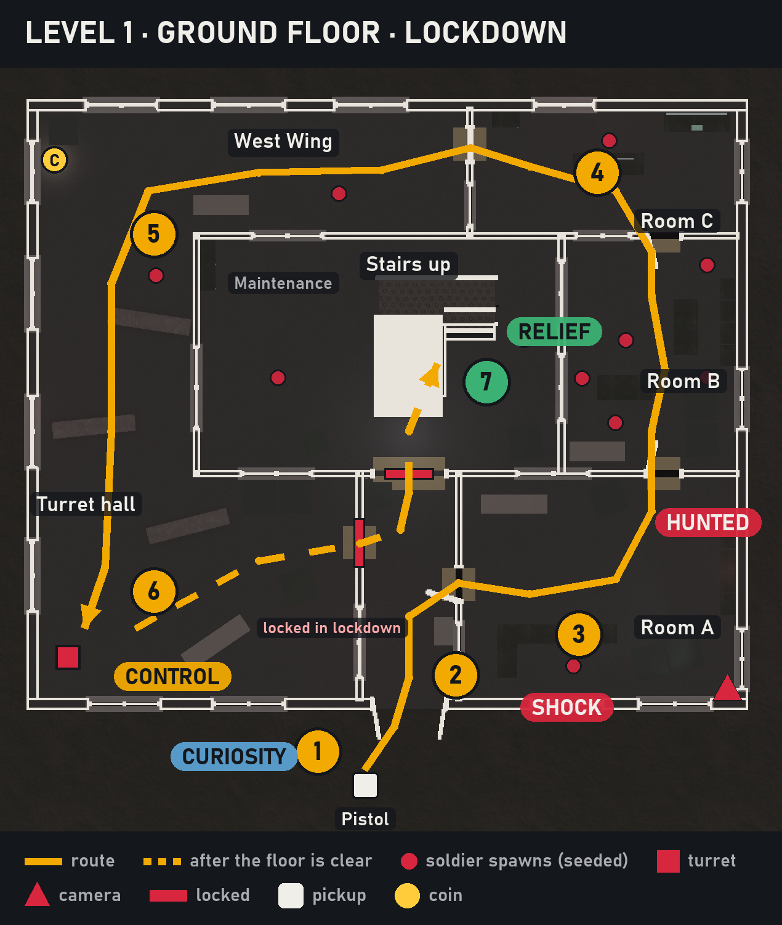
Figure 3: Level 1, ground floor (top-down plan rendered from the scene).

Critical Path
Pistol → entrance (trap) → Room A → Room B → Room C → West Wing → turret hallway → floor clear → shutter up, stairs open.

Encounters
The alarm trigger just inside the entrance, or the security camera in Room A if it sees the player for 0.6 s, starts the hunt: every level 1 soldier comes for the player. The camera can be shot first, the one choice before the trap. The turret holds the hallway at the end of the loop.

Level Walkthrough
The player is pushed into Room A and fights around corners with a weak gun while soldiers arrive from the loop. Regaining control comes room by room; the turret hallway is the last test. When the last enemy dies the siren stops, the shutter rolls up and the red stair shutter turns green.

Closing Material
Banner LEVEL CLEARED; the stairs lead up. The coin of this floor sits in a dead end off the loop.
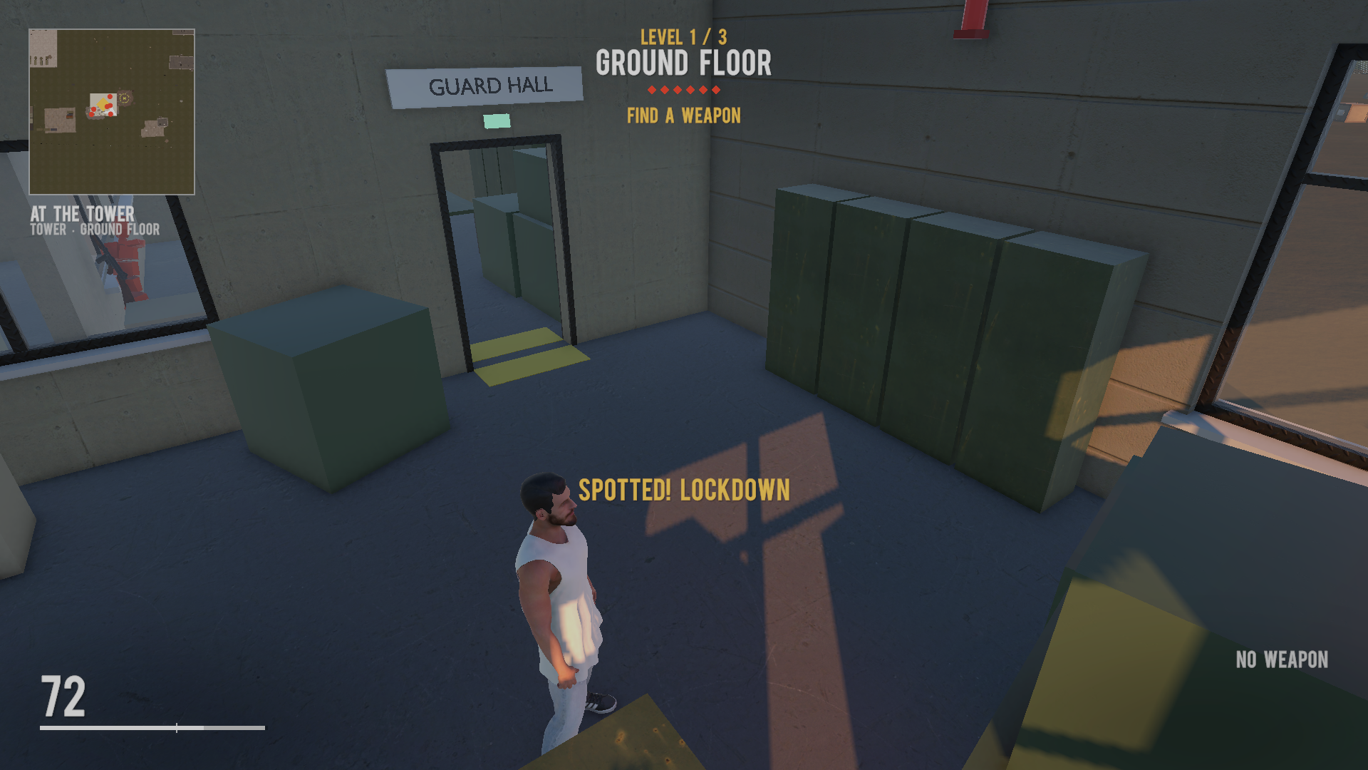
Figure 4: The lockdown: red lights, siren and the HUD goal.

Level #2, The Armory

Synopsis
A puzzle under fire: find the rifle and the key, bring the key to the slot.

Objectives
- Take the rifle from the Armory.
- Take the key from the Office desk and insert it in the slot by the stairwell gate (E).
- Kill everyone on the floor.

Physical Description
A long hall with barricades, the Armory, the Office and the stairwell. Five soldiers, two turrets and two drones overhead. The stairwell gate only opens with the key in and the floor clear.

Map
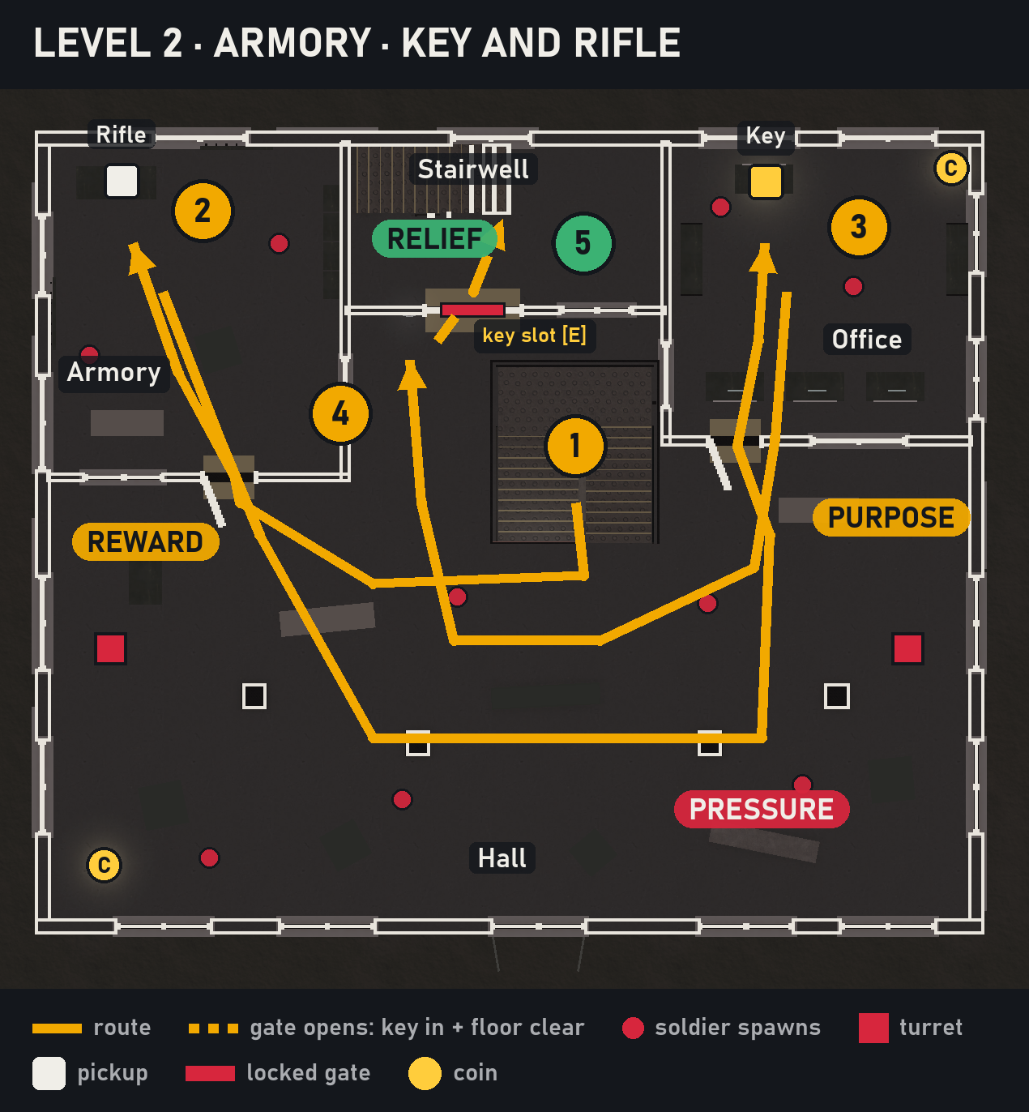
Figure 5: Level 2, the Armory floor.

Critical Path
Stairs → hall → Armory (rifle) → Office (key) → key slot → floor clear → stairwell gate.

Encounters
Mid-range fights across the hall with drones above; the rifle is a power spike before the hardest floor. Soldiers are never placed where they can see the restart point within 14 m.

Level Walkthrough and Closing Material
The key glows on the desk and flies into the player's hands; the slot turns it and its lamp goes green: relief, then the gate rolls up when the last enemy dies. Two coins: the far end of the Office and a corner of the hall.

Level #3, The Destroyed Floor

Synopsis
The set piece. Rooms, then the blown-out outside, then the machine.

Objectives
- Kill the indoor soldiers (barracks, comms, hall): the robot room opens.
- Go through the robot room and the breach in its south wall into the open area.
- Kill both outside patrols: the SE room opens.
- Destroy the heavy robot with the rifle; everyone dead opens the exit to the helipad stairs.

Map
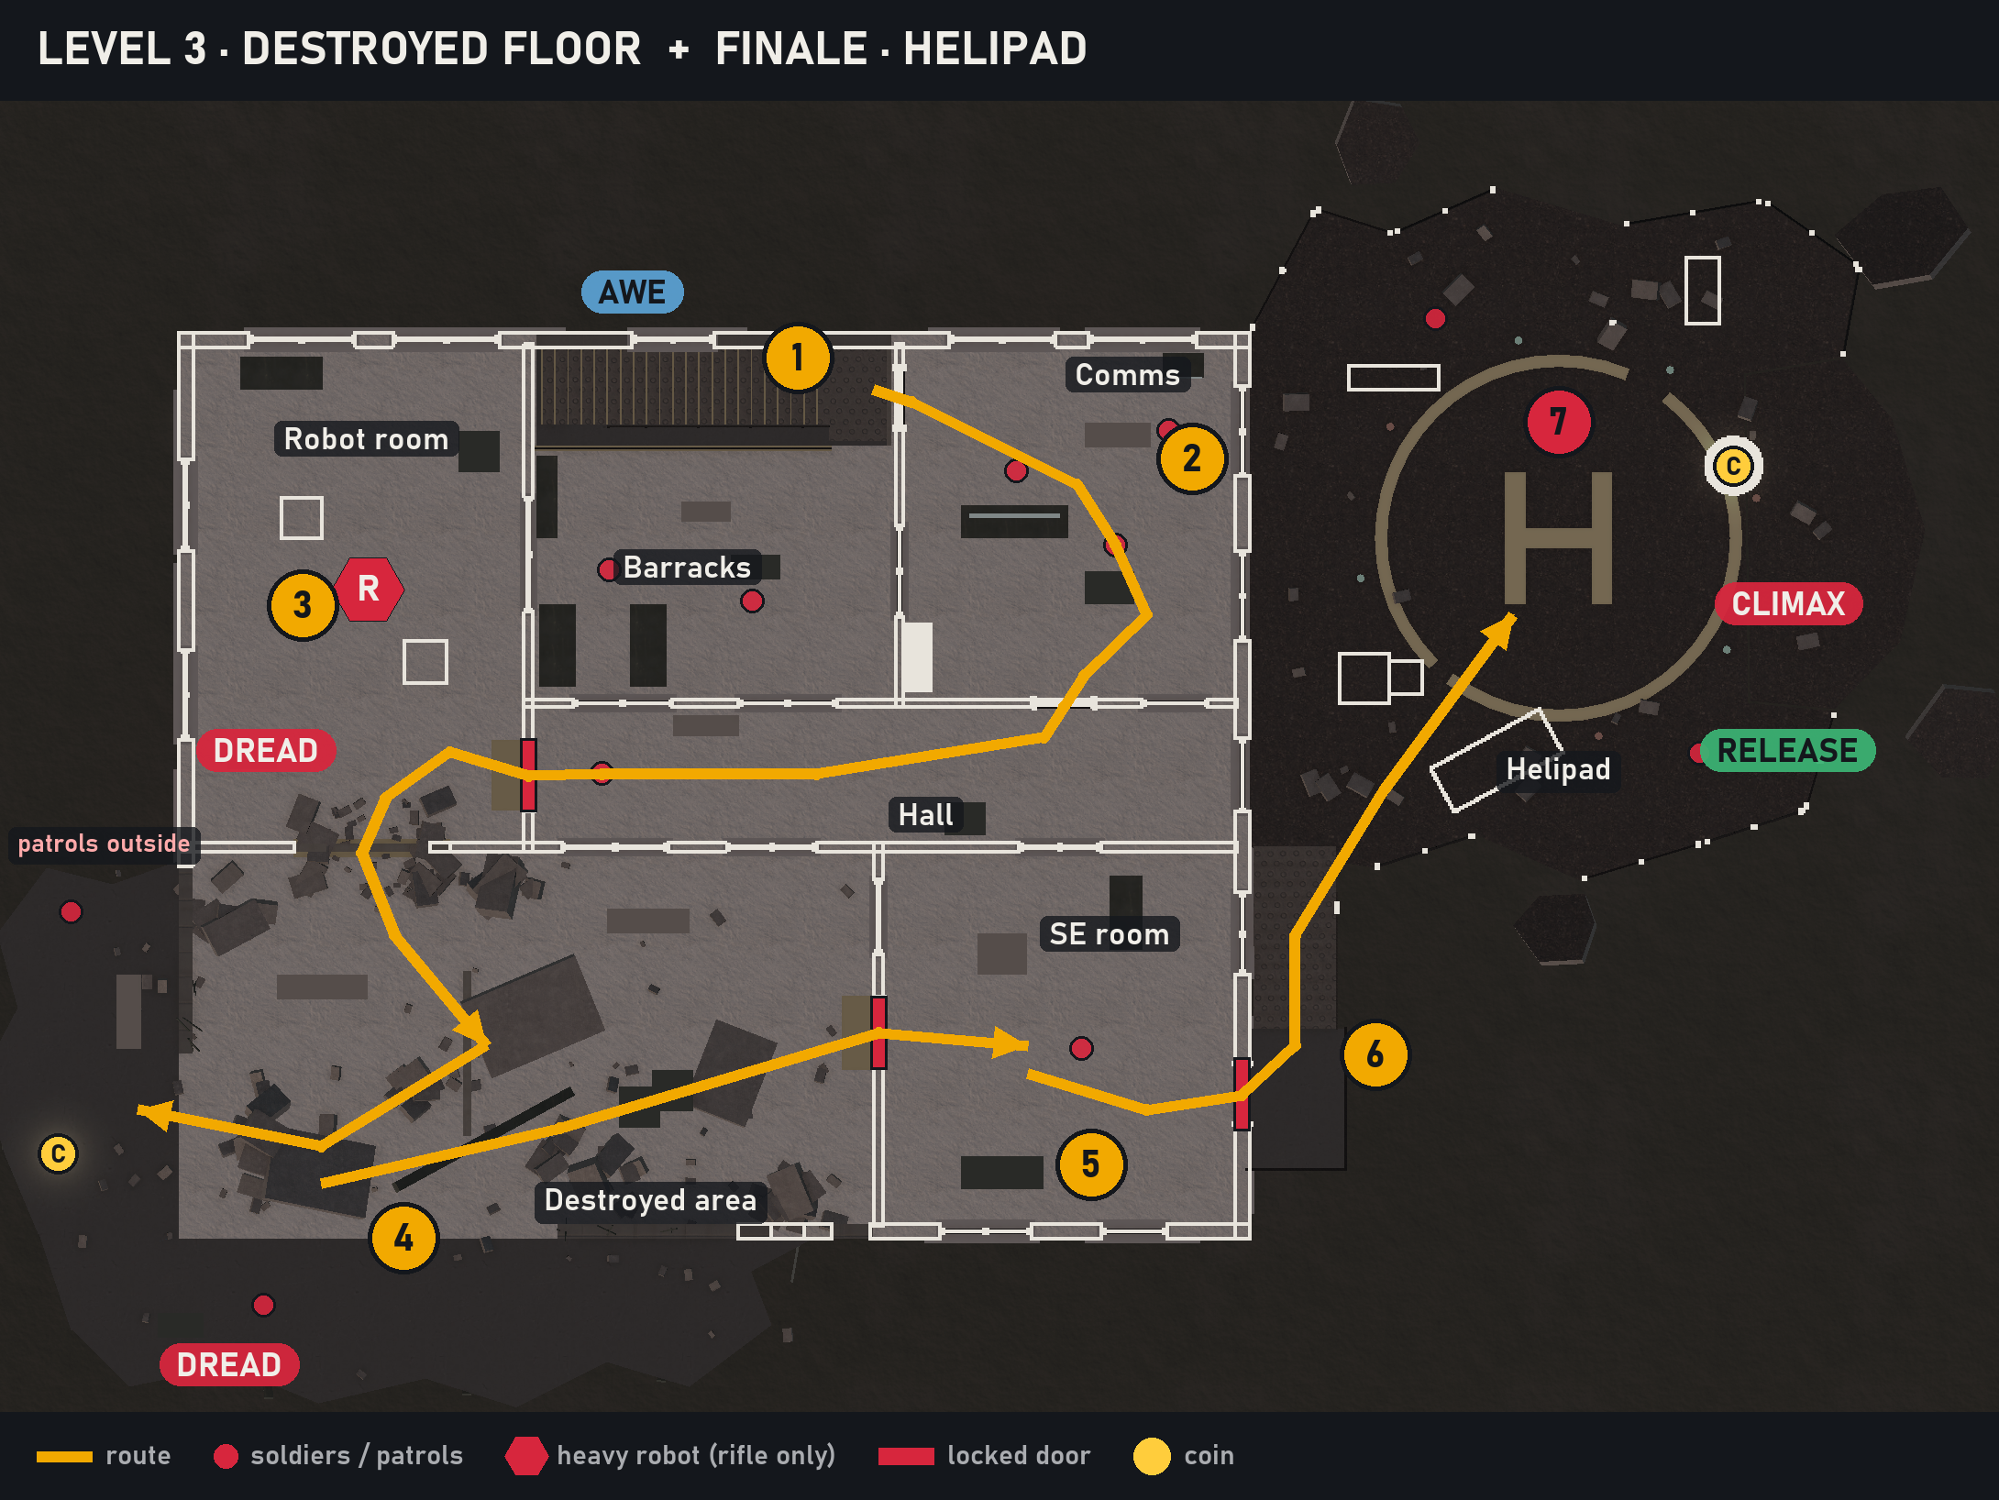
Figure 6: Level 3, the destroyed floor, and the helipad.

Critical Path
Stairs → barracks, comms, hall → robot room → breach → open area (patrols alerted) → SE room → exit → outside stairs.

Encounters
Mixed range: rooms first, then exposed outside ground on the broken slab where the patrols walk. The robot answers pistol hits with a warning; only the rifle hurts it.

Closing Material
The exit with the HELIPAD sign unlocks. The coin sits on the patrolled broken slab.
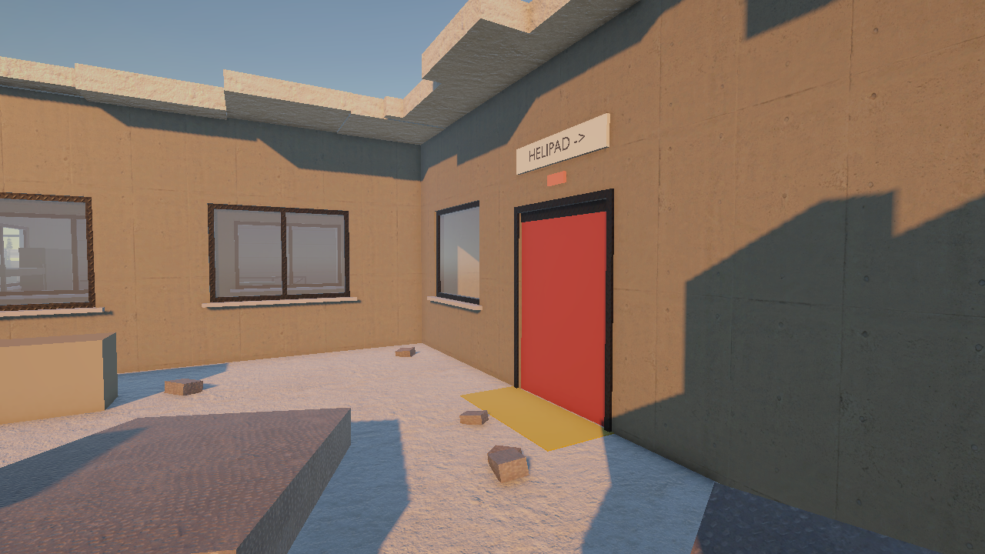
Figure 7: Level 3: daylight through the destroyed roof and the exit to the helipad.

Finale, The Helipad
Two soldiers on the platform; stepping on the pad spawns the boss on the NavMesh nearest its marker. The boss fires telegraphed bursts and charges after a one-second wind-up. Its death starts the extraction: the helicopter flies in over the valley, the camera pulls back and the end screen shows THE TOWER IS SILENT, the time, deaths, coins and achievements. The last coin is on the far edge of the pad.
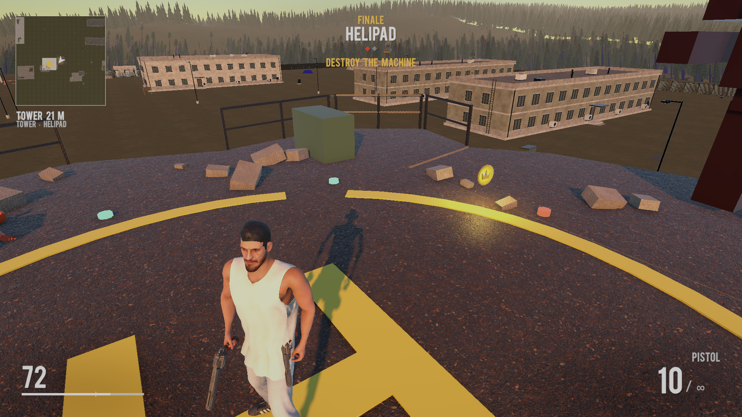
Figure 8: The boss on the helipad.

Interface

Visual System

HUD - What controls
Element | Position | What it shows
Level and goal | Top centre | Level n / 3 or Finale, its name, one pip per enemy, the goal of the moment, coins
Health | Bottom left | Health with a tick where regeneration stops
Weapon | Bottom right | Weapon and ammo
Centre | Centre | Aimed-at enemy health, kill marker, short messages, the [E] prompt at the key slot
Minimap | Top left | Baked map, player arrow, tower pinned to the edge, nearby enemies, distance, the warning ring
Feedback | Full screen | Damage flash, vignette, banners, the ring warning, death and end screens

Menus
No main menu: Play starts the intro. Death screen and end screen (Enter for a new run).

Rendering System
Unity 6, Universal Render Pipeline, Forward+ (PC renderer), soft shadows low, two cascades over 50 m, SSAO at half resolution. Occlusion culling baked for the tower.

Camera
The template's over-the-shoulder third-person camera. A custom component keeps it 0.3 m clear of walls and fades only small objects (up to 5 m) between camera and player. Cinematics take the camera over through one shared system.

Lighting Models
A golden-hour directional sun at 24°, one global post-processing volume. The alarm adds four flashing red lights and beacons; the key, coins and camera cone have small unshadowed lights. None of the added lights casts shadows (performance).

Control System
Input | Action
WASD / mouse | Move / look
Left Shift | Run
Left Ctrl (hold) | Crouch
Space | Take cover (near a wall or prop) / vault (facing an obstacle)
Double-tap a direction | Roll
Right mouse / left mouse | Aim / shoot
R | Reload
1 / 2 / 3 | Holster / pistol / rifle
G (hold) / F | Grenade / melee
E | Use the key slot
Enter | Play again
Any key | Skip the intro

Audio
Audio carries threat and place: the siren is the lockdown, the drone hum gives drones away before they are seen, the sentries' crack and glint tell where a ring shot came from.

Music
The intro has a music slot; in-level there is no music, only ambience (wind in the forest, generators, humming floodlights). Own music is planned.

Sound Effects
Sound | Purpose
Alarm siren | Starts with the lockdown, stops when level 1 is clear
Drone hum | Locates drones overhead
Weapon sounds | Template guns and hits
Sentry crack, warning call, radio loop | Ring shots and the sentries' presence
Coin chime | Pickup confirmation (synthesised)
Ambience | Wind, generators, floodlights (synthesised)
Most effects are synthesised in code for now; sound slots are ready for own recordings.

Help System
No tutorial screens. The intro names the rule and the objectives; the HUD names the goal of the moment; the key slot is the only interaction and the only [E] prompt; enemies telegraph their shots. The README lists the controls.

Artificial Intelligence

Opponent AI

Enemy AI, Soldiers
Soldiers run the course template's fighter brain, tuned by VantageEnemyAggression into a small set of behaviours:
State | Behaviour | Enter when | Exit when
Guard / patrol | Holds its room or walks its Blender patrol route | Default | Sees the player; alarm; alert
Attack | Locks on and fires bursts (0.7 s pause, 3.5° error); no cover, never retreats | Sees the player on its floor | Loses sight (to hunt or guard)
Hunt | Runs to the player through open doors | Alarm on L1; alert trigger; the last enemies of a level | Sees the player (attack); player leaves its floor
Dead | Body stays | Health 0 | —

Alert propagation, enemies interacting with each other
One event alerts many: the alarm (trigger or camera) sends every level 1 soldier after the player; entering the level 3 open area alerts both outside patrols; when only the last enemies are left, they come for the player so the end of a level never turns into a search. Hunting soldiers only hunt while the player is on their floor, and a safety net returns soldiers that leave it.

Drones and turrets
Drones fly over the level 2 hall and fire every 1.8 s at 30 % accuracy; turrets fire every 0.45 s at 30 %. Both make their eye glow brighter just before each shot.

Heavy robot and boss
NavMesh agents that think every 0.2 s, fire telegraphed three-shot bursts and judge each hit by the attacker's gun: pistol rounds bounce off. The boss adds a charge after a one-second wind-up.

Sentries
Patrol their rim back and forth with a ±60° outward scan at the ends. They read the player's zone around the tower: quiet in the free zone, scripted warning shots in the warning band, hits in the kill zone or after 5 s in the band. Each shot is announced by a red glint. They fight like soldiers only when the player is on their level, hold no door shut and stay dead once killed.

Non-combat Characters
The intro's deserter: a soldier with its AI off, walked, run and shot by script.

Friendly Characters
None.

Support AI

Player and Collision Detection
Template character controller and hit boxes (per body part). Enemies only target objects on the Character layer with a different side. Triggers (alarm, alert, helipad) react to the player only.

Pathfinding
Unity NavMesh baked for the real body radius (0.3 m). Doors are left out of the bake so agents path through openings; locked doors and the closed shutter carve the NavMesh at runtime. Blockers over the stairs keep enemies on their floor.

Technology

Target Hardware
PC, Windows 10/11. Tuned to run on a laptop with integrated graphics (Intel Iris Xe).

Development hardware and software
Engine | Unity 6000.0.58f2 (URP)
Language | C#
3D | Blender (tower, world, player export), Avaturn (avatar)
IDE | Visual Studio / VS Code, Claude Code
Version control | Git with Git LFS, GitHub
Repository | https://github.com/AdhurimThaqi/vantage-level-world-design

Development procedures and standards
- Everything generated comes from editor tools, not hand edits: Tower → Set Up Tower, World → Build Military World; re-run after a change.
- Level rules live in the Blender file as custom properties (door type, unlock condition, kill lists), turned into components on import.
- No hardcoded layers or heights; shared ray masks and body points; no per-frame lookups.
- One component per file; events over hard references.
- Every gameplay change is verified with the autoplay bot; every change is logged in WORKLOG.md.

Game Engine
Unity 6, URP, AI Navigation (NavMesh), TextMesh Pro, the old Input Manager (template).

Network
None. Single-player only.

Scripting Language
C# exclusively. Key scripts: VantageTowerLevels (level brain), VantageAlarm, VantageSecurityCamera, VantageEnemyAggression, VantageDrone, VantageHeavyRobot, VantageSentries/VantageSentry, VantageBoundary, VantageIntro, VantageExtraction, VantageCinematic, VantagePlayerHUD, VantageMinimap, VantageRun; editor tools VantageTower, VantageMilitaryBase, VantageAutoplay.

Game Art

Concept Art
The concept is the Blender model itself: the tower was blocked out and modelled in Blender with its gameplay markers, triggers and patrol paths in a separate gameplay file. Top-down floor plans rendered from the scene serve as the level maps.
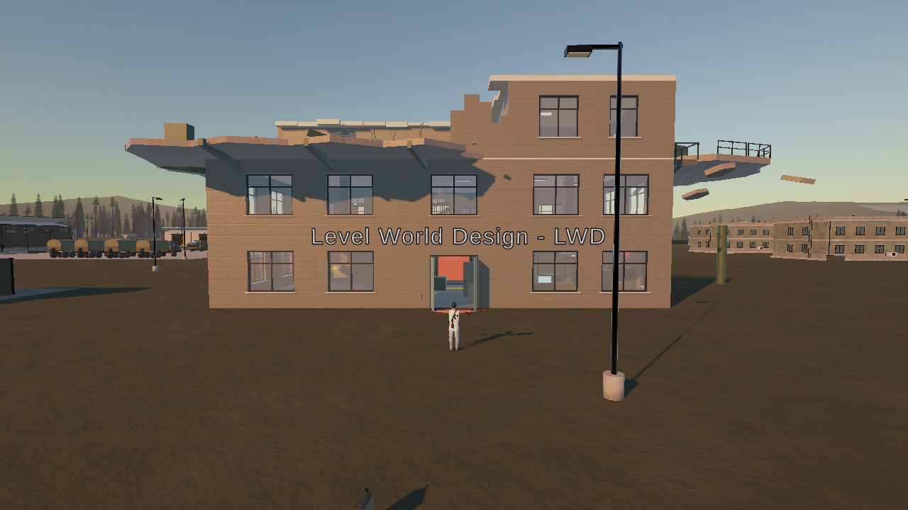
Figure 9: The approach: the tower's entrance seen from the plot.

Style Guides
Grounded military, slightly stylised. Muted concrete and sand tones; red is reserved for danger and locks (alarm, locked doors, the red stair shutter), green for open, gold for rewards (coins, the key). Low-poly characters against textured architecture.

Characters
The player is the author's avatar, retargeted onto the template rig by a tool that keeps guns and hit boxes. Soldiers wear the Low Poly Soldiers body, swapped onto the template soldier the same way. The boss is the ISO Mech with a URP material built for it. The heavy robot and the helicopter are placeholders until own models replace them.

Environments
The tower (own Blender model, Poly Haven CC0 textures) and the 1 km military world (own Blender model). The tower's import script turns Blender properties into doors, triggers and pickups.
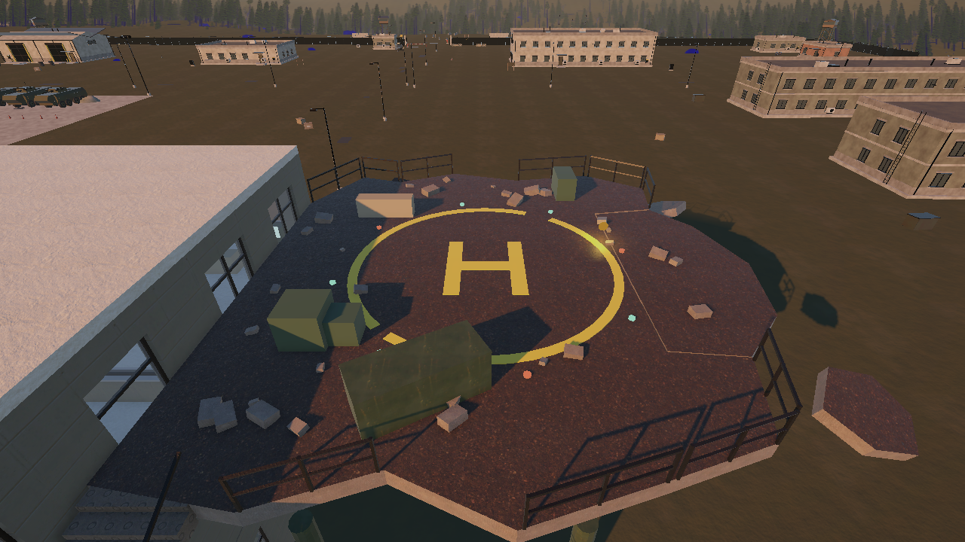
Figure 10: The helipad, the finale's arena.

Equipment
Template pistol and drum rifle, the key, the key slot, coins (Stylized Coin Pack).

Cut scenes
Intro flyover and extraction, built in code from camera paths (see Cut Scenes).

Miscellaneous
Alarm beacons and lights, the security camera's light cone, glints and tracers for the sentries' shots.

Design Process and Iterations
This chapter documents the core loop, the prototype iterations, interesting choices, balancing, juiciness, gamestate visualisation, design patterns and user testing.

Core Loop Diagram
The loops are written as text flowcharts (left to right; the last step feeds back into the first).

Micro loop, moment to moment
READ THE ROOM -> TAKE COVER -> PEEK AND SHOOT -> REPOSITION / RELOAD -> (back to READ THE ROOM)

Macro loop, per level
ARRIVE ON THE STAIRS -> LEARN THE GATE -> FIGHT THROUGH THE ROOMS -> MEET THE CONDITION -> GATE OPENS -> CLIMB

Meta loop, across levels
NEW FLOOR -> NEW KIND OF GATE / NEW ENEMY / MORE DAMAGE -> NEW WEAPON OR TOOL -> CLIMAX (BOSS) -> RELEASE (HELICOPTER)
The micro loop is the template's cover shooting; the macro loop gives every floor a clear arc with its own lock; the meta loop escalates by changing the question each floor asks, not only the enemy count.

Prototype, Iteration 1: Blockout watchtower
Setup. A ProBuilder blockout tower generated by an editor tool, first in first person: lobby, corridors, collapsed level, roof, with a procedurally generated level 2 layout. Findings. First person could not use the cover the spaces were built around, so the game moved to third person with the course template (Oct 5). The first playtest found see-through walls, stairs that caught the character, soldiers that did not shoot back and flickering surfaces (shadow acne); all were fixed, with an automated playtest bot built to find such problems in batch mode.

Prototype, Iteration 2: Six-storey command tower
Change. The author's first Blender tower replaced the blockout: four levels of storey pairs, every enemy must die before red shutters open the next. The surrounding industrial asset pack was replaced by the author's own Blender military base. Findings. The storey pairs played alike and “kill everything” was the only goal. The lecturer's feedback asked for more focus on the level and world design.

Prototype, Iteration 3: Three floors and a helipad (current)
Change. A new Blender tower with three distinct floors and a helipad, and one kind of gate per level (lockdown, key, robot and kill door, boss), coins, checkpoints, the boss-then-helicopter finale. After the presentation (Oct 21) the sentries and the warning ring gave the boundary a reason, and the intro became the briefing the lecturer suggested. Why. Every level now teaches one new thing, and the pacing has a peak and a release.
Each change came from testing, not from theory: the iteration that exposed a weakness is named in the concept document's revision table.

Interesting Choices
Choice 1, Shoot the camera or not. The security camera in Room A sweeps with a visible cone. Shooting it first keeps it from seeing the player, but the trigger inside the entrance still springs the trap: the choice is when and where the lockdown starts, not whether.
Choice 2, Cover or push. Soldiers do not take cover and come for the player; holding a cover is safe but lets them close in, pushing gains ground but exposes. The longer burst pauses (0.7 s) open windows to move.
Choice 3, Rifle or key first on level 2. Both are in different rooms off the hall. The rifle first makes the rest easier; the key first shortens the route.
Choice 4, Coins or safety. Coins sit off the critical path, one on the patrolled broken slab and one on the far edge of the pad: every coin is a detour into danger.
Choice 5, How far to stray. The base is walkable, but the warning band starts 15 m past the plot. The player can test the rule, and the HUD warning and warning shots make the cost visible before it is paid.

Balancing
Rule of thumb after the Oct 26 playtest: a single soldier in the open must need a few seconds to kill the player, and a restart must never kill on arrival.
Parameter | Value | Tuning rationale
Damage per hit | L1 6, L2 7, L3/finale 8 | Halved from 8/10/12 after 15 deaths in one run; still rises per level
Soldier burst pause | 0.7 s (was 0.25 s) | One soldier dealt ~76 damage/s at close range; pauses give a window to move
Soldier aim error | 3.5° | Misses at range read as suppression, close range stays dangerous
Drones | every 1.8 s, 30 % | Overhead threat that pushes the player off one cover, not a killer
Turrets | every 0.45 s, 30 % | Area denial in the hallway and hall
Player health | 100 HP, regen to 60 % | Regeneration rewards breaking contact, but not to full
Restart protection | 3 s, gun drawn | 8 of 15 deaths were within 1–6 s of a restart
Safe arrival radius | 14 m | No soldier spawns within 14 m with a view of a restart point
Warning ring | free 15 m, band to 35 m, 5 s grace | Room to move round the plot; clear warning before a hit
Enemies per level | L1 5 + turret; L2 5 + 2 turrets + 2 drones | Three fewer after the Oct 15 playtest (too many enemies)
All values are Inspector tunables on the level brain or the prefabs and are applied by Setup.

Juiciness
- The trap: the shutter slams, the siren starts, red lights flash and the beacons spin, all in one moment.
- Drones and turrets glow before they fire; the sentries' shots are announced by a red glint, a tracer, a crack and dust at the player's feet.
- The key floats, spins and glows, flies into the player's hands; in the slot it turns and the lamp goes from red to green.
- Kill markers, enemy pips that dim on a kill, damage flash and vignette.
- Coins spin and bob and chime on pickup.
- LEVEL CLEARED banner; the siren stops and the shutters roll up.
- The extraction: the helicopter over the valley, the camera pulling back, THE TOWER IS SILENT.
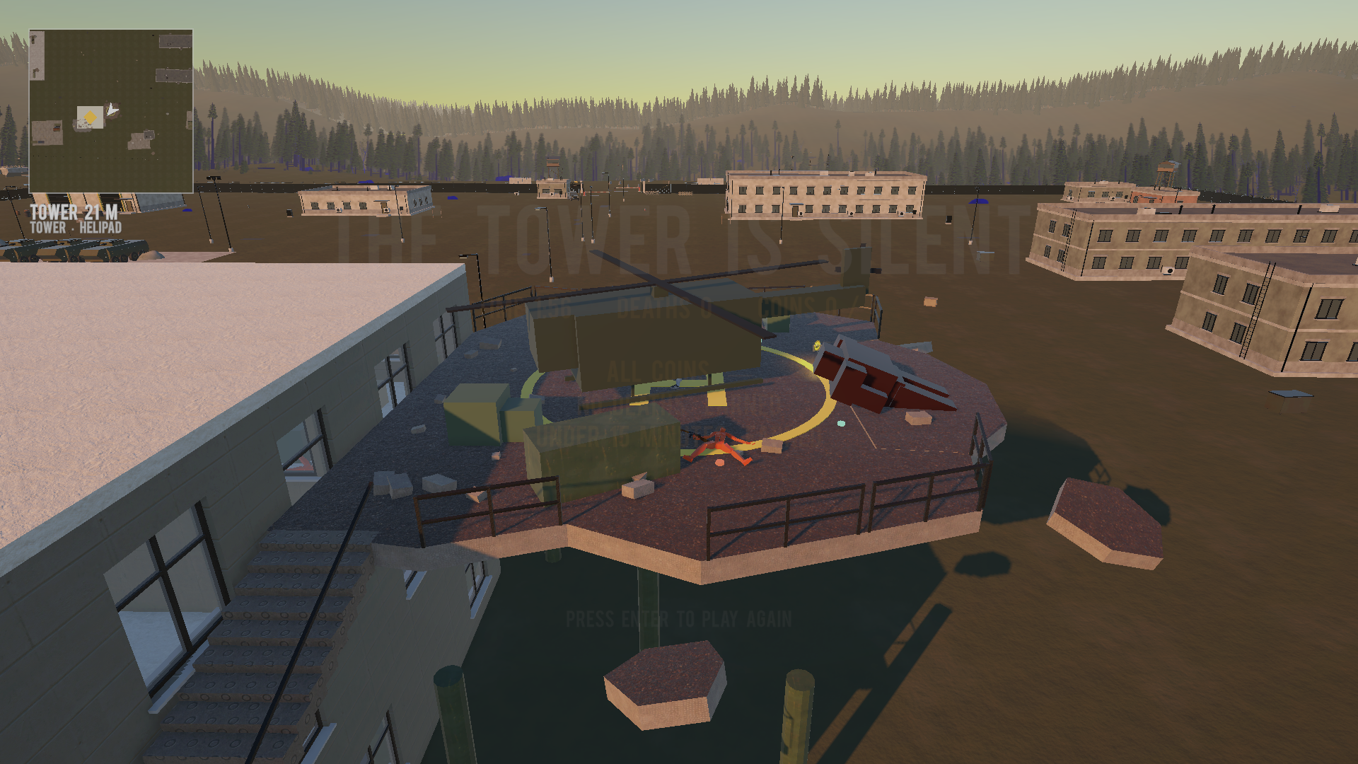
Figure 11: The end screen: time, deaths, coins and achievements.

Gamestate Visualisation
- Progress: Level n / 3 on the HUD and one pip per enemy, dimmed when it dies.
- Objective state: the goal of the moment on the HUD; the key slot lamp red or green; the stair shutter red or green.
- Threat state: siren and red light while the lockdown lasts; glowing eyes before shots; the ring warning on the HUD.
- Boundary: the minimap draws the warning ring (inner edge as a line, band tinted red).
- Rewards: the coin counter on the HUD and the end screen.

Design Patterns
Pattern | Where it is used
State machine | Soldier behaviour (template fighter brain plus guard / attack / hunt), level progression (level n active, cleared, next)
Observer / Event | VantageEvents: kills, pickups, alarm raised/stopped, coins, boss spawned, game won; kill-locked doors react to kill events instead of polling
Static state / Singleton | VantageRun (run state across the death reload), VantageCinematic (one owner of camera takeovers)
Component (Unity) | Small MonoBehaviours, one per file
Data-driven design | Level rules authored as Blender custom properties, turned into components by the import script
Builder / tool pipeline | Editor tools generate stairs, gates, covers, coins, soldiers and the world, so every change is reproducible
Object pooling (considered) | Not used: only the current level's enemies exist and counts are small

User Testing

Playtest Session 1, Oct 7 (own playtest, command tower)
Findings. Walls see-through, stairs buggy, enemies not shooting back, flickering textures. Changes. Camera clearance instead of fading floors, smooth stair surfaces, soldiers that fire off-screen, shadow bias fixed; an automated playtest bot built to repeat the checks.

Playtest Session 2, Oct 14–16 (own playtest, new tower)
Findings. A second route skipped the planned loop on level 1; a collision at the green stair gate; [E] prompts everywhere; the level 2 gate never opened because soldiers were stuck or blinking between floors; too many enemies; level 3 could not be finished (a door dependency loop found while drawing the maps). Changes. The left corridor door locks during the lockdown, the key slot is the only [E], three fewer enemies, soldiers stay on their floor and hunt, the robot room opens after the indoor soldiers.

Presentation feedback, Oct 21
Findings. The lecturer suggested a cutscene; nothing stopped the player from walking off into the base. Changes. The intro flyover and the sentries' warning ring.

Playtest Session 3, Oct 26 (own playtest, logged)
Findings. 15 deaths in one run, 8 on level 3 within 1–6 s of the restart; two soldiers spawned 4–6 m from the top of the stairs with a clear view; the level 3 stairs were entered sideways over bare steps; handrails only half way up; the player did not know what to do at the start. Changes. Enemy fire halved, safe restarts, side steps and full handrails, the intro as a briefing with objective captions.

Planned Playtest Session 4, peers
A peer playtest on the final build, with the playtest logger running and the Tester notes section of each report filled in:
- Playability: can a new player name the goal within 60 seconds after the intro?
- Guidance: does anyone walk backwards or get lost (position trails, back-tracking events)?
- Difficulty: deaths per level and time per level from the logs.
- Juiciness: tester rates 1–5 the trap, the key slot, the robot, the boss and the extraction.

Management

Detailed Schedule
Phase | Work | Status
Concept | Concept document, first-person blockout tower (Oct 4–6) | Done
Third person | Course template character, cover, soldiers (Oct 5) | Done
World | Own Blender military base, minimap (Oct 6–7) | Done
Iteration 2 | Six-storey command tower, kill-to-unlock levels, bot (Oct 7–8) | Done, replaced
Iteration 3 | Three-floor tower, gates, alarm, key, robot, boss, coins, checkpoints (Oct 14–16) | Done
Presentation | Floor plans, slides (Oct 16) | Done
Boundary and intro | Sentries, warning ring, intro flyover (Oct 21) | Done
Enemy models | Low Poly Soldiers, ISO Mech boss (Oct 22) | Done
Balancing | Playtest fixes, safe restarts, stairs, briefing (Oct 26) | Done
Stretch | Story props, per-space moods, own robot and helicopter models, own audio, peer playtest | Planned

Budget
No financial budget beyond the bought Asset Store packs. Free engine licence (Unity Personal), free GitHub hosting, own models.

Risk Analysis
Risk | Mitigation
Solo development time pressure | Mechanics from the course template; effort goes into the level, not systems
A level that cannot be finished (softlock) | The autoplay bot walks the critical path and checks reachability of every gated area
Blender re-export renames objects | Names are the API: a report tool lists all objects, Setup and the bot fail loudly
Performance on laptops | World thinned outside 220 m, lighter shadows, occlusion culling, F9 captures
Licensing for a commercial release | Every third-party asset listed; licences to check before shipping

Localization Plan
English only. Out of scope.

Test Plan
An automated playtest bot (Vantage → Test → Run Autoplay Test) plays the real level in batch mode and checks the intro, the trap, the entrance, enemy fire, every gate, the key, the robot, every stair flight, the finale, checkpoints, safe restarts, the warning ring and the sentries (58 of 59 checks passed on Oct 26). Human playtests as described in User Testing; every session writes a report and a position trail.

Appendices

Asset List

Art
Asset | Source | License
VANTAGE Tower (three floors, helipad, props, markers) | Own work, Blender | Own
Tower textures (concrete, metal, asphalt) | Poly Haven | CC0
Military world (terrain, forest, base, props) | Own work, Blender | Own
Player character | Own avatar, Avaturn, exported from Blender | Avaturn terms
Third Person Cover Shooter 1.6 (character, AI, cover, weapons) | Course template, Unity Asset Store | Asset Store EULA
Pistol Animset Pro (animations) | Kubold | Asset Store EULA
Low Poly Soldiers (demo) | Unity Asset Store | Asset Store EULA
ISO Mech (boss) | Unity Asset Store | Asset Store EULA
Stylized Coin Pack | PolyKebap, Unity Asset Store | Asset Store EULA
Heavy robot, helicopter | Placeholders built in code | Own

Sound
Asset | Source | License
Ambience, siren, drone hum, coin chime | Synthesised in code | Own
Weapon sounds | Course template | Asset Store EULA

Music
None yet (slot in the intro). Own music planned.

Voice
No voice acting.

Repository: https://github.com/AdhurimThaqi/vantage-level-world-design
Author: Adhurim Thaqi, HSLU Level & World Design, HS26

