Linux Bash Scripting Lab Assignments - Solutions
Adhvay Banerjee
2301410002
BTech CSE Cybersecurity
Semester - 6
---
Question 1: Directory Operations
Objective: Create main directory YourName_RollNo, perform listed sub-operations
Step-by-Step Commands:
# Create main directory and enter it
mkdir YourName_RollNo
cd YourName_RollNo
# a) Create subdirectories Lab1, Lab2, Lab3
mkdir Lab1 Lab2 Lab3
# b) Move Lab3 inside Lab1
mv Lab3 Lab1/
# c) Create file studentinfo.txt inside Lab2
touch Lab2/studentinfo.txt
# d) Copy studentinfo.txt into Lab1
cp Lab2/studentinfo.txt Lab1/
# e) Show directory tree structure
# For formatted tree view (install tree first if not available):

[root@5258cd58e7e6 YourName_RollNo]# tree
.
├── Lab1
│ ├── Lab3
│ └── studentinfo.txt
└── Lab2
└── studentinfo.txt
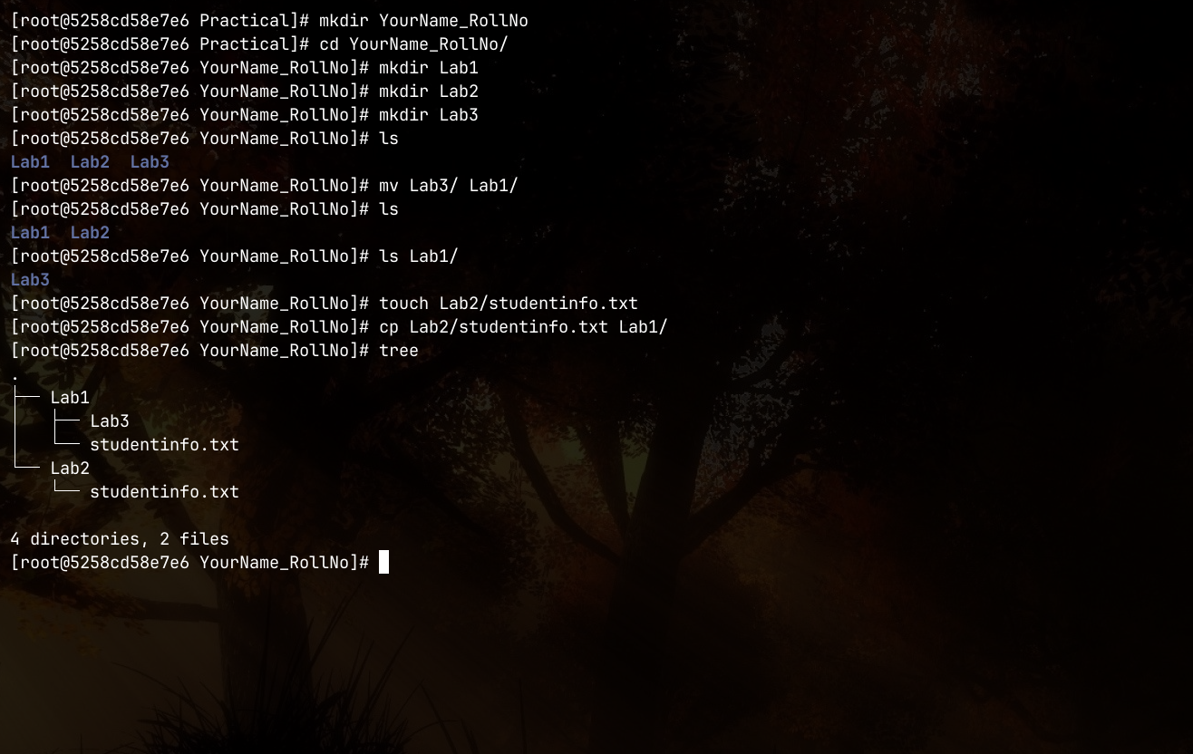
---
Question 2: Shell Script (scriptB_RollNo.sh)
Objective: Accept two numbers, display addition, subtraction, multiplication, and the greater number (replace RollNo with your actual roll number in the filename).
Full Script Code:
#!/bin/bash
# Accept two numbers from user
echo "Enter first number: "
read num1
echo "Enter second number: "
read num2
# Addition
add=$((num1 + num2))
echo "Addition: $add"
# Subtraction (num1 - num2)
sub=$((num1 - num2))
echo "Subtraction: $sub"
# Multiplication
mul=$((num1 * num2))
echo "Multiplication: $mul"
# Display greater number
if [ $num1 -gt $num2 ]; then
echo "Greater number: $num1"
elif [ $num1 -lt $num2 ]; then
echo "Greater number: $num2"
else
echo "Both numbers are equal"
fi
Test Run Output (Input: 10 and 5):
Enter first number: 69
Enter second number: 96
Addition: 165
Subtraction: -27
Multiplication: 6624
Greater number: 96
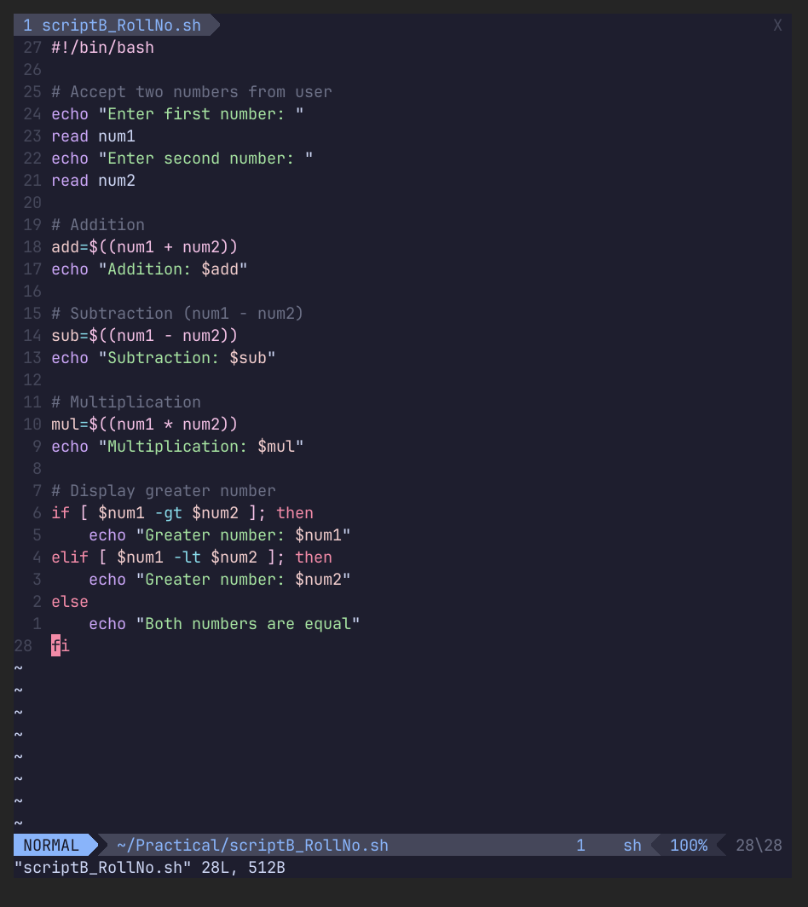
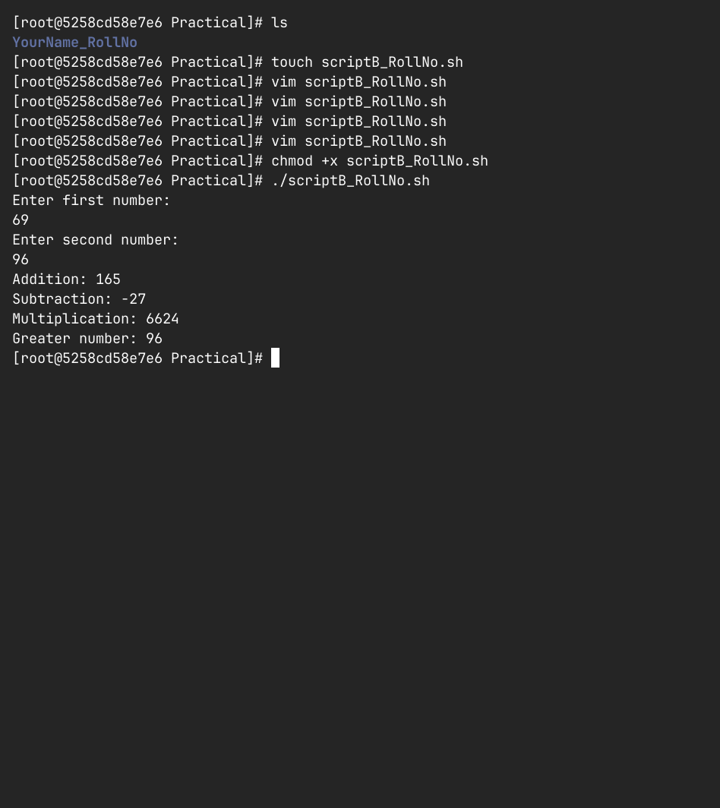

---
Question 3: Names File Operations
Objective: Create names_RollNo.txt with 5 names, perform listed operations (replace RollNo with your actual roll number in the filename).
File Content (names_RollNo.txt):
John
Alice
Bob
David
Sarah
Operations & Commands:
a) Sort names alphabetically
Command:
sort names_RollNo.txt
Expected Output:
Alice
Bob
David
John
Sarah
b) Search names containing letter a (case-insensitive)
Command:
grep -i "a" names_RollNo.txt
Expected Output:
Alice
Sarah
c) Count number of lines
Command:
wc -l names_RollNo.txt
Expected Output:
5 names_RollNo.txt
d) Display first 3 lines
Command:
head -n 3 names_RollNo.txt
Expected Output:
John
Alice
Bob
e) Display last 2 lines
Command:
tail -n 2 names_RollNo.txt
Expected Output:
David
Sarah
