PRODUCT REQUIREMENTS DOCUMENT
Velocyverse
M365 Environment Security Assessment — Automation Platform
Version 2.0 — MASTER BUILD DOCUMENT (complete with UI screen specification)
Date: 10 August 2026
Classification: Internal / Confidential

0. Document Control
Field | Detail
Product Name | Velocyverse — M365 Automation & Security Assessment Tool
Document Owner | Product / Founder
Status | Version 2.0 — Master build document, ready to hand to Kilo AI
Intended Audience | Engineering (Kilo AI agent + human reviewers), Design, Founder/Stakeholders
Related Artifacts | Front_End_-_Complete_tool.docx (source wireframes, fully incorporated into Section 26), UserFlow_Automation.jpg (source flow diagram, refined into Diagrams 1A/1B/2/3/6 in Section 7), this document (self-contained — no other files required to begin the build)
Build Scope (confirmed) | Full platform in first build: Client, Admin, and Assessor roles; Trial, Quick, and Detailed assessment tiers
Primary Tech Stack (confirmed) | Next.js/React frontend, Node.js backend, MySQL database
Tenant Auth Model (confirmed) | Multi-tenant Azure AD (Entra ID) app registration, admin-consent, read-only Microsoft Graph + Graph Security API
Marketplace / Billing | Open decision — see Section 17 (Open Questions). PRD assumes Azure Marketplace as the primary discovery/launch surface per the original flow; billing integration approach (Marketplace metering vs. Stripe) to be confirmed before Payments epic starts.

Change Log
Version | Date | Author | Notes
1.0 | 10 Aug 2026 | Product (w/ Claude) | Initial comprehensive draft, derived from wireframes + flow diagram + stakeholder answers
1.1 | 10 Aug 2026 | Product (w/ Claude) | Added Sections 21–25: assessment tier permission mapping, subscription plans + org roles + feature matrix, monetization opportunities, incremental consent strategy, and enhancement recommendations
2.0 | 11 Aug 2026 | Product (w/ Claude) | Added Section 26: complete screen-by-screen UI specification incorporating all 21 unique screens from the source wireframes, with an explicit reconciliation note on the Assessor manual-review workflow (FR-11.4). This is now a self-contained master build document.

Table of Contents
1. Executive Summary
2. Problem Statement & Opportunity
3. Goals & Success Metrics
4. Personas & Roles
5. Scope & Build Phasing
6. Assessment Tiers — Detailed Specification
7. User Flows
8. Functional Requirements
9. Manual Assessment Workflow (Detailed Tier)
10. Admin Portal Requirements
11. Assessor Portal Requirements
12. Reporting Specification
13. Non-Functional Requirements
14. System Architecture
15. Data Model
16. Microsoft Graph Integration Details
17. Open Questions & Assumptions
18. Risks & Mitigations
19. Release Plan
20. Appendix
21. Assessment Tier Classification & Permission Scope-to-Tier Mapping
22. Subscription Plans, Organization Roles & Feature Matrix
23. Monetization & Revenue Opportunities
24. Permission & Incremental Consent Strategy
25. Product Enhancement Recommendations
26. Complete Screen-by-Screen UI Specification

1. Executive Summary
Velocyverse is a SaaS platform that automates security posture assessment of a customer's Microsoft 365 environment. A prospective or existing customer connects their M365 tenant (via a multi-tenant, admin-consented Azure AD app) and Velocyverse pulls configuration data across eight core M365 surfaces — Microsoft Entra ID, the M365 Admin Center, Microsoft Purview, Email/Exchange Online (incl. Defender for Office 365), Intune, Cloud Apps (Defender for Cloud Apps), Teams, and SharePoint — evaluates that data against a structured control catalog, and produces a scored, prioritized security assessment report.
The product offers three assessment tiers of increasing depth and decreasing automation share: a free Trial Assessment (0% automated, a 10–12 question self-reported questionnaire that produces an estimated score), a Quick Assessment (100% automated, covers critical controls across all eight modules), and a Detailed Assessment (80% automated + 20% expert-reviewed manual assessment, intended for compliance-grade, audit-ready output). A Detailed Assessment routes the residual 20% to an internal Assessor via an Admin-managed assignment queue, closing the loop between automation and human judgment for controls that require business context (e.g., "is this exception justified?").
This PRD is written to hand off to an AI coding agent (Kilo AI) for scaffolding and iterative build, and covers the full platform: Client, Admin, and Assessor experiences, all three assessment tiers, the assessment/scoring engine, and the underlying Microsoft Graph integration — as confirmed for the first build.

2. Problem Statement & Opportunity

2.1 The Problem
Organizations running Microsoft 365 frequently have security misconfigurations they are unaware of — MFA not enforced tenant-wide, no Conditional Access policies, legacy authentication left enabled, DLP not configured, audit logging disabled, admin accounts not separated from day-to-day accounts, and so on. Discovering these gaps today typically requires either a manual audit by an internal IT/security team (time-consuming, requires specialist M365 security knowledge) or an expensive third-party security assessment engagement (consulting-led, slow turnaround, high cost, low repeatability).

2.2 The Opportunity
- Self-serve, automated first pass: most of what a manual M365 security audit checks can be pulled programmatically via Microsoft Graph and evaluated against a known-good control baseline (aligned to frameworks like CIS Microsoft 365 Foundations Benchmark, Microsoft Secure Score, and NIST/ISO mappings).
- Tiered depth matches buyer intent: a free/low-friction Trial builds trust and demonstrates value pre-purchase; a Quick Assessment gives a fast, cheap, fully-automated read; a Detailed Assessment adds expert review for organizations that need audit-ready, defensible output (e.g., for compliance, cyber-insurance, or board reporting).
- Recurring/repeatable revenue: because assessments are cheap to run once the platform exists, this supports both one-off paid assessments and a recurring "re-assess periodically" motion (referenced directly in the wireframes: "Take action & Improve security... re-assess").

2.3 Why Now
Microsoft Graph and the Graph Security API expose the vast majority of configuration signals needed for this kind of assessment via well-documented, delegated-permission APIs, and Azure Marketplace provides a natural distribution channel directly to the ICP (any organization already running Microsoft 365 / Azure).

3. Goals & Success Metrics

3.1 Product Goals
- Let any M365 admin get a credible security score in under 2 minutes with zero setup (Trial Assessment).
- Let a connected tenant get a fully automated, control-level assessment across 8 M365 modules in minutes, not days (Quick Assessment).
- Offer a compliance-grade assessment that blends automation with human expert review, with full traceability of which findings are automated vs. manually verified (Detailed Assessment).
- Give internal Admins and Assessors an efficient queue-and-review workflow so Detailed Assessments can scale without a 1:1 headcount-to-customer ratio.
- Produce a report that is genuinely useful to hand to a CISO, auditor, or insurer — not just a marketing artifact.

3.2 Success Metrics (initial targets — to validate with stakeholder)
Metric | Target (initial hypothesis) | Notes
Trial → Tenant Connection conversion rate | ≥ 25% | Primary activation funnel metric
Tenant Connection → Paid Assessment conversion | ≥ 40% | Quick + Detailed combined
Time to complete Quick Assessment (end to end) | < 10 minutes | From "Start" click to Results Dashboard
Time to complete Detailed Assessment | < 3 business days | Includes Assessor turnaround SLA
Assessor time per Detailed Assessment | < 90 minutes | Manual-portion effort target
Report download / share rate | ≥ 80% of completed assessments | Proxy for perceived value
Repeat-assessment rate (90 days) | ≥ 20% | Indicates recurring-usage viability
Data-collection success rate per module | ≥ 95% | Excludes cases where tenant denies scope

4. Personas & Roles

4.1 Client / End User ("User")
The primary buyer/operator persona — typically an IT Admin, MSP engineer, vCISO, or founder/ops lead at an SMB running Microsoft 365. Logs in with their own account (tenant-agnostic identity — this is a Velocyverse account, separate from the M365 tenant identity), then separately connects one or more client M365 tenants for assessment.
- Goals: quickly understand security posture, get actionable remediation guidance, produce a shareable report.
- Key actions: sign up/login, run Trial, connect tenant, run Quick/Detailed assessment, view results, download/share report, view assessment history, manage account.

4.2 Admin (Platform/Internal Admin)
Internal Velocyverse staff who operate the Detailed Assessment pipeline and manage the Assessor workforce. Not a customer-facing role.
- Goals: keep the Detailed Assessment queue moving, ensure every request is assigned to a qualified Assessor, manage the Assessor roster.
- Key actions: view/manage active Detailed Assessment requests, assign requests to Assessors, manage Assessors (add/remove/edit), view released reports.

4.3 Assessor (Internal Subject-Matter Expert)
Internal (or vetted contractor) M365 security specialist who performs the manual 20% of a Detailed Assessment: reviewing automated findings in context, gathering business requirements, requesting supporting documentation from the client, and recording expert judgment findings.
- Goals: efficiently work through assigned requests, get what they need from the client without excessive back-and-forth, produce defensible findings.
- Key actions: view assigned requests, view completed requests, collect additional data, request supporting documents from client, record findings that feed the Recommendation Engine.

4.4 Role Summary Table
Role | Access Surface | Cannot Do
Client / User | Own org's dashboard, own tenant connections, own assessments, own reports | See other orgs' data; assign Assessors; access Admin/Assessor portals
Admin | Admin portal: all Detailed requests, Assessor roster, released reports | Directly edit a client's raw assessment data; impersonate a client without audit trail
Assessor | Assessor portal: only requests assigned to them | See unassigned requests; manage other Assessors; access Admin functions

5. Scope & Build Phasing
Confirmed scope for the first build: the full platform — Client, Admin, and Assessor roles, and all three assessment tiers (Trial, Quick, Detailed). This section defines what "full platform" includes and proposes a recommended internal build sequence so an agentic coding tool (Kilo AI) can work through the system in a logical, testable order without changing the overall scope commitment.

5.1 In Scope (First Build)
- Client-facing web app: sign up/login/MFA, tenant onboarding guide, Trial Assessment, tenant connection flow, Quick Assessment, Detailed Assessment request, Results Dashboard, report download (PDF/Excel), assessment history, account management.
- Admin portal: Detailed Assessment request queue, Assessor management (add/edit/remove), released reports view.
- Assessor portal: assigned requests, completed requests, manual data collection workflow, document request workflow, findings entry.
- Assessment engine covering all 8 M365 modules: Entra ID, M365 Admin Center, Purview, Email (Exchange/Defender), Intune, Cloud Apps, Teams, SharePoint.
- Microsoft Graph / Graph Security API integration with multi-tenant admin-consent app registration.
- Scoring & Recommendation Engine (overall score, per-area score, findings, recommendations).
- Reporting: Assessment Summary, Overall Score, Area-Specific Score, Executive Summary, Detailed Control-Level Report; PDF and Excel export.

5.2 Explicitly Out of Scope for First Build (flag if this changes)
- Native mobile apps (web-responsive only).
- Continuous/scheduled re-assessment automation (recurring cron-based re-assessment) — first build is on-demand only.
- Multi-language / localization.
- White-label / reseller (MSP multi-client management under one login) — noted as a strong likely Phase 2 given the ICP includes MSPs, but not in first build unless re-confirmed.
- SSO/SCIM for enterprise buyer identity federation (client-side).

5.3 Recommended Build Sequence (engineering sequencing, not a scope cut)
Because "full platform" is a large surface, we recommend Kilo AI builds and validates in the following order — each stage produces a working, demoable slice, and later stages build on tested foundations rather than everything being built in parallel with nothing working end-to-end:
Stage | Deliverable | Why this order
1 | Auth + Account shell (signup/login/MFA, profile, org model) + empty dashboard | Everything else depends on identity & org context
2 | Trial Assessment (fully self-contained, no Graph integration needed) | Fastest path to an end-to-end demoable flow; validates scoring UI patterns early
3 | Tenant Connection flow + Microsoft Graph app registration + consent handling | Highest technical risk item — de-risk early
4 | Quick Assessment (automated data collection, 1 module end-to-end, then expand to all 8) | Validates the full automated pipeline before adding manual workflow complexity
5 | Scoring & Recommendation Engine + Results Dashboard + Report export (PDF/Excel) | Shared by Quick and Detailed — build once, reuse
6 | Detailed Assessment request + Admin portal (queue, assignment) + Assessor portal (workflow) | Depends on stages 4–5 being stable
7 | Polish: notifications, assessment history, account management edge cases, billing hook-up | Lower-risk, can run in parallel with stage 6 once core is stable

6. Assessment Tiers — Detailed Specification

6.1 Comparison Overview
 | Trial Assessment | Quick Assessment | Detailed Assessment
Automation | 0% (self-reported questionnaire) | 100% automated | 80% automated + 20% manual (Assessor)
Tenant connection required? | No | Yes | Yes
Input method | 12-question guided wizard | Live Microsoft Graph pull, all 8 modules | Live Microsoft Graph pull (8 modules) + Assessor review
Coverage | Key security areas only (high-level) | Critical security controls across all modules | All security controls across all modules, incl. exceptions/context
Output | Estimated score (0–100) + top recommendations | Full scored report: overall + per-area scores, findings, recommendations | Full scored, expert-reviewed, audit-ready report
Turnaround | Instant | Minutes | Up to a few business days (Assessor SLA)
Price (from wireframes — confirm before build) | Free | $5 (example price shown in wireframe) | $7 (example price shown in wireframe)
Best for | First-touch / lead generation | Fast self-serve check, regular re-checks | Compliance, audits, cyber-insurance, board reporting

6.2 Trial Assessment
A 10–12 question guided wizard covering the highest-signal security controls (MFA enforcement, Defender for Office 365, admin account separation, Conditional Access, Intune device management, disk encryption, privileged access hygiene, password policy, audit logging, DLP, backup, security awareness training — as shown in the existing wireframe). Each question is Yes / No / Unsure. A weighted scoring formula converts answers into a 0–100 score with a qualitative band (Poor/Fair/Good/Excellent), matching the existing "25/100 – Poor" wireframe. No tenant connection or Graph permissions are required — this is entirely self-reported, and the report should be explicit that this is an estimate, not a verified assessment. The results page always ends with a strong CTA to connect the tenant for a verified assessment.

6.3 Quick Assessment
Fully automated. Once a tenant is connected, Quick Assessment pulls a defined subset of "critical" controls (a curated high-signal subset of the full control catalog) across all 8 modules, runs them through the Assessment Engine and Scoring Engine, and produces the full Results Dashboard shown in the wireframe (overall score, per-module score for Entra/Email/Purview/Intune, top findings with severity, next steps, downloadable PDF/Excel report). Designed to complete in minutes with no human involvement.

6.4 Detailed Assessment
Automated data collection runs across the full control catalog (not just the critical subset) for all 8 modules — this constitutes the "80% automated" portion. The remaining ~20% consists of controls that inherently require human judgment or business context and cannot be fully resolved from configuration data alone — for example: "Is this specific Conditional Access exception justified by a documented business reason?", "Does the DLP policy scope match the organization's actual sensitive-data footprint?", or controls where the automated check surfaces an ambiguous/needs-review state. These are routed into the Manual Assessment Workflow (Section 9), assigned by an Admin to an Assessor, who reviews context, requests supporting documents from the client if needed, and records findings that are merged back into the same assessment by the Scoring & Recommendation Engine.
Note: the exact 80/20 split is a target design ratio, not a hard rule enforced in code — the real mechanism is: every control in the catalog is tagged automatable: true/false (see Section 15 data model, ControlCatalog.automatable), and the ~20% figure is simply the expected proportion of controls tagged non-automatable across the full catalog. This should be validated once the control catalog is finalized.
See Section 21 for exactly how each tier's classification (checklist / high-level automated / detailed automated+manual) determines the Microsoft Graph permission footprint requested, Section 22 for how tier availability is gated by subscription plan, and Section 24 for the incremental consent mechanism that avoids ever requesting all permissions in one blanket ask.

7. User Flows
The flows below refine and extend the original hand-drawn flow diagram and wireframe scenarios into implementation-ready flows, split into digestible diagrams. Screen references in [brackets] map to the existing wireframes in Front_End_-_Complete_tool.docx.

7.1 Diagram 1A — Onboarding & Trial Assessment
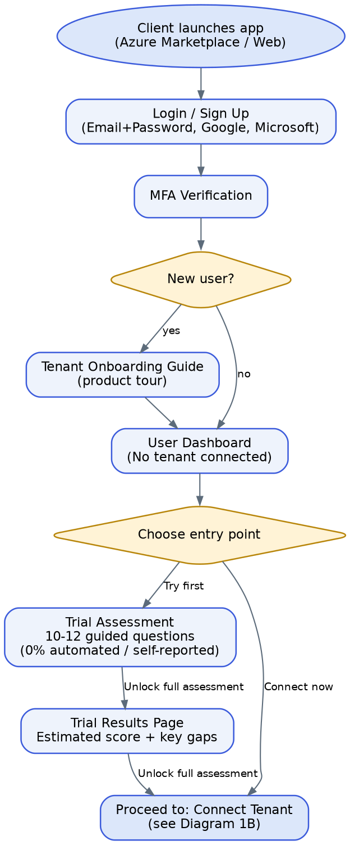
Diagram 1A: Launch → Login/MFA → Onboarding → Trial Assessment

7.2 Diagram 1B — Tenant Connection & Assessment Execution
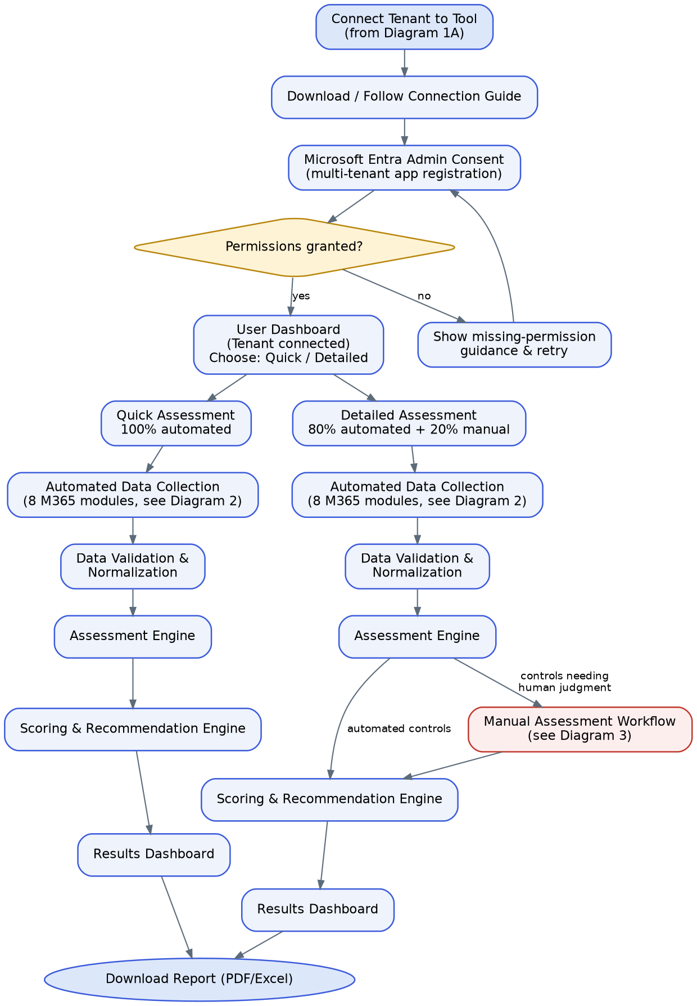
Diagram 1B: Tenant Connection (Graph consent) → Quick / Detailed Assessment execution → Results → Report

7.3 Diagram 2 — Automated Data Collection Detail (per module, both tiers)
This generalizes the original diagram's repeated per-module blocks into a single loop, since Quick and Detailed both run the same collection logic across the same 8 modules (Detailed simply evaluates more controls per module). This is the recommended implementation model: a configuration-driven loop over a MODULES list, not 8 hand-coded blocks.
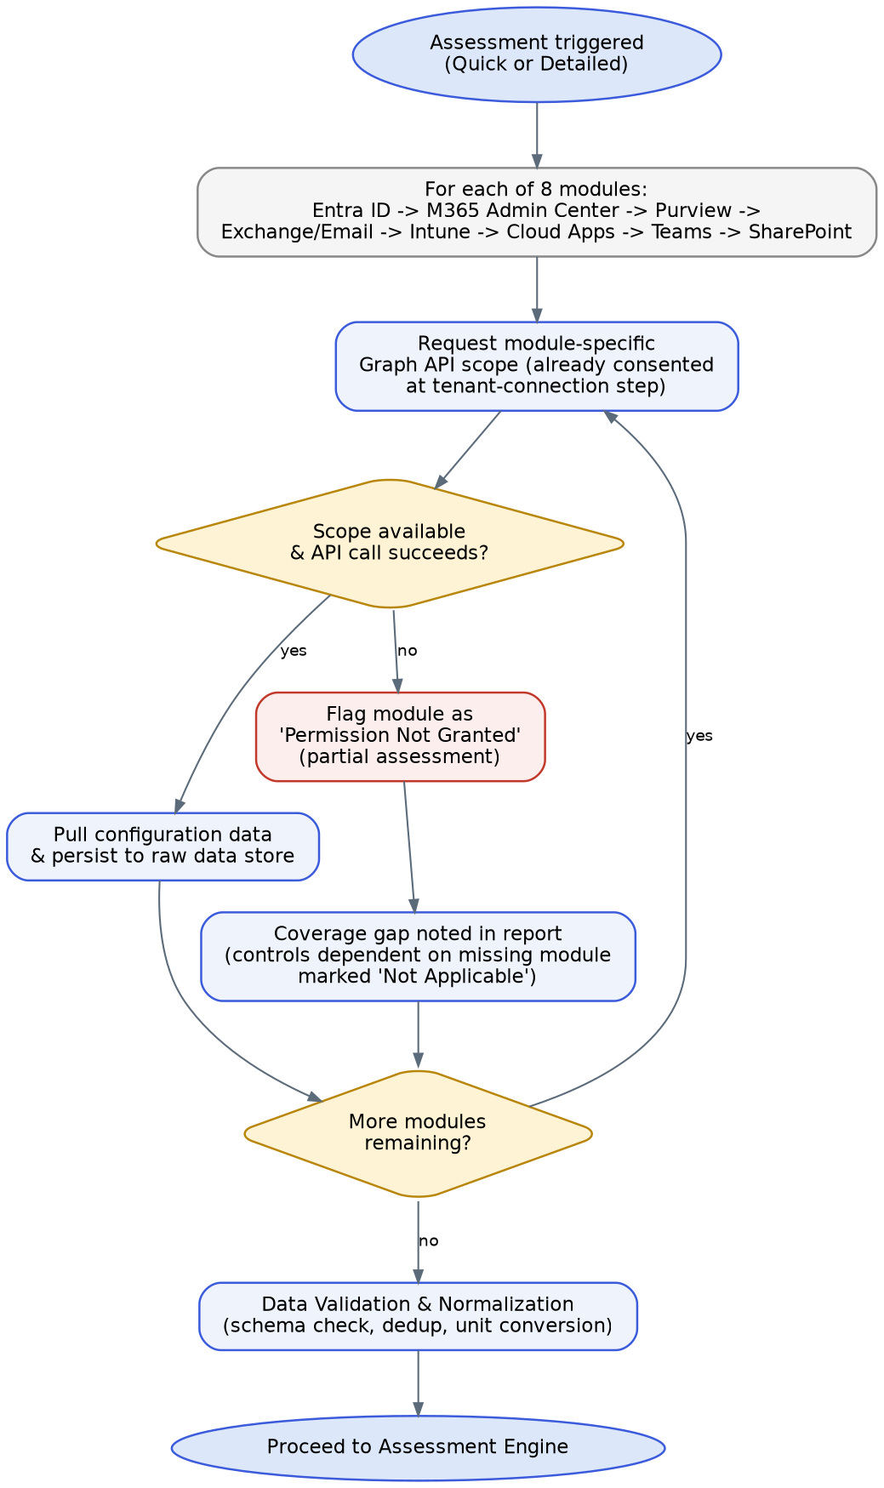
Diagram 2: Per-module data collection loop with permission-denied handling

7.4 Diagram 3 — Detailed Assessment Manual Workflow (swimlane: Client / System / Admin / Assessor)
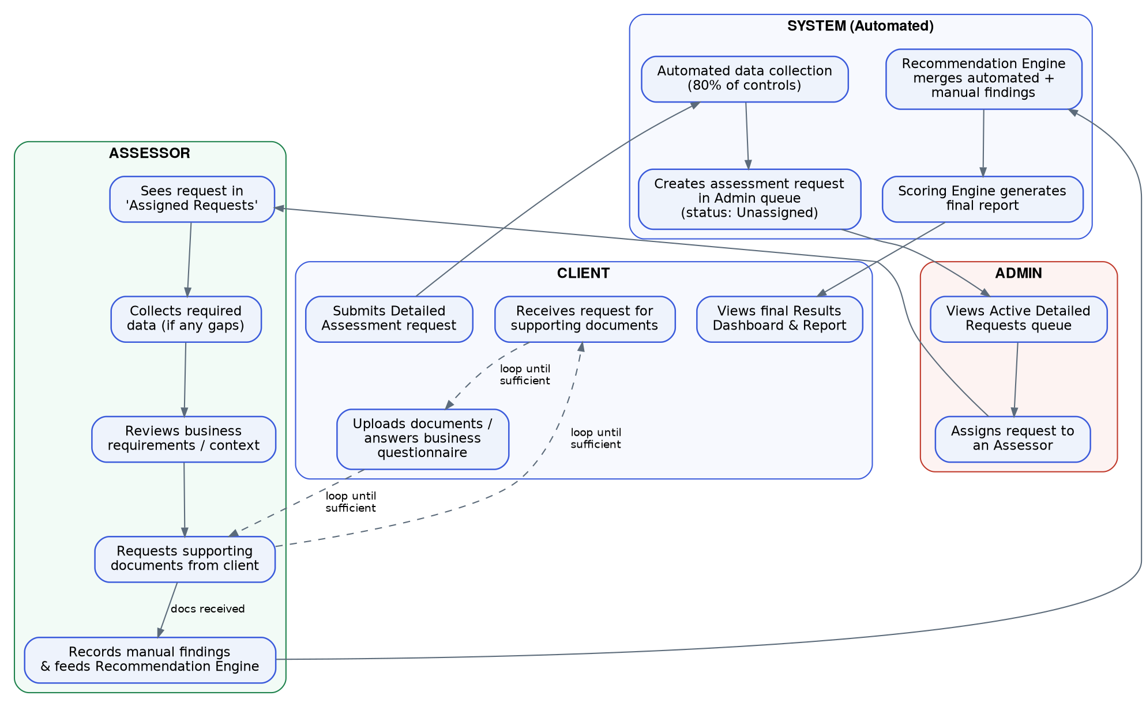
Diagram 3: End-to-end Detailed Assessment manual review swimlane

7.5 Scenario Walkthroughs (mapped to existing wireframes)

Scenario 1 — New user, Trial then Quick Assessment
- Client launches app from Azure Marketplace [Login Page]
- Signs up with tenant email [Client Information Page / Sign Up]
- Logs in [Login Page] → completes [MFA]
- Lands on [Dashboard before establishing tenant connection] → chooses Trial Assessment
- Answers [Trial Assessment Questions] → views [Trial Assessment Results Page]
- Follows [Guide to connect the Tenant to the tool] → grants admin consent
- Lands on [User Dashboard after connection established] → starts Quick Assessment
- Views [Quick Assessment Loading Screen] → views [Quick Assessment Results Page]

Scenario 2 — Returning user, Detailed Assessment
- Logs in [Login Page] → [MFA Page]
- System re-validates tenant connection [Tenant Connection Verification Page]
- Lands on [User Dashboard] → starts Detailed Assessment
- Views [Detailed Assessment Loading Page] (automated portion)
- If manual review is required: request enters Admin queue (client sees status = In Progress in Assessment History until Assessor completes review)
- Views [Detailed Assessment Result Page] once merged results are ready

Scenario 3 — Admin assigns a Detailed Assessment
- Admin logs in [Admin Login Page] → [Admin MFA Page]
- Views [Admin Dashboard – List of Detailed Assessment Requests]
- Opens [Admin Dashboard – List of Assessors] → assigns request to an available Assessor

Scenario 4 — Assessor performs manual review
- Assessor logs in [Assessor Login Page] → [Assessor MFA Page]
- Views [Assessor Dashboard] → opens assigned item
- Works through [Assessor Assessment Page]: reviews automated findings, adds manual findings, requests supporting docs from client if needed
- Submits — findings feed the Recommendation Engine and the assessment moves to Completed

Scenario 5 — Account & miscellaneous
- [User Actions Available] menu → [User Assessment History Page], [Password Change Page], [Change Name Page], [Change Email / Phone Number Page], Delete Account

8. Functional Requirements

8.1 Authentication & Account Management
ID | Requirement
FR-1.1 | Users can sign up with Full Name, Email, Password, Company Name, Company Size, and Phone Number (with country code). Email must be validated as a real, deliverable address; a warning note should discourage personal email addresses (per wireframe: "Kindly enter your tenant's mail id").
FR-1.2 | Users can log in with Email/Password, Google OAuth, or Microsoft OAuth.
FR-1.3 | MFA is required at login for all roles (Client, Admin, Assessor). Support at minimum TOTP authenticator app; email/SMS OTP as a secondary option.
FR-1.4 | "Forgot password" and "Resend verification email" flows are supported.
FR-1.5 | Users can change Name, Email, Phone Number, and Password from account settings.
FR-1.6 | Users can delete their account (soft-delete with a grace/recovery period recommended; must cascade-handle or anonymize associated assessment data per retention policy).
FR-1.7 | Sessions expire after a configurable inactivity window; "Remember me" extends session lifetime per security policy.
FR-1.8 | Admin and Assessor accounts are provisioned by an Admin (not self-service sign-up) and use the same login/MFA mechanism, routed to role-specific dashboards post-login.

8.2 Onboarding
ID | Requirement
FR-2.1 | First-time users see a Tenant Onboarding Guide (product tour) after signup, explaining Trial vs. Tenant Connection paths.
FR-2.2 | The pre-connection User Dashboard presents exactly two clear entry points: "Start Trial Assessment" and "Connect Your Tenant", each with a short benefits list, matching the existing wireframe.
FR-2.3 | A downloadable step-by-step PDF/User Guide is available for the tenant connection process, plus in-app guided steps.

8.3 Trial Assessment
ID | Requirement
FR-3.1 | Present a fixed set of 10–12 Yes/No/Unsure questions covering the highest-signal control areas (see Section 6.2).
FR-3.2 | Compute a weighted score (0–100) and qualitative band (e.g., Poor <40, Fair 40–69, Good 70–89, Excellent 90–100 — confirm exact thresholds with stakeholder before build).
FR-3.3 | Results page shows: overall score gauge, answer summary (counts of Yes/Unsure/No), per-question breakdown, Key Recommendations (derived from "No"/"Unsure" answers), and a persistent CTA to connect the tenant.
FR-3.4 | Results can be downloaded and the trial retaken.
FR-3.5 | Trial Assessment does not require a tenant connection and stores no M365 configuration data — only the questionnaire answers.

8.4 Tenant Connection
ID | Requirement
FR-4.1 | Tenant connection uses a multi-tenant Azure AD (Entra ID) app registration. The client's tenant Global Admin (or equivalent privileged role) completes the Microsoft admin-consent flow, granting the read-only Graph scopes listed in Section 16.
FR-4.2 | The system must clearly state, before consent, exactly what permissions are requested and that access is read-only.
FR-4.3 | If consent is denied or partially granted, the affected module(s) must be clearly flagged; the user can retry consent at any time from the dashboard.
FR-4.4 | A tenant can be reconnected/re-authorized if a token expires or is revoked; connection status is visible on the dashboard (Connected / Needs Attention / Disconnected).
FR-4.5 | One Velocyverse account/org can connect one or more client tenants (data model supports many-to-one Org → TenantConnection for future MSP/multi-client support, even though multi-client UI is Phase 2).
FR-4.6 | On successful connection, the dashboard updates to the post-connection state offering Quick and Detailed Assessment (Trial remains available).

8.5 Automated Data Collection Engine (shared by Quick & Detailed)
ID | Requirement
FR-5.1 | Data collection is implemented as a configuration-driven pipeline iterating over a MODULES registry (Entra ID, M365 Admin Center, Purview, Email, Intune, Cloud Apps, Teams, SharePoint) — not hard-coded per-module logic — so modules can be added/modified without structural rework.
FR-5.2 | For each module, the pipeline calls the relevant Microsoft Graph / Graph Security API endpoints, using only the previously consented scopes.
FR-5.3 | Quick Assessment executes only the 'critical control' subset of API calls per module; Detailed Assessment executes the full control set per module.
FR-5.4 | If a required scope is missing or an API call fails for a module, that module is flagged 'Permission Not Granted' / 'Collection Failed', the assessment continues for remaining modules (partial assessment is allowed and clearly labeled), and dependent controls are marked 'Not Applicable' rather than 'Failed'.
FR-5.5 | Raw collected data is persisted (object storage) per assessment/module for traceability, audit, and potential re-scoring without re-collection.
FR-5.6 | A loading/progress screen shows stage-by-stage status (Initializing → Collecting Data → Analyzing Data → Preparing Results) with percentage complete, matching the existing wireframe.
FR-5.7 | Data collection must be idempotent and safely retryable (network/API failures should not corrupt partial state).
FR-5.8 | Rate limiting / throttling handling for Microsoft Graph (respect 429 Retry-After) is required given the volume of calls per assessment.

8.6 Data Validation & Normalization
ID | Requirement
FR-6.1 | Raw Graph API responses are validated against expected schemas per module before being handed to the Assessment Engine.
FR-6.2 | Data is normalized into a consistent internal representation (e.g., unify differing Graph API versions/response shapes, normalize timestamps, dedupe overlapping signals collected from multiple endpoints).
FR-6.3 | Validation failures for a specific data point should degrade gracefully (mark the specific control as 'Unable to Verify') rather than failing the entire module/assessment.

8.7 Assessment Engine
ID | Requirement
FR-7.1 | The Assessment Engine evaluates normalized data against the Control Catalog (Section 15), producing a Pass / Fail / Not Applicable / Needs Manual Review result per control, with supporting evidence captured.
FR-7.2 | The Control Catalog is externalized (database-driven, versioned) — not hard-coded in application logic — so controls can be added, updated, or re-weighted without a code deployment.
FR-7.3 | Each control maps to one or more industry framework references (e.g., CIS Microsoft 365 Foundations Benchmark, Microsoft Secure Score actions) for credibility and future compliance-mapping features.
FR-7.4 | Controls tagged 'automatable: false' (or that return an ambiguous automated result) are routed to the Manual Assessment Workflow for Detailed Assessments; for Quick Assessments these controls are simply excluded from scoring/marked Not Applicable, since Quick has no manual step.

8.8 Scoring & Recommendation Engine
ID | Requirement
FR-8.1 | Each control carries a weight and severity; per-module score = weighted pass rate of applicable controls in that module (0–100).
FR-8.2 | Overall score is a weighted roll-up of module scores (weighting scheme to be defined/tunable, not hard-coded).
FR-8.3 | Score bands (e.g., Poor / Fair / Good / Excellent) and their thresholds are configurable, not hard-coded, to allow tuning post-launch.
FR-8.4 | For every Failed control, the engine generates a human-readable recommendation (remediation guidance); recommendations are ranked by severity for the 'Top Findings' / 'Key Recommendations' views.
FR-8.5 | For Detailed Assessments, the engine merges automated findings with Assessor-submitted manual findings into a single unified result set before final scoring — the client should not need to know which findings were automated vs. manual unless they drill into detail (source field retained internally for audit/traceability).

8.9 Results Dashboard
ID | Requirement
FR-9.1 | Shows: assessment metadata (type, tenant, completion date/time, duration, controls assessed count), overall score gauge with qualitative band, per-module score cards (Entra, Email, Purview, Intune, Cloud Apps, Teams, SharePoint — as many as were assessed), a Results Overview donut (Passed/Failed/Not Applicable), Top Findings (ranked by severity with counts), Next Steps, and Report download (PDF/Excel), matching the existing wireframe.
FR-9.2 | 'View all findings' opens a full, filterable/sortable control-level results table (pass/fail, severity, module, description, recommendation).
FR-9.3 | Reports/results are retained and viewable for a defined retention window (30 days per existing wireframe copy — confirm as product policy, not just UI copy) after which they may be archived or require re-generation.
FR-9.4 | 'Share Report' allows generating a shareable link or sending the report to another recipient (define access control: expiring link vs. requires login — flagged as an open question, Section 17).

8.10 Assessment History
ID | Requirement
FR-10.1 | Users see a table of all past/ongoing assessments: Request ID, Type, Client/Tenant Name, Requested On, Completed On, Status (Completed/In Progress), Overall Score, and an action to View Report or Continue (for in-progress Detailed Assessments).
FR-10.2 | Supports search (by request ID or name) and filtering by type/status.

9. Manual Assessment Workflow (Detailed Tier)
This is the differentiator of the Detailed Assessment and the most operationally complex part of the system — it is effectively a lightweight case-management workflow layered on top of the automated pipeline.

9.1 Trigger
When a Detailed Assessment's automated pass completes, the Assessment Engine determines whether any evaluated controls are tagged non-automatable or returned a 'Needs Manual Review' result. If so, the assessment status is set to Pending Manual Review and a request record is created in the Admin queue with status Unassigned.

9.2 Requirements
ID | Requirement
FR-11.1 | Every Detailed Assessment requiring manual review must appear in the Admin's Active Detailed Requests queue with client name, request date, and status.
FR-11.2 | Admin can assign a request to any Active Assessor; reassignment must be supported (e.g., Assessor unavailable).
FR-11.3 | Once assigned, the request appears in that Assessor's Assigned Assessment Requests list; it disappears from other Assessors' views.
FR-11.4 | The Assessor's workspace for a request shows: (a) the automated findings already collected, organized by module/control, (b) a way to record a manual finding for each non-automatable control (result + evidence + notes), (c) a way to request supporting documents/business context from the client, (d) a way to mark the review complete.
FR-11.5 | Requesting supporting documents from the client triggers a client-facing notification and a document upload / questionnaire response surface; this can loop (Assessor may request follow-up documents) until the Assessor has enough information.
FR-11.6 | Client-submitted documents/answers are only visible to the assigned Assessor and Admins, not to other Assessors.
FR-11.7 | On submission, manual findings are fed into the Scoring & Recommendation Engine, merged with the automated result set, and the assessment status moves to Completed; the client is notified and the final Results Dashboard/report becomes available.
FR-11.8 | Full audit trail: every status transition (Unassigned → Assigned → In Review → Awaiting Client → Completed) is timestamped and attributable to a user.

9.3 Status Model
Status | Meaning | Who can transition it
Unassigned | Automated pass complete; awaiting Admin assignment | System (entry) → Admin (exit)
Assigned | Assessor identified, work not yet started | Admin
In Review | Assessor actively working the request | Assessor
Awaiting Client | Assessor requested docs/info, waiting on client | Assessor / Client action
Completed | Manual findings submitted, merged, report available | Assessor (submits) → System (finalizes)

10. Admin Portal Requirements
ID | Requirement
FR-12.1 | Admin Dashboard summarizes: Active Detailed Requests count, Assessors count, and quick links (View Requests, Manage Assessors, Change Password), matching the existing wireframe.
FR-12.2 | Active Detailed Requests view: list/manage all Detailed Assessment requests needing assignment or in progress, with the ability to assign/reassign an Assessor.
FR-12.3 | Assessors view: table of all Assessors (Name, Email, Phone, Status, Added On) with actions to Add, Rename, Change Email/Phone, Remove.
FR-12.4 | Released Reports view: audit list of completed/released Detailed Assessment reports.
FR-12.5 | Admin actions (assign, remove Assessor, etc.) are all audit-logged.
FR-12.6 | (Phase 2 candidate, flag not build) Admin-level analytics: conversion funnel, assessment volume, average Assessor turnaround.

11. Assessor Portal Requirements
ID | Requirement
FR-13.1 | Assessor Dashboard shows Assigned Assessment Requests and Completed Assessment Requests as primary navigation, matching the existing wireframe.
FR-13.2 | Assigned Assessment Requests list shows request ID, client name, assigned date, and due/SLA indicator if defined.
FR-13.3 | Assessor Assessment Page (the core workspace) implements the workflow in Section 9.2 (FR-11.4).
FR-13.4 | Completed Assessment Requests is a read-only historical list for the Assessor's own past work.
FR-13.5 | Assessors have the same account-management surface as Clients (Change Password, Change Name, Phone Number, Email, Delete Account) minus billing/org-level settings.

12. Reporting Specification
Report structure is taken directly from the existing flow diagram's 'Report Format' block and expanded into an implementable spec. Reports are generated in both PDF (primary, shareable/printable) and Excel (primary, for further analysis/filtering) formats.

12.1 Report Sections
Section | Contents
1. Assessment Summary | Tenant Name, Assessment Type (Trial/Quick/Detailed), Assessment Date, Duration, Controls Assessed, Assessment Owner (for Detailed: assigned Assessor name/contact)
2. Overall Security Score | 0–100 score, qualitative band, one-paragraph plain-English interpretation
3. Area-Specific Security Score | Per-module score (Entra, Email, Purview, Intune, Cloud Apps, Teams, SharePoint, M365 Admin Center) with Passed/Failed/N-A counts
4. Executive Summary | Two short paragraphs per assessed area: Para 1 = Positives, Para 2 = Negatives & Areas for Improvement — written in plain business language, not raw control IDs
5. Detailed Assessment Report | Every control evaluated: Control name/description, module, Pass/Fail/N-A, severity, evidence summary, Suggested Improvement; grouped by module
6. Appendix (Detailed tier only) | Manual review notes, supporting documents referenced, Assessor sign-off

12.2 Export & Sharing Requirements
- PDF export must be print-ready (proper pagination, headers/footers, no cut-off tables).
- Excel export must be a usable working file: one sheet per report section or a structured 'Findings' sheet with filterable columns (Module, Control, Result, Severity, Recommendation) at minimum.
- Reports are available for download for the retention window (30 days per current wireframe copy); UI must clearly show remaining availability.
- Share Report: generates a link or delivers via email — access model (public-with-expiry vs. authenticated) is an open question, see Section 17.

13. Non-Functional Requirements

13.1 Security
- This is a security-assessment product; the platform's own security posture is existential to credibility. Follow OWASP ASVS practices minimum; plan for a third-party penetration test before GA.
- All Microsoft Graph permissions requested must be read-only / least-privilege — never request write/modify scopes.
- Access tokens/refresh tokens for connected tenants must be encrypted at rest (e.g., envelope encryption, secrets manager / Azure Key Vault) — never stored in plaintext.
- Role-based access control enforced at the API layer (not just UI) for Client/Admin/Assessor boundaries — an Assessor must be structurally unable to query another Assessor's assigned requests, not just UI-hidden from them.
- All authentication supports MFA; enforce strong password policy; rate-limit login attempts.
- Full audit logging of: consent grants/revocations, data collection runs, admin actions, assessor actions, report access/downloads.

13.2 Privacy & Compliance
- Collected M365 configuration data is customer data — handle under a clear Data Processing Agreement; the existing sign-up screen already references 'data transfer, hosting and processing outside the EU' — data residency commitments must be decided and reflected accurately in ToS/Privacy Policy (do not just leave placeholder copy).
- Support data deletion on request (GDPR-style right to erasure) including cascading deletion of raw collected data in object storage.
- Target compliance posture appropriate for a B2B security SaaS handling sensitive tenant configuration data: SOC 2 Type II readiness should be a design consideration from day one even if certification comes later.

13.3 Performance & Scalability
- Quick Assessment: full pipeline (collection → validation → scoring) should complete in well under 10 minutes for a typical tenant.
- Data collection must be horizontally scalable (queue/worker model) to support many concurrent assessments without one large tenant blocking others.
- Microsoft Graph throttling must be handled gracefully (backoff/retry) without failing the whole assessment.

13.4 Availability & Reliability
- Target 99.5%+ uptime for the client-facing app once GA.
- Assessment runs must be resumable/retryable on transient failure rather than forcing a full restart.

13.5 Multi-Tenancy (platform architecture, not M365 tenancy)
- The platform itself is multi-tenant SaaS (many Velocyverse customer Orgs); strict data isolation between Orgs is required at the database and storage layer.

13.6 Auditability
- Every score must be explainable — the platform should always be able to answer 'why did we fail this control' by pointing to the exact evidence collected, for defensibility in compliance/audit contexts.

14. System Architecture
Reflects the confirmed stack: Next.js/React frontend, Node.js backend, MySQL database, with Azure-native integration for the Microsoft Graph connector given the multi-tenant Entra ID app-registration model.
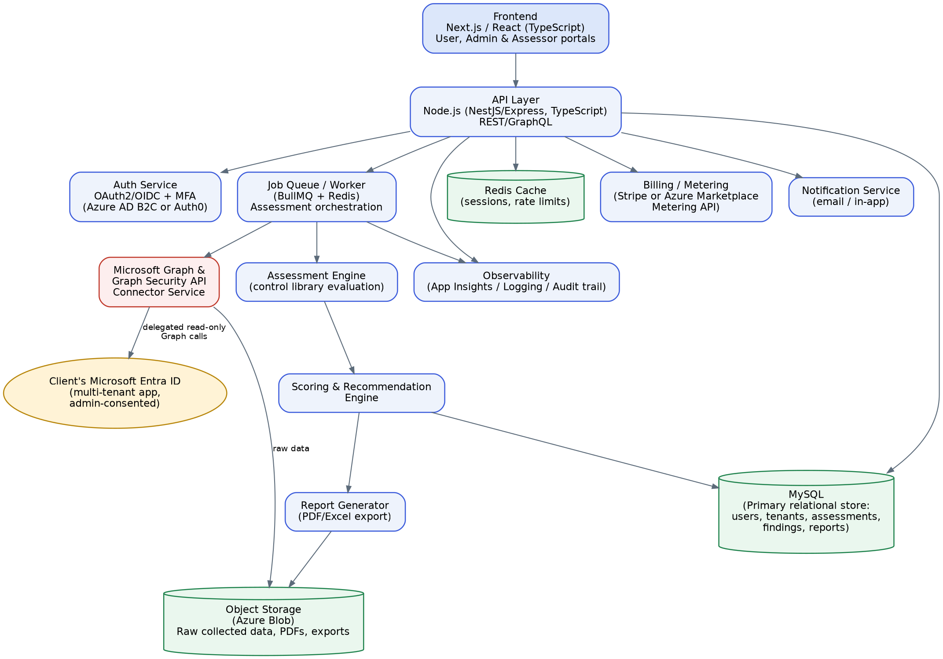
High-level system architecture

14.1 Component Notes
Component | Notes
Frontend | Next.js/React (TypeScript). Three portals (Client/Admin/Assessor) — recommend a single codebase with role-based routing/layouts rather than three separate apps, to share components (score gauges, tables, report viewers).
API Layer | Node.js (NestJS recommended for structure/DI/testability at this scope, or Express if the team prefers minimal framework overhead). Exposes REST (or GraphQL if the team prefers a single flexible contract across 3 portals) endpoints.
Auth | OAuth2/OIDC-based, MFA-capable identity provider — either a managed service (e.g., Azure AD B2C, Auth0) or a self-built auth service; recommend a managed provider to avoid building MFA/OAuth-social-login from scratch.
Job Queue / Worker | Assessment runs (especially Detailed, multi-module) are long-running and should not block the request/response cycle — use a queue (e.g., BullMQ + Redis, or Azure Service Bus) with dedicated worker processes.
Microsoft Graph Connector | Isolated service/module responsible for all outbound Graph/Graph Security API calls, token refresh, and throttling logic — keeping this isolated makes it easier to test, mock, and later extend to more modules.
Database | MySQL as the primary relational store for structured entities (users, orgs, tenant connections, assessments, findings, control catalog, reports metadata).
Object Storage | Raw collected JSON payloads, generated PDF/Excel reports, and uploaded supporting documents (Assessor workflow) — not suited to a relational DB; use Azure Blob Storage (or S3-compatible equivalent).
Cache | Redis for session/rate-limit data and to reduce redundant Graph calls within a single assessment run.
Report Generator | Dedicated service/library for PDF (e.g., a headless-Chromium/Puppeteer HTML-to-PDF pipeline, or a PDF templating library) and Excel (e.g., ExcelJS) generation from the same underlying findings data set.
Notifications | Email (assessment complete, document requested, assessment assigned) at minimum; in-app notification bell is already implied by the wireframes.
Billing/Metering | Placeholder integration point — see Section 17 for the open decision between Azure Marketplace metering and a standalone processor (e.g., Stripe).
Observability | Centralized logging + APM (e.g., Application Insights) and an explicit audit-log table (see Section 15) distinct from operational logs.

15. Data Model
Core entity-relationship model (illustrative — Kilo AI should refine exact columns/types during implementation, but the entities and relationships below should hold).
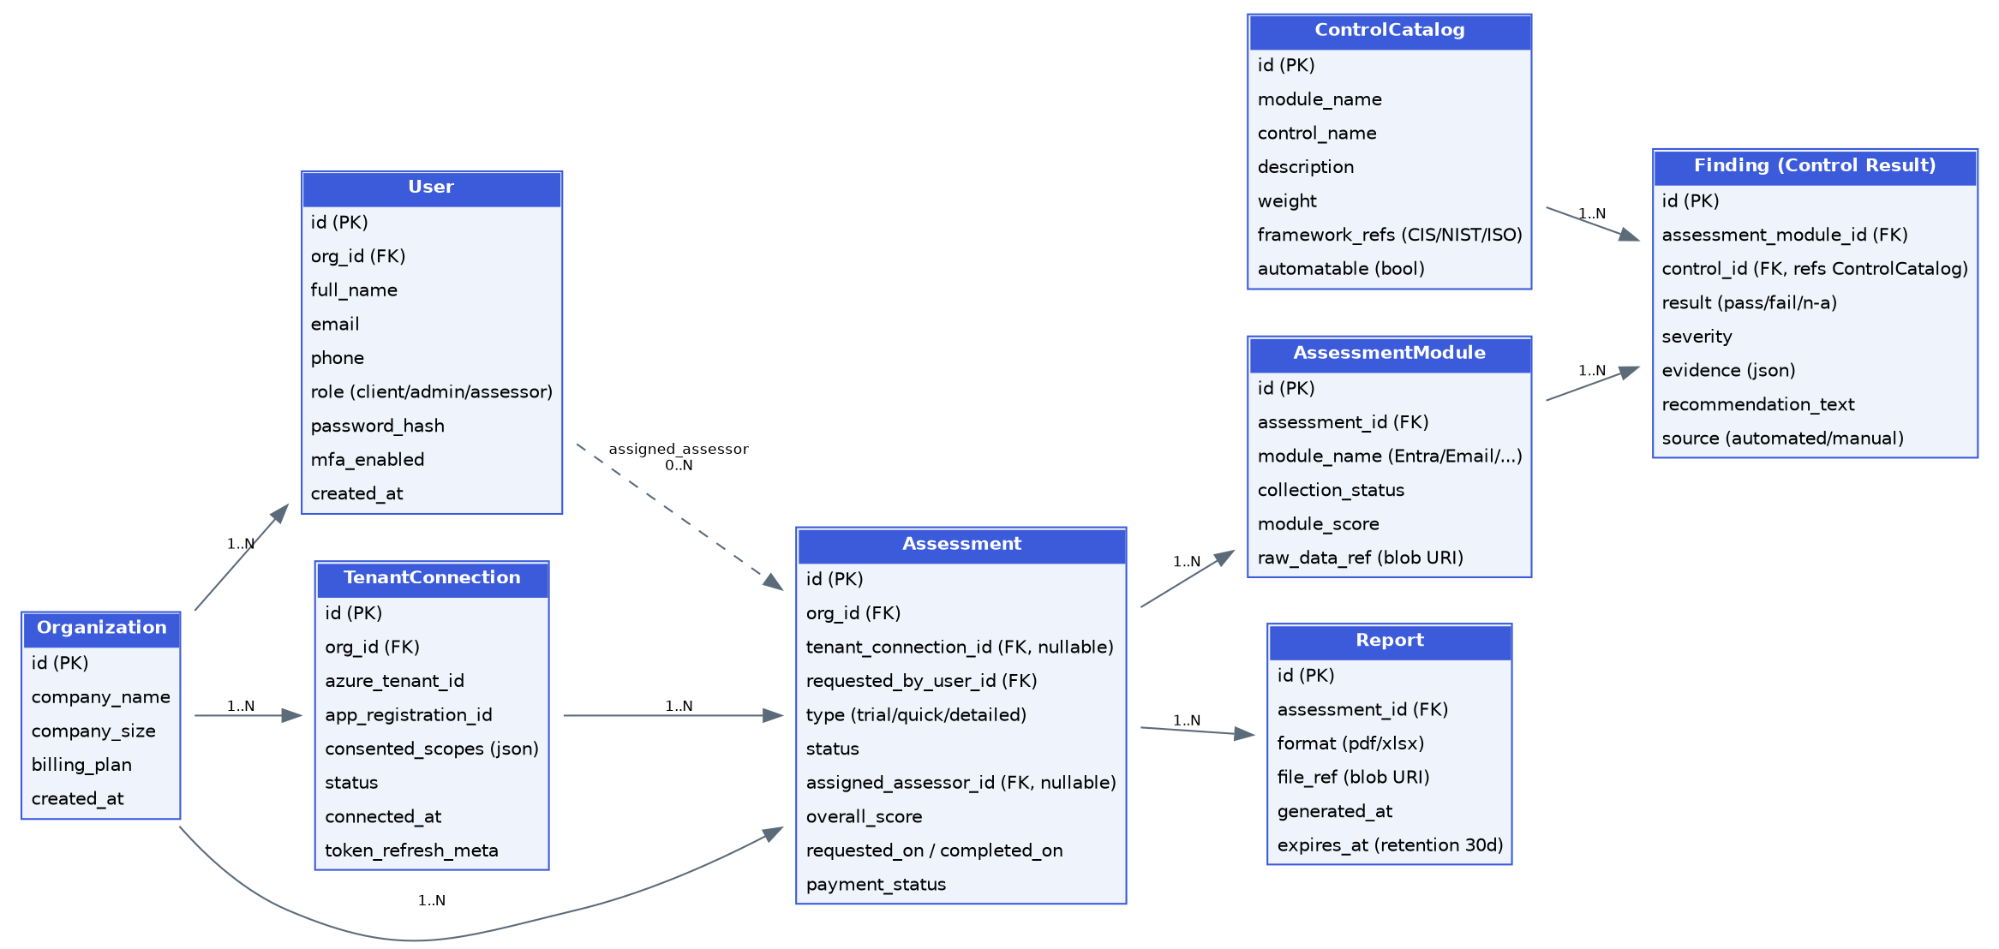
Core entity-relationship diagram

15.1 Entity Notes
Entity | Purpose
Organization | A Velocyverse customer account (the paying entity). Owns Users, TenantConnections, and Assessments.
User | A platform login, scoped to role: client / admin / assessor. Client users belong to an Organization; Admin/Assessor users are internal (Organization may be null or a dedicated 'internal' org).
TenantConnection | Represents one connected client Microsoft 365 tenant: the Azure tenant ID, the app-registration/consent record, which scopes were actually granted, and connection status/health.
Assessment | One assessment run of a given type (trial/quick/detailed) for an Organization (and, for quick/detailed, a specific TenantConnection). Carries overall status, overall score, and — for Detailed — the assigned Assessor.
AssessmentModule | One per M365 module within an Assessment (Entra, Email, Purview, Intune, Cloud Apps, Teams, SharePoint, M365 Admin Center): collection status, module-level score, pointer to raw data in object storage.
ControlCatalog | The versioned master list of all controls the platform knows how to evaluate: which module, description, weight, severity, framework references (CIS/NIST/ISO), and whether it's automatable.
Finding | The result of evaluating one ControlCatalog entry within one AssessmentModule: pass/fail/n-a, severity, evidence, recommendation text, and source (automated vs. manual) for traceability.
Report | A generated artifact (PDF or Excel) for a completed Assessment, with a storage pointer and expiry (retention policy).

15.2 Notable Design Decisions
- ControlCatalog is a first-class, versioned table — not hard-coded — so the assessment logic and the control definitions evolve independently (FR-7.2).
- Finding.source (automated/manual) preserves the audit trail required for Detailed Assessment defensibility (FR-8.5, NFR 13.6) without needing to duplicate the schema for manual vs. automated results.
- TenantConnection is modeled separately from Assessment (not embedded) to support future reuse — e.g., running multiple assessments against the same connection over time without re-consenting.

16. Microsoft Graph Integration Details
All scopes below are illustrative/representative of the read-only Microsoft Graph and Graph Security API permissions typically required for this class of assessment; Kilo AI / engineering should validate exact permission names and minimum required scopes against current Microsoft Graph documentation at implementation time, since Microsoft periodically revises permission naming and granularity.
Module | Representative Data Pulled | Representative Graph Permissions (read-only)
Entra ID (Identity) | MFA registration/enforcement state, Conditional Access policies, privileged role assignments, guest access settings, password policy, sign-in risk settings | Policy.Read.All, Directory.Read.All, UserAuthenticationMethod.Read.All, RoleManagement.Read.Directory
M365 Admin Center | Tenant-wide service configuration, license/subscription posture, general tenant settings | Organization.Read.All, Directory.Read.All
Purview | DLP policy configuration, information protection/sensitivity labels, retention policies, audit log configuration | InformationProtectionPolicy.Read.All, SecurityEvents.Read.All (Graph Security API), Purview-specific Compliance API scopes as applicable
Email (Exchange Online / Defender for Office 365) | Anti-phishing/anti-malware policy config, external forwarding rules, mailbox audit logging state, Safe Links/Safe Attachments config | SecurityEvents.Read.All, Mail.Read (config-level, not content), ThreatAssessment.Read.All
Intune | Device compliance policies, device encryption status, enrollment configuration, app protection policies | DeviceManagementConfiguration.Read.All, DeviceManagementManagedDevices.Read.All
Cloud Apps (Defender for Cloud Apps) | Discovered/sanctioned cloud app inventory, risky app/session policies | SecurityEvents.Read.All, CloudAppSecurity-specific scopes as applicable
Teams | Meeting/external access policies, guest access configuration, Teams-level security settings | TeamSettings.Read.All, Policy.Read.All
SharePoint | External/anonymous sharing settings, site-level permission posture | Sites.Read.All, SharePointTenantSettings.Read.All (or equivalent)

16.1 Consent & Token Handling
- A single multi-tenant Azure AD app registration is used across all customers (standard SaaS pattern); the client's Global Admin performs one-time admin consent covering all scopes above.
- Store the resulting refresh token encrypted; the Graph Connector Service handles silent token refresh before each collection run.
- If a customer later revokes consent in their own Entra admin center, the next collection attempt will fail with an auth error — the platform must detect this specifically (not just a generic failure) and prompt the user to reconnect.
- Support incremental/least-privilege consent evolution: if new modules or controls require an additional scope in the future, the platform must be able to request incremental consent without forcing a full re-onboarding.

17. Open Questions & Assumptions
These items are called out explicitly because they change architecture or scope decisions and were not fully resolved in scoping. Recommend resolving before the corresponding build stage starts (see Section 19 Release Plan for when each becomes blocking).
# | Question | Why it matters | Assumption made in this PRD (if any)
OQ-1 | Is billing via Azure Marketplace metering, a standalone processor (e.g., Stripe), or both? | Changes the Billing/Metering integration design (Section 14) and whether per-assessment pricing ($5/$7 shown in wireframes) is enforced by Velocyverse or by Marketplace. | PRD treats billing integration as a pluggable component; no specific processor is hard-wired into the architecture.
OQ-2 | Are the $5 (Quick) / $7 (Detailed) prices shown in the wireframes final, or illustrative? | Directly affects pricing/paywall UI and any Marketplace SKU setup. | Treated as illustrative pending confirmation.
OQ-3 | What is the Assessor SLA (target turnaround time) for a Detailed Assessment? | Needed to set client-facing expectations and any internal alerting for overdue requests. | PRD suggests 'up to a few business days' as a placeholder target.
OQ-4 | What is the exact retention period for reports/raw data, and is 30 days a hard deletion or just download-availability? | Affects storage lifecycle policy and compliance messaging. | Treated as the stated policy (30 days) per existing wireframe copy; recommend confirming as a deliberate product decision, not just placeholder UI text.
OQ-5 | 'Share Report' — should shared reports require the recipient to log in, or use an expiring public link? | Security/compliance implication (sensitive security posture data) vs. ease of sharing with e.g. a client's leadership or auditor. | No assumption made — flagged for design decision before building Share Report.
OQ-6 | Should Quick/Detailed Assessment be a one-time purchase, a subscription (e.g., monthly re-assessment), or credit-based? | Affects the Organization/billing data model and the 'Assessment History / re-assess' recurring-usage motion referenced in wireframes. | Data model (Section 15) is billing-model-agnostic; recommend deciding before Payments epic (Section 19, Stage 7).
OQ-7 | Is MSP / multi-client management (one Velocyverse login managing many end-client tenants) in scope for a near-term phase? | The persona and pricing suggest MSPs are a likely buyer; the data model already supports it (Org → many TenantConnections) but the UI does not yet. | Explicitly out of first build (Section 5.2), flagged as a likely Phase 2.
OQ-8 | Exact scoring formula weights and score-band thresholds (Poor/Fair/Good/Excellent cutoffs). | Directly affects perceived product credibility — needs security-domain expert input, not just engineering judgment. | Placeholder thresholds suggested in Section 8.8; must be finalized with a security SME before launch.
OQ-9 | Data residency commitment (the existing sign-up screen references processing 'outside the EU') — is this accurate and intended, especially for EU customers under GDPR? | Legal/compliance exposure if inaccurate; affects hosting region decisions. | Flagged only — not resolved in this PRD; recommend legal review.

18. Risks & Mitigations
Risk | Impact | Mitigation
Microsoft Graph permission/API changes break data collection for a module | High — silently wrong or missing findings undermine product credibility | Isolate all Graph calls in the Connector Service (Section 14); add automated schema/contract tests against Graph responses; monitor Microsoft Graph changelog
Customers hesitate to grant broad admin-consent permissions to a new/unknown vendor | High — blocks the core activation funnel (Trial → Connect) | Be maximally transparent about exact scopes and read-only nature before consent (FR-4.2); publish a security/trust page; consider a security questionnaire/whitepaper for enterprise buyers
Assessor bottleneck as Detailed Assessment volume grows | Medium — SLA breaches, poor client experience | Admin queue + assignment tooling built from day one (Section 10); track turnaround metrics; design the manual-review UI to minimize Assessor time per request
Scoring methodology perceived as arbitrary or inconsistent with Microsoft's own Secure Score | Medium — undermines trust with security-literate buyers | Map controls to recognized frameworks (CIS/NIST/ISO) explicitly in the report (FR-7.3); have a security SME validate weighting
Sensitive tenant configuration data breach | Critical — existential for a security-positioned product | Encryption at rest/in transit, least-privilege scopes, RBAC enforced server-side, pen test before GA (Section 13.1)
Scope creep from 'full platform' first build stalling any demoable progress | Medium — delivery risk | Recommended build sequence (Section 5.3) ensures a working slice exists early and continuously, even though total scope is large

19. Release Plan
Maps the recommended build sequence (Section 5.3) to concrete epics with rough relative sizing, for Kilo AI task breakdown. Sizing is relative (S/M/L/XL), not calendar estimates, since actual velocity with an agentic coding tool will vary.
Stage | Epic | Size | Key Dependencies / Blocking Open Questions
1 | Auth, account, Organization/User data model, empty role-aware dashboards | M | None
2 | Trial Assessment (questionnaire, scoring, results page) | S | OQ-8 (scoring thresholds) should be finalized before this ships, not just for later stages
3 | Tenant Connection: Azure AD multi-tenant app registration, consent flow, connection status UI | L | None functionally, but requires an actual Azure AD app registration + Azure subscription to be provisioned
4 | Automated Data Collection Engine (all 8 modules) + Control Catalog seed data | XL | Section 16 scopes must be validated against live Graph docs
5 | Scoring & Recommendation Engine, Results Dashboard, PDF/Excel Report generation | L | OQ-8 scoring weights
6 | Quick Assessment end-to-end (glue of stages 3–5 for the 100%-automated path) | M | Stages 3–5
7 | Detailed Assessment: manual-review routing, Admin queue/assignment, Assessor workspace, document request loop | XL | Stages 3–5; OQ-3 (SLA)
8 | Billing/paywall integration | M | OQ-1, OQ-2, OQ-6 must be resolved first
9 | Notifications, Assessment History polish, account-management edge cases, Share Report | M | OQ-5 for Share Report specifically
10 | Security hardening pass + third-party penetration test | L | Should run before GA regardless of feature completeness

20. Appendix

20.1 Glossary
Term | Definition
Tenant | A customer's Microsoft 365 / Azure AD (Entra ID) environment — distinct from a 'Velocyverse Organization' (the platform account).
Admin Consent | The Microsoft OAuth flow where a tenant's Global Admin grants an application access to specified Graph API scopes on behalf of the whole organization.
Control | A single, discrete security check (e.g., 'MFA is enforced for all users') evaluated as Pass/Fail/N-A.
Control Catalog | The full, versioned library of all Controls the platform can evaluate.
Finding | The result of evaluating one Control within one Assessment.
Automatable Control | A Control that can be fully resolved from Graph API data alone, with no human judgment required.
Graph Security API | A Microsoft Graph API surface specifically for security-relevant signals (alerts, secure scores, threat data) used alongside general Graph endpoints.

20.2 Sample Control Catalog Entries (illustrative, not exhaustive)
The full control catalog (target: several hundred controls across 8 modules, consistent with the '312 controls' figure shown in the existing Quick Assessment results wireframe) should be developed as a structured content deliverable in parallel with engineering — likely owned by a security SME rather than derived purely from this PRD. The table below illustrates the expected shape.
Module | Control | Automatable
Entra ID | MFA is enforced for all users (incl. privileged roles) | Yes
Entra ID | Legacy authentication protocols are disabled | Yes
Entra ID | Conditional Access exceptions are business-justified and documented | No — manual review
Email | Anti-phishing policy is enabled tenant-wide | Yes
Email | External email forwarding is restricted or monitored | Yes
Purview | DLP policy scope matches the organization's actual sensitive-data footprint | No — manual review
Intune | Device encryption (BitLocker) is enforced by compliance policy | Yes
SharePoint | Anonymous/external sharing is restricted to approved use cases | No — manual review (context-dependent)

20.3 Source Materials Referenced
- Front_End_-_Complete_tool.docx — existing hi-fidelity wireframes for Login/Signup, Trial/Quick/Detailed flows, Admin and Assessor portals, and account management (24 screens).
- UserFlow_Automation.jpg — original hand-drawn end-to-end flow diagram, refined and split into Diagrams 1A/1B/2/3 in Section 7 of this PRD.

20.4 Next Steps
- Resolve OQ-1, OQ-2, OQ-6 (billing model) before Stage 8; everything else can proceed without them.
- Get a security SME to validate/expand the Control Catalog and scoring weights (OQ-8) — this is the single highest-leverage non-engineering task.
- Provision the Azure AD multi-tenant app registration early (Stage 3) since it may involve Microsoft review/verification lead time for a multi-tenant app requesting sensitive scopes.
- Hand this PRD + the two source wireframe/flow files to Kilo AI along with the recommended build sequence (Section 5.3) as the first scaffolding prompt.

21. Assessment Tier Classification & Permission Scope-to-Tier Mapping
This section formalizes the tier definitions confirmed by the stakeholder and ties them directly to how much Microsoft Graph access each tier requires. The core principle: never request more permission than the tier the user is actually running needs, and never request it before the user has chosen to run that tier.

21.1 Tier Classification (confirmed)
Tier | Classification | What it evaluates | Graph permission footprint
Trial | Checklist-based self-assessment | User answers 10–12 Yes/No/Unsure questions from memory; nothing is verified against the tenant | None — zero Graph scopes requested
Quick | High-level automated assessment | Automated pull of the 'critical control' subset per module — the handful of highest-signal checks per module (e.g., is MFA enforced at all, not every nuance of every Conditional Access policy) | Critical-subset read-only scopes only, per module actually included in Quick
Detailed | Full/deep automated assessment + manual expert review | Automated pull of the entire control catalog per module, plus the ~20% of controls needing human judgment (Section 9) | Full read-only scope set per module — critical-subset scopes plus the additional deeper scopes (e.g., Purview content-level DLP config, detailed audit log retention settings)

21.2 Why This Matters for Consent Design
Because Quick and Detailed request different depths of access, and Trial requests none at all, permission requests must be resolved dynamically per action, not requested once upfront as a single bundle. A user who only ever runs Quick Assessments should never be prompted for the deeper Detailed-only scopes. See Section 24 for the full incremental consent mechanism this requires.

21.3 Tier Availability by Subscription (cross-reference)
Which tiers a given Organization can run is itself gated by subscription plan — see the Feature Matrix in Section 22.2. For example, a Free-tier Organization may be limited to Trial only; a Starter/PAYG Organization can run Quick and Detailed but pays per assessment; Professional and above include a monthly allowance of Quick/Detailed credits (Section 22.2, Section 23).

22. Subscription Plans, Organization Roles & Feature Matrix
This introduces a client-side organizational role model (distinct from the platform-level Client / Admin / Assessor roles in Section 4) and a subscription plan structure with tenant-inclusion limits, as requested. This is new scope relative to the original wireframes and should be treated as a confirmed addition to the data model (Section 15) and Section 8 functional requirements.

22.1 Organization-Level Roles (new)
Today's wireframes show a single undifferentiated Client/User role. Once billing, seats, and tenant limits exist, a real B2B buyer will expect basic team management — at minimum, someone who owns billing and others who don't. Recommend introducing four org-scoped roles, enforced server-side:
Org Role | Can do | Cannot do
Owner | Everything Admin can, plus: manage subscription/billing, purchase add-ons, delete the Organization, transfer ownership | N/A — top of the hierarchy (exactly one Owner per Organization)
Admin | Connect/disconnect tenants (within plan limits), run any assessment tier available on the plan, invite/remove Members and Viewers, view all reports | Change subscription plan, view/edit billing details, delete the Organization
Member | Run assessments (within plan credit limits), view results/reports for tenants they have access to | Connect/disconnect tenants, manage other users, view billing
Viewer | View dashboards and completed reports only | Run assessments, connect tenants, manage users, view billing
This is additive to Section 4 — the platform-level Client role now contains this internal org hierarchy; Admin/Assessor (Section 4.2–4.3) remain unchanged as internal Velocyverse roles.

22.2 Subscription Plans (proposed structure)
Proposed five-tier structure balancing self-serve PAYG (matches the existing $5/$7 wireframe pricing) with recurring subscription revenue. Exact prices are placeholders pending pricing/finance sign-off (see Open Questions, Section 17, OQ-2) — the structural mechanics (tenant limits, credit allowances, feature gates) are the part that should be locked in for engineering.
Plan | Price (illustrative) | Tenants included | Assessment credits included | Seats | Notable features
Free | $0 | 0 (Trial needs no tenant) | Unlimited Trial Assessments | 1 | Trial only — no tenant connection possible
Starter (PAYG) | $0/mo + pay-per-assessment | 1 included | None included — pay $5/Quick, $7/Detailed per run (wireframe pricing) | 3 | Good for occasional/one-off use; no monthly commitment
Professional | e.g. $99/mo | Up to 5 included | e.g. 10 Quick + 2 Detailed / month, additional at PAYG rate | 10 | Scheduled monthly re-assessment, 90-day report retention, trend view
Business / MSP | e.g. $299/mo | Up to 5 included, add-ons available (Section 22.3) | e.g. 30 Quick + 8 Detailed / month | Unlimited | White-label reports, priority Assessor SLA, API access, MSP multi-client dashboard
Enterprise | Custom | Custom (negotiated) | Custom / unlimited | Unlimited | SSO/SCIM, continuous monitoring & alerting, custom compliance framework mapping, dedicated CSM

22.3 Tenant Inclusion Limit & Add-On Pricing (confirmed mechanic)
As specified: every paid plan includes a maximum of 5 tenants (M365 environments) by default. Connecting a 6th+ tenant is not blocked outright — it is offered as a paid add-on, priced per additional tenant per month (e.g., illustrative $15–$25/tenant/month, to be finalized with pricing).
- TenantConnection creation is gated server-side (not just UI-side) against Subscription.included_tenant_slots + Subscription.addon_tenant_slots — see the updated data model in Section 22.5.
- When an Organization attempts to connect a tenant beyond its included limit, the UI presents an upsell modal: 'Add another tenant for $X/mo' (self-serve checkout) rather than a hard block — this is a direct, low-friction expansion-revenue moment.
- Add-on tenant slots are billed on the same cycle as the base subscription (prorated on purchase) and can be released (reducing future billing) if a tenant is disconnected, subject to a minimum commitment period to prevent thrashing.
- Enterprise plans negotiate tenant count directly rather than using the add-on metering path.

22.4 Feature-by-Plan Matrix
Feature | Free | Starter (PAYG) | Professional | Business/MSP | Enterprise
Trial Assessment | ✓ Unlimited | ✓ Unlimited | ✓ Unlimited | ✓ Unlimited | ✓ Unlimited
Quick Assessment | — | ✓ Pay-per-run | ✓ Included credits + PAYG overage | ✓ Included credits + PAYG overage | ✓ Unlimited
Detailed Assessment | — | ✓ Pay-per-run | ✓ Included credits + PAYG overage | ✓ Included credits + PAYG overage | ✓ Unlimited
Tenants included | 0 | 1 | 5 | 5 (+ add-ons) | Custom
Additional tenant add-on | — | Available | Available | Available | Negotiated
Report formats | PDF (Trial only) | PDF + Excel | PDF + Excel | PDF + Excel + white-label | PDF + Excel + white-label
Report retention | N/A | 30 days | 90 days | 90 days | Custom / indefinite
Scheduled re-assessment | — | — | Monthly (Quick) | Monthly (Quick) + configurable | Continuous monitoring
Trend/history dashboard | — | — | ✓ | ✓ | ✓ + benchmarking
MSP multi-client dashboard | — | — | — | ✓ | ✓
API access | — | — | — | ✓ | ✓
Priority Assessor SLA | — | Standard | Standard | Priority (48h) | Dedicated SLA
Compliance framework mapping | CIS (default) | CIS (default) | CIS (default) | CIS + 1 additional | Custom / multiple
SSO / SCIM | — | — | — | — | ✓
Note: the Role × Feature boundary (Section 22.1) applies within any plan — e.g. a Viewer on an Enterprise plan still cannot run assessments, regardless of how generous the plan's credits are. Plan gates 'what the Organization can do'; Org Role gates 'what this specific person within the Organization can do'.

22.5 Data Model Additions
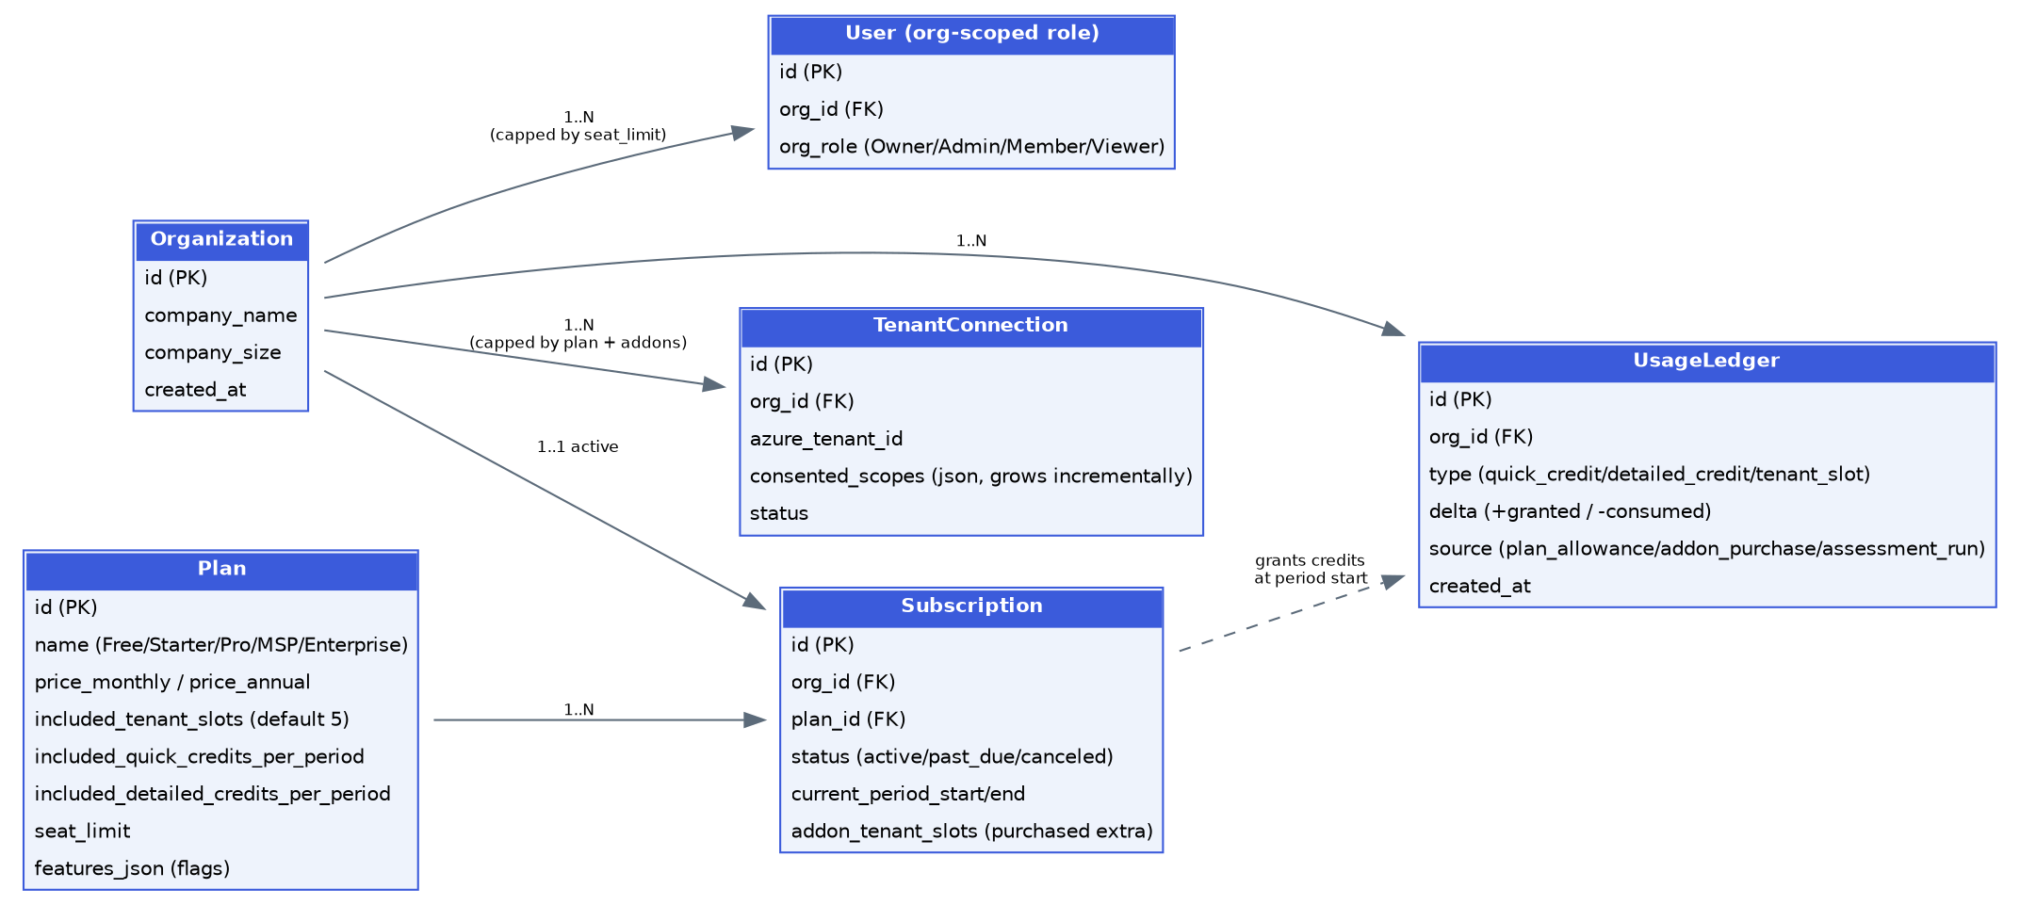
Billing/subscription entities — additive to the core ERD in Section 15
- Plan: the catalog of purchasable plans (or the Free tier) — price, included tenant slots, included assessment credits per billing period, seat limit, and a feature flag set.
- Subscription: an Organization's current plan enrollment, including any purchased add-on tenant slots, billing status, and current period.
- UsageLedger: an append-only ledger of credit grants (from plan allowance or add-on purchase) and consumption (one entry per assessment run or tenant-slot use) — this makes 'how many Quick credits do I have left this month' a simple sum query and gives a clean audit trail for billing disputes.
- User gains an org_role field (Owner/Admin/Member/Viewer) enforced at the API layer alongside the existing platform-level role field (client/admin/assessor).

23. Monetization & Revenue Opportunities
Subscriptions and pay-per-assessment (Section 22) are the primary revenue engine, but the platform generates several additional, credible monetization surfaces once the core product exists. These are listed roughly in order of how directly they build on what's already being built, not necessarily priority for launch.

23.1 Core Revenue (already covered)
- Recurring subscriptions (Free / Starter / Professional / Business / Enterprise, Section 22.2).
- Pay-as-you-go per-assessment purchases for non-subscribers or overage beyond plan credits ($5 Quick / $7 Detailed per existing wireframes).
- Add-on tenant slots beyond the plan's included limit (Section 22.3) — a natural, low-friction expansion-revenue lever since it's tied directly to real usage growth.
- Add-on seats beyond plan seat limits, and add-on assessment credit packs (e.g., '5 extra Detailed credits for $30').

23.2 Additional Revenue Opportunities
Opportunity | Description | Fit
Azure Marketplace transactable listing | List as a transactable SaaS offer so enterprise buyers can pay via their Azure bill and draw down existing Microsoft Azure Consumption Commitment (MACC) spend — this is a genuine purchase-decision accelerant for enterprise IT buyers, not just a discovery channel. | High — the entry point already assumes Marketplace; making it transactable (not just a launch link) is a natural next step.
White-label / MSP reseller program | MSPs on the Business/MSP plan can rebrand reports with their own logo and run assessments across their client tenants under one login (multi-client dashboard, Section 5.2 Phase 2). Charge a licensing premium for white-labeling. | High — the persona research already flags MSPs as a likely buyer; the data model (Org → many TenantConnections) already supports it.
Continuous monitoring / drift alerting add-on | Beyond point-in-time assessment, offer a subscription add-on that watches for configuration drift (e.g., 'MFA was just disabled for a user') and alerts in near-real-time. Natural upsell since the Graph connector and control catalog already exist — this reuses the assessment engine on a schedule/webhook trigger rather than requiring new core infrastructure. | High — strong expansion revenue, and it directly improves the product (Section 24.1).
Compliance framework add-on packs | Default reporting maps to CIS Microsoft 365 Foundations Benchmark. Sell additional framework-specific report views (HIPAA, PCI-DSS, SOC 2, ISO 27001, NIST CSF) as paid add-ons — the underlying Finding data doesn't change, just the framework-mapping layer and report template. | Medium-high — relatively cheap to build once Control Catalog framework_refs are populated (Section 15.2), high perceived value for regulated customers.
Remediation-as-a-service / partner marketplace | Many customers who get a Detailed Assessment won't have in-house capacity to fix everything. Offer (a) Velocyverse's own paid remediation service using Assessors, or (b) a referral marketplace connecting customers to vetted MSP/consulting partners, taking a placement or revenue-share fee. | Medium — higher-touch, but the Assessor role and workflow already exist as a foundation.
Cyber-insurance partnerships | Insurers increasingly want a security-posture assessment as part of underwriting. Partner with cyber-insurance providers: either a referral fee for leads, or insurers requiring/subsidizing a Velocyverse assessment as part of the application — a distribution channel that is also a revenue stream. | Medium — requires business development, not just engineering, but leverages the exact deliverable already being built.
'Verified Secure' trust badge / certification | A paid, renewable (e.g., annual) certificate/badge based on achieving a minimum score, that a customer can display on their website or in sales materials — similar to a SOC 2 badge. Low build cost (mostly a public verification page + badge asset) relative to perceived value. | Medium — marketing-driven revenue, cheap to build, needs legal care around what the badge is/isn't claiming.
API / embedded assessment licensing | License the assessment engine via API to other platforms (GRC tools, other MSP tooling) who want to embed M365 security scoring rather than build their own — usage-based API pricing. | Lower near-term priority, but the modular Assessment Engine / Scoring Engine architecture (Section 14) is already API-shaped internally, so exposing it externally is mostly a productization and legal exercise later.
Anonymized benchmark data product | Aggregate anonymized posture data across the customer base ('the average SMB in your industry scores 62/100 on MFA enforcement') as a sellable report or a comparison feature inside the product (Section 24.4). Must be explicitly consented, aggregated, and de-identified. | Lower near-term priority — needs meaningful assessment volume first, and requires careful privacy/consent design before any building starts.

23.3 Suggested Sequencing
Recommend launching with core subscriptions + PAYG + tenant add-ons only (Section 22), since that's a direct extension of what's already being built. Continuous monitoring and compliance framework packs are the next-highest-leverage additions because they reuse existing infrastructure almost entirely. Marketplace-transactable billing should be resolved alongside Section 17 OQ-1. Everything else (white-label/MSP, insurance partnerships, certification badge, API licensing, benchmark data) is credible but should wait until there's a stable core product and real usage volume to build on.

24. Permission & Incremental Consent Strategy
Direct answer to the concern raised: no, the platform should not — and technically does not need to — request every Microsoft Graph permission in one blanket consent screen. A single request listing 15–20 high-privilege 'Read.All' scopes is exactly the kind of prompt that makes a Global Admin hesitate or bail out entirely, and it also violates least-privilege best practice. The fix is to request only what the specific action the user just took actually needs, at the moment they take it.

24.1 Core Principle: Consent Scope Is Derived From (Assessment Tier + Modules), Not Requested Upfront
This formalizes and extends the per-module consent pattern already implied by the original flow diagram (each module showing its own 'Users Grants the Required Permissions' step) into an explicit, tier-aware algorithm:
- Trial Assessment requests zero Graph permissions — it needs none (Section 21.1).
- The first time a user runs a Quick Assessment, the system resolves the minimum scope set needed for Quick's critical-control subset across whichever modules Quick covers, and requests only those — not Detailed's deeper scopes.
- If that same user later runs a Detailed Assessment, the system diffs the full Detailed scope requirement against what's already been consented (from the earlier Quick run) and requests only the incremental delta — the user is never re-prompted for scopes they already granted.
- Within either tier, scopes are still requested grouped by module (Entra, Email, Purview, etc.) with a short plain-English description of exactly what that module's access enables, matching the original wireframe's per-module structure — this keeps each individual consent screen short and understandable rather than one long wall of permissions.
- If the admin declines a specific module's scopes, that module is marked 'Permission Not Granted' and the assessment proceeds without it (already specified in FR-4.3 / Diagram 2) — consent is granular and non-blocking per module.
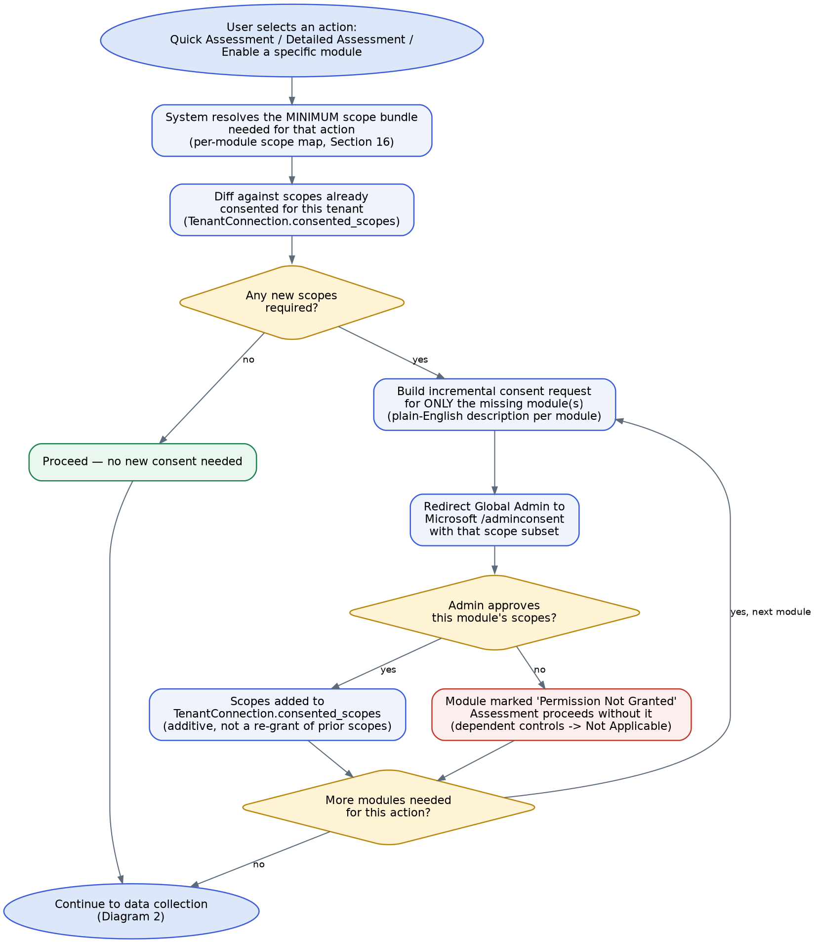
Incremental, tier-aware consent resolution — requests only the delta scope needed for the action just taken

24.2 Technical Mechanism (Microsoft identity platform)
- Microsoft's OAuth2/OIDC admin-consent flow natively supports incremental consent: a scope parameter can be submitted to the /adminconsent (or /authorize with prompt=consent for admin-restricted scopes) endpoint containing only the specific permissions needed for that step. Previously granted scopes remain granted — Azure AD accumulates consent on the tenant's service principal for that app registration rather than replacing it.
- The system of record for 'what has this tenant actually granted us' is TenantConnection.consented_scopes (Section 15.1) — always diff against this stored value, not against what the UI last showed, since the admin could have modified consent directly in their own Entra admin center.
- Detect revocation: if a previously consented scope starts failing with an authorization error on a Graph call, treat that specifically (not as a generic API failure) — update TenantConnection status and prompt reconnection for just that module, per FR-4.4.
- Because these are org-wide, privileged 'Application' permissions (not delegated 'Sign in and read user profile' style scopes), each incremental grant still requires a Global Admin (or equivalent privileged role) to approve — this is expected and appropriate for this class of access; the goal of incremental consent here is to minimize the size and frequency of each ask, not to avoid admin approval altogether.

24.3 Practical Sequencing (recommended default)
Step | When it happens | What's requested
1 | User runs Trial | Nothing
2 | User clicks 'Connect Your Tenant' intending to run Quick | Critical-subset scopes for the modules Quick covers, requested as one consent screen per module (or grouped, if Microsoft's consent UI allows a single combined screen with clear per-resource breakdown — implementation detail to validate)
3 | Same user later upgrades to Detailed Assessment for the first time | Only the incremental additional scopes Detailed needs beyond what Quick already has — typically a smaller ask than step 2
4 | A future product update adds a new module or a new control requiring a new scope | Only that new scope, requested the next time the user runs an assessment that would use it — never a forced mass re-consent

24.4 UX Recommendation
Before each consent redirect, show an in-app screen (not just Microsoft's native consent screen) that plainly states, in the user's language rather than Graph scope names: what module is being connected, what specific data will be read (e.g., 'MFA enrollment status and Conditional Access policy configuration'), and confirms it is read-only. This matches the existing wireframe's 'Secure and read-only connection' messaging and should be applied consistently at every incremental step, not just the first one.

25. Product Enhancement Recommendations (Beyond Confirmed Scope)
Direct answer to 'what else would make this a complete, powerful, efficient tool' — these are not required for the first build, but are flagged because several of them reuse infrastructure already in this PRD almost for free, and materially increase both product value and monetization surface (Section 23). Ordered roughly by leverage (value relative to build cost given what's already planned).

25.1 High Leverage (reuses existing infrastructure directly)
Idea | Why it's high leverage
Continuous monitoring & drift alerts | The Graph connector, Control Catalog, and Assessment Engine already exist — this is mostly 'run the existing pipeline on a schedule/webhook and diff against the last result' plus a notification. Also a strong subscription upsell (Section 23.2).
Score trend / history dashboard | Assessment and Finding records already carry timestamps and scores — a trend chart is largely a query/visualization feature on data already being captured, not new data collection.
AI-generated executive summary narrative | The report's 'Executive Summary' section (Section 12.1) already needs plain-English positives/negatives per area — an LLM can draft this from structured Finding data, reducing manual report-writing effort (relevant for Assessor efficiency in Detailed Assessments, Section 23.2 margin improvement).
Assessor-assist suggestions | For the manual review workflow (Section 9), surface AI-suggested findings/recommendations for non-automatable controls based on the automated data already collected, which the Assessor reviews and confirms rather than writing from scratch — cuts Assessor time per request, directly improving the target in Section 3.2 (< 90 minutes).
Compliance framework selector in the report UI | Control Catalog already carries framework_refs (Section 15.1) — exposing a toggle to view the same underlying Findings mapped to a different framework's language is largely a presentation-layer feature once that field is populated.

25.2 Medium Leverage (moderate new build, clear value)
- Integrations: push findings to Jira/ServiceNow/Slack/Teams so remediation work is tracked where the customer's team already works, rather than only living inside Velocyverse.
- MSP multi-client dashboard: an aggregate, at-a-glance risk view across all tenants an MSP manages (average score, worst-performing tenant, overdue re-assessments) — already implied by the data model's Org → many TenantConnections shape.
- Notification/alerting engine: beyond drift alerts, notify on assessment completion, Detailed Assessment status changes, consent revocation, and plan/credit exhaustion — reduces the need for customers to keep checking back manually.
- Public API for programmatic assessment triggering — lets sophisticated customers wire an assessment into their own CI/CD or change-management process (e.g., 'run a Quick Assessment automatically after any Conditional Access policy change').

25.3 Lower Near-Term Priority (credible, but needs scale or partnerships first)
- Peer/industry benchmarking ('compare your score to similar-sized companies') — needs real assessment volume and a carefully designed anonymization/consent model before it's meaningful or safe to ship.
- One-click auto-remediation (having the platform actually change a tenant's configuration, not just report on it) — powerful but requires write-scope Graph permissions, a much higher trust bar, and a very deliberate safety/rollback design; recommend treating as a distinct, carefully-scoped future initiative rather than folding into the assessment product's permission model.
- Certification badge program and cyber-insurance partnerships (Section 23.2) — valuable but primarily gated by business development and legal work, not engineering.

25.4 Recommendation
Do not build any of Section 25 in the first release — the recommended build sequence in Section 5.3 and 19 is already substantial. This section exists so Kilo AI's architecture (module-driven Control Catalog, isolated Graph Connector Service, ledger-based usage tracking, source-tagged Findings) is built in a way that doesn't have to be re-architected to add these later. Several of the data model choices already made in Section 15 and 22.5 (e.g., Finding.source, ControlCatalog.framework_refs, UsageLedger) exist specifically because they're cheap to include now and expensive to retrofit.

26. Complete Screen-by-Screen UI Specification
This section documents every screen in the existing hi-fidelity wireframes (Front_End_-_Complete_tool.docx, 24 source images), deduplicated into 21 unique screen templates (several images are the same template reused across scenarios — e.g., Login and MFA appear identically for Client, Admin, and Assessor). Each screen below is tagged with a Screen ID, its purpose, key UI elements, and the PRD requirement(s) it implements, so Kilo AI can treat this section as the authoritative UI build spec alongside Sections 8–11 (Functional Requirements).

26.0 Screen Index
ID | Screen Name | Portal | Appears In
S01 | Login Page | Client | Scenario 1 (entry), Scenario 2 (entry)
S02 | Sign Up / Client Information Page | Client | Scenario 1
S03 | MFA / OTP Verification | Client / Admin / Assessor (shared template) | All scenarios, post-login
S04 | Pre-Connection Dashboard | Client | Scenario 1
S05 | Trial Assessment Questionnaire | Client | Scenario 1
S06 | Trial Assessment Results | Client | Scenario 1
S07 | Connect Tenant / User Guide | Client | Scenario 1
S08 | Post-Connection Dashboard (Choose Assessment Type) | Client | Scenario 1, Scenario 2
S09 | Assessment Loading Screen | Client | Scenario 1 (Quick), Scenario 2 (Detailed, extended variant)
S10 | Assessment Results Page | Client | Scenario 1 (Quick), Scenario 2 (Detailed) — shared template
S11 | Tenant Connection Verification | Client | Scenario 2
S12 | Internal Sign In | Admin / Assessor (shared template) | Scenario 3, Scenario 4
S13 | Admin Dashboard — Detailed Requests Queue | Admin | Scenario 3
S14 | Admin Dashboard — Assessors Roster | Admin | Scenario 3
S15 | Assessor Dashboard | Assessor | Scenario 4
S16 | Assessor Start Assessment Workspace | Assessor | Scenario 4
S17 | Account Menu / User Actions Dropdown | Client (and equivalent for Admin/Assessor) | Scenario 5
S18 | Assessment History Page | Client | Scenario 5
S19 | Change Password Page | Client / Admin / Assessor (shared template) | Scenario 5
S20 | Change Name Page | Client | Scenario 5
S21 | Update Phone Number / Email Page | Client / Assessor (shared template) | Scenario 5

26.1 Scenario 1 Screens — New User: Trial → Connect → Quick Assessment

S01 — Login Page
Entry point for all client users. Combined Login/Sign Up toggle in one screen.
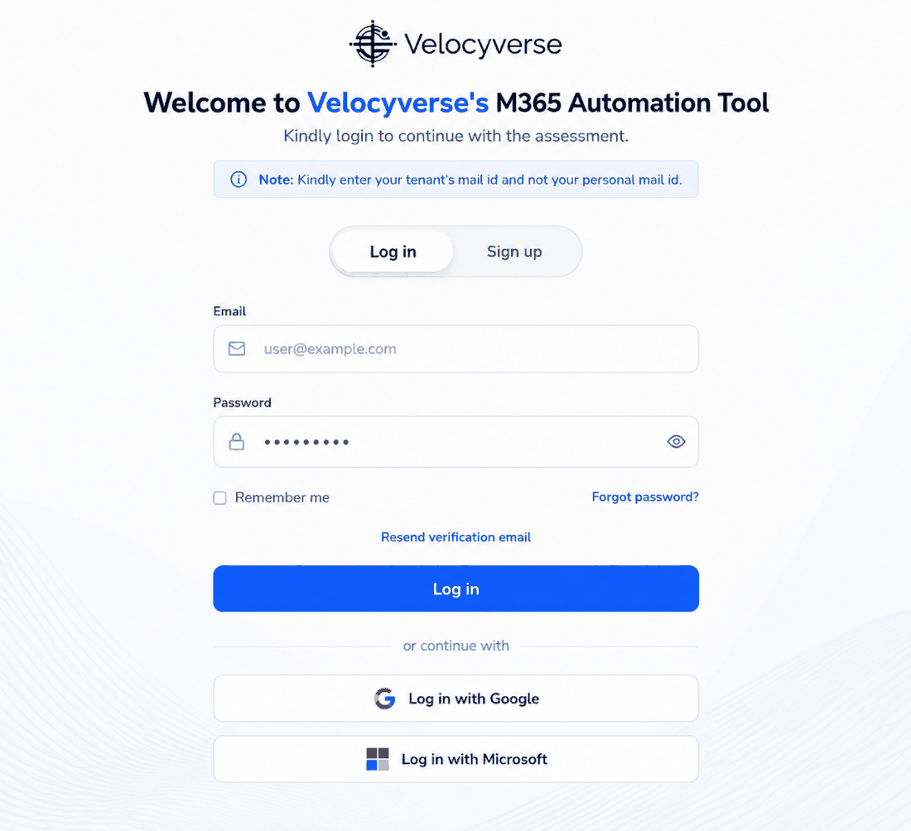
Key UI elements: Log in / Sign up toggle, Email field, Password field with show/hide, Remember me, Forgot password?, Resend verification email, primary Log in button, divider, Log in with Google, Log in with Microsoft. A note warns users to enter their tenant email, not a personal address.
Related requirements / flow refs: FR-1.1, FR-1.2, FR-1.4. Diagram 1A step 2.

S02 — Sign Up / Client Information Page
Account creation form shown when the user selects 'Sign up' from S01.
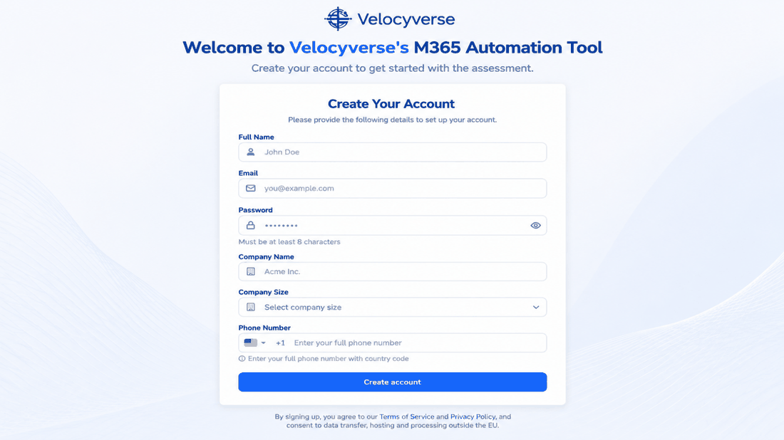
Key UI elements: Full Name, Email, Password (min 8 chars, shown as a hint), Company Name, Company Size (dropdown), Phone Number with country selector, Create account button, ToS/Privacy Policy consent text (currently references data processing 'outside the EU' — flagged in Section 17 OQ-9 for legal review).
Related requirements / flow refs: FR-1.1. Diagram 1A step 2 (sign-up branch).

S03 — MFA / OTP Verification
Shown immediately after successful login/signup credentials, before any dashboard access — used identically for Client, Admin, and Assessor logins (same template, Section 26 dedup).
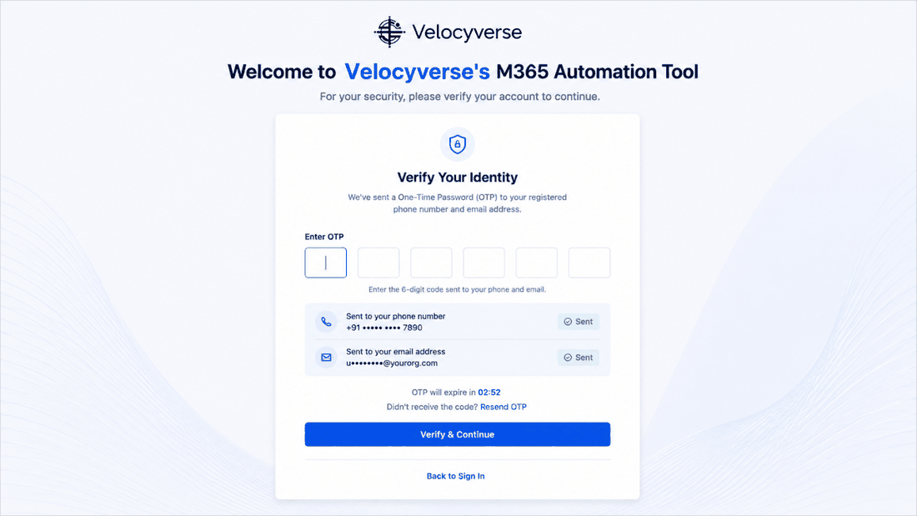
Key UI elements: 6-digit OTP input (auto-advancing boxes), delivery confirmation for both phone and email channels with masked destination, countdown timer for expiry, Resend OTP link, Verify & Continue button, Back to Sign In link.
Related requirements / flow refs: FR-1.3. Diagram 1A step 3; also the MFA step in Scenarios 2, 3, and 4.

S04 — Pre-Connection Dashboard
First screen after onboarding for a user with no tenant connected yet. Presents the two entry points side by side, matching the confirmed product flow (Trial first vs. connect immediately).
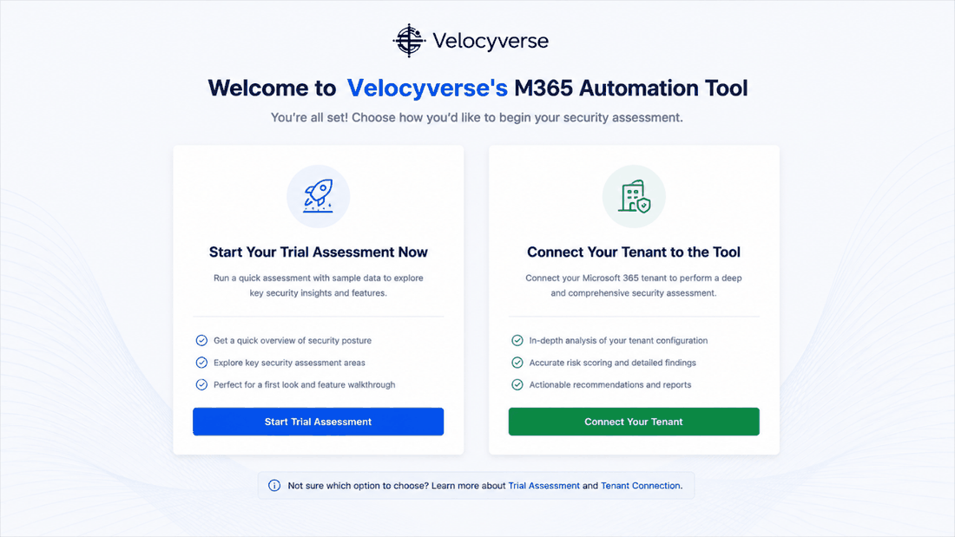
Key UI elements: Two cards: 'Start Your Trial Assessment Now' (with 3 benefit bullets, Start Trial Assessment button) and 'Connect Your Tenant to the Tool' (with 3 benefit bullets, Connect Your Tenant button); a footer note linking to more info on each option.
Related requirements / flow refs: FR-2.2. Diagram 1A steps 4–5.

S05 — Trial Assessment Questionnaire
The 12-question self-reported checklist that produces the Trial score (Section 21.1 classification: checklist-based, zero Graph permissions).
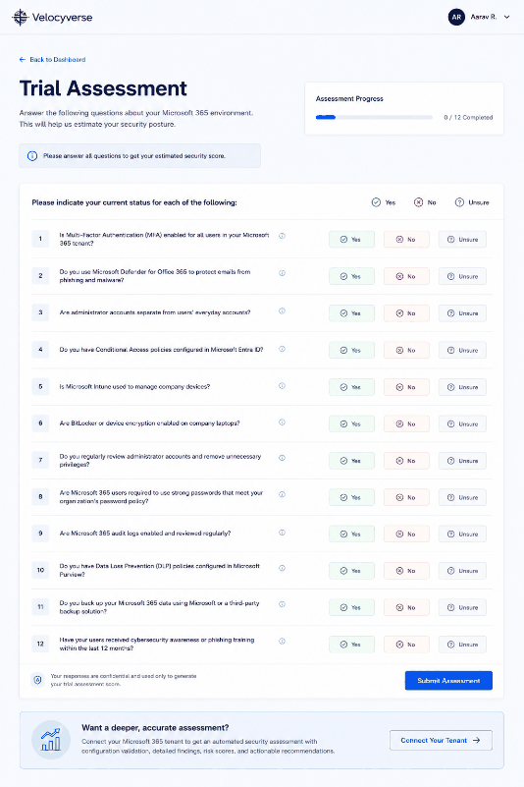
Key UI elements: Progress indicator (X / 12 Completed) plus a duplicate top-right progress bar, 12 numbered questions each with Yes / No / Unsure buttons, an info banner reminding the user to answer all questions, a confidentiality note, and Submit Assessment button. Footer CTA teases the full automated assessment.
Related requirements / flow refs: FR-3.1. Diagram 1A step 6.

S06 — Trial Assessment Results
Instant results after questionnaire submission.
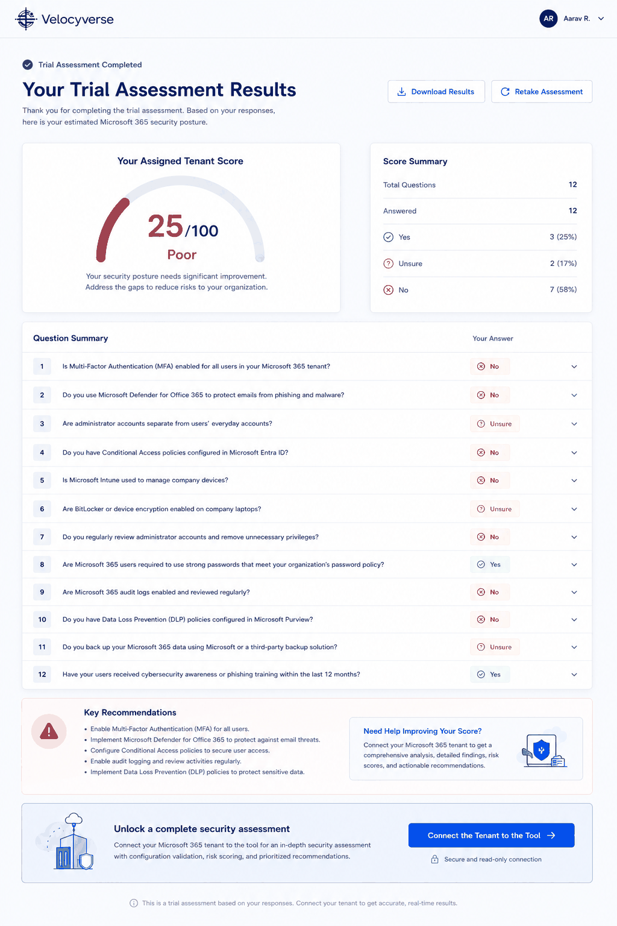
Key UI elements: Status banner ('Trial Assessment Completed'), score gauge (0–100 with qualitative band), Score Summary panel (question/answer counts by Yes/Unsure/No), full Question Summary table with per-question answer, Key Recommendations list, a 'Need Help Improving Your Score?' panel, and a prominent 'Connect the Tenant to the Tool' CTA banner. Download Results and Retake Assessment actions in the header.
Related requirements / flow refs: FR-3.2, FR-3.3, FR-3.4. Diagram 1A step 7.

S07 — Connect Tenant / User Guide
Bridges Trial (or direct 'Connect Now') into the actual tenant-connection technical flow by first offering a downloadable guide.
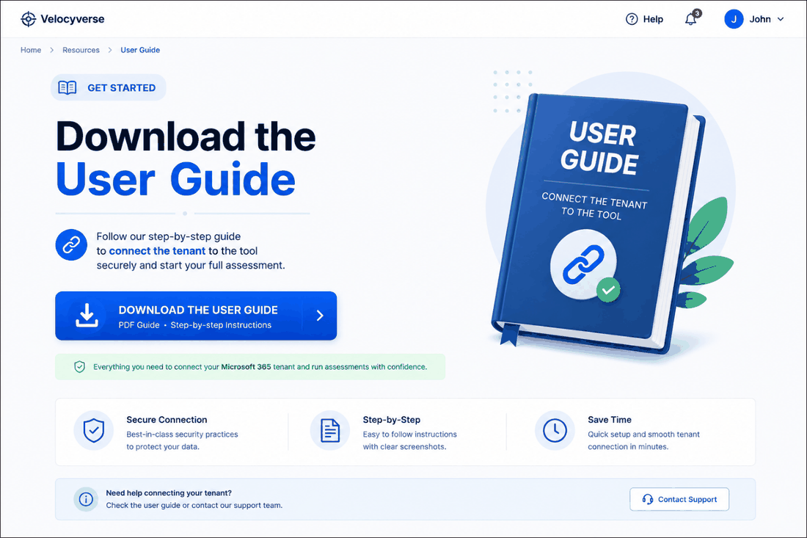
Key UI elements: 'Download the User Guide' hero panel with PDF download CTA, three benefit tiles (Secure Connection, Step-by-Step, Save Time), and a 'Need help connecting your tenant?' support banner with a Contact Support button.
Related requirements / flow refs: FR-2.3. Diagram 1B step 2.

S08 — Post-Connection Dashboard — Choose Assessment Type
Shown once the tenant connection succeeds; the main hub a returning connected user lands on.
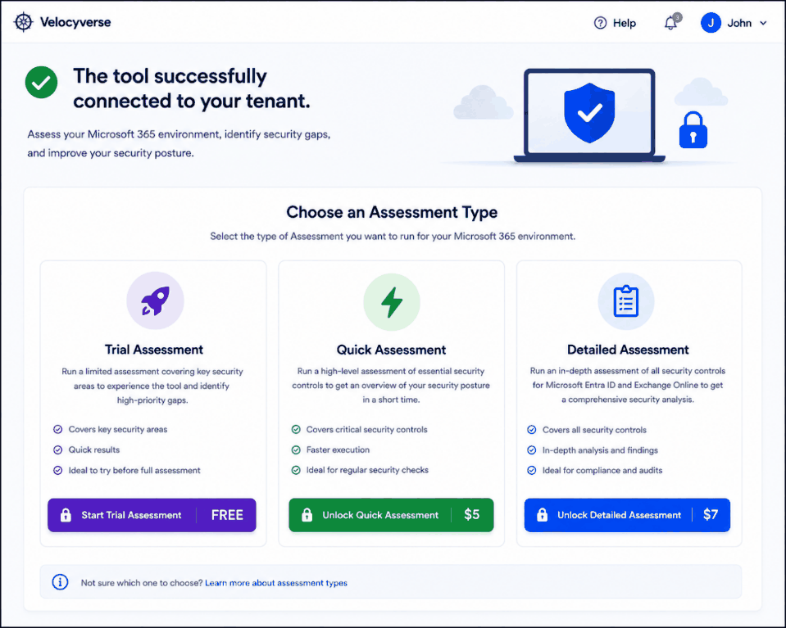
Key UI elements: Success banner ('The tool successfully connected to your tenant'), three assessment-type cards (Trial / Quick / Detailed) each with an icon, description, 3 benefit bullets, and a price-tagged CTA button (Free / $5 / $7 per current wireframe pricing — see Section 17 OQ-2), plus a help footer link.
Related requirements / flow refs: FR-4.6. Diagram 1B (post-consent state); Section 6.1 tier comparison; Section 22.4 feature matrix determines which cards are enabled per subscription plan.

S09 — Assessment Loading Screen
Shown while a Quick (or Detailed) Assessment pipeline runs. The Detailed variant (same template) adds an Assessment Owner contact block at the bottom once an Assessor becomes relevant — not re-embedded here for brevity, see Note.
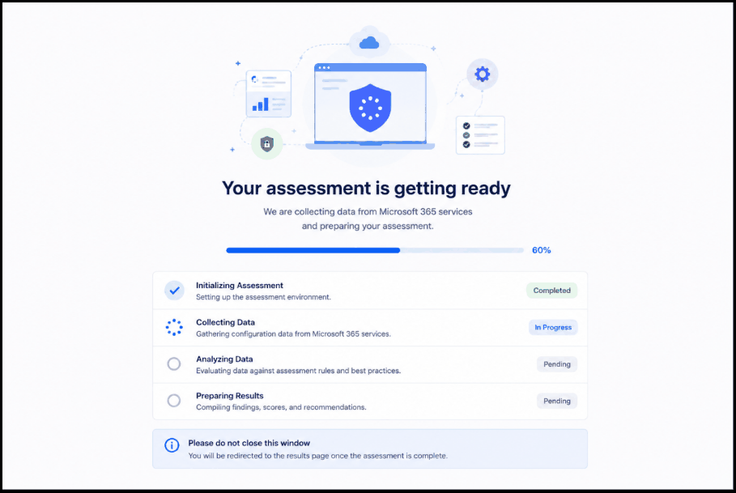
Key UI elements: Illustration, headline, percentage progress bar, 4-stage checklist (Initializing Assessment → Collecting Data → Analyzing Data → Preparing Results) each with a status pill (Completed / In Progress / Pending), and a 'please do not close this window' notice.
Related requirements / flow refs: FR-5.6. Diagram 1B (data collection + validation + engine stages); Diagram 2 (per-module collection detail).
Note: The Detailed Assessment variant of this screen additionally shows an 'Assessment Owner' card (Name/Phone/Email) — this is the wireframe's only visual hint of the Assessor before the manual-review step; recommend keeping this to set client expectations that a human will be involved.

S10 — Assessment Results Page
The core results view, shared by both Quick and Detailed tiers (same template — the source wireframe's populated example happens to show a Detailed Assessment for Contoso Ltd).
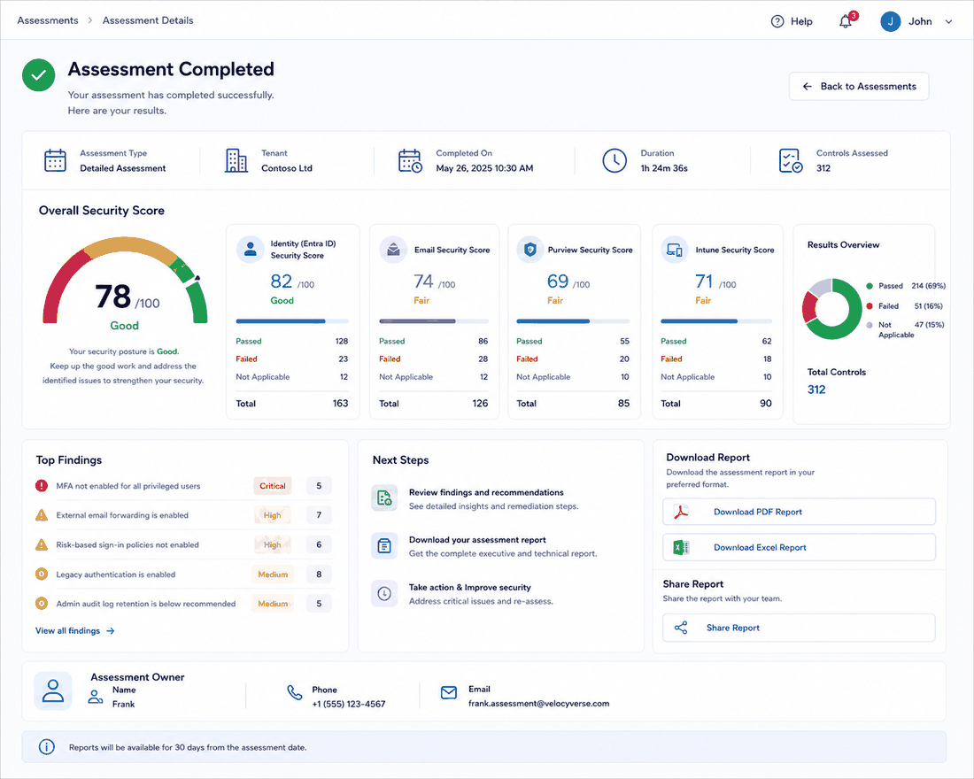
Key UI elements: Status banner, metadata row (Assessment Type, Tenant, Completed On, Duration, Controls Assessed), Overall Security Score gauge with interpretation text, per-module score cards (Identity/Entra, Email, Purview, Intune — extend to all connected modules), a Results Overview donut (Passed/Failed/Not Applicable), Top Findings list with severity tags and counts, Next Steps panel, Download Report (PDF/Excel) and Share Report actions, and an Assessment Owner block.
Related requirements / flow refs: FR-9.1, FR-9.2, FR-9.4. Section 12 Reporting Specification. Diagram 1B final results step.

26.2 Scenario 2 Screens — Returning User: Detailed Assessment
Scenario 2 reuses S01 (Login) and S03 (MFA) identically, and lands on S08 (Post-Connection Dashboard) and eventually S09/S10 (Loading/Results) as in Scenario 1 — only the one new screen below is unique to this path.

S11 — Tenant Connection Verification
Shown for a returning user to re-validate an existing tenant connection is still healthy before proceeding — a lightweight health-check step distinct from the full first-time consent flow (S07/Diagram 1B).
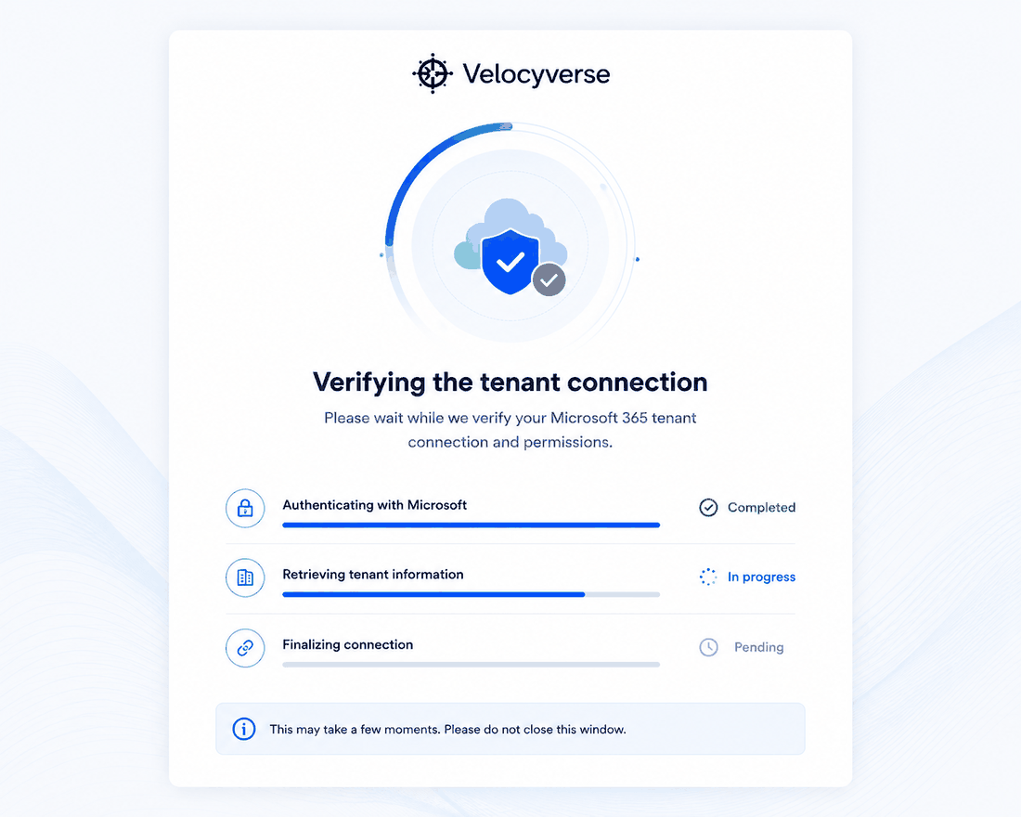
Key UI elements: Circular progress illustration, headline ('Verifying the tenant connection'), and a 3-step checklist (Authenticating with Microsoft → Retrieving tenant information → Finalizing connection) each with a status indicator, plus a 'please wait' notice.
Related requirements / flow refs: FR-4.4 (reconnection/health status). New in this PRD: recommend this check runs automatically and silently on dashboard load when possible, falling back to this visible screen only when re-authentication is actually required, to avoid adding friction for the common case where the connection is already healthy.

26.3 Scenario 3 Screens — Admin Assigns a Detailed Assessment

S12 — Internal Sign In
Simplified login used identically for both Admin and Assessor portals (no self-service sign-up, no social login) — accounts are provisioned by an Admin per FR-1.8.
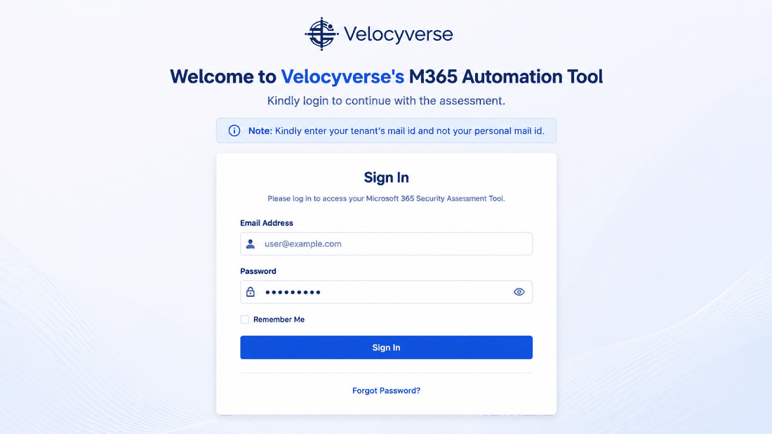
Key UI elements: Email Address, Password, Remember Me, Sign In button, Forgot Password link, and the same tenant-email note as the client login.
Related requirements / flow refs: FR-1.8. Diagram 3 / Scenario 3 & 4 entry points.

S13 — Admin Dashboard — Detailed Requests Queue
Admin's operational home screen for managing the Detailed Assessment pipeline (Section 9, Section 10).
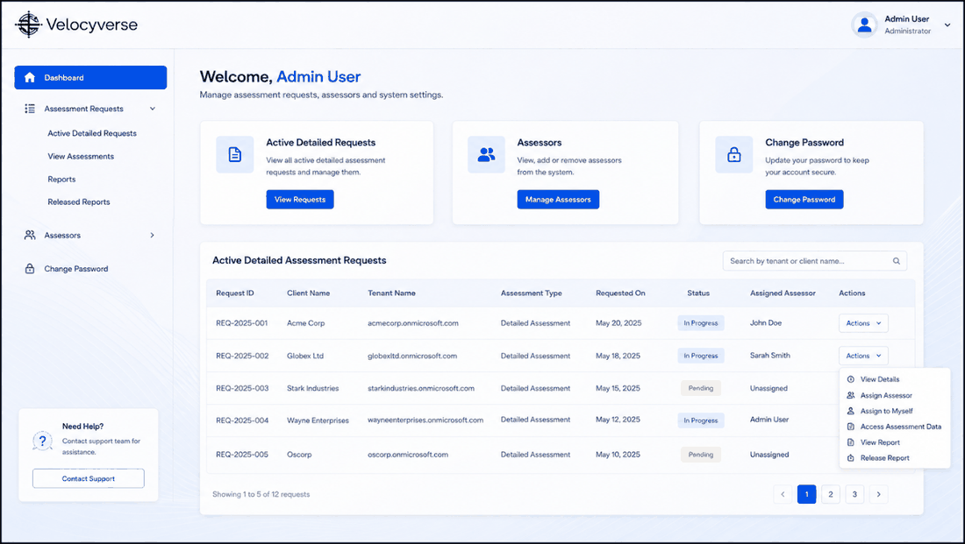
Key UI elements: Welcome header, three summary cards (Active Detailed Requests, Assessors, Change Password) each with a quick-action button, and the full Active Detailed Assessment Requests table (Request ID, Client Name, Tenant Name, Assessment Type, Requested On, Status, Assigned Assessor) with a per-row Actions menu (View Details, Assign Assessor, Assign to Myself, Access Assessment Data, View Report, Release Report), search, and pagination.
Related requirements / flow refs: FR-12.1, FR-12.2, FR-11.2, FR-11.3. Section 9.3 status model.

S14 — Admin Dashboard — Assessors Roster
Assessor workforce management screen, reached via the left nav or the 'Manage Assessors' quick action on S13.
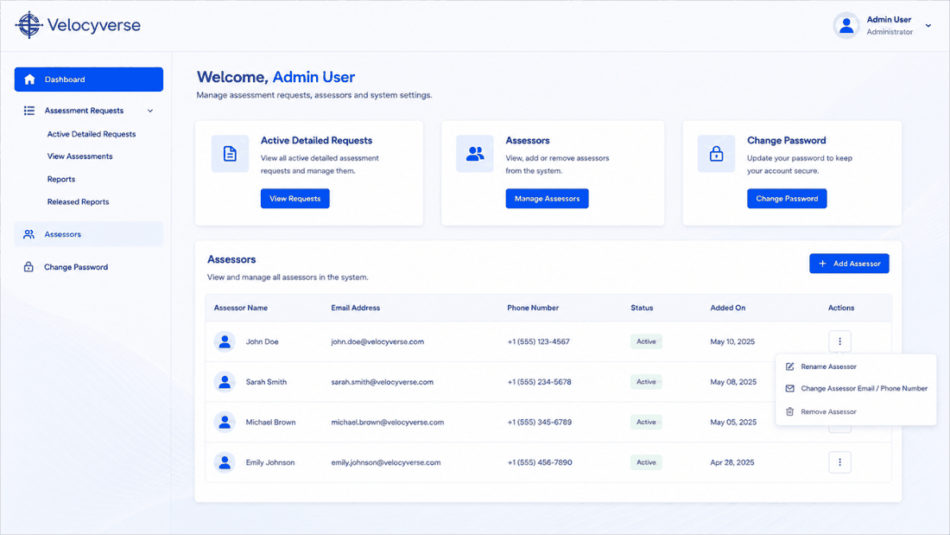
Key UI elements: Left nav (Dashboard, Assessment Requests submenu, Assessors, Change Password), summary cards, and an Assessors table (Assessor Name, Email, Phone, Status, Added On) with a per-row action menu (Rename, Change Email/Phone, Remove) and an Add Assessor button.
Related requirements / flow refs: FR-12.3.

26.4 Scenario 4 Screens — Assessor Performs Manual Review
Scenario 4 reuses S12 (Internal Sign In) and S03 (MFA) identically to Scenario 3.

S15 — Assessor Dashboard
Assessor's home screen — narrower scope than Admin's, showing only requests assigned to this specific Assessor (FR-13.1, enforced server-side per NFR 13.1).
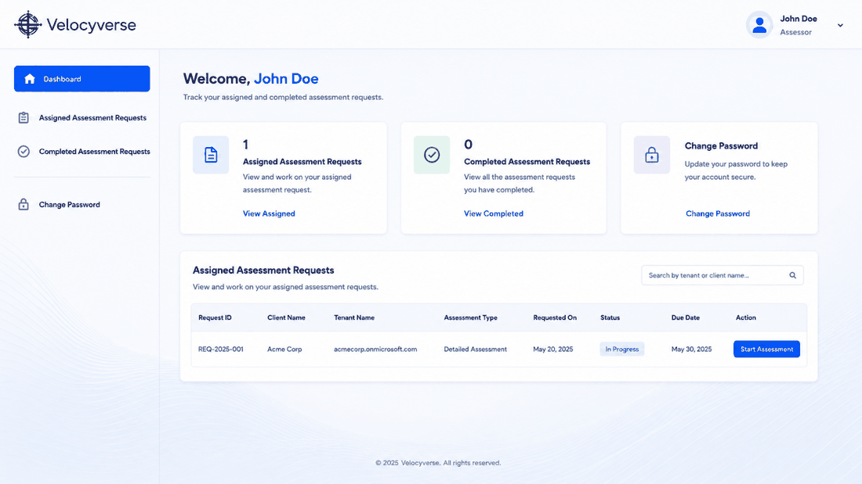
Key UI elements: Welcome header, three summary cards (Assigned Assessment Requests count, Completed Assessment Requests count, Change Password), and an Assigned Assessment Requests table (Request ID, Client Name, Tenant Name, Assessment Type, Requested On, Status, Due Date) with a Start Assessment action per row.
Related requirements / flow refs: FR-13.1, FR-13.2. Note the Due Date column already implies an SLA target should be tracked per request — see Section 17 OQ-3.

S16 — Assessor Start Assessment Workspace
The Assessor's actual working screen for a specific request — this is the most important screen to reconcile against Section 9's functional requirements (see Note below).
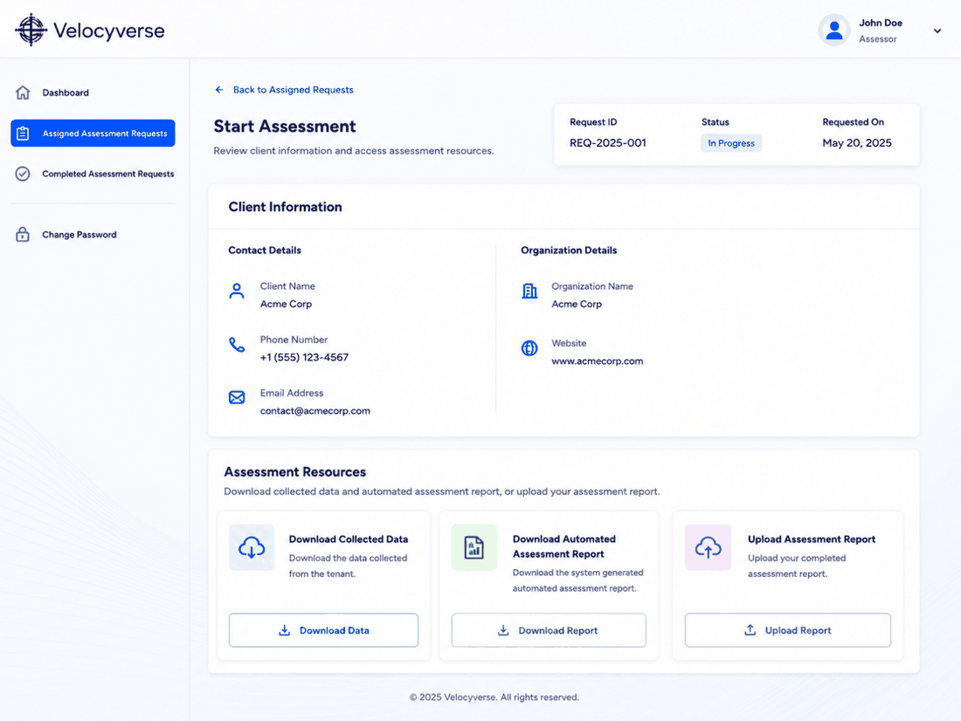
Key UI elements: Request metadata bar (Request ID, Status, Requested On), a Client Information panel (Contact Details: name/phone/email; Organization Details: name/website), and an Assessment Resources panel with three actions: Download Collected Data, Download Automated Assessment Report, and Upload Assessment Report.
Related requirements / flow refs: FR-11.4 through FR-11.7.
Note: IMPORTANT RECONCILIATION: this wireframe shows a download/offline-review/upload pattern (Assessor downloads collected data and the automated report, does their review outside the tool — e.g., in a document — then uploads a completed report), which is simpler to build than the structured in-app 'record a finding per non-automatable control' workspace originally specified in FR-11.4. The offline-upload pattern is faster to ship but the uploaded file is not structured data, so it cannot automatically merge into the Scoring & Recommendation Engine (FR-11.7) or preserve the Finding.source audit trail (Section 15.2) without an additional parsing/re-entry step. Recommend for the first build: keep Download Collected Data and Download Automated Report as-is (useful regardless), but replace 'Upload Assessment Report' with a structured findings form (one entry per non-automatable control, matching FR-11.4) so results flow directly into scoring — optionally still allow attaching a supporting document alongside each structured finding for audit backup. Flagging this explicitly rather than silently picking one, since it changes both the UI build and the Assessor's day-to-day workflow.

26.5 Scenario 5 Screens — Account & Miscellaneous

S17 — Account Menu / User Actions Dropdown
The account dropdown, opened from the top-right avatar/name on any authenticated Client screen (shown here over S08).
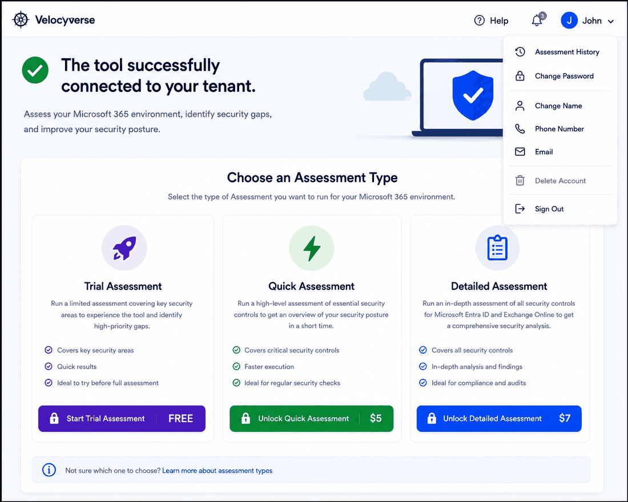
Key UI elements: Assessment History, Change Password, Change Name, Phone Number, Email, a destructive Delete Account item, and Sign Out. Admin/Assessor portals show an equivalent menu scoped to their own applicable items (e.g., no billing).
Related requirements / flow refs: FR-1.5, FR-1.6, FR-10.1. Section 22.1 — note Owner/Admin/Member/Viewer org roles should each see a menu scoped to what they're permitted to do (e.g., only Owner sees billing/subscription management, once that's added).

S18 — Assessment History Page
Full list of a user's past and in-progress assessments.
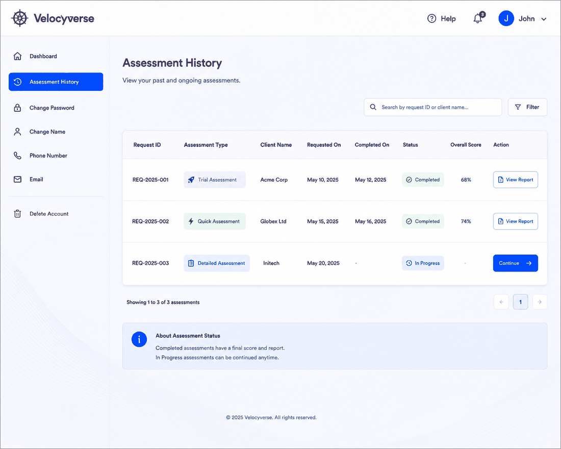
Key UI elements: Table with Request ID, Assessment Type (tagged pill), Client Name, Requested On, Completed On, Status (Completed/In Progress), Overall Score, and an Action column (View Report for completed, Continue for in-progress), plus search, filter, and pagination. An info banner explains status semantics.
Related requirements / flow refs: FR-10.1, FR-10.2.

S19 — Change Password Page
Standard password-change form, shown identically in Client, Admin, and Assessor portals with only nav differences.
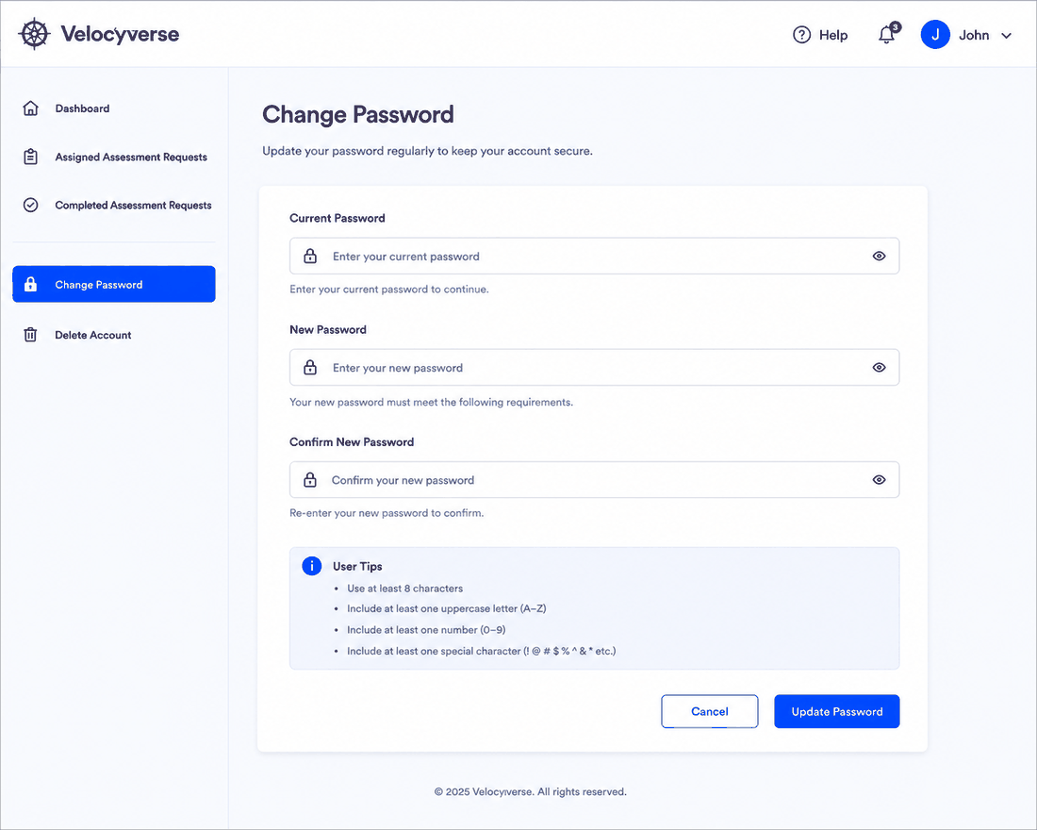
Key UI elements: Current Password, New Password, Confirm New Password fields (each with show/hide), a User Tips panel listing password complexity rules, Cancel and Update Password buttons.
Related requirements / flow refs: FR-1.5.

S20 — Change Name Page
Simple profile-field update form.
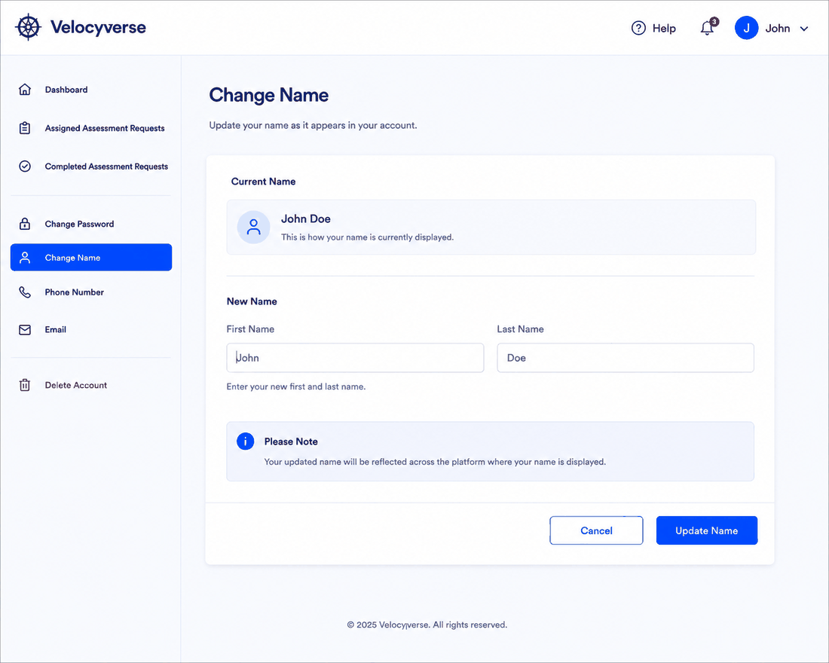
Key UI elements: Current Name display card, New First Name / Last Name inputs, a note that the change propagates everywhere the name is displayed, Cancel and Update Name buttons.
Related requirements / flow refs: FR-1.5.

S21 — Update Phone Number / Email Page
Combined contact-detail update screen (phone and email sections stacked on one page).
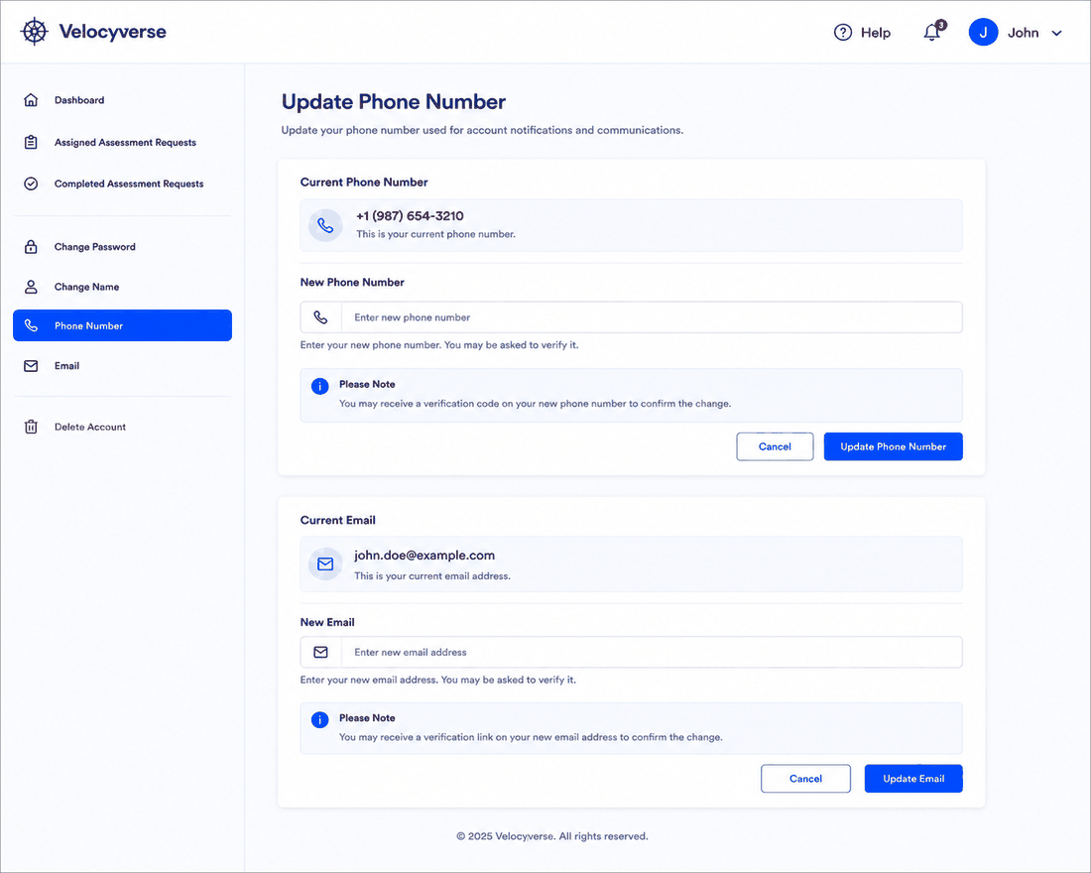
Key UI elements: Current Phone Number display, New Phone Number input with a verification-code notice, Update Phone Number action; Current Email display, New Email input with a verification-link notice, Update Email action.
Related requirements / flow refs: FR-1.5.

