## OUTPUT: Code:

#include <reg51.h> // Header file for 89C52

// Lm016L

//Control Signals for LCD

sbit RS = P3^2;

sbit RW = P3^3;

sbit EN = P3^4;

#define LCD_PORT P2

// Delay function in milliseconds

void delay(unsigned int time)

{

  unsigned int i, j;

  for(i=0; i<time; i++)

    for(j=0; j<1275; j++);

}

// Send Command to Lcd

void sendCommand(unsigned char command){

    LCD_PORT = command;

    RW = 0;

    RS = 0;

    EN = 1;

        delay(1);

    EN = 0;

}

// send data to lcd to display

void sendData(unsigned char dat){

    LCD_PORT = dat;

    RW = 0;

    RS = 1;

    EN = 1;

        delay(1);

    EN = 0;

}

// initialize lcd

void init(){

    sendCommand(0x38); //2 lines ,5x7

    delay(12);

    sendCommand(0x0F); //display on,cursor on

    delay(12);

}

void run(char* message1,char* message2){

    unsigned short int i;

    while(1){

        sendCommand(0x01); //clear screen

            delay(10);

        sendCommand(0x80); //1st line

            delay(10);

        i=0;

        while(message1[i] != '\0'){

            sendData(message1[i]); //send Data

            i++;

            delay(30);

        };

        i=0;

        sendCommand(0xC0); //2nd line

        delay(10);

        while(message2[i] != '\0'){

            sendData(message2[i]); //send Data

            i++;

            delay(30);

        };

    }

}

void main() {

    init();

    run("Hello","World");

}

# CODE Timer

#include <reg51.h> // Header file for 89C52 Timer

// Define segment LEDs

sbit LED0 = P0^0;

sbit LED1 = P0^1;

sbit LED2 = P0^2;

sbit LED3 = P0^3;

sbit LED4 = P0^4;

sbit LED5 = P0^5;

sbit LED6 = P0^6;

sbit LED7 = P0^7;

// Define control pins for the 7-segment displays

sbit CON0 = P2^2;

sbit CON1 = P2^3;

sbit CON2 = P2^4;

sbit CON3 = P2^5;

sbit CON4 = P2^6;

sbit CON5 = P2^7;

    unsigned int noOfTimes = 20;

    unsigned char partOfDay = 11;

    unsigned char time[] = {2, 7,0};

// Digit patterns for a common cathode 7-segment display (0-9)

unsigned char digits[] = {

    0x3F, // 0

    0x06, // 1

    0x5B, // 2

    0x4F, // 3

    0x66, // 4

    0x6D, // 5

    0x7D, // 6

    0x07, // 7

    0x7F, // 8

    0x6F,// 9

    0x40, //:,index 10

    0x77, //index 11 ,A

    0x73 //index 12,P

};

void delay_three_ms(){

  TH1=0xF4;

  TL1=0x48;

  TR1=1;

  while (TF1 != 0);

  TR1=0;

  TF1=0;

}

// Delay function

void delay_ms() {//default 50ms

  TL0 =0x00;

  TH0 =0x4c;

  TR0 =1;

}

void isr_timer() interrupt 1 {

    delay_ms();

    if(noOfTimes == 0) {

        noOfTimes = 20;

        time[2]++;

        if (time[2] < 60) return;

        time[1]++;

        time[2] = 0;

        if (time[1] < 60) return;

        time[1] = 0;

        time[0]++;

        if(time[0]<12) return;

        time[0]=0;

        partOfDay = partOfDay==11 ? 12 :11;

    }else{

        noOfTimes--;

        return;

    }

}

void init(){

  IE = 0x82;

  TMOD =0x01;

  delay_ms();

}

// Function to display a digit on a specific 7-segment display

void display_digit(unsigned char digit, unsigned char position) {

    // Clear all control pins

    CON0 = 0;

    CON1 = 0;

    CON2 = 0;

    CON3 = 0;

    CON4 = 0;

    CON5 = 0;

    // Output the segment data

    P0 = digits[digit];

    // Activate the selected display

    if (position == 0) CON0 = 1;

    if (position == 1) CON1 = 1;

    if (position == 2) CON2 = 1;

    if (position == 3) CON3 = 1;

    if (position == 4) CON4 = 1;

    if (position == 5) CON5 = 1;

    delay_three_ms();

}

void main() {

  int i = 80;

  init();

    while (1) {

        display_digit((time[0]/10), 0);

        display_digit((time[0] % 10), 1);

        display_digit(10, 2);

        display_digit((time[1]/10), 3);

        display_digit((time[1]%10), 4);

        display_digit(partOfDay,5);

    }

}

## OUTPUT

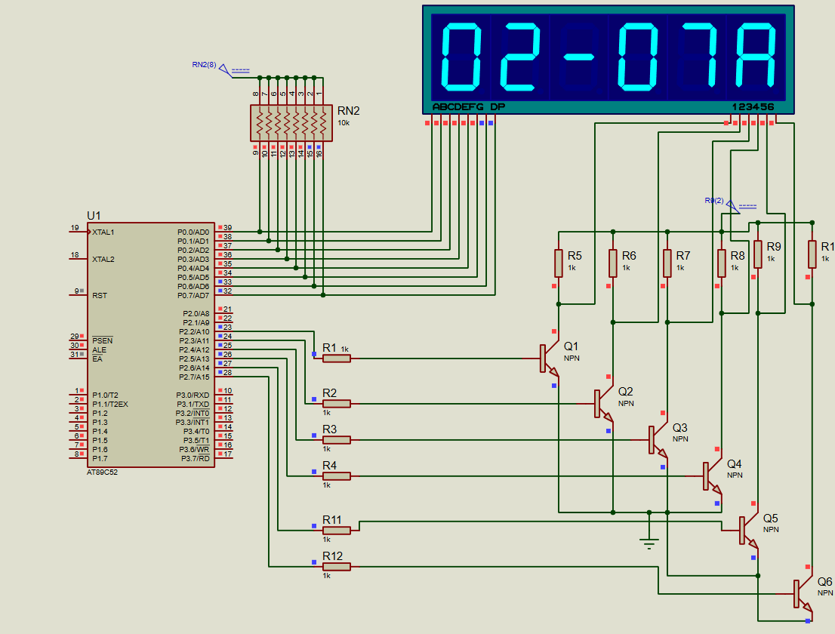

Code:  
  
  
#include <reg51.h> // Header file for 89C52

// Define segment LEDs

sbit LED0 = P0^0;

sbit LED1 = P0^1;

sbit LED2 = P0^2;

sbit LED3 = P0^3;

sbit LED4 = P0^4;

sbit LED5 = P0^5;

sbit LED6 = P0^6;

sbit LED7 = P0^7;

// Define control pins for the 7-segment displays

sbit CON0 = P2^0;

sbit CON1 = P2^1;

sbit CON2 = P2^2;

sbit CON3 = P2^3;

// Digit patterns for a common cathode 7-segment display (0-9)

unsigned char digits[] = {

    0x3F, // 0

    0x06, // 1

    0x5B, // 2

    0x4F, // 3

    0x66, // 4

    0x6D, // 5

    0x7D, // 6

    0x07, // 7

    0x7F, // 8

    0x6F// 9

    };

// Delay function

void delay_ms(unsigned int ms) {

    unsigned int i, j;

    for (i = 0; i < ms; i++) {

        for (j = 0; j < 1275; j++);

    }

}

// Function to display a digit on a specific 7-segment display

void display_digit(unsigned char digit, unsigned char position) {

    // Clear all control pins

    CON0 = 0;

    CON1 = 0;

    CON2 = 0;

    CON3 = 0;

    // Output the segment data

    P0 = digits[digit];

    // Activate the selected display

switch (position) {

        case 0: CON0 = 1; break;

        case 1: CON1 = 1; break;

        case 2: CON2 = 1; break;

        case 3: CON3 = 1; break;

        default: break;

    }

    // Small delay for persistence

    delay_ms(1);

}

void main() {

    unsigned char year[] = {2, 0, 2, 5}; // Digits of the year 2025

    while (1) {

        // Display each digit on the corresponding 7-segment display

        display_digit(year[0], 0); // Display '2' on the first display

        display_digit(year[1], 1); // Display '0' on the second display

        display_digit(year[2], 2); // Display '2' on the third display

        display_digit(year[3], 3); // Display '5' on the fourth display

    }

}

OUTPUT:

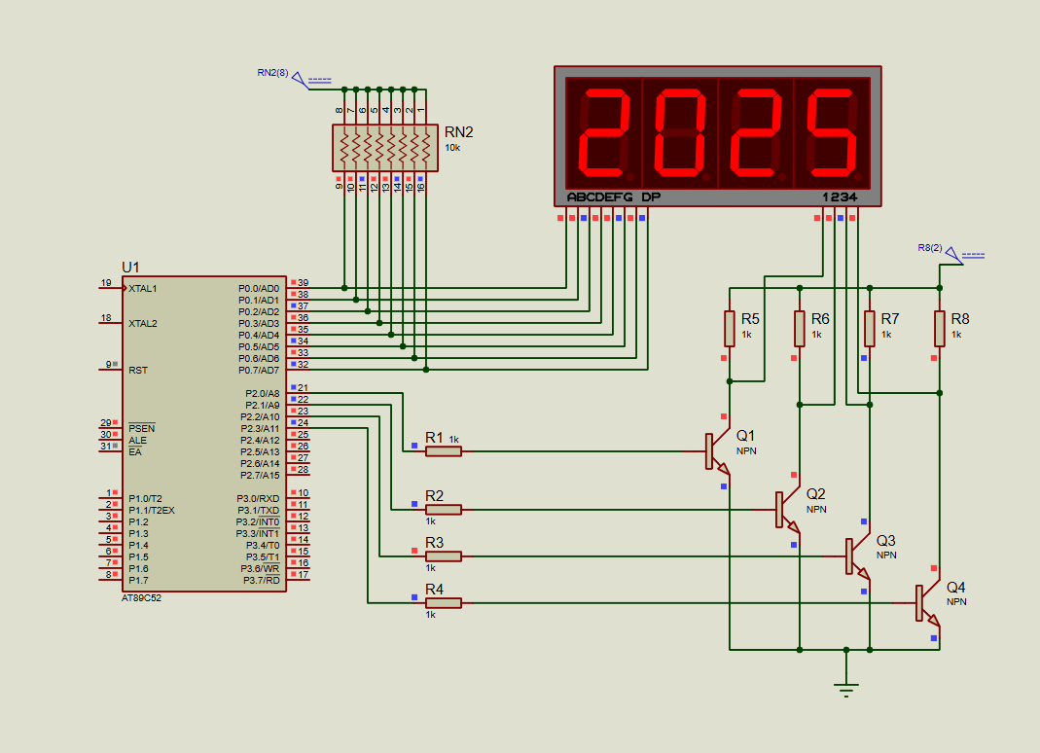

## Output – 2.1:

## Output – 2.2:

## 

## OUTPUT – 2.3:

## 

## Output 2.4 Output 2.5:

