**Assignment 11.3**

**Problem Statement:**

Write a Pig UDF to find the tweets posted by **@realDonaldTrump** from the given dataset.

**Program:**

* **UDF**

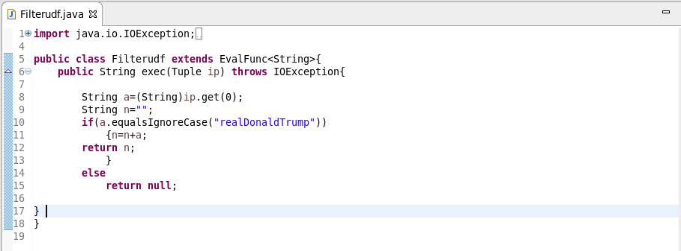

* **Pig script**

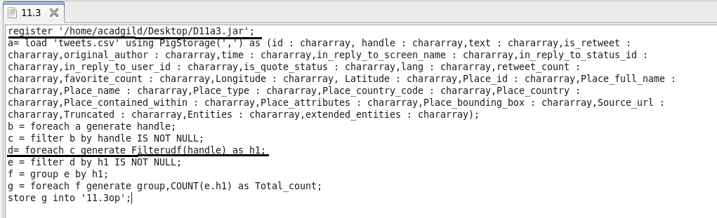

**Output:**

