**Assignment 11.6**

**Problem Statement:**

Find the top five kinds of GoogleKnowlege_Occupation people who were guests in the show, in a particular time period i.e., between '1/11/99' and 6/11/99. You need to write an UDF to compare the dates.

UDF to compare dates:

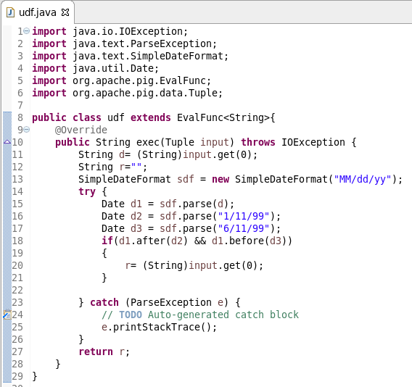

Pig script:

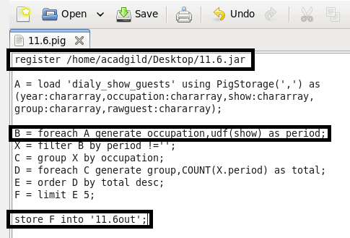

Running pig script:

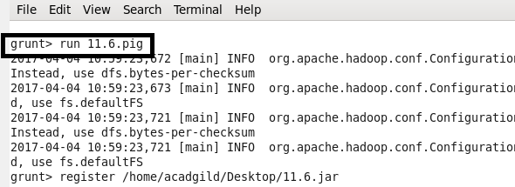

Output:

