**Assignment 16.5**

Problem Statement:

Write a map reduce program to join the below given two datasets using map side join.

Input:

You can download the datasets from the below link:

<https://drive.google.com/open?id=0ByJLBTmJojjzSWhfXzI5NGh4RGM>

Dataset description of dataset1.csv is as follows: id,first_name,last_name,email,gender,ip_address Dataset description of tdataset2.csv is as follows: id,first_name,last_name

Program:

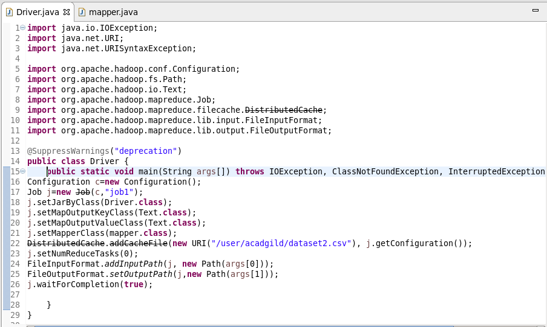

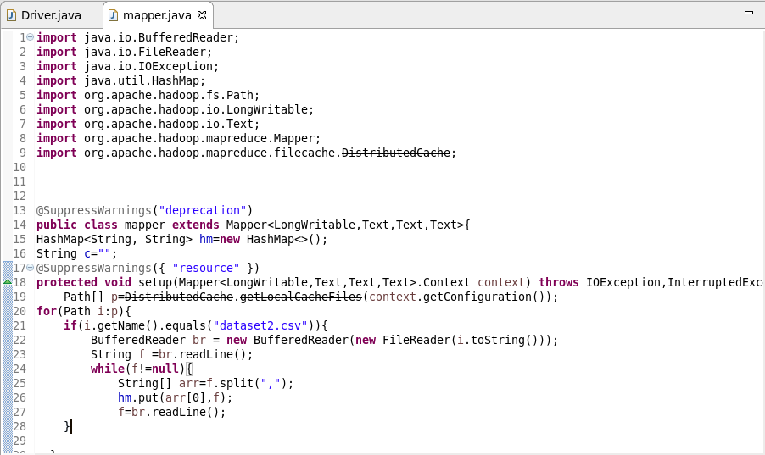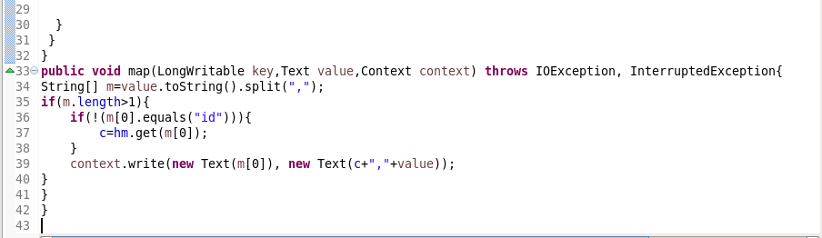

**Output:**

