**16.6**

**Problem Statement:**

Write a map reduce program to join the below given two datasets using Reducer side join. You can download the datasets from the below link :

<https://drive.google.com/open?id=0ByJLBTmJojjzSWhfXzI5NGh4RGM>

**Program:**

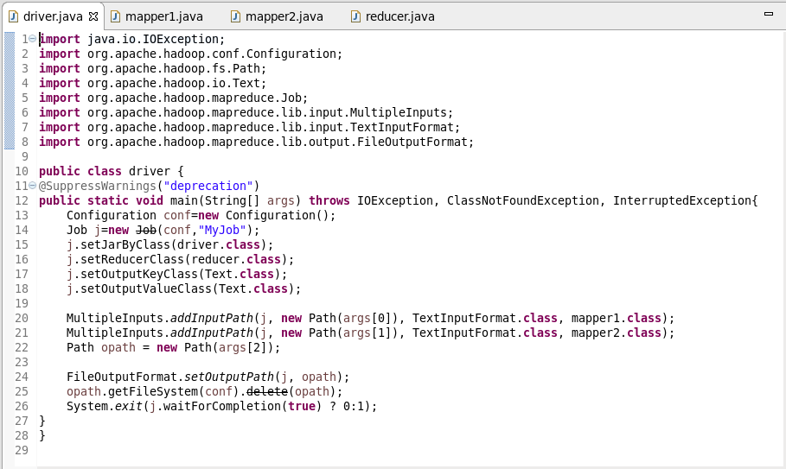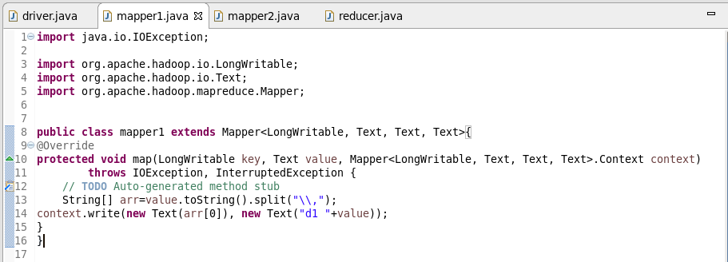

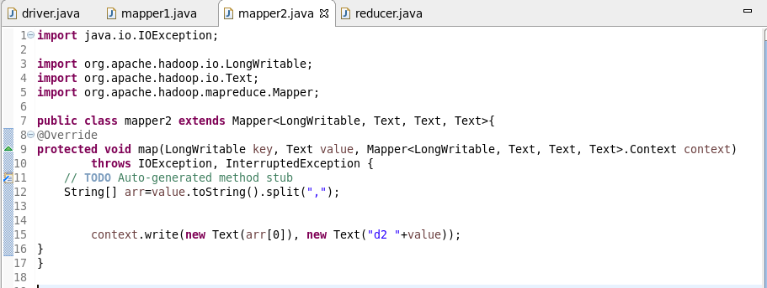

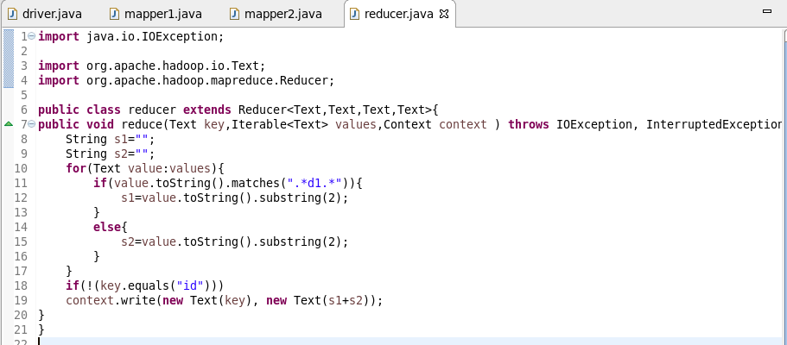

**Output:**

