**20.2**

**Enhance the task 8 (refer session 19, assignment 1) to calculate the top 3 state-wise sales for each company. You may use multiple reducers for this activity.**

**DRIVER CLASS:**

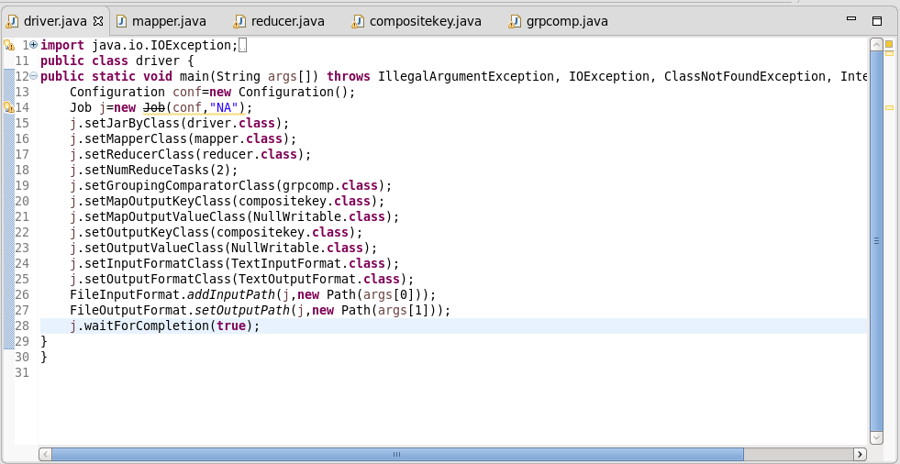

**MAPPER CLASS:**

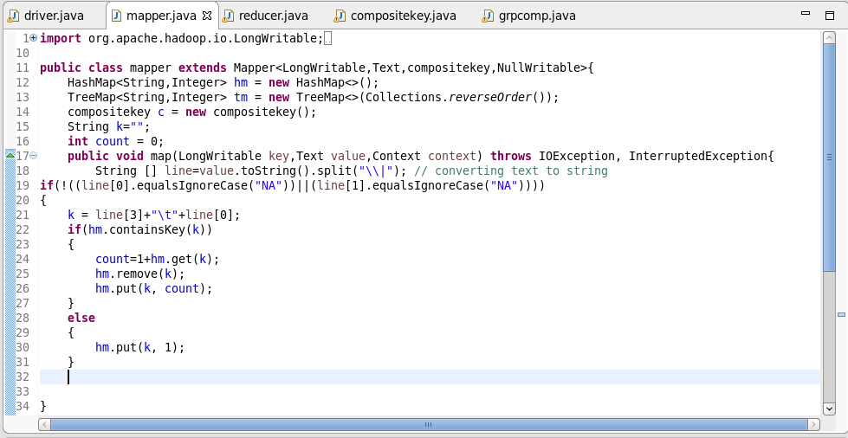

**COMPOSITEKEY CLASS:**

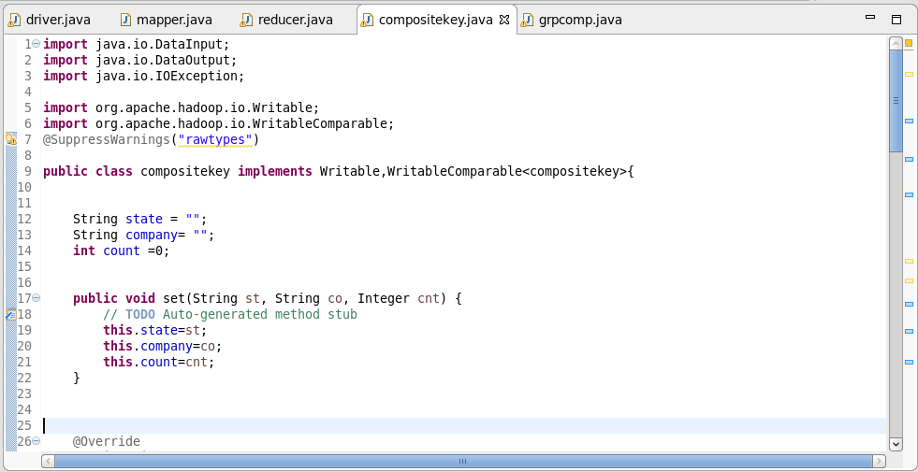

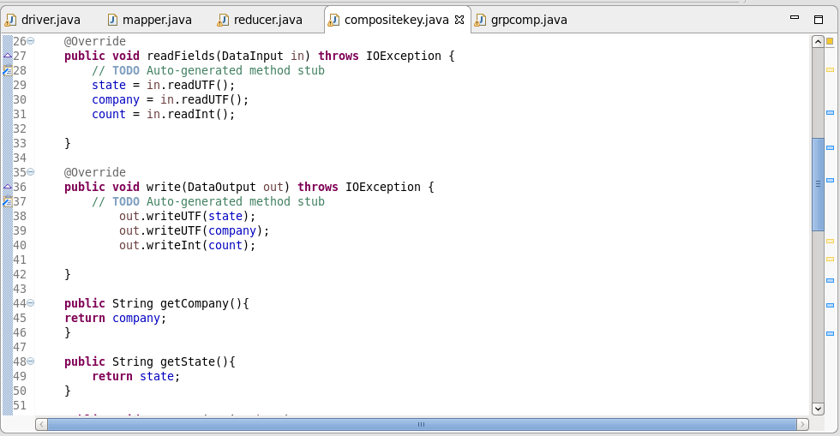

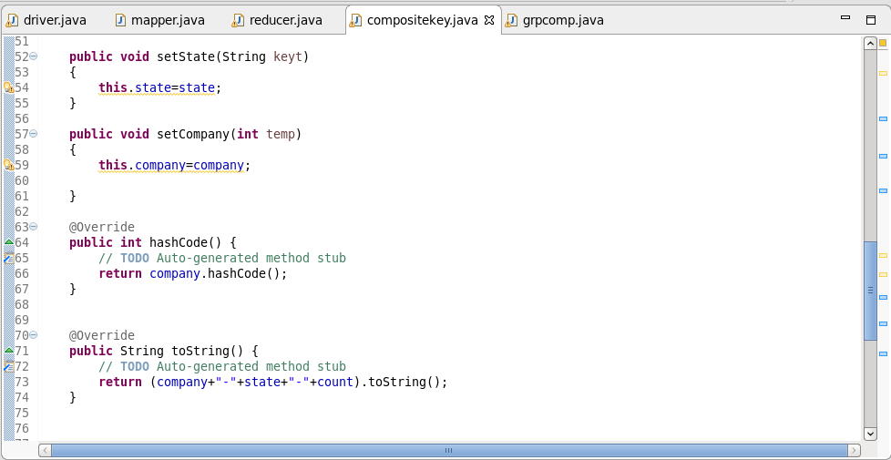

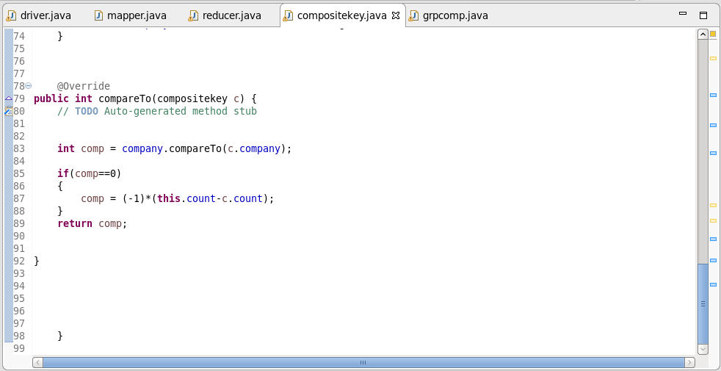

**GROUP COMPARATOR:**

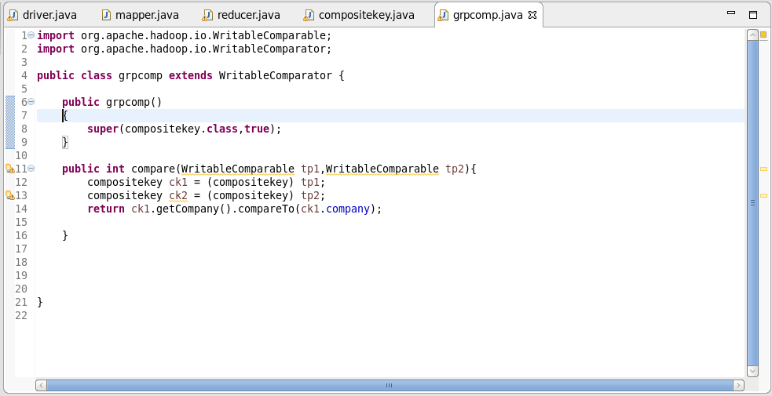

**Overriding hashcode():**

* Since multiple reducers are used it is necessary that a particular company should go to particular reducer.
* Since default hash modulo partitioner is used. In hash code method, company is sent.

**Overriding compareto() methods:**

By default it orders by ascending order, hence we multiply by -1 to get it ordered in descending order

**Overriding ToString():**

displays the company, state ,sales.

**REDUCER CLASS:**

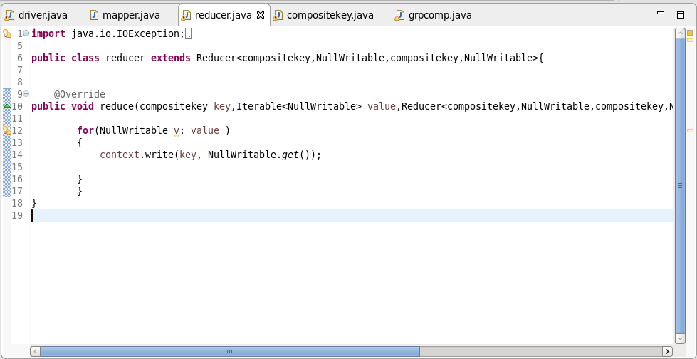

**OUTPUT:**

