**22.1**

Write a Wordcount program and Store the result in Mysql db.

Driver class:

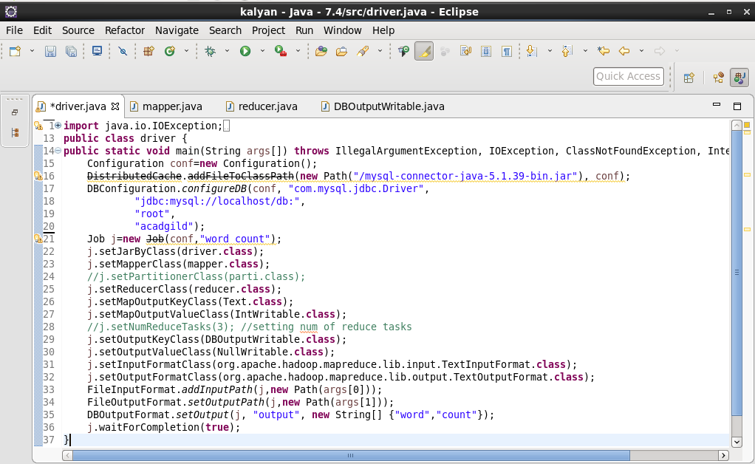

Mapper class:

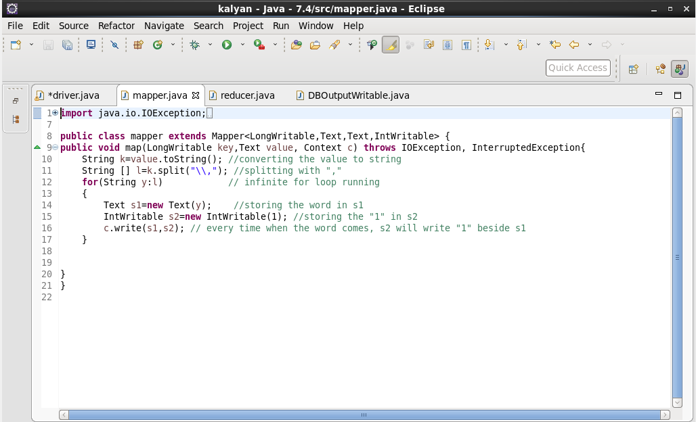

Reducer class:

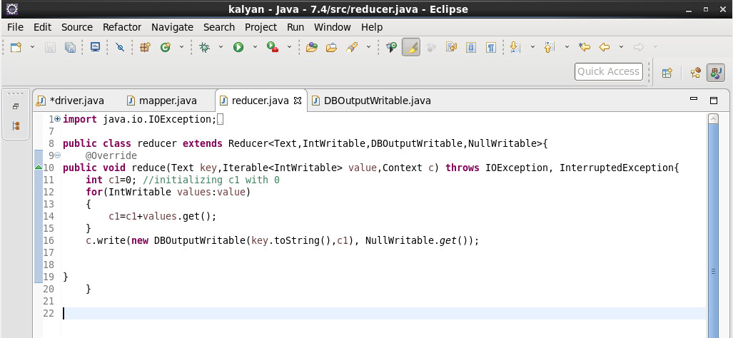

DBOutputWritable class:

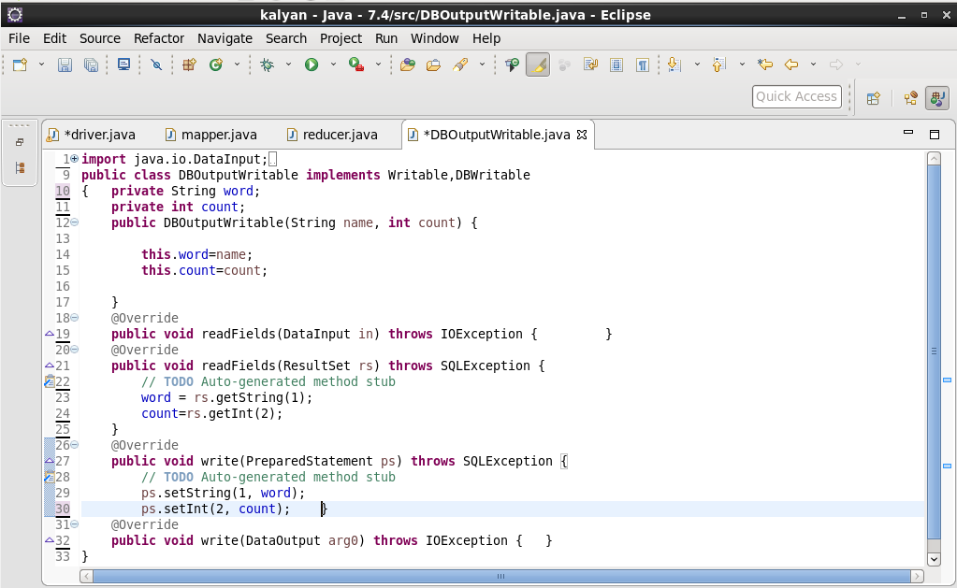

OUTPUT: successfully saved the output in mysql

