**Assignment 25.4**

**Problem Statement:**

1. Write a hive query to find the top 20 destination people travel the most: Based on the given data.

2. Write a hive query to find the top 20 locations from where people travel the most.

**Output:**

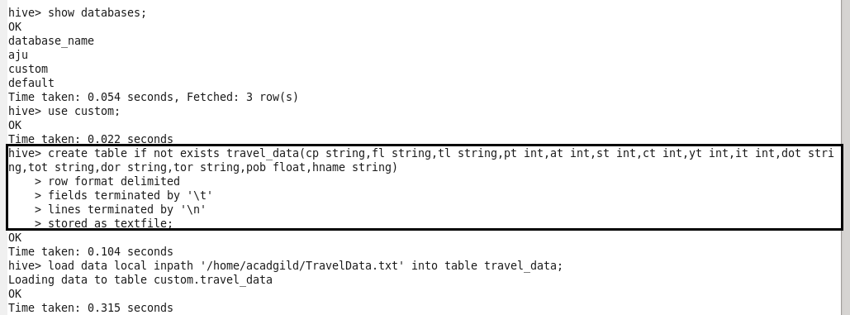

**Problem 1:**

Write a hive query to find the top 20 destination people travel the most: Based on the given data.

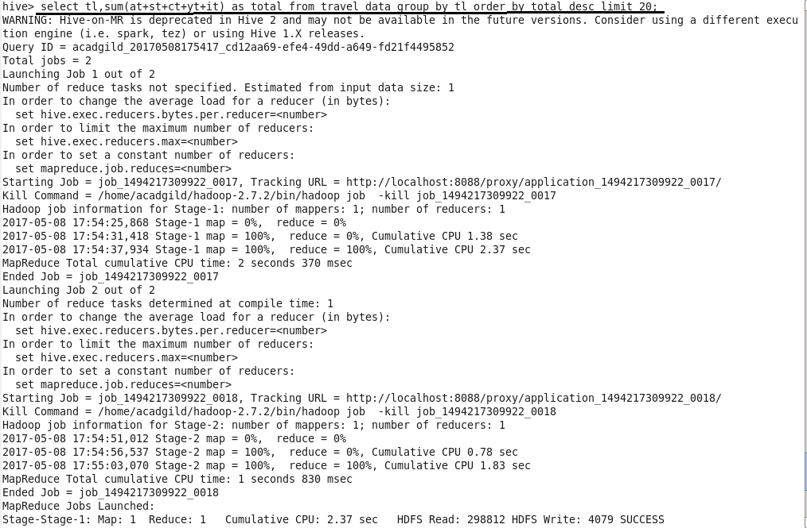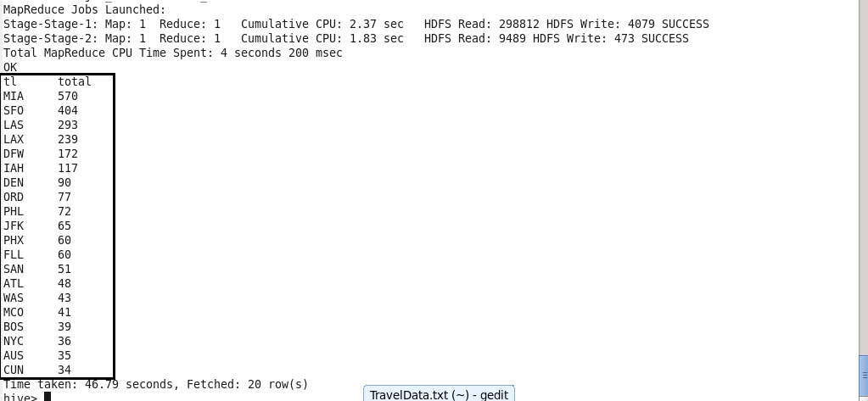

**Problem 2:**

Write a hive query to find the top 20 locations from where people travel the most.

