**Assignment 25.5**

**Problem Statement:**

1. Write a hive query to list top 5 residency details which lie in the budget of 60000-120000, an area more than 1450, sold after 17th may, min bedroom 3 and, min bathroom 2.

2. Write a hive query to separate list of residential apartments with more than 2 beds. Also include columns in following order City, Baths,Sq_feet,Price,flat_type,Beds respectively.

**Output:**

Creating table real_state in custom database and loading real_state data into the table:

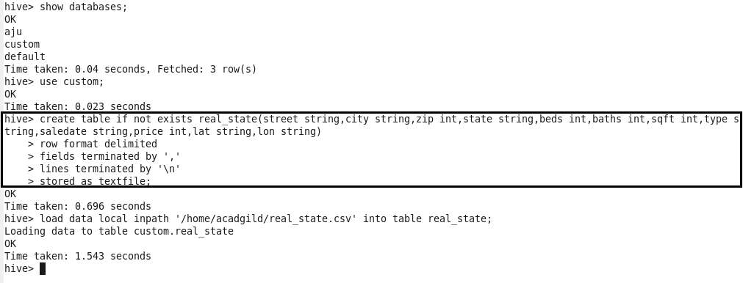

**Problem 1:**

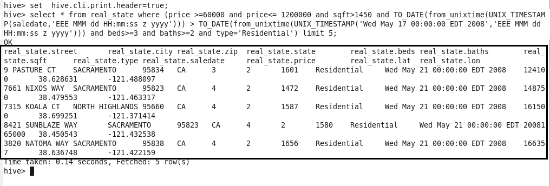

**Problem 2:**

