**25.6**

**Problem Statement:**

1. Write a hive query to find the city wise list all the Condos which is not less than ten thousand.

2. Write a hive query to find which is the cheapest Condo in CA. name the city,street and price for the Condo.

3. Write a hive query to list top 5 residency details which lie in the budget of 60000-120000, an area more than 1450, sold after 17th may, min bedroom 3 and,

4. Write a hive query to separate list of residential apartments with more than 2 beds. Also include columns in following order City, Baths,Sq_feet, Price, flat_type, Beds respectively.

**Output:**

Creating table real_state in custom database and loading real_state data into the table:

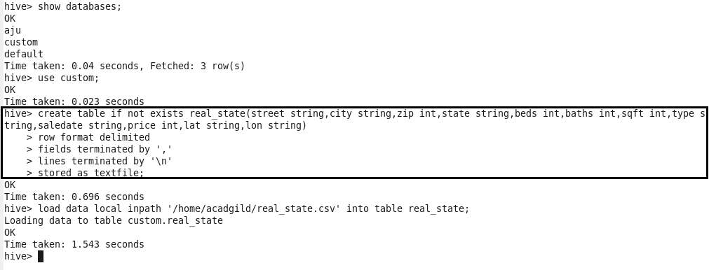

**Problem 1:**

Write a hive query to find the city wise list all the Condos which is not less than ten thousand.

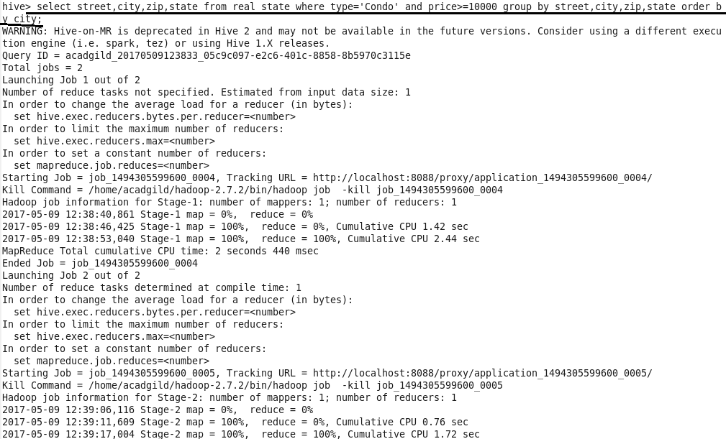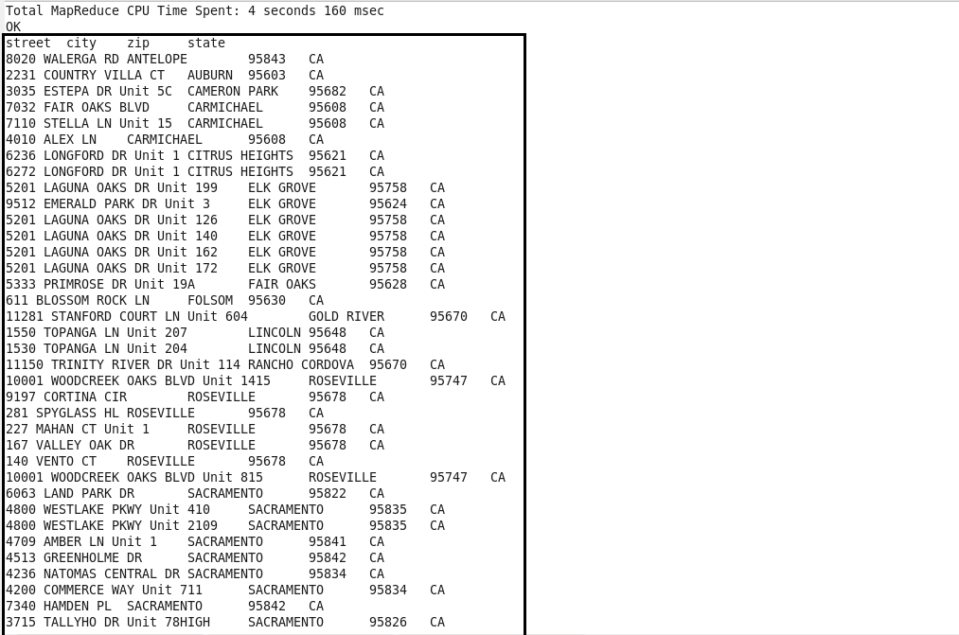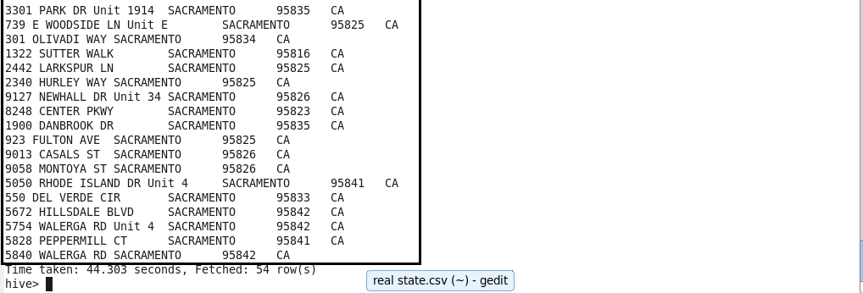

**Problem 2:**

Write a hive query to find which is the cheapest Condo in CA. name the city,street and price for the Condo.

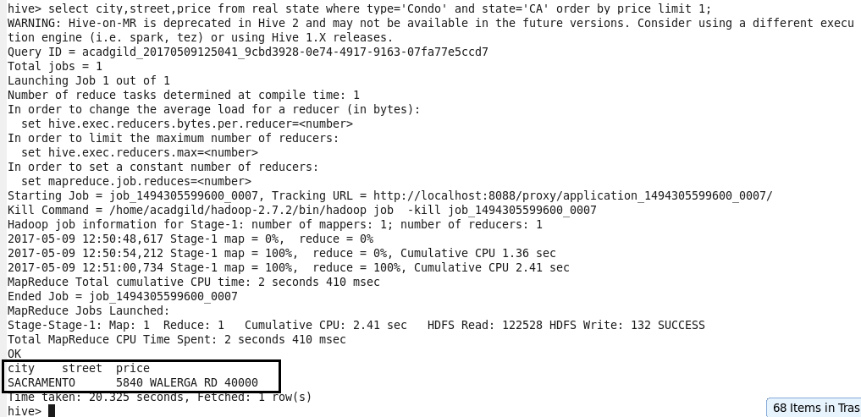

**Problem 3:**

Write a hive query to list top 5 residency details which lie in the budget of 60000-120000, an area more than 1450, sold after 17th may, min bedroom 3 and, min bathroom 2.

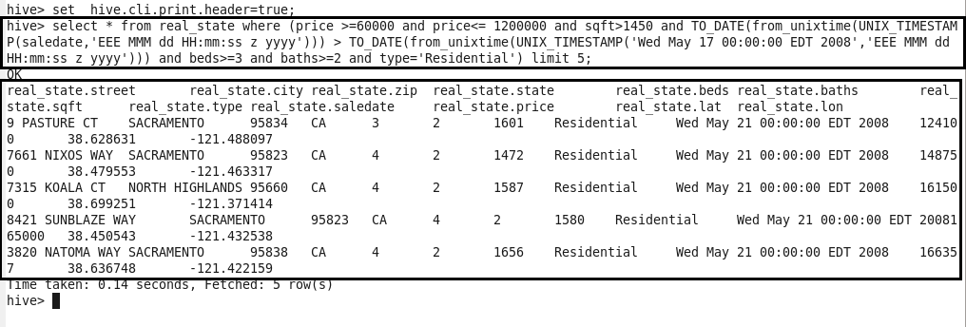

**Problem 4:**

Write a hive query to separate list of residential apartments with more than 2 beds. Also include columns in following order City, Baths, Sq_feet, Price, flat_type, Beds respectively.

