**Assignment 26.3**

**Problem Statement:**

* Create table RealEstate in Hive database, with all the columns present in dataset.
* Load dataset into table realEstate.
* Using Dynamic partition get separate lists of residential apartments with more than 2 beds and include columns in following order:City,Baths,Sq_feet,Price,flat_type,Beds respectively.

**Input:**

You can download the dataset from the link below:

<https://drive.google.com/file/d/0B1QaXx7tpw3SNDVoWEhPTk1SSjQ/view>

**Problem 1:**

Create table RealEstate in Hive database, with all the columns present in dataset.

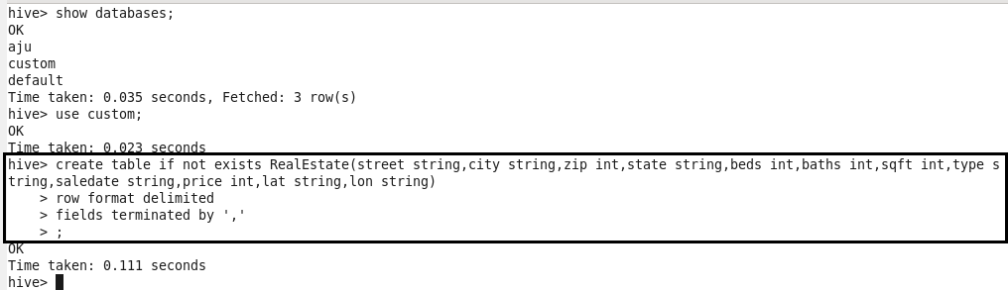

**Problem 2:**

Load dataset into table realEstate.

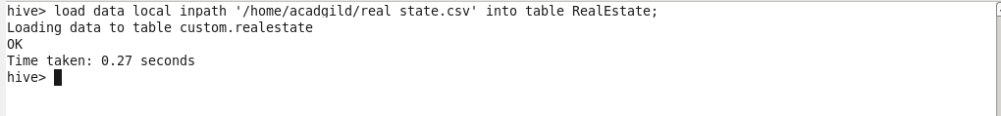

**Problem 3:**

