**Assignment 26.4**

**Problem Statement:**

Implement view in hive by following the steps in the below blog:

<https://acadgild.com/blog/hive-view-introduction/>

**Output:**

**Hive View:**

For writing queries, we sometimes find it difficult to frame query when it is nested and complex.

Encapsulating the complexity makes it easier for end users to construct complex queries from reusable parts.

We have following tables:

* Emp_salary
* employee

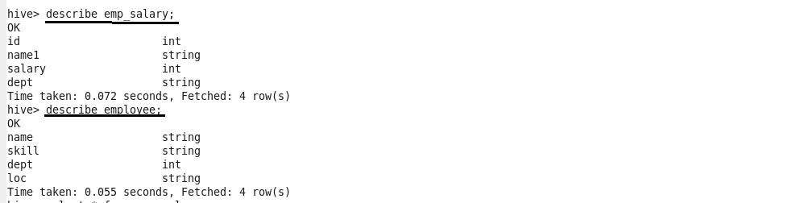

The two tables are joined using name.

